KNOWLEDGE WORKER EDITION

ChatGPT Sites
Command Center
  - A practical guide to building, governing, monitoring, and safely improving a portfolio of AI-created Sites.
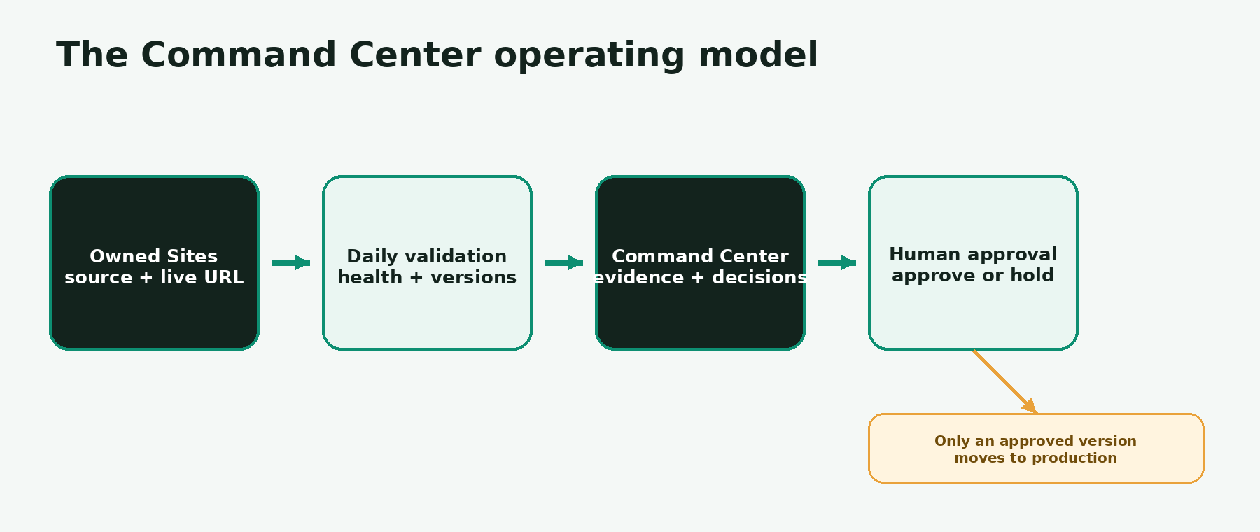
A single operating loop turns Site signals into evidence-based human decisions.
AUDIENCE  Knowledge workers using AI | VERSION  1.0 • September 2026 | LIVE EXAMPLE  Command Center v20
Open the live ChatGPT Sites Command Center

START HERE

How to use this guide
Read the first three chapters in order. Then use the task-based chapters whenever a decision, warning, or publishing question appears.
IF YOU NEED TO… | GO TO | YOU WILL LEARN
Understand Sites quickly | Chapters 1–2 | What a Site is, what the Command Center adds, and the vocabulary that matters.
Start using the Command Center | Chapters 3–5 | How to scan the portfolio, open a record, and interpret health.
Review a proposed release | Chapters 6–7 | How saved and live versions differ, and how to approve safely.
Respond to a problem | Chapters 8–9 | How to assess incidents, recover, and preserve evidence.
Run the portfolio over time | Chapters 10–12 | Automations, evidence, standards, reports, and relationships.
Build or improve a Site | Chapters 13–16 | Prompts, testing, sharing, and practical operating playbooks.
Look up a term or checklist | Appendices | Glossary, troubleshooting matrix, and one-page checklist.

LEARNING DESIGN Each chapter uses a repeatable pattern: concept → screenshot → interpretation → action → “what good looks like.” You do not need to understand code to use the operating controls.

The five rules to remember
- Evidence over guesswork — If a fact cannot be verified, record “Pending audit.”
- Saved is not live — A saved version is a candidate; a deployed version is production.
- Health is not access — A Site can be public and unhealthy—or private and healthy.
- Silence is not approval — Production changes require an explicit decision.
- History is append-only — Corrections add new evidence; they do not erase the old record.
01

ChatGPT Sites, in plain language
Learn what Sites can build and where the Command Center fits.

What is a ChatGPT Site?
A ChatGPT Site is a hosted website, web app, dashboard, internal tool, or game created and managed through ChatGPT. You describe the audience and job to be done; ChatGPT can build the experience, let you refine it, save a reviewable version, and deploy an approved version to a hosted URL.
PLAIN LANGUAGE Think of Sites as “from idea to working web experience” without assembling a separate hosting workflow. It can support static content or interactive tools with durable records, uploaded files, and identity-aware experiences when requested.
TERM | MEANING | WHY IT MATTERS
Site | The persistent hosted experience. | It remains available from the Sites list after the build chat ends.
Saved version | A deployable candidate. | Review it before making it live.
Deployment | A saved version published to production. | Every deployment URL is a production deployment.
Audience | Who can visit the Site. | Choose the narrowest access that fits the purpose.
Command Center | This portfolio-level operations Site. | It consolidates evidence and decisions across many Sites.

What Sites is good for
- Focused internal dashboards and trackers
- Searchable resource libraries and learning hubs
- Interactive calculators, planners, and reporting views
- Public information experiences with optional sign-in
- Apps that persist structured data or uploaded files

Choose a starting pattern
PATTERN | START WITH | EXAMPLE
Content hub | Trusted source material, search, and navigation. | Policies, research library, learning center
Decision tool | Inputs, transparent logic, and a useful result. | Planner, estimator, prioritization assistant
Operational app | Persistent records, roles, status, and history. | Tracker, intake workflow, portfolio dashboard

A STRONG FIRST BRIEF Name one audience, one job, the trusted source material, the few actions users must take, and what success looks like. Add persistent data, identity, or public access only when the workflow needs them.
AVAILABILITY Sites is currently described by OpenAI as a public beta. Plan eligibility, usage limits, region, and workspace settings can affect access. Always use the current Sites interface as the source of truth for your account.
02

The Command Center mental model
See the portfolio as a governed system—not a folder of links.
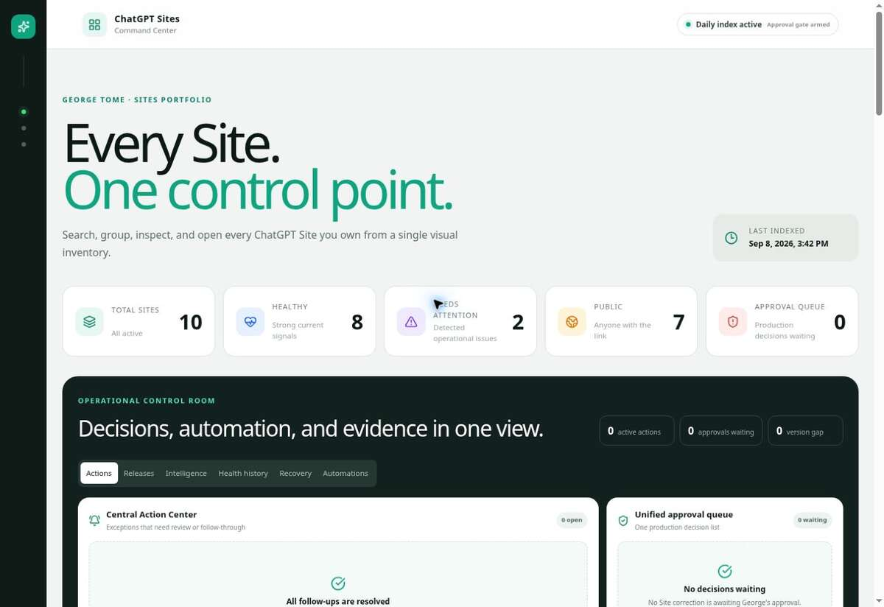
Live portfolio overview: summary metrics, operational control room, and searchable catalog.
The Command Center has four jobs: inventory every owned Site, surface exceptions, preserve decision evidence, and make production changes deliberate. It is not merely an uptime dashboard; it connects each signal to a record, an assessment, a corrective action, and—when needed—an approval gate.
LAYER | QUESTION IT ANSWERS | PRIMARY VIEW
Portfolio | What exists, and what needs attention? | Summary + Site catalog
Operations | What changed or needs a decision? | Actions, Releases, Intelligence
Reliability | Is it healthy, current, and recoverable? | Health history, Recovery, Automations
Governance | What evidence supports the decision? | Evidence, Standards, Reports, Relationships
Site record | What is the complete story for one Site? | Record sheet + append-only history

KEY DISTINCTION “Needs attention” is a health signal. “Active action” is an actionable work item. “Approval waiting” is a human decision. Their counts can differ without contradiction.
03

Your 10-minute quick start
Build confidence with one safe, repeatable scan.

Minute 0–2: orient yourself
- Confirm the Last indexed timestamp. Old evidence may look current until you check the timestamp.
- Read Total Sites, Healthy, Needs attention, Public, and Approval queue as separate measures.
- Treat “Pending audit” as an explicit unknown—not as a passing result.

Minute 2–5: scan the operational controls
- Open Actions for work that needs follow-up.
- Open Releases for saved-versus-live differences.
- Open Intelligence to see meaningful changes since the last sync.

Minute 5–8: inspect one Site record
- Search by Site name, purpose, asset, or note.
- Select View record.
- Read saved/live versions, freshness, runtime, incident gate, and history.

Minute 8–10: close the loop
- If there is no action: leave the evidence intact.
- If evidence is stale: request verification.
- If a correction is prepared: review the assessment and explicitly approve or hold production.
WHAT GOOD LOOKS LIKE You can explain what changed, what evidence supports it, whether users are affected, and whether a human decision is required—in under ten minutes.
04

Read the portfolio overview
Turn top-line numbers into a prioritized scan.
METRIC | READ IT AS | DO NOT ASSUME
Total Sites | The indexed owned portfolio. | That every historical or shared Site is included.
Healthy | Strong current signals within configured checks. | That every content claim or workflow was manually audited.
Needs attention | One or more operational signals deserve review. | That production is necessarily down.
Public | Accessible to anyone with the link. | That public is the correct audience.
Approval queue | Production decisions explicitly waiting. | That no work exists when the queue is zero.

A reliable triage order
- Approval queue — Decisions can block already-prepared work.
- Active actions — Resolve confirmed follow-ups and ownership gaps.
- Version gaps — Decide whether saved candidates should move forward.
- Needs attention — Investigate health, freshness, and audit signals.
- Public exposure — Confirm the audience is intentional and safe.
POINT-IN-TIME DATA Screenshots in this guide show the live Command Center on September 8, 2026. Counts and versions will change; the reading method remains the same.
05

Open and interpret a Site record
Move from summary signal to complete operating evidence.
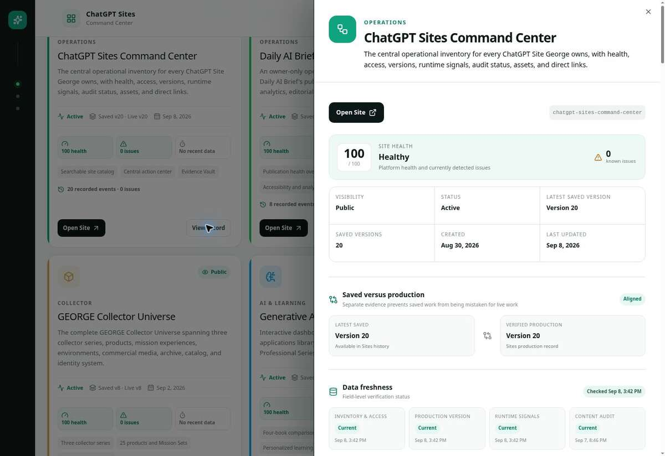
The Site record separates identity, health, saved/live versions, and evidence freshness.

Read the record from top to bottom
- Identity and purpose — Confirm you opened the intended Site.
- Visibility and status — Who can visit, and whether the Site is active.
- Saved vs production — Whether a candidate differs from the deployed version.
- Freshness — When inventory, access, runtime, content, and production evidence were last verified.
- Runtime and incident gate — What failed, impact, confidence, and whether approval is required.
- History — The append-only evidence trail for issues, updates, decisions, and verification.
06

Manage releases safely
Understand the only difference that matters at publish time: candidate versus production.
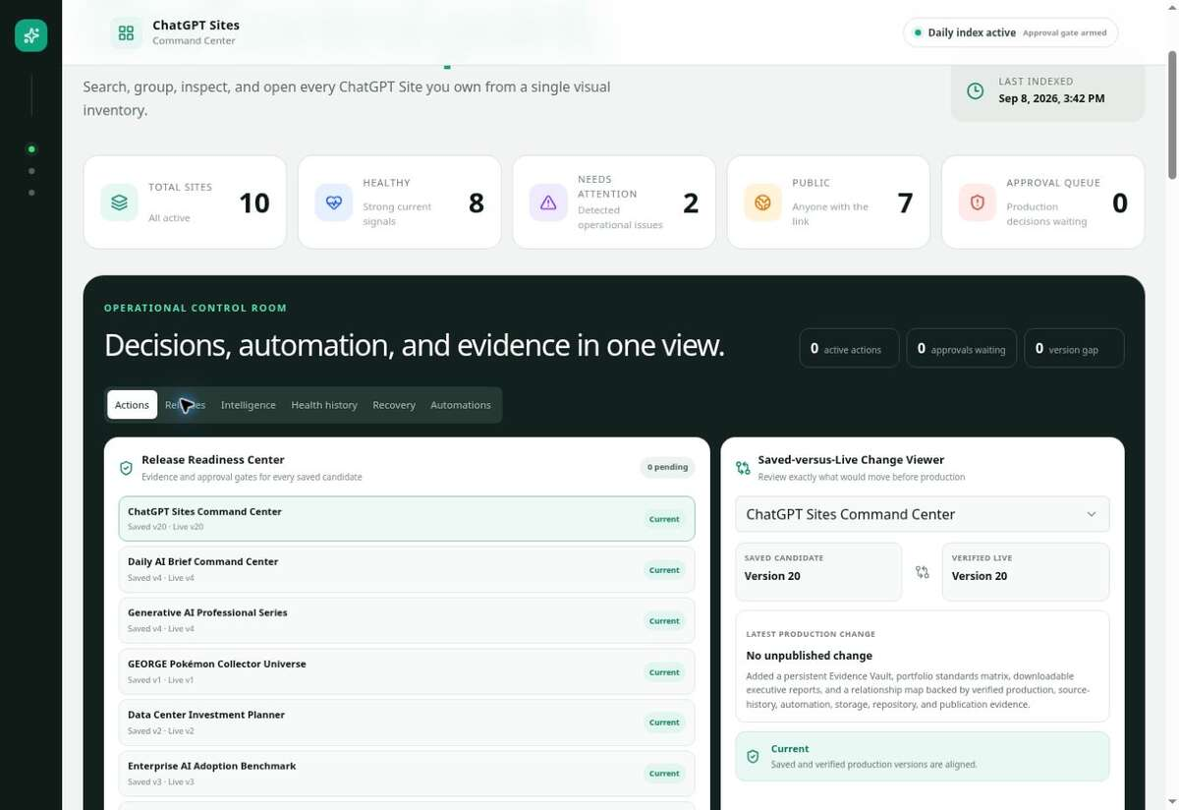
Release Readiness surfaces saved-versus-live gaps and the evidence needed for a decision.
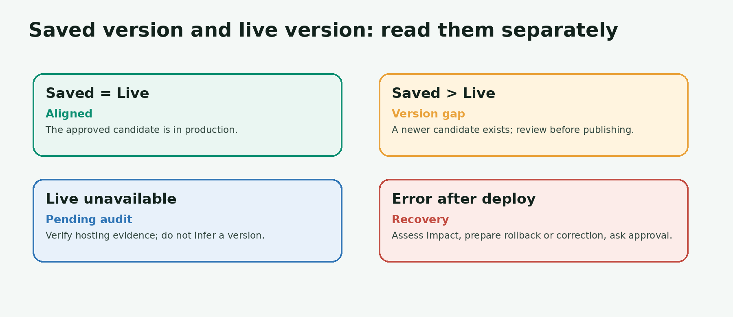
Four common version states and the correct response.

The production decision checklist
- Confirm the intended saved version number and the current live version.
- Review the change summary and affected routes or workflows.
- Check build, link, mobile, accessibility, and key interaction results.
- Confirm privacy, audience, secrets, and data handling remain correct.
- Identify a recovery target: rollback version or tested corrective release.
- State the decision explicitly: “Approve production” or “Do not publish.”
PRODUCTION RULE Every Sites deployment URL is production. If you want a reviewable candidate without changing live users, ask ChatGPT to save a version without deploying it.
07

Use the approval gate
Keep AI fast while keeping humans in control.
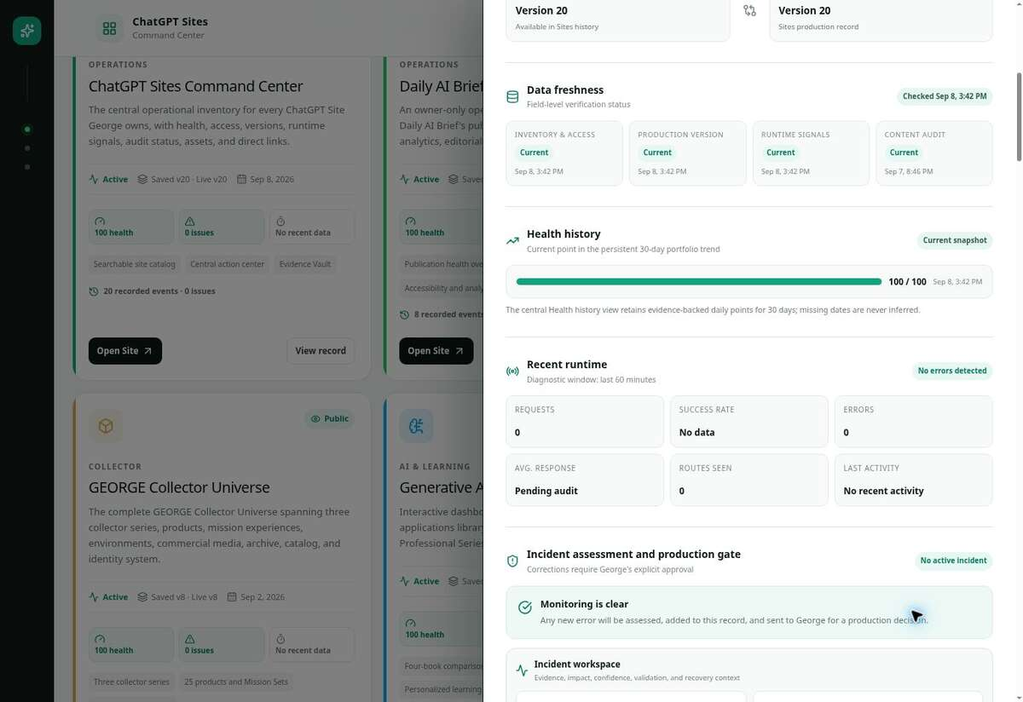
Incident assessment and the production gate live together in the Site record.

A decision-ready notification contains
FIELD | WHAT TO EXPECT
Error | The route, behavior, status, time window, and reproducible symptom.
Assessment | Probable cause, impact, affected audience, and confidence.
Corrective action | Specific code, asset, configuration, or routing change prepared.
Validation | Build result, route checks, link checks, responsive and accessibility results.
Recovery | Known-good version or corrective path if the release regresses.
Decision | A direct request to approve production or hold.

HUMAN CONTROL A notification is not authorization. Silence, acknowledgement, or asking a follow-up question does not approve production.

How to answer
- Approve production — Use only when the version, scope, validation, and audience are clear.
- Do not publish — Use when evidence is incomplete, risk is unacceptable, or the change is not intended.
- Hold—verify X — Name the smallest missing check that would change the decision.
08

Respond to incidents
Move from a detected error to a verified correction without skipping judgment.
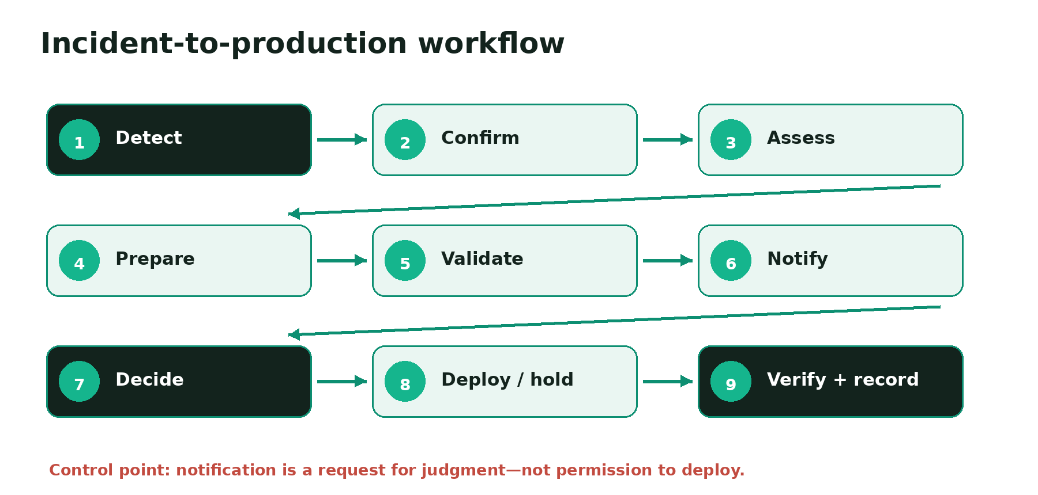
The controlled incident workflow—from detection through evidence capture.

Assessment questions for non-experts
QUESTION | WHY IT HELPS
What exactly failed? | Separates a broken page, asset, route, data request, or monitoring check.
Who is affected? | Distinguishes a private owner workflow from a public user outage.
Can it be reproduced? | Turns a one-off signal into testable evidence.
What changed recently? | Narrows the likely cause without assuming it.
What is the smallest correction? | Reduces risk and speeds validation.
How will we recover? | Prevents deployment from becoming a one-way door.

09

Preserve complete issue and update history
Use the ledger to learn, audit, and recover—not just to count errors.
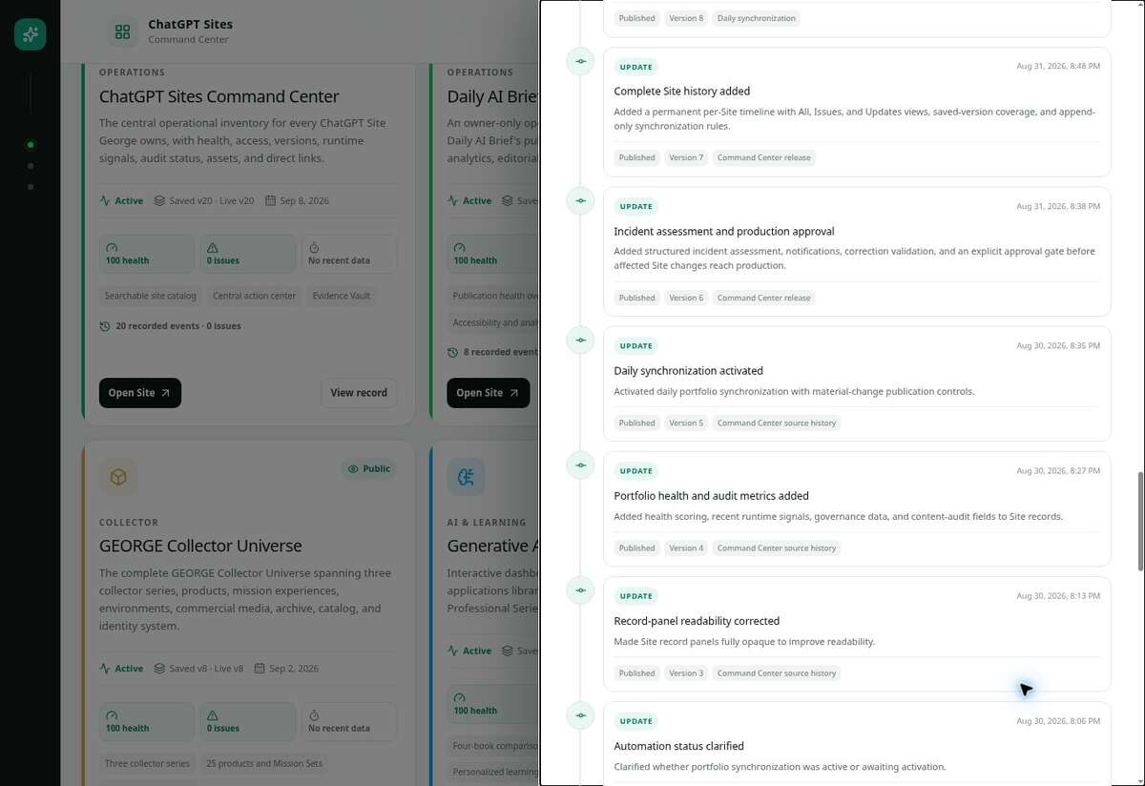
The append-only ledger preserves releases, incidents, approvals, and verification events.

Why append-only history matters
- Accountability — You can see what was known at the time of a decision.
- Recovery — A known-good version and prior corrective path remain visible.
- Learning — Recurring causes and weak controls become measurable.
- Trust — Corrected facts are not silently rewritten.
EVENT TYPE | MINIMUM EVIDENCE
Issue detected | Timestamp, signal, affected route or behavior, source.
Assessment | Impact, cause hypothesis, confidence, needed correction.
Decision | Approver, approved/held outcome, version, time.
Deployment | Saved version, live version, production result.
Verification | Checks performed, results, residual risk.
Correction to prior record | What changed, why, and which prior entry it supersedes.

How to read a ledger entry
- Locate the trigger — Start with the issue, request, release, or scheduled check that created the entry.
- Separate fact from interpretation — Direct observations are evidence; cause and impact statements are assessments.
- Follow the decision — Find the explicit approval, hold, or verification request and its version scope.
- Confirm closure — Look for post-deployment verification, a residual risk, or the next owned action.
CORRECTION PATTERN When a prior entry is wrong, append a correction that names the superseded entry and explains why. Preserve both so the timeline remains auditable.
10

Use health history and freshness
Prefer trends and timestamps to reassuring snapshots.
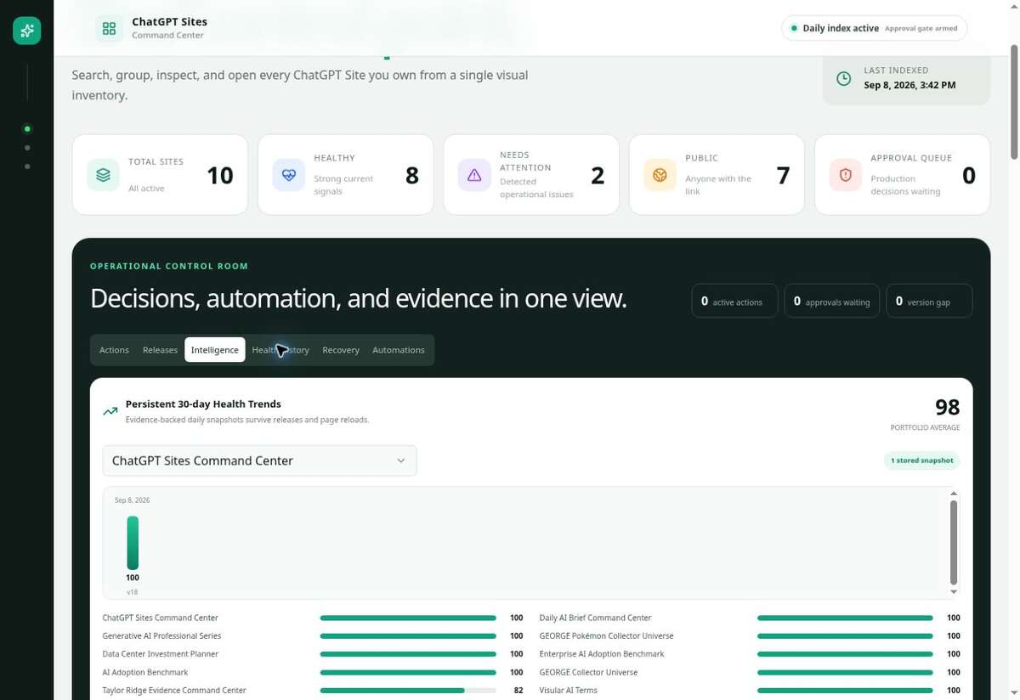
Health Trends shows the portfolio over time, not just the current score.

Three questions for every health signal
- Is the evidence recent enough for the decision?
- Is the signal one point or a repeated trend?
- Does the signal measure uptime, content, accessibility, links, or release control?
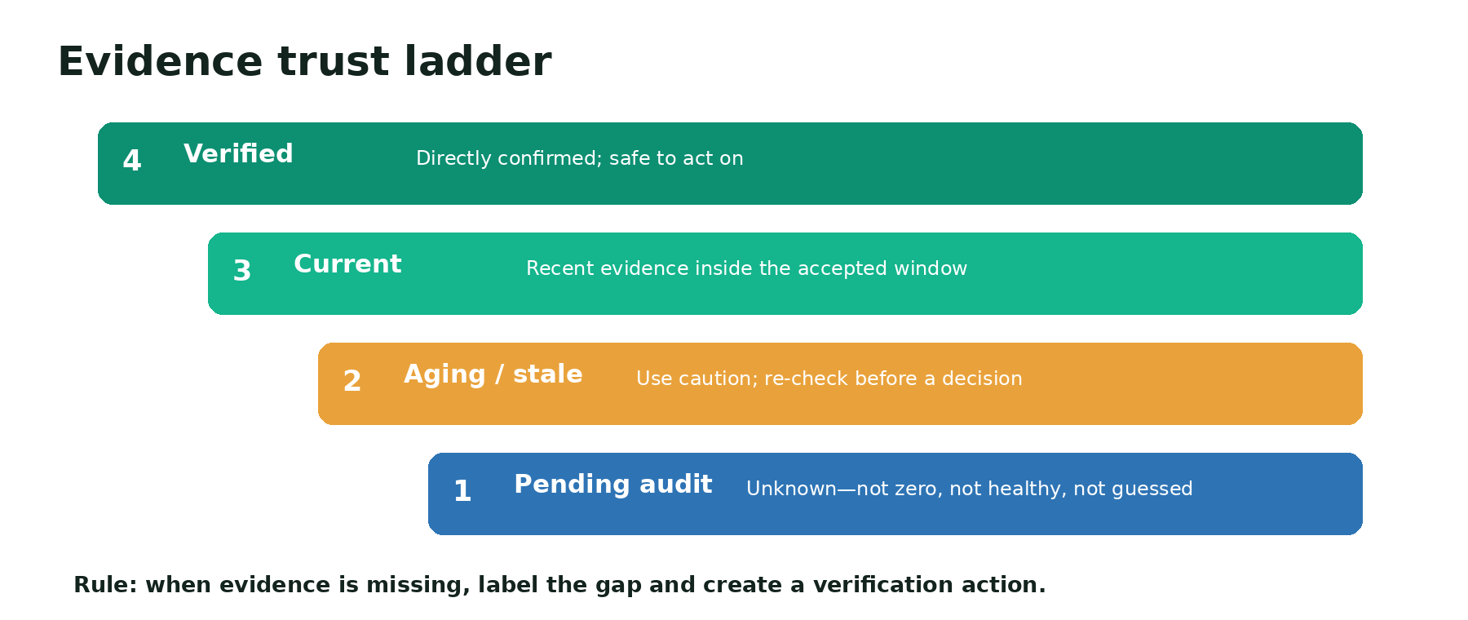
Use explicit evidence states instead of filling gaps with assumptions.
INTERPRETATION A history count includes resolved events. A current issue count represents what still needs action. Never subtract one from the other to infer quality.
11

Run reliable automations
Automate verification and synchronization—never the production decision.
The portfolio uses one combined daily schedule to validate both Command Centers, synchronize the Sites inventory, update operational fields, and apply the human production gate. A retired standalone sync remains paused to prevent duplicate indexing and notifications.
AUTOMATE | KEEP HUMAN-GATED
Inventory discovery and metadata refresh | Changing a public audience
Version and production evidence checks | Publishing a saved version
Runtime, link, freshness, and health signals | Accepting material content or data changes
Duplicate detection and history append | Choosing a recovery strategy
Notification preparation | Resolving ambiguous evidence

When a schedule misbehaves
- Check the last recorded run and next expected run.
- Confirm only one active schedule owns each responsibility.
- Look for duplicate ledger entries or duplicate notifications.
- Pause the redundant schedule; preserve its history.
- Run a controlled validation and verify one clean appended event.
CURRENT PATTERN One active combined schedule plus paused retired schedules is easier to audit than overlapping automations with similar names.
12

Use evidence, standards, reports, and relationships
Turn a dashboard into an accountable operating system.
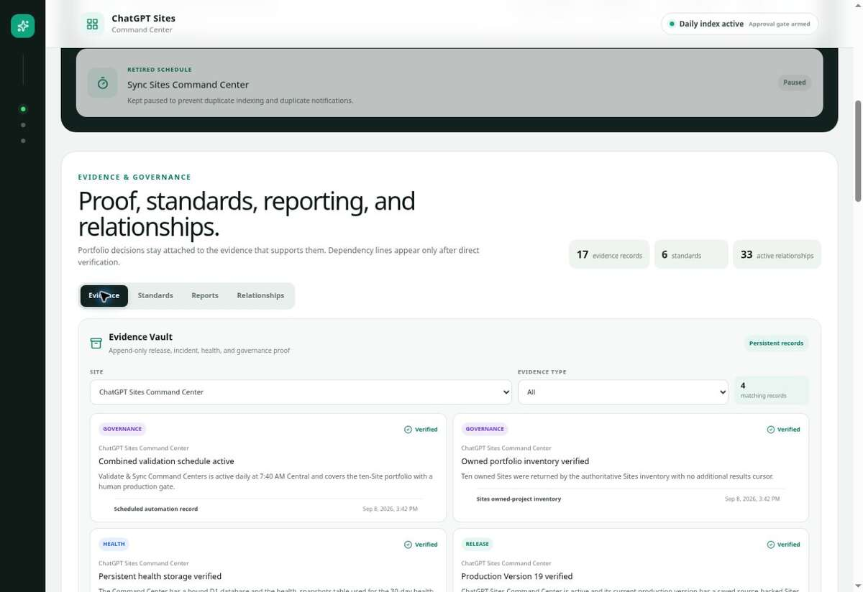
Evidence Vault records persist beyond a browser session; individual cards may describe prior versions.
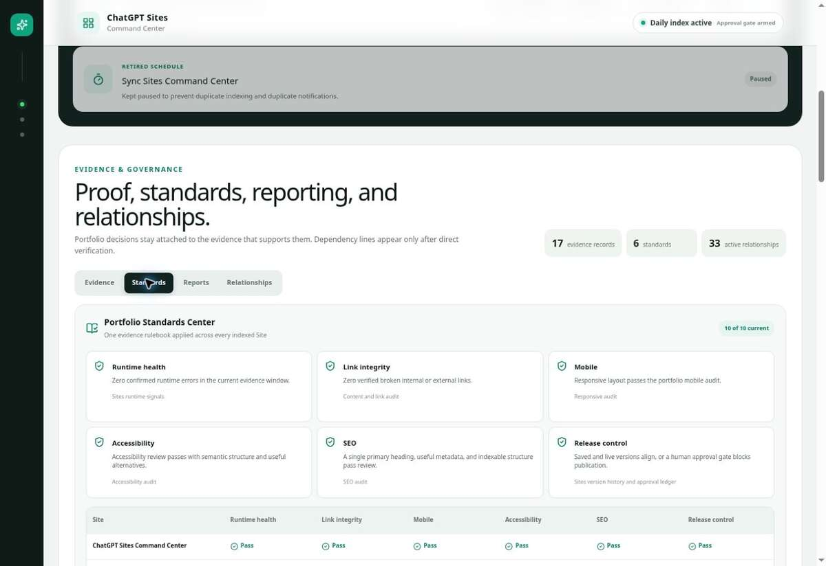
Portfolio Standards Center applies the same baseline across all indexed Sites.
GOVERNANCE VIEW | USE IT FOR | DECISION QUESTION
Evidence | Facts, checks, and supporting records. | What proves this claim?
Standards | A consistent portfolio baseline. | Which control applies?
Reports | Executive PDF/Markdown summaries. | What must a reviewer know?
Relationships | Verified dependencies and ownership. | What else changes if this changes?

DEPENDENCY RULE A relationship is displayed only after direct verification. Similar names, common ownership, or likely architecture are not enough.
13

Build and improve a Site
Use a prompt that makes audience, evidence, behavior, and approval explicit.

A strong starter prompt
Build a focused Site for [audience] that helps them [primary job]. Use [approved files/data] as the source of truth. Include [essential views/actions]. Persist [records/uploads] between visits. Keep the initial audience [owner/workspace/selected/public]. Test the primary path on desktop and mobile, check links and accessibility, list missing evidence as “Pending audit,” save a reviewable version, and do not publish or change access until I explicitly approve production.

Work in four passes
PASS | FOCUS | OUTPUT
1. Scope | One audience, one job, one success measure. | Short plan and information model.
2. Build | Core content, behavior, and approved data. | Working private preview.
3. Validate | Main paths, mobile, accessibility, privacy, links. | Evidence-backed release candidate.
4. Govern | Audience, version, recovery, approval. | Explicit publish or hold decision.

STORAGE LANGUAGE If people expect data or uploaded files to remain between visits, say so explicitly. Ask for structured durable data, file storage, or both based on the workflow.
14

Share access deliberately
Treat visitor access, editing access, and in-app identity as separate controls.
CONTROL | WHAT IT DOES | SAFE DEFAULT
Audience | Determines who can open the Site. | Owner and workspace admins during review.
Visitor invitation | Grants selected people access. | Named people or groups when possible.
Editor access | Allows trusted workspace members to change and publish. | Only people trusted with code and live data.
Sign in with ChatGPT | Adds identity-aware features inside a public Site. | Optional unless personalization is required.
Public publishing | Lets anyone on the internet visit. | Use only after content and data review.

Before sharing
- Review generated text, images, links, uploaded files, forms, and interactions.
- Remove secrets and confidential or unauthorized third-party content.
- Test from the intended visitor experience—not only as the owner.
- Confirm what personal information is collected and where it is stored.
- Choose the narrowest audience that still accomplishes the job.
- Open the shared URL and verify the intended audience can access it.
IMPORTANT Visitor access does not grant editing. Promoting an editor does not automatically change the Site audience. Keep those decisions separate.
15

Use practical operating playbooks
Apply the Command Center to common knowledge-work situations.

Playbook A — Morning portfolio scan
- Confirm the index timestamp.
- Review approvals, actions, and version gaps.
- Open each changed Site record.
- Record the smallest verified follow-up.
- Leave stable evidence untouched.

Playbook B — Review an AI-prepared correction
- Read the reproduced error and user impact.
- Compare the proposed change to the stated cause.
- Check build and route validation evidence.
- Confirm recovery target and audience.
- Approve production, hold, or request one targeted verification.

Playbook C — Prepare an executive review
- Set the reporting window.
- Explain material changes, risks, decisions, and stale evidence.
- Use reports for summary and Site records for supporting detail.
- Separate confirmed facts from interpretation.
- Name owners and next verification dates.

Playbook D — Onboard a colleague
- Explain saved versus live first.
- Demonstrate search, View record, and history.
- Walk through a fictional approval—do not publish.
- Show how “Pending audit” prevents guessing.
- Confirm what they may view, edit, approve, or share.
16

Adopt a sustainable operating rhythm
Keep control lightweight enough to use consistently.
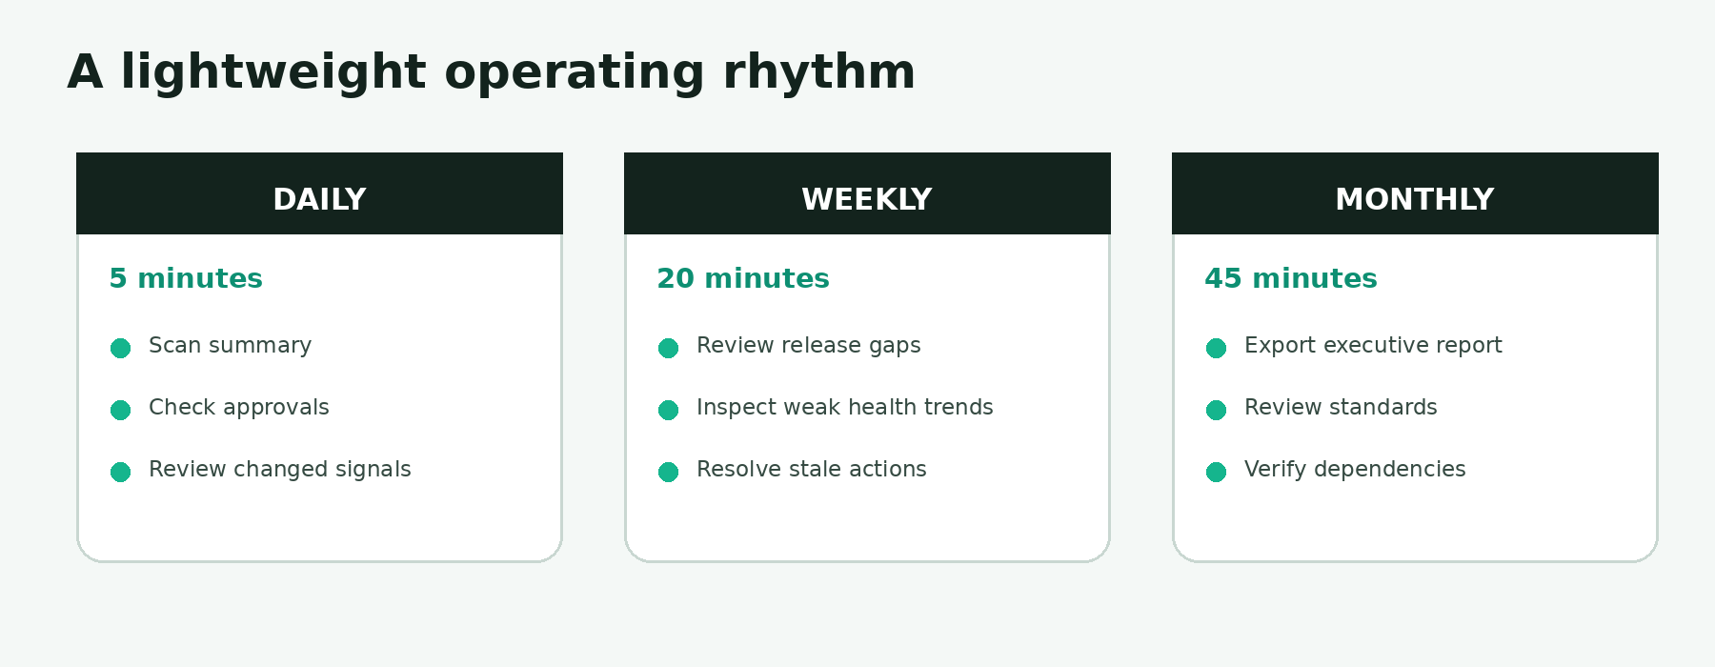
Daily, weekly, and monthly reviews keep the portfolio current without turning governance into bureaucracy.
CADENCE | OWNER OUTPUT | SUCCESS SIGNAL
Daily | Clean action and approval queues. | No decision waits unnoticed.
Weekly | Resolved stale signals and intentional release gaps. | Every exception has evidence and an owner.
Monthly | Executive report, standards review, verified relationship map. | Portfolio claims are current and reproducible.
After each release | Deployment and verification entries. | Saved/live alignment or documented hold.
After each incident | Assessment, decision, recovery, and learning. | The history explains what happened end to end.

17

Troubleshooting matrix
Use symptoms to choose the smallest safe next check.
SYMPTOM | LIKELY INTERPRETATION | NEXT CHECK
Site is Active/Public but health is low | Publication status and runtime health are separate. | Open runtime and freshness evidence.
Saved version is higher than live | A reviewable candidate exists. | Review change scope and validation; do not auto-publish.
Health is 100 but evidence is stale | The last known result passed, but may be outdated. | Run or request verification.
History shows issues; current issues is 0 | Prior issues are resolved but preserved. | Check the latest closure/verification event.
Two notifications describe the same run | Overlapping or duplicate schedules may exist. | Inspect automation ownership; pause the redundant job.
A route returns 404 | The route or asset may be missing. | Confirm exact URL, status, and intended route.
A request fails immediately | Often routing, permissions, missing resource, or app exception. | Check route/status/log evidence before changing code.
Production version is unknown | Evidence is unavailable. | Mark Pending audit and verify through Sites.
Public link works for owner only | Audience or invitation settings may differ. | Test as the intended visitor.
Change is ready but approval unclear | No valid production decision exists. | Request explicit approve/hold wording.

18

Glossary
Use shared language to reduce operational ambiguity.
TERM | DEFINITION
Active action | A confirmed follow-up that needs work or ownership.
Approval gate | The point where a human explicitly authorizes or holds production.
Deployment | A saved version published to the production URL.
Evidence freshness | How recently a specific fact was directly verified.
Health score | A combined view of configured operational signals; not an audience or approval measure.
Incident | A detected failure or degraded behavior requiring assessment.
Live version | The version currently serving production visitors.
Pending audit | A fact that has not been verified; never a substitute for zero or healthy.
Recovery target | The known-good version or correction used if production regresses.
Relationship | A directly verified dependency such as source, production, automation, repository, publication, or storage.
Saved version | A deployable release candidate that may or may not be live.
Site record | The complete operational view and append-only history for one Site.

19

One-page operator checklist
Print this page or keep it beside the Command Center.

SCAN
- □ Confirm Last indexed time
- □ Review approval queue, actions, and version gaps
- □ Scan health and public exposure separately

VERIFY
- □ Open the affected Site record
- □ Check saved/live alignment
- □ Check freshness, runtime, impact, and confidence
- □ Replace unknowns with Pending audit

DECIDE
- □ Review the exact corrective action
- □ Confirm validation and recovery evidence
- □ Approve production / Do not publish / Hold—verify X

CLOSE
- □ Verify production behavior and audience
- □ Append the deployment or hold decision
- □ Preserve the issue, assessment, correction, and outcome
- □ Confirm automation will not duplicate the event
OPERATOR PROMISE No silent promotion. No guessed facts. No erased history. Every production change is traceable to evidence and an explicit decision.
20

Sources and guide notes
Know which guidance comes from OpenAI and which comes from the observed Command Center.

Primary OpenAI sources
Sites — ChatGPT Learn Official product guidance for creation, versions, deployments, analytics, access, storage, sharing, secrets, review, and limits.
Build and deploy internal apps — ChatGPT Use Cases Workflow guidance for scoping, testing, privacy, and approval before sharing.
Building a shareable Site — ChatGPT Training Sharing and audience-control walkthrough.

Command Center evidence
Live ChatGPT Sites Command Center Screens and operational behavior observed September 8, 2026; Command Center Version 20.
The Command Center is a portfolio-specific operating layer built on ChatGPT Sites. Its health model, approval workflow, evidence vault, standards center, reporting, and relationship map are features of this implementation—not universal labels in every Site.
CURRENCY NOTE ChatGPT Sites is evolving. Use the live OpenAI documentation and current interface for plan eligibility, regional availability, limits, permissions, and workspace-specific controls. This guide’s operating principles remain useful even when labels move.

Document control
GUIDE RECORD ChatGPT Sites Command Center User Guide • Knowledge Worker Edition • Version 1.0 • Prepared September 2026 • Live example: Command Center Version 20. Review after a major change to Command Center navigation, governance, access, or the Sites product.

