END-USER GUIDE

Context Engineering
Mission Control
  - A practical, learner-centered guide for understanding the mission flow, improving weak context packages, and using every run as a lesson in better AI inputs.
Best first mission  Customer support resolution | Primary learning goal  See why stronger context improves output reliability | Visual source  Updated with uploaded application screenshots

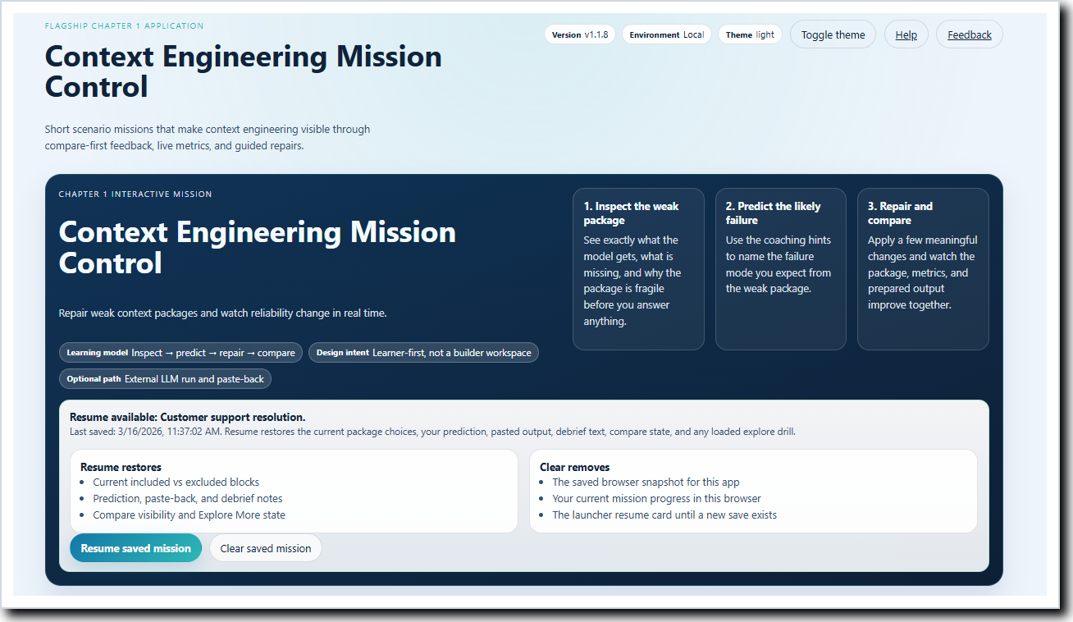
Figure 1. The application opens with a mission-based learning experience built around inspect, predict, repair, compare, and debrief.
What this guide helps you do
- Start with the right mission instead of guessing where to begin.
- Read the weak package as evidence, not just as text on the screen.
- Interpret the metrics dock as a teaching tool instead of a mystery score.
- Use optional features such as Explore More, compare, and debrief at the right time.
- Leave each mission with a clearer mental model of what strong context looks like.

How to use this guide
Read straight through for a complete orientation, or jump to the sections that match what you are doing inside the application.
Section | What you will get from it
1. Start here | What CEMC is, what it teaches, and how to think about the app.
2. Get value fast | The best first mission and the shortest path to a useful first run.
3. Choose the right mission | What each scenario family teaches and when to use it.
4. Understand the workflow | How the five mission stages fit together.
5. Work the mission screen | What to do in inspect, predict, repair, compare, and debrief.
6. Read the metrics dock | What each metric means and how to use it well.
7. Use optional features well | Progress, Explore More, best-practice reveal, and reflection.
8. Learn more effectively | Habits, controls, and common questions.

Best first reading path
- Start with Section 2 if you want to run the application immediately.
- Read Section 5 before your first complete mission.
- Keep Section 6 open if you want help interpreting the live metrics.

1. Start here: what CEMC teaches
Context Engineering Mission Control is a guided learning environment, not a blank prompt builder. It begins with a visible weak package so you can study what the model would actually receive before any repair is made.
The educational value comes from visible cause and effect. You inspect the package, predict the likely failure, improve it deliberately, compare the weak and current states, and finish with a short debrief that turns interaction into understanding.
The most useful mindset is to treat each mission like a short lab. You are not trying to click through every feature. You are trying to explain why the package is weak, what changed, and why the stronger package should produce a better result.
What strong performance looks like in CEMC
- You can explain the weakness before you repair anything.
- You make one or two meaningful changes and can name which metrics should move.
- You compare the package states instead of chasing a number blindly.
- You finish with a debrief that explains the lesson in plain language.

2. Get value fast with your first mission
For most users, Customer support resolution is the best first run. It makes grounding, dynamic facts, answer structure, and token budgeting easy to see without needing specialized background knowledge.  A strong first run is not about touching every optional control. It is about completing the core learning loop once and understanding why the stronger package is better than the weak one. | 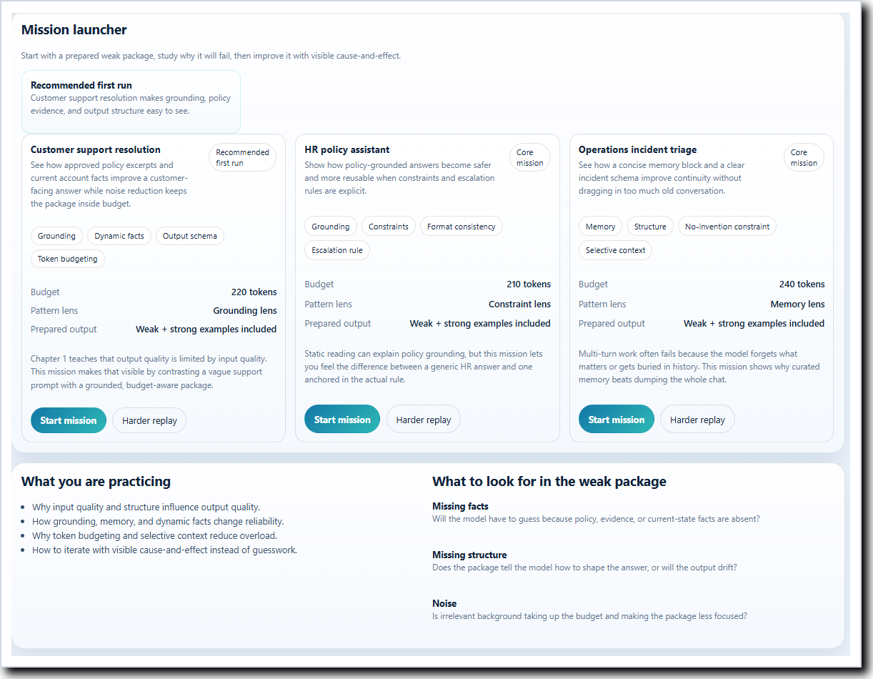

Figure 2. The mission launcher helps new learners start with the recommended first scenario.
First-run step | What to do
1. Start the mission | Choose Customer support resolution from the launcher.
2. Inspect the weak package | Look at what the model has, what is missing, and what seems noisy.
3. Predict the failure | Commit to the most likely weak-state outcome before editing.
4. Repair selectively | Add only the blocks that clearly improve grounding, structure, or continuity.
5. Compare the states | Study what changed and why the metrics moved.
6. Debrief | Write a short explanation of what mattered most and why.

Three first-run reminders
- Predict from the visible package, not from memory.
- Do not add every possible block just because it is available.
- Do not skip the debrief; that is where the lesson becomes usable outside the app.

3. Choose the right mission for the lesson you want
All three scenario families teach the same core principle: output quality is constrained by input quality. They differ in the kind of context problem they make easiest to see.

Figure 3. The launcher presents three scenario families with different concept lenses.
Scenario family | What it teaches best | Use it when…
Customer support resolution | Best first run; grounding, dynamic facts, output structure, and budget discipline. | When you want the clearest visible link between missing evidence and generic answers.
HR policy assistant | Policy grounding, escalation rules, constraints, and reusable answer format. | When you want to practice safe boundaries and rule-based guidance.
Operations incident triage | Memory curation, continuity, structure, and no-invention guardrails. | When you want to see why selected memory beats dumping old conversation history.

4. Understand the mission workflow before you begin
The application is organized around a simple five-stage learning rhythm. You do not need to memorize the interface if you remember the order: inspect, predict, repair, compare, then debrief.
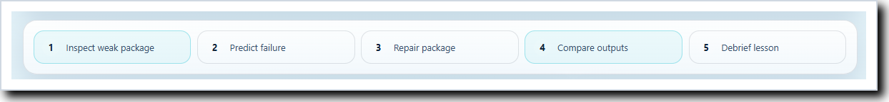
Figure 4. The stage strip keeps the core learning flow visible while you work.
- Inspect tells you what evidence the model would actually receive.  - Predict forces you to name the likely failure before editing.  - Repair teaches selective improvement instead of context stuffing.  - Compare makes the weak and current states visible side by side.  - Debrief turns the interaction into a reusable lesson. | 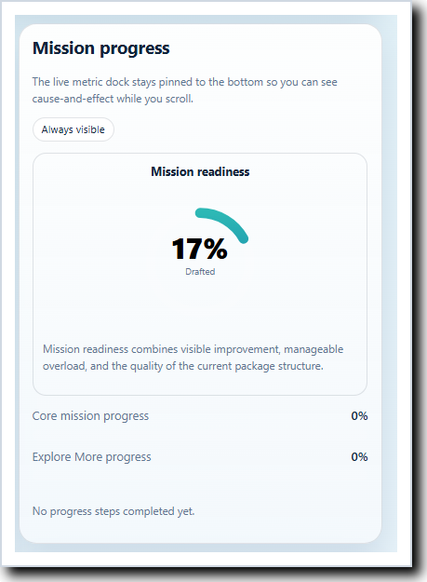

Figure 5. The progress card reminds you that core completion matters more than racing through extras.

5. Work the mission screen with confidence
The mission screen is arranged to keep the learning task in front of you. The package stays central, the support rail keeps progress and optional deepening nearby, and the metrics dock stays visible so you can connect your changes to visible consequences.
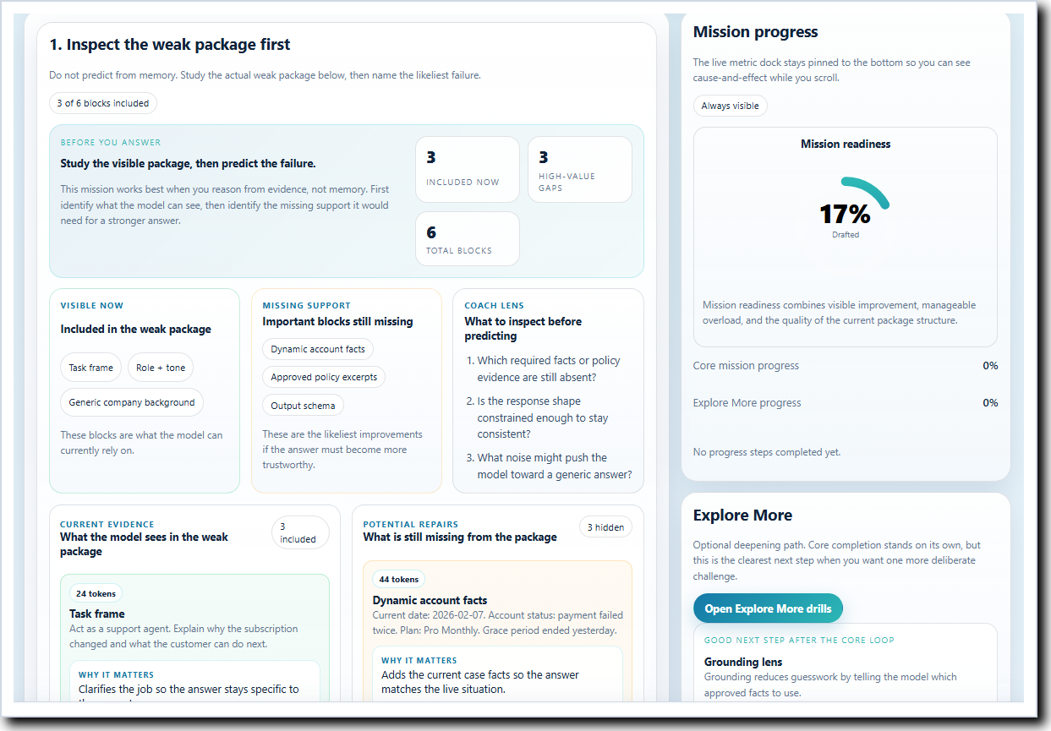
Figure 6. The mission workspace keeps inspection, progress, optional drills, and support actions within one coherent learning flow.
Screen area | How to use it
Mission brief | Tells you what the scenario is trying to teach and why it matters.
Weak package area | Shows what the model currently has and what is still missing.
Prediction panel | Locks in your hypothesis before you begin improving the package.
Repair area | Lets you make deliberate changes through guided buttons or card selection.
Comparison workspace | Shows the weak state and current state side by side.
Debrief area | Captures what changed, what mattered, and what you learned.
Progress rail | Keeps mission progress and optional Explore More drills easy to find.
Metrics dock | Shows live cause-and-effect so you do not need to guess whether a change helped.

5.1 Inspect the weak package first
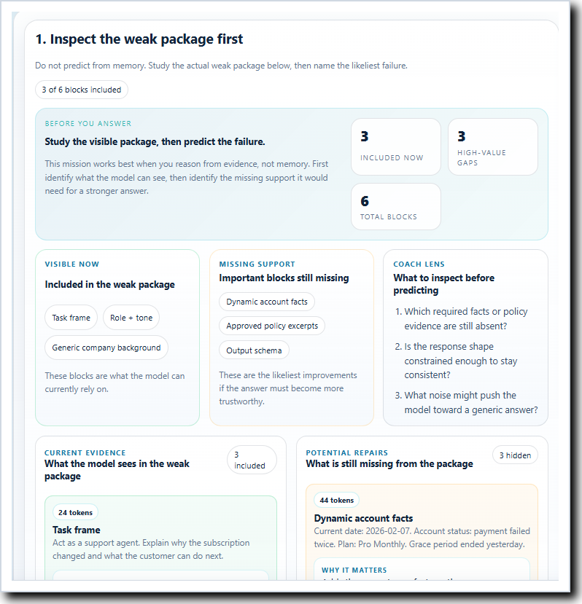 | This is the most important first move in the app. Read the package as evidence: what facts are included, what constraints are missing, and what background looks generic or distracting.  A good inspection is specific. Instead of thinking “this feels weak,” ask what the model would have to guess, what answer structure is missing, and whether the package is spending budget on the wrong material.  What to notice in this screen  - Included cards show what the model can already use.  - Missing cards show what the stronger package may still need.  - The card language explains why each block matters and which metrics it usually affects.

Figure 7. The weak package view separates what is included now from what is missing and worth noticing.

5.2 Predict the weak-state failure before editing
Prediction is the moment where the learning becomes deliberate. Before changing anything, choose the output problem you think is most likely from the package that is currently visible.  This matters because it trains you to connect package weakness to output behavior. Even when your prediction is imperfect, you learn more by committing to a hypothesis before you start repairing.  Use these quick lenses  - Grounding: Is the model missing approved facts and likely to guess?  - Structure: Does the package tell the model how the answer should be organized?  - Overload: Is generic or irrelevant background crowding out useful signal? | 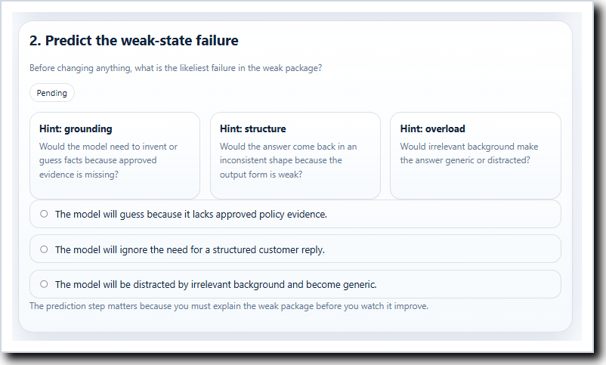

Figure 8. Prediction turns visible package weakness into an expected model failure you can test.

5.3 Repair the package deliberately
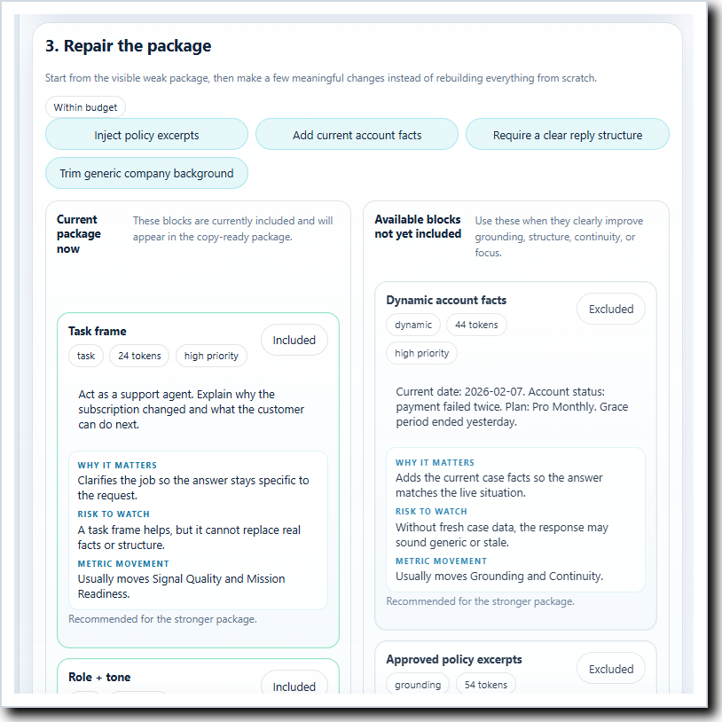 | New users should start with the guided repair buttons. They highlight the strongest first moves for the scenario and reduce the temptation to rebuild the package from scratch.  The goal is selective improvement, not maximal accumulation. A strong package is usually more grounded, more clearly structured, and more disciplined about noise—not simply longer.  Good repair habits  - Make one or two clear changes before making many at once.  - Treat removing noise as a real improvement.  - Use the card descriptions to understand why a block belongs in the stronger package.

Figure 9. The repair area helps you make meaningful package changes without losing the learning thread.

5.4 Compare the weak state and the current state
The comparison workspace teaches back to you. It shows what changed in the package, explains why the metrics moved, and lets you compare the expected behavior of the weak and current package.  Use this area to explain the package difference in plain language. The compare view is most valuable when you can name the single change that mattered most. | 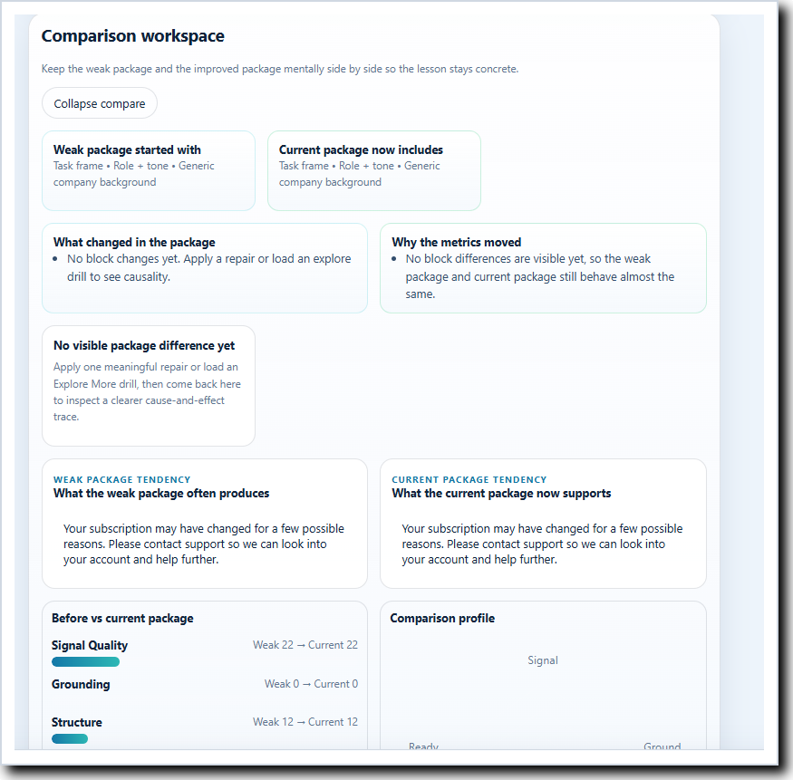

Figure 10. The compare view keeps the weak package and current package mentally side by side.

6. Read the metrics dock as a teaching tool
The bottom metrics dock is one of the most useful parts of the application because it stays visible while you scroll. It is not there to pressure you into chasing perfection. It is there to help you explain what each meaningful change actually did.
Figure 11. The always-visible metrics dock keeps cause and effect in view while you work.
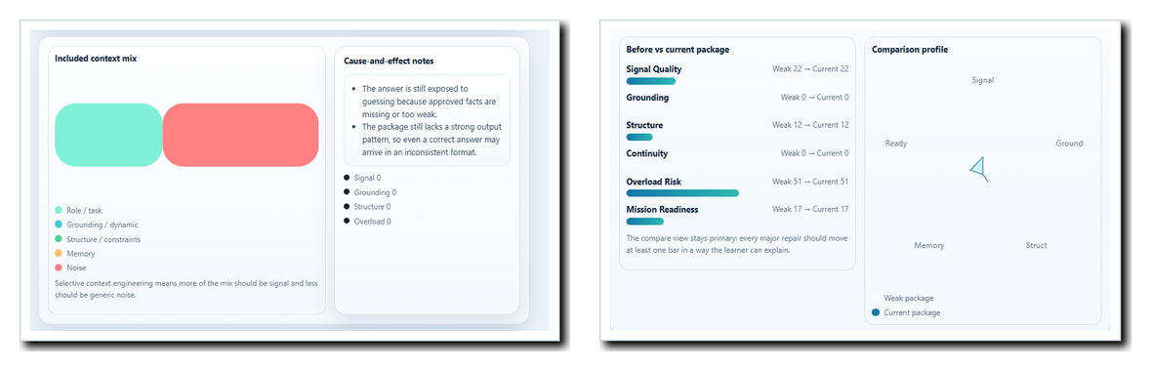
Figure 12. Supporting metrics visuals help you see composition, movement, and the overall comparison profile.
Metric | How to interpret it
Signal Quality | Asks whether the package is becoming more specific, relevant, and task-focused.
Grounding | Shows whether approved facts or current case details are present enough to reduce guessing.
Structure | Reflects whether the answer is likely to come back in a reusable, consistent shape.
Continuity | Shows whether the package carries the right prior context forward.
Overload Risk | Tells you whether noise, extra context, or token pressure are starting to dilute the useful signal.
Mission Readiness | Summarizes whether the current package is strong enough for a better run, but it should always be read together with the other metrics.

How to use the metrics well
- Check the dock after each meaningful repair, not only at the end.
- Ask which metric should move before you make the change.
- Remember that lower overload is good, even when the other metrics rise.
- Treat Mission Readiness as a summary signal, not as a substitute for understanding.

7. Use optional features at the right time
Optional features deepen the learning experience, but they work best after you understand the core loop. Complete the main mission first, then decide whether you want one more drill, a best-practice comparison, or a stronger reflection.
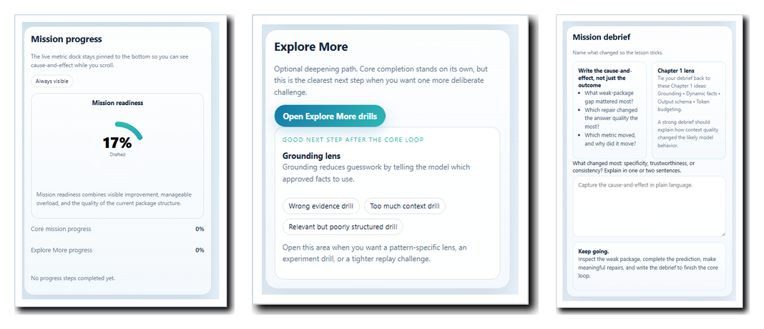
Figure 13. Progress, Explore More, and debrief features extend the lesson without replacing the core mission.
Optional feature | Best use
Mission progress | Use it to confirm that the core loop is complete. It keeps the app learner-focused instead of feature-focused.
Explore More drills | Open these after the main mission when you want one more focused experiment on wrong evidence, too much context, or weak structure.
Mission debrief | Use it every time. This is where you explain the lesson to yourself in plain language.
Reveal and load best-practice package | Best used after your own attempt so you can compare your choices to a stronger reference state.
Copy current package / paste back observed output | Use this when you want to test the package in an external model and reflect on what happened.
Resume saved mission / restart | Helpful for replaying the lesson without losing orientation.

8. Learn more effectively in CEMC
Habits that produce the best learning
- Inspect before you edit.
- Predict before you repair.
- Make one meaningful change at a time when you are still learning the mission.
- Use compare and debrief to explain the lesson, not just to confirm a score.
- Repeat one scenario until you can explain why each major block matters.

Quick control reference
Control | What it does for the learner
Start mission | Opens the selected scenario and begins from the prepared weak package.
Guided repairs | Apply the strongest scenario-specific improvements quickly.
Include / exclude cards | Let you practice deliberate package curation block by block.
Open Explore More drills | Launches optional mini-drills after the main mission.
Restart weak package | Resets the same mission so you can replay the lesson from the beginning.
Back to launcher | Returns to scenario selection without changing what the app is designed to teach.
Theme toggle / Help / Feedback | Improve readability, orientation, and reflection without changing mission logic.

Frequently asked questions
I am not sure what failed in the weak package.
Return to the package and ask three questions: what is missing, what is weakly structured, and what looks noisy or generic.
Should I use Explore More on my first run?
Usually no. Finish the core mission first, then use Explore More when you want one more pattern-specific experiment.
What counts as a good debrief?
A short explanation of what was weak, what change mattered most, and which metric movement convinced you that the package became stronger.
I revealed best practice too early. Did I ruin the lesson?
No. Compare what the stronger package includes, then restart the weak package and try again with that insight.
The metrics moved, but I do not understand why.
Go back to the compare view and isolate one repair at a time. The best explanation is usually visible in the package difference itself.

Final takeaway
- CEMC teaches a simple but important idea: the model can only work from the package you give it.
- When the package is weak, the answer tendency is weak.
- When the package becomes grounded, structured, selective, and well-scoped, the answer tendency improves in ways you can see and explain.
Recommended next step
- Run Customer support resolution again and make only one or two deliberate repairs.
- Watch the metrics dock after each change and explain which metric moved and why.
- Use Compare and Debrief to turn the run into a reusable lesson.


