CHAPTER 2 LEARNING APP
Rubric Runner Lab
End-User Guide for the Current App Experience
Guide focus: first-run success, evaluation discipline, and the full learner workflow
Audience | Guide basis | Primary learning focus
Non-developer learners and knowledge workers | rr_lab_v1_5_1 package; captured UI shows the v1.5.0 build line in screenshots | Execution, Evaluation, and Iteration

What this guide helps you do: Understand what the lab is teaching, choose a good first scenario, score the baseline outputs with confidence, learn from the best-practice review, test one targeted change, and interpret the result without over-trusting the metrics.

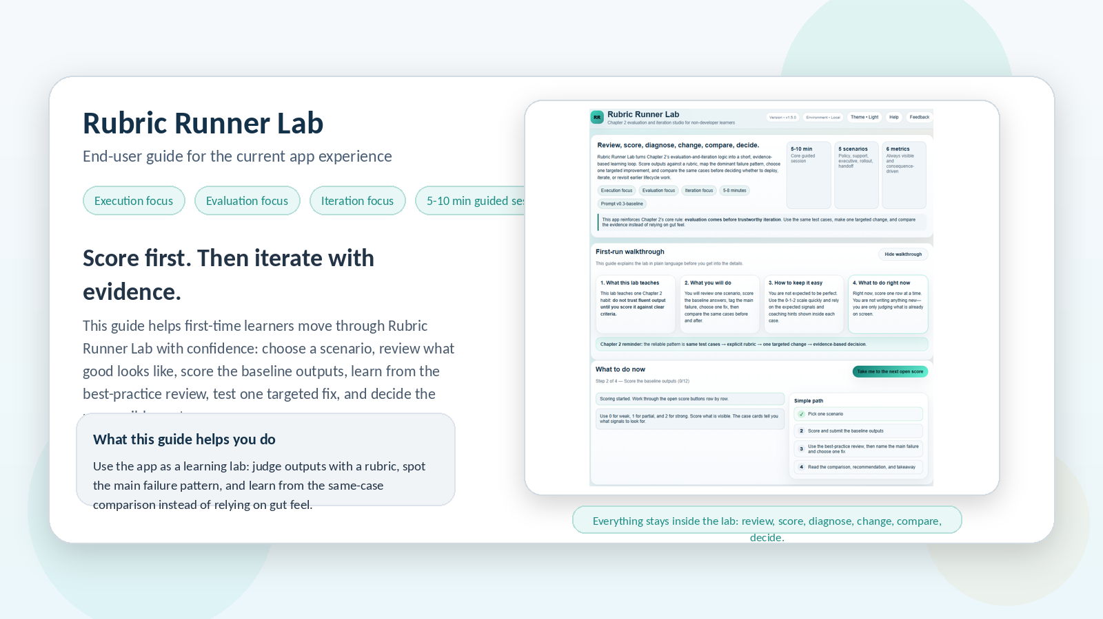
Figure 1. Rubric Runner Lab at a glance: a short, self-contained evaluation-and-iteration learning lab for first-time users.

1. Guide at a glance
Rubric Runner Lab is a short-session learning app that teaches a disciplined way to judge AI outputs before you trust them. Instead of asking you to build prompts or write new answers, it gives you pre-authored workplace scenarios, explicit rubrics, representative test cases, and a structured way to compare one targeted change against the same cases.
Important grounding note: Some older planning documents inside the package use the internal placeholder name “Lifecycle Navigator Studio,” but the current application and learner-facing experience are Rubric Runner Lab.

What this guide covers  - The purpose of the app and what makes it different from a generic AI workflow tool  - The first-run sequence from scenario choice through decision and takeaway  - How to read the rubric, best-practice review, failure tags, metrics, and recommendation state  - How to use the lab for practice rather than treating it as a one-time click-through | How to read it  - Read Section 2 and Section 3 before your first run  - Use the scenario guide to pick a sensible starting case  - Keep the scoring and best-practice sections open while you work in the app  - Return to the quick reference and glossary after your first completed run

2. What Rubric Runner Lab is actually teaching
The app focuses most deeply on the middle reliability loop of context engineering: Execution, Evaluation, and Iteration. It teaches why explicit rubrics matter, why representative test cases matter, why one targeted change is stronger than random tweaking, and why the same cases should be reused when you judge improvement.
Not a ChatGPT send-out flow: Rubric Runner Lab is self-contained. You are not sending a package to ChatGPT and pasting an external answer back. You are evaluating baseline outputs that are already inside the lab, then testing a pre-authored change so the evidence stays comparable.

3. First-run recommendation
Start with Policy Answer Reliability. It is the clearest first scenario because the questions are concrete, the rubric is easy to reason about, and the consequences of missing exceptions or policy boundaries are immediately understandable.
Why it is a good first case  - Only three representative test cases  - Clear rubric language: grounding, completeness, policy boundaries, clarity  - The wrong answer can sound fluent while still being unsafe or unsupported | What to notice during the run  - Whether an answer invents approval or reimbursement rules  - Whether key exceptions and escalation paths are missing  - Whether a “clear” answer is actually safe to trust

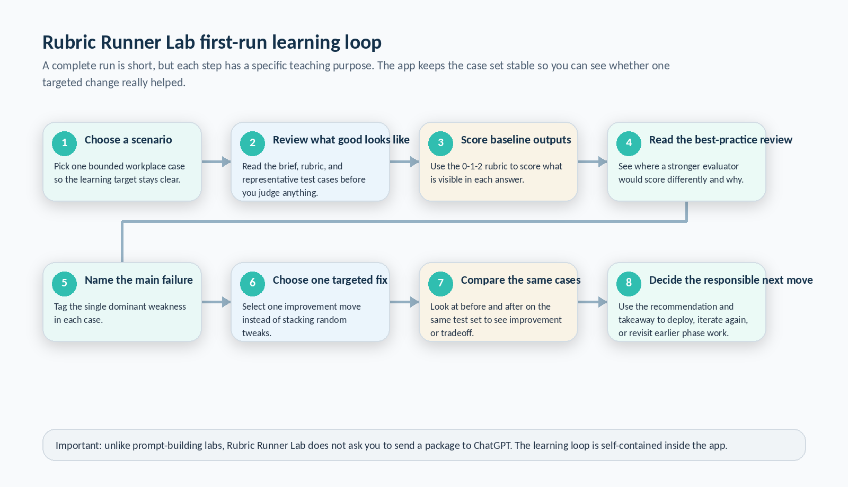
Figure 2. The first-run learning loop in Rubric Runner Lab. The run stays inside the app and keeps the same cases stable so you can judge one targeted change responsibly.

4. Know the interface before you begin
Rubric Runner Lab is designed to reduce guesswork. The launcher is not just a landing page; it is an orientation surface. It explains the purpose of the app, gives you a first-run walkthrough, and shows the next unfinished action.
Useful interface detail: The app shows two progress views at once. “What to do now” is the calmer four-step coaching path. “Core path” is the detailed six-step run progression in the sidebar.

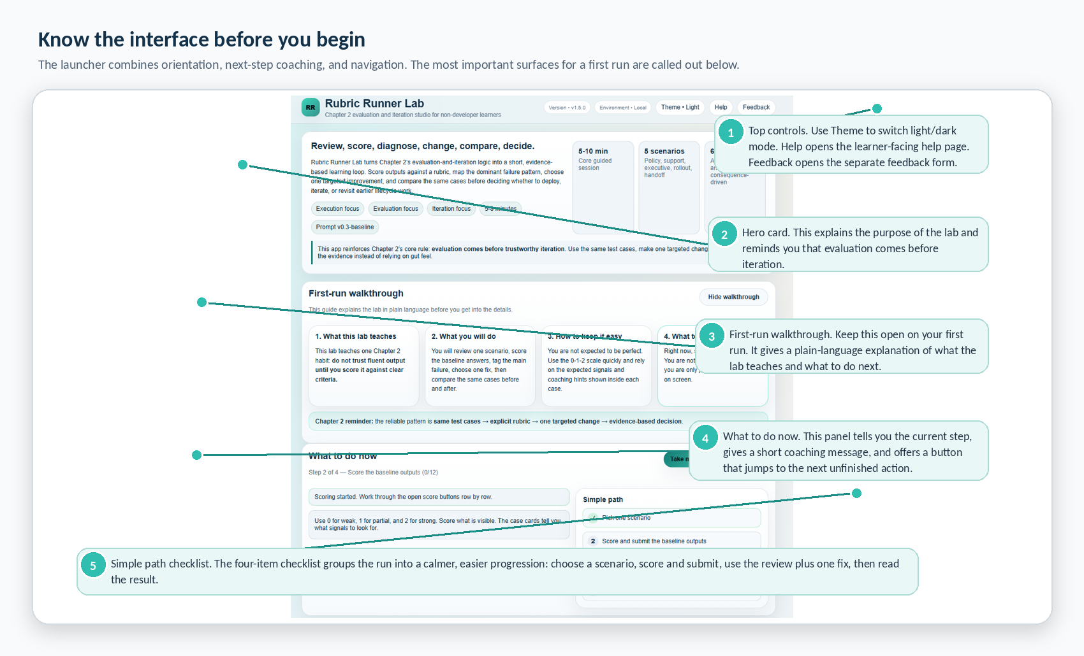
Figure 3. The home experience: hero card, first-run walkthrough, current-task guide, and simplified path checklist.
On your first run, keep the walkthrough visible. Hide it only after you understand what the lab is asking you to do. When you are unsure where to go next, the current-task button is the safest control to use because it jumps to the next incomplete action instead of making you hunt for it yourself.
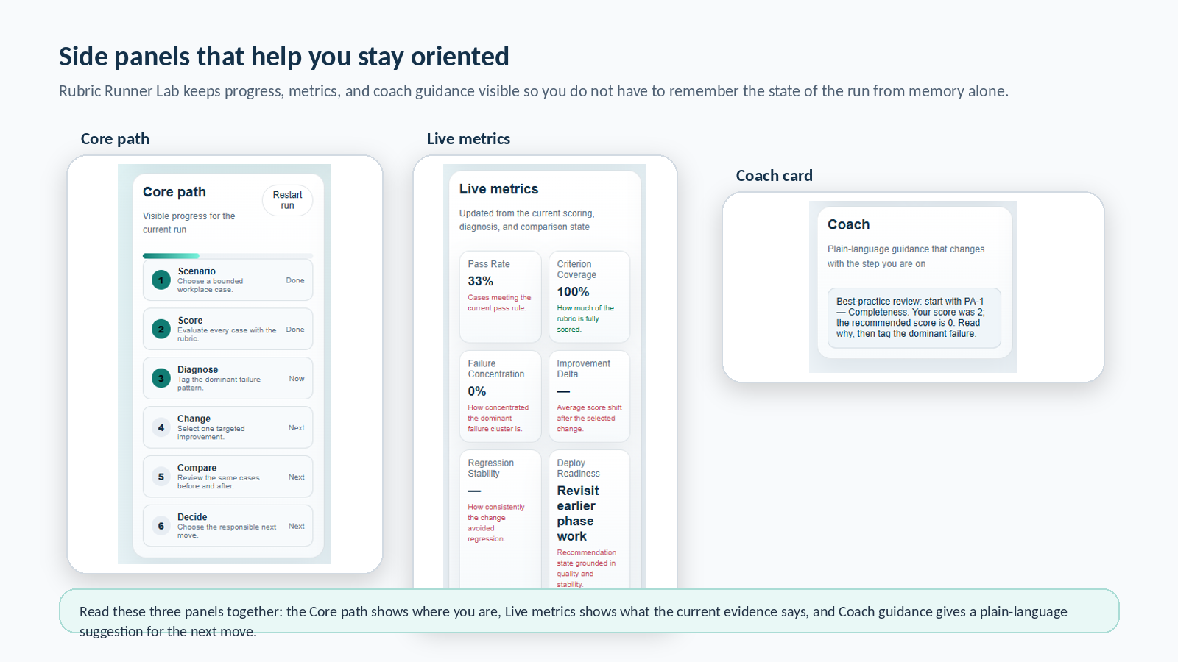
Figure 4. The side panels that keep the run legible: Core path, Live metrics, and the Coach card.

5. Scenario guide: what each case teaches
All five scenarios reinforce the same evaluation-and-iteration discipline, but each one trains your judgment in a different kind of workplace artifact.
Scenario | What you practice | First-run fit | Typical targeted fix choices
Policy Answer Reliability | Testing whether policy answers stay grounded, complete, and boundary-aware | Yes - best first run | Tighten source-boundary instructions; Add exception checklist
Support Case Triage Summary | Preserving facts, escalation triggers, and next-step clarity under queue pressure | Good second run | Add escalation trigger checklist; Condense into one-line triage headline
Executive Briefing Draft | Judging strategic usefulness without flattening risk or nuance | More advanced | Force decision-oriented ending; Compress to one-paragraph snapshot
Change Rollout Notice | Checking whether a rollout message is truly actionable and scoped | Good after policy/support | Force who-when-what-support structure; Lead with a short friendly announcement
Cross-Team Handoff Summary | Seeing whether ownership, blockers, and readiness survive summarization | Good after rollout | Force owner-blocker-next-step structure; Condense to a status snapshot

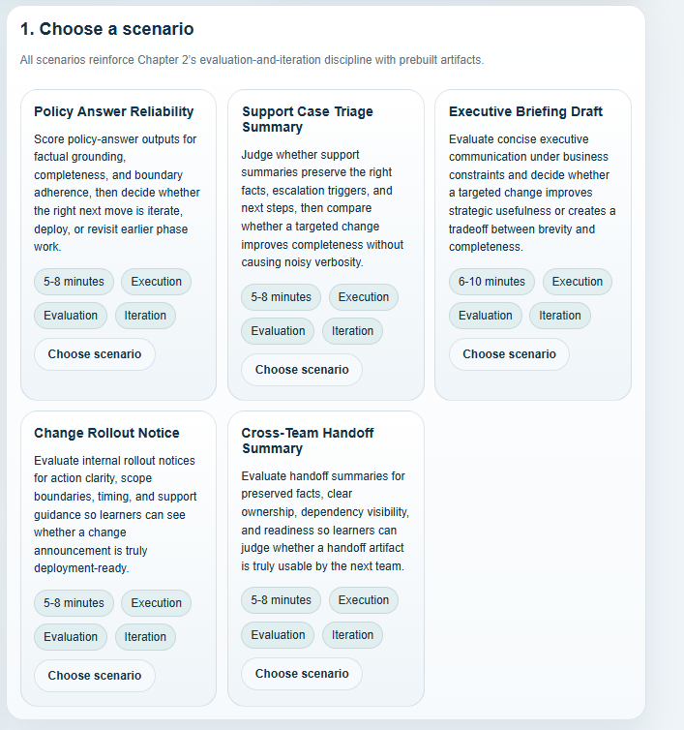
Figure 5. Scenario selection view. Each card tells you the scenario goal, estimated time, and the three chapter focus areas it reinforces.

6. Review what good looks like before you score
The review section is where the lab defines the judging standard. Do not skip it. The scenario brief tells you the business situation, the plain-language scoring guide tells you what 0, 1, and 2 mean, and the representative test cases tell you what a strong answer needs to preserve.
Best first-run habit: Read the full section once before you press Start scoring now. Then come back to the representative test cases whenever your scoring starts to drift.

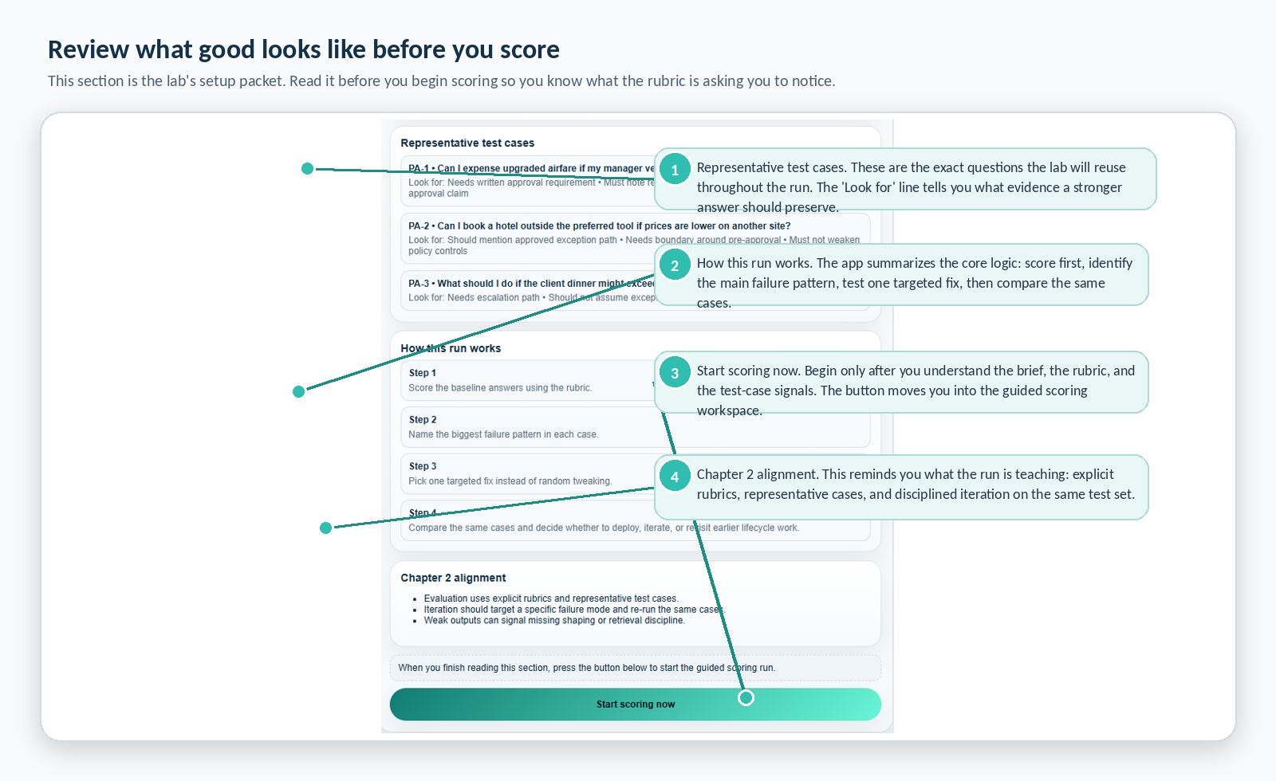
Figure 6. The review section: representative test cases, run logic, Chapter 2 alignment, and the Start scoring button.
0 = weak | 1 = partial | 2 = strong
The answer misses or breaks the criterion in a meaningful way. | Some useful signal is present, but the answer is still incomplete, risky, or uneven. | The answer clearly meets the criterion for this case.

7. Score the baseline outputs carefully
The scoring workspace is where the app becomes most concrete. Each case card keeps the question, expected signals, baseline output, and rubric controls in the same place so you can judge without losing context.
Scoring discipline that matters: Score what is visible. Do not imagine missing evidence into existence. A fluent answer can still be weak if it invents rules, skips exceptions, or hides the action path.

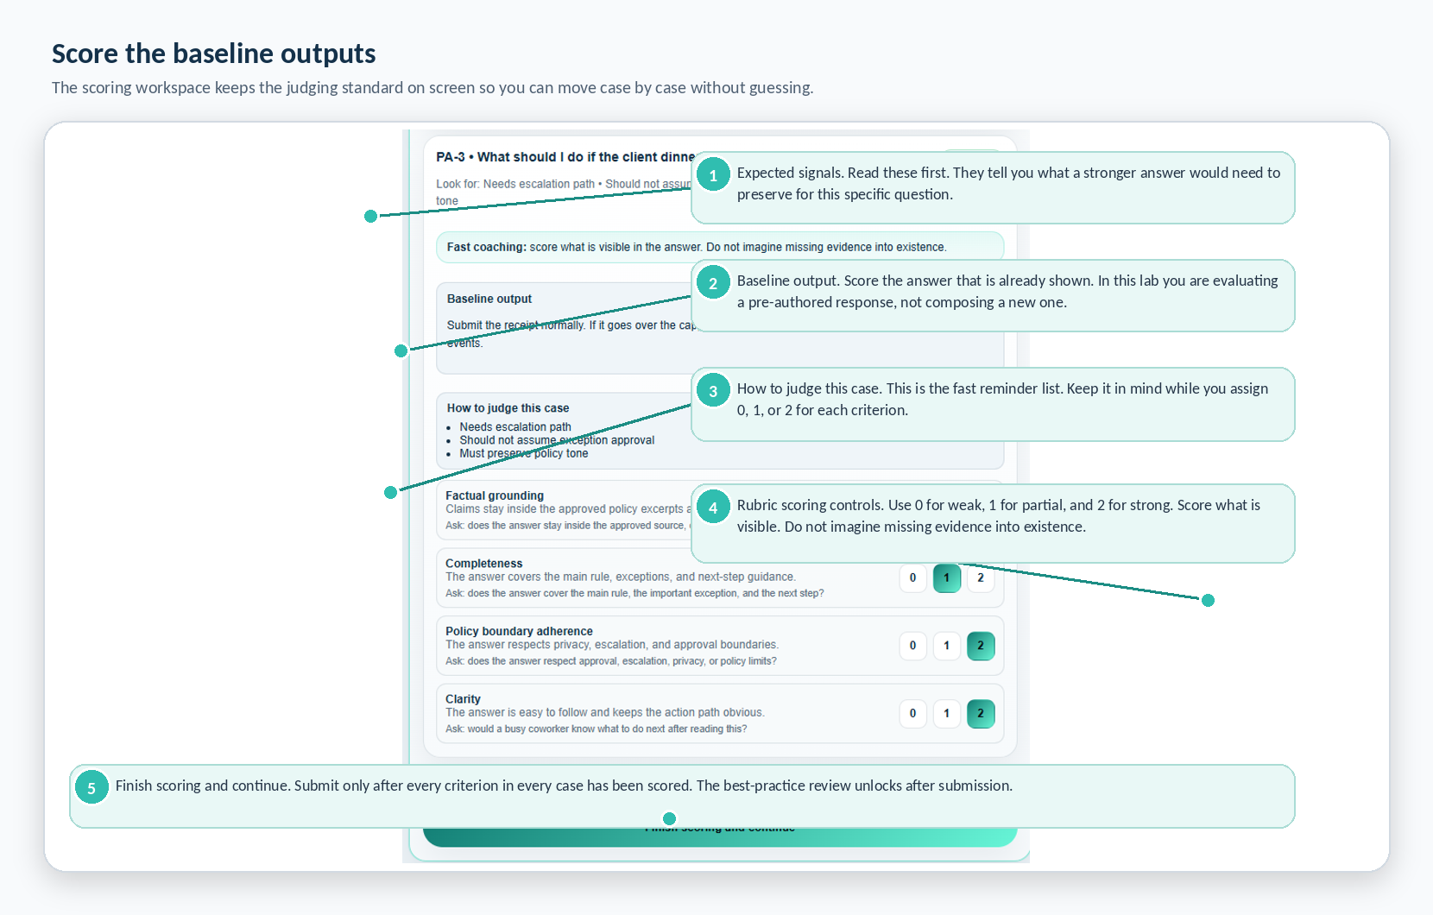
Figure 7. The scoring workspace: expected signals, baseline output, judging hints, rubric rows, and the scoring-submit button.
How to score well
- Read the “Look for” signals before you read the baseline answer. This prevents you from rewarding polish that misses the real requirement.
- Use the rubric row prompts. They tell you what each criterion is asking you to judge.
- Keep the same standard across all cases. Do not make one case harder just because it feels higher stakes.
- Submit only after the entire set is scored. Coverage matters because the later pattern view is only trustworthy when the whole set has been judged.

8. Use the best-practice review to calibrate your judgment
After you submit your baseline scoring, the app reveals the best-practice review. This is one of the most valuable teaching surfaces in the lab. It shows where a stronger evaluator would score differently and why.
Read this step correctly: The review is calibration, not punishment. You scored first. The app then shows the biggest gaps so you can learn what the rubric was really asking you to notice.

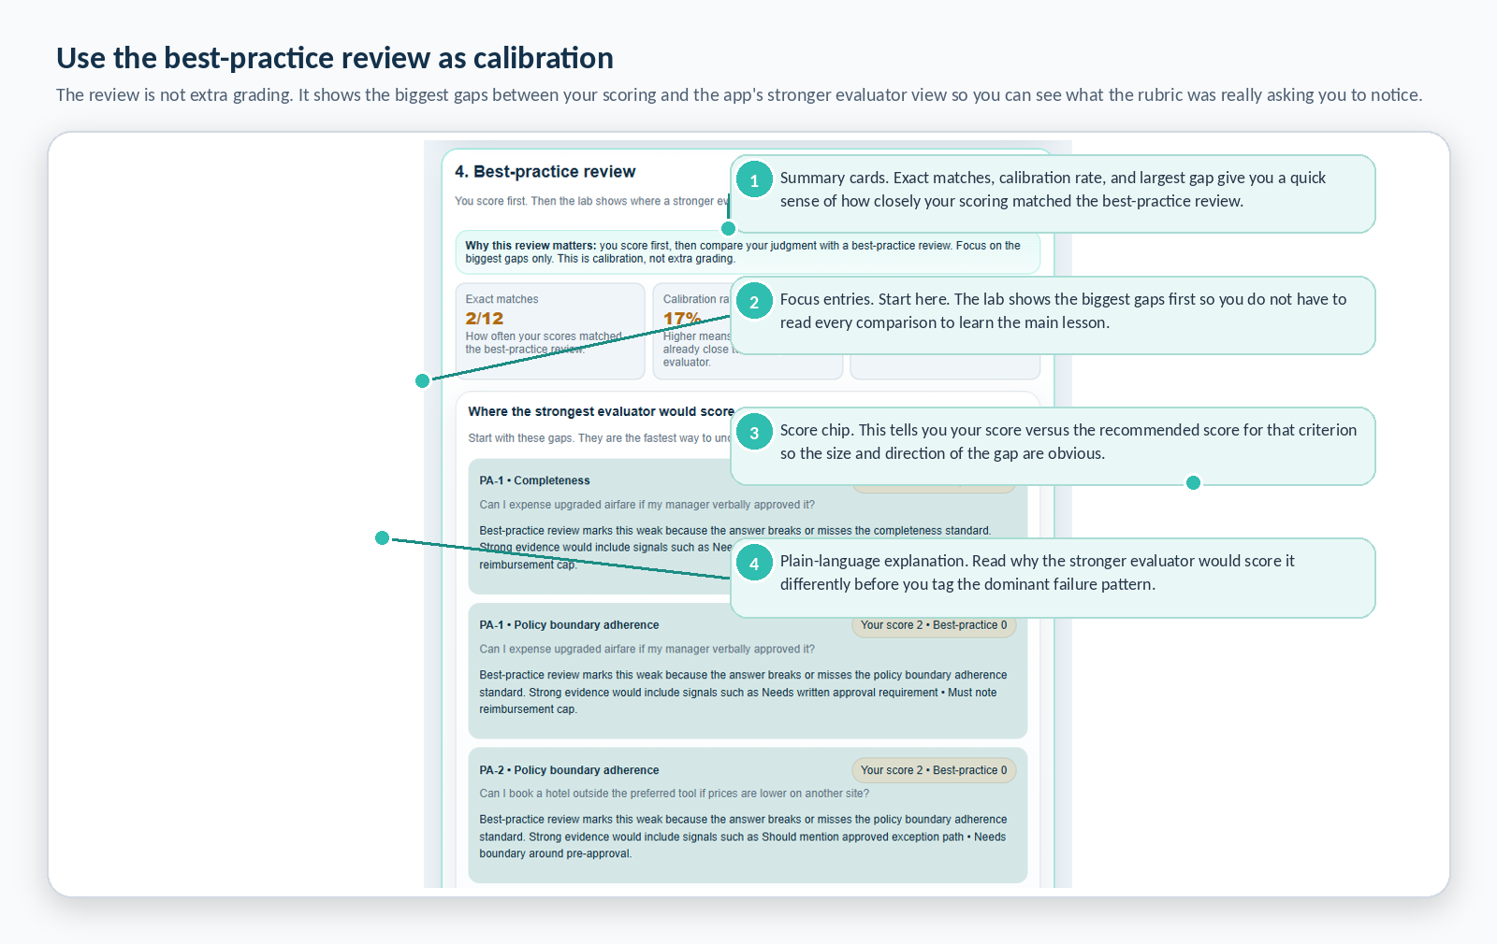
Figure 8. Best-practice review: summary metrics at the top and the biggest scoring gaps below.
What to do when you disagree with the review
Do not assume the app is automatically right and do not assume you are automatically right either. First read the plain-language explanation. Then check the representative case signals again. The question to ask is: what evidence did the stronger evaluator think should have been preserved, and did I actually reward that evidence in my score?

9. Name the main failure, choose one fix, then compare the same cases
Once the scoring gap is visible, the app moves you into diagnosis and iteration. This is where the run becomes disciplined rather than random.
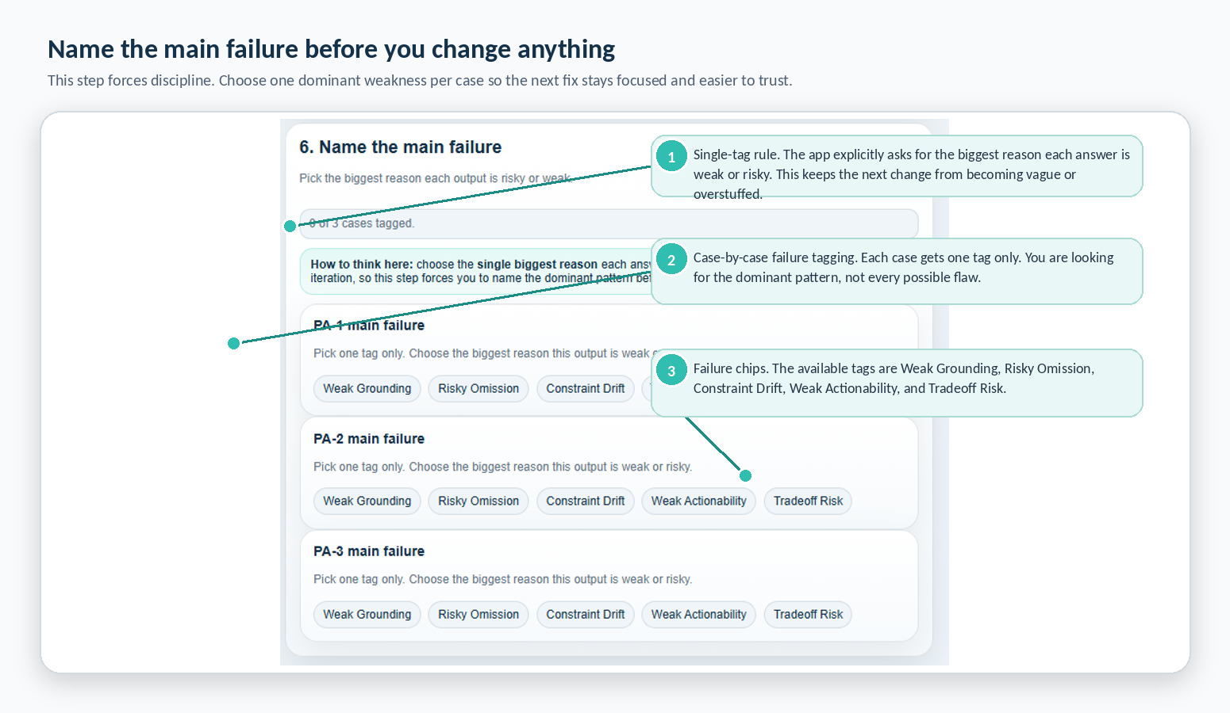
Figure 9. Failure tagging: one dominant weakness per case keeps the next change focused.
Failure tag | What it means in plain language
Weak Grounding | The answer adds unsupported claims or drifts outside the approved source boundary.
Risky Omission | A required fact, exception, or next step is missing.
Constraint Drift | The answer ignores tone, format, scope, or policy rules.
Weak Actionability | The answer sounds fluent but still does not tell the reader what to do next.
Tradeoff Risk | A change helps one dimension but weakens another.

What happens after diagnosis
- Change - You select one targeted fix. Each scenario offers two change options so the lesson stays controlled.
- Compare - The app reuses the same cases and shows before/after evidence so you can see improvement, regression, or tradeoff instead of guessing.
- Decide - The recommendation state summarizes whether the current evidence supports deployment, another iteration, or a return to earlier phase work.
Why the same-case comparison matters: If the cases change, you cannot tell whether the fix helped or whether the test got easier. Rubric Runner Lab protects the lesson by reusing the same scenario evidence.

10. How to read the live metrics and the recommendation state
The live metrics update from the current scoring, diagnosis, and comparison state. They are meant to support judgment, not replace it.
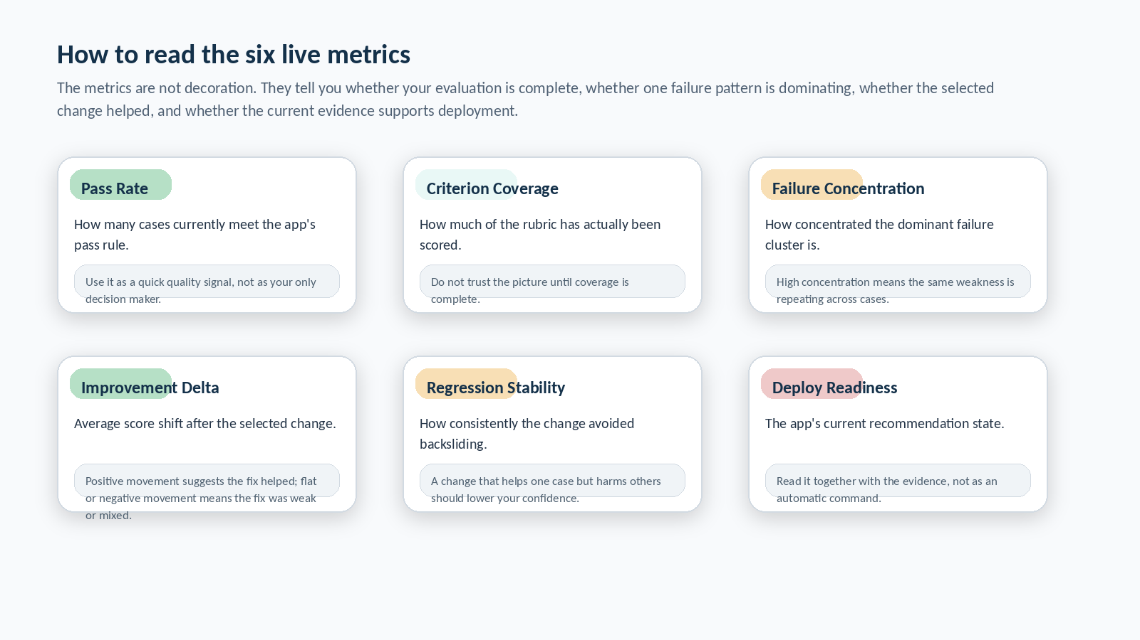
Figure 10. The six live metrics: what each one is trying to tell you.
Read the metrics as a set. Pass Rate and Criterion Coverage tell you whether the scoring picture is complete and strong enough to trust. Failure Concentration tells you whether the same weakness is repeating. Improvement Delta and Regression Stability tell you whether the selected change helped consistently. Deploy Readiness turns that evidence into a recommendation state.
Recommendation states you will see: Deploy means the evidence is strong enough to move forward. Iterate again means the change helped but the run is still mixed. Revisit earlier phase work means the weakness may be upstream, and more small tweaks would not be the responsible next move.

11. Important limitation: what the scoring can and cannot tell you
Mandatory plain-English limitation: Rubric Runner Lab’s review is structured and explainable, but it is still approximate. It does not truly understand an answer like a human reviewer or a deep semantic AI judge. It is checking visible signals against an explicit rubric, representative test-case expectations, pre-authored best-practice scores, and rule-based thresholds.

- A strong answer that uses unexpected wording may still under-score if the required evidence is not clearly visible.
- A weak answer can sometimes over-score if it accidentally hits the expected phrases without being genuinely trustworthy.
- Deploy Readiness is a recommendation state grounded in the app's thresholds; it is not a substitute for human judgment.
- The lab is strongest as a teaching tool for evaluation discipline, not as a final authority on real-world deployment.
What the lab is really asking
- Did the learner apply the rubric consistently?
- Did the learner notice the right kind of missing evidence, exception, or boundary condition?
- Does the selected fix improve the same cases instead of just sounding better in the abstract?
- Does the current evidence support deployment, another iteration, or a return to earlier lifecycle work?
12. How to learn more from each run
The highest-value runs are reflective. After you finish, compare what you originally rewarded with what the best-practice review highlighted. Then look at whether the selected fix produced broad improvement, narrow improvement, or a tradeoff.
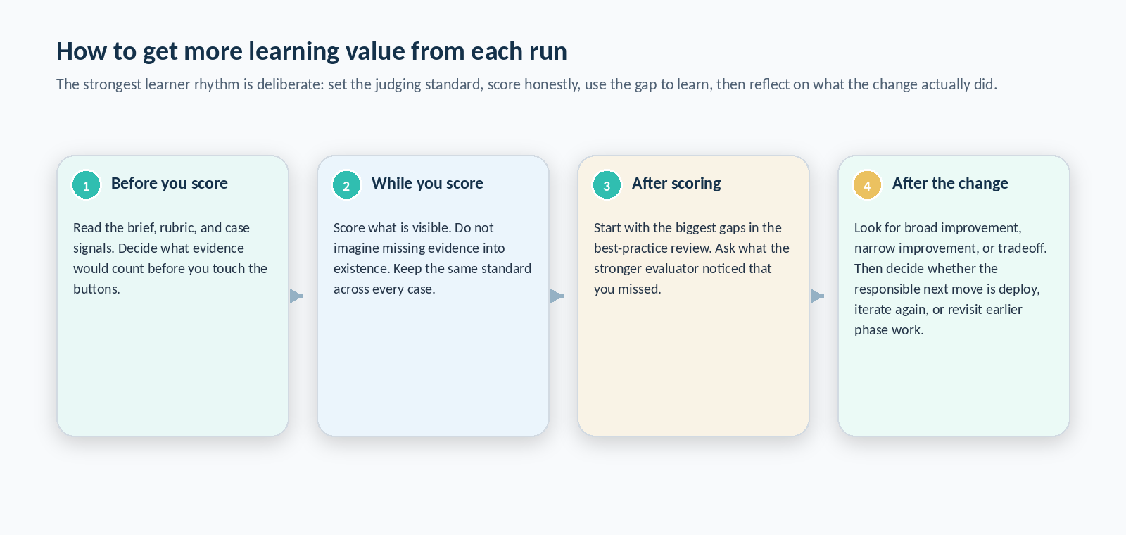
Figure 11. A strong learner rhythm: set the standard, score honestly, use the gap to learn, then reflect on what the change actually did.
Optional learning checks
After the core lesson, the app can open optional learning checks. These do not replace the main run. They either raise the final deploy bar, explain why the selected fix helped, or show the risk of skipping evaluation altogether. You do not need them to count the run as successful.
13. Control reference and quick help
Control or surface | What it does | Best time to use it
Theme | Switches light and dark mode | Any time readability feels off
Help | Opens the separate learner-facing help page | Before your first run or when you want the app's built-in explanation
Feedback | Opens the separate feedback form | After you finish a run and want to report friction or improvement ideas
Hide walkthrough / Show walkthrough again | Collapses or restores the first-run walkthrough | Hide only after you understand the flow
Take me to the current step | Jumps to the next unfinished action | Whenever you feel lost
Restart run | Resets the current scenario run | When you want to rescore the same scenario from scratch
Choose scenario | Selects the case you want to practice | At the start of a new run
Start scoring now | Moves from review into the scoring workspace | Only after reading the setup packet
Finish scoring and continue | Submits the baseline scoring and unlocks the best-practice review | After every criterion in every case is scored
Failure chips | Lets you name the dominant weakness in each case | After reading the best-practice review
Use this fix | Selects one targeted change option | After all cases have a main failure tag

14. Troubleshooting and FAQ
Which scenario should I start with?
Start with Policy Answer Reliability. It is the cleanest first case for learning the scoring discipline.
Do I need to read every representative test case before scoring?
Yes. The test cases tell you what the rubric should reward. Scoring without them increases drift.
What if the best-practice review disagrees with me?
Read the explanation and compare it against the case signals. Treat the disagreement as a learning opportunity, not an automatic error message.
Does the lab generate new answers with ChatGPT?
No. This app is self-contained. You are evaluating pre-authored outputs and then testing a pre-authored change inside the lab.
Do I have to finish the optional learning checks?
No. The core lesson is complete once you reach the recommendation and takeaway summary.
15. Glossary
Term | User-friendly meaning
Scenario | A bounded workplace case the app uses to teach one evaluation-and-iteration lesson.
Representative test case | A specific question inside the scenario that the lab reuses throughout the run.
Rubric | The explicit scoring standard used to judge each answer.
Baseline output | The answer currently shown by the app before any targeted fix is applied.
Best-practice review | The stronger evaluator view shown after you submit your own scoring.
Failure tag | The one dominant weakness you assign to each case before selecting a fix.
Targeted fix | A single change option chosen to test whether the same cases improve.
Same-case comparison | The before/after view that uses the exact same cases to make the evidence trustworthy.
Deploy Readiness | The app's current recommendation state based on scores and stability signals.

16. Final takeaways and best practices
- Do not skip the setup packet. The brief, rubric, and representative test cases are the standard for the whole run.
- Score what is visible. The lab is strongest when you refuse to reward evidence that is not on the screen.
- Use the best-practice review to calibrate, not to defend your first impression.
- Tag one dominant failure and test one targeted fix. The lesson gets weaker when you pile on multiple changes.
- Read the recommendation state as guidance grounded in evidence, not as the final word.
- Use the app repeatedly. The educational value compounds when you compare how different artifact types fail and improve.
The most important habit to keep: Evaluation comes before trustworthy iteration. Rubric Runner Lab is valuable because it slows the loop down just enough for you to see what changed, why it changed, and whether that change deserves trust.

