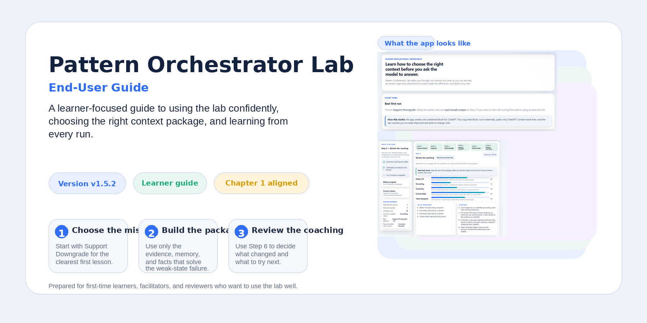
Version covered: v1.5.2 • Audience: first-time learners, facilitators, reviewers • Focus: using the lab well

What This Guide Helps You Do
This guide is written for people using Pattern Orchestrator Lab as a learning environment, not as a developer workspace. It explains what you see on screen, what each step is asking you to do, why those steps are ordered that way, and how to learn from the feedback the lab gives you after each run.
By the end of this guide, you should be able to start the app, pick the right first mission, build a stronger context package, use ChatGPT correctly outside the app, paste the answer back, and interpret Step 6 coaching without guessing what the score means.
What the lab is really teaching: Choose the right context mechanism before you ask the model to answer. In this app, that means learning when the answer needs grounding, memory, dynamic facts, or a mixed package.

How to Use This Guide
You can read this guide straight through for a full orientation, or jump to the section that matches the question you have right now. The order below is the best path for a first-time user.
• 1. What Pattern Orchestrator Lab is and what makes it different
• 2. A first-run recommendation
• 3. Know the interface before you begin
• 4. The six-step mission workflow
• 5. Mission types and when to choose each one
• 6. How to build a good package
• 7. How to use ChatGPT correctly in this lab
• 8. How review coaching works
• 9. Important scoring limitation
• 10. How to learn more from each run
• 11. Control reference
• 12. Troubleshooting and FAQ
• 13. Glossary and final best practices
Reading path | Best for | What to read first
Quick start | First-time learners | Sections 2, 3, 4, and 7
Learn the scoring | Users who want to understand Step 6 | Sections 8 and 9
Mission selection | Users choosing what to practice next | Section 5
Reference mode | Returning users | Sections 11 and 12

1. What Pattern Orchestrator Lab Is
Pattern Orchestrator Lab is a Chapter 1 learning application aligned to Foundations of AI Context Engineering. The lab teaches one practical skill: choosing the right context mechanism before you ask a model to answer. Instead of hiding that lesson behind a generic prompt box, the app walks you through a visible six-step flow so you can see what changed, why it changed, and what to try next.
That is what makes Pattern Orchestrator Lab different from a generic prompt builder. The app is not mainly about writing from scratch inside the browser. It is about understanding when the answer needs source evidence, when it needs carryover context, when it depends on live facts, and when more than one of those mechanisms matters at the same time.
The workflow is deliberately transparent. The app does not call a live model from inside the interface. Instead, it builds a visible combined block for ChatGPT, lets you run that block externally, and then coaches you on the answer when you paste it back.
What the lab is  A step-by-step learning lab that helps you diagnose weak context, build a better package, run it in ChatGPT, and study the result. | What the lab is not  A hidden scoring engine, a code tool, or a blank prompt workspace that expects you to guess what changed.

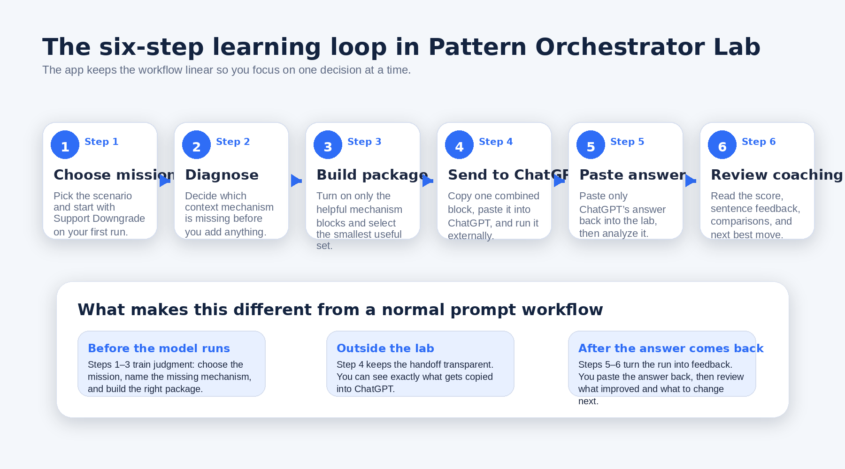
Figure 1. The six-step learning loop in Pattern Orchestrator Lab: choose the mission, diagnose the missing mechanism, build a small package, run it in ChatGPT, paste the answer back, and use the coaching to decide the next move.

2. A First-Run Recommendation
Start with Support Downgrade. The app itself recommends this mission first, and it is the cleanest place to see the central lesson of the lab. The answer sounds plausible when policy evidence is missing, but it becomes much more reliable when the package includes the actual billing rules plus the current account facts.
This first run is also a good place to practice the full external-model loop without a lot of domain complexity. You can focus on the reasoning pattern: diagnose the weak state, add only the evidence that decides the answer, run the package externally, then use Step 6 to see whether the improvement happened for the right reason.
Good first-run goal: Do not try to master every feature on the first attempt. Complete the six-step loop once, understand why Support Downgrade improves with grounding, and learn how Step 6 guides the next attempt.

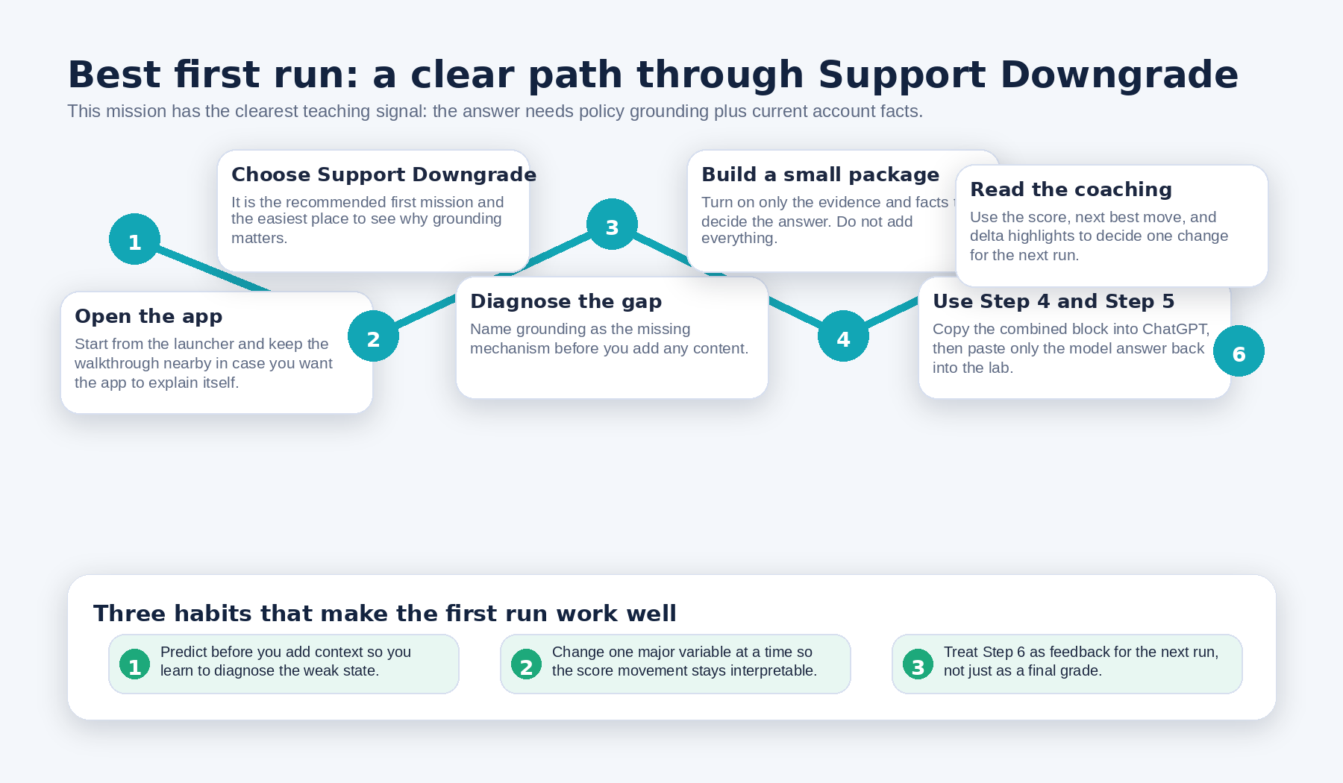
Figure 2. A practical first-run path through Support Downgrade, including the habits that make the first attempt easier to understand.

3. Know the Interface Before You Begin
The interface is organized so you always know what to do next. The top shell gives you the app identity, version pill, environment, Help, Feedback, Walkthrough, and theme control. The startup area gives first-run orientation. The main wizard keeps only one step active at a time, while the left rail reminds you what the current step is for and tracks progress during the session.
On a first true app open, the lab can show a first-run walkthrough. After that, you can reopen it with the Walkthrough button in the top bar any time you want the app to explain itself again.
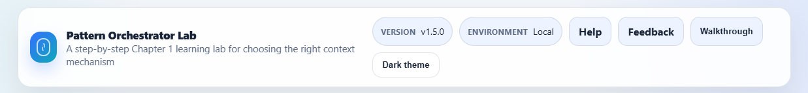
Figure 3. The top shell: app identity, version and environment pills, Help, Feedback, Walkthrough, and theme control.
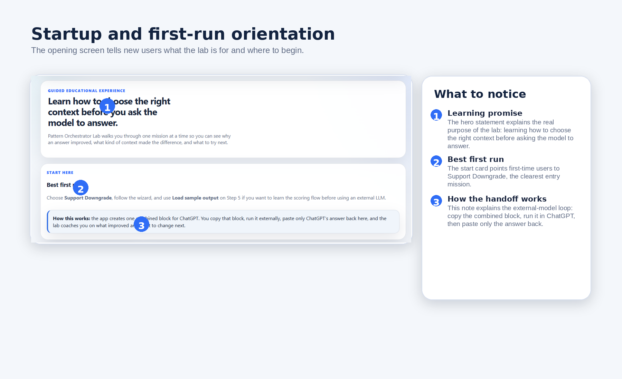
Figure 4. Startup and first-run orientation: the opening view explains what the lab teaches, recommends the best first mission, and shows how the external ChatGPT handoff works.
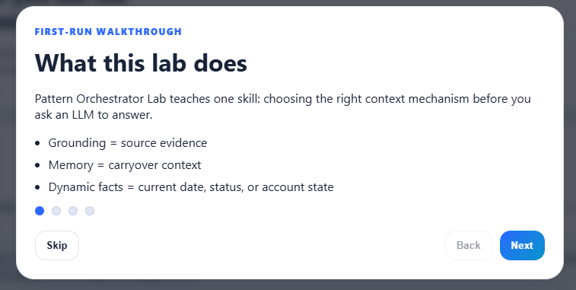
Figure 5. The first-run walkthrough introduces the core mechanisms: grounding, memory, and dynamic facts.

4. The Mission Workflow
Pattern Orchestrator Lab uses a six-step operating model. You move through the steps in order. This matters because the app is trying to teach judgment, not just completion. If you skip ahead too early, you lose the cause-and-effect lesson that makes the lab valuable.

Step 1 — Choose mission
Step 1 is where you choose the scenario you want to practice. On a first run, Support Downgrade is the best choice because the teaching signal is clear and easy to verify. The mission cards also tell you the domain, time estimate, and the kind of answer quality each scenario is meant to surface.
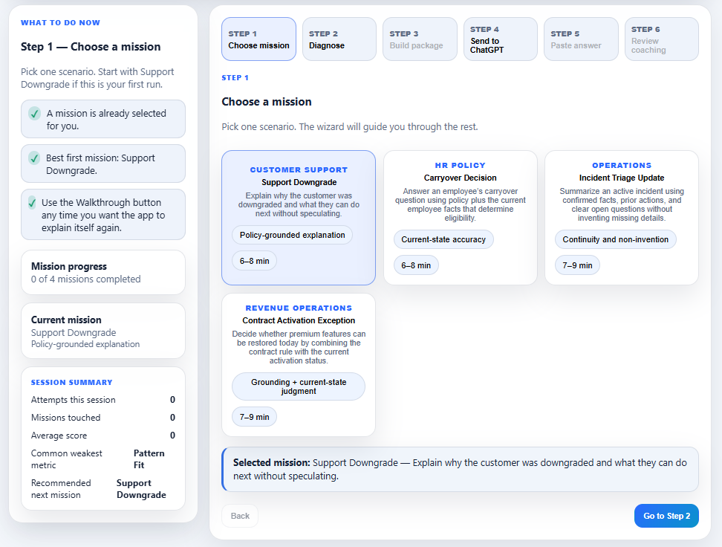
Figure 6. Step 1 shows the current mission options and highlights the selected mission before you move into diagnosis.

Step 2 — Diagnose
In Step 2, the lab asks you to decide what kind of context the weak-state answer is missing before you add anything. This is one of the most important habits the app teaches. A polished answer can still be wrong, generic, or weakly grounded if the mechanism choice is wrong.
The four diagnosis options are grounding, memory, dynamic facts, and mixed. Use the mission brief and weak-state clues to decide which one matters most. In Support Downgrade, the answer mainly needs the governing policy text, so grounding is the right diagnosis.
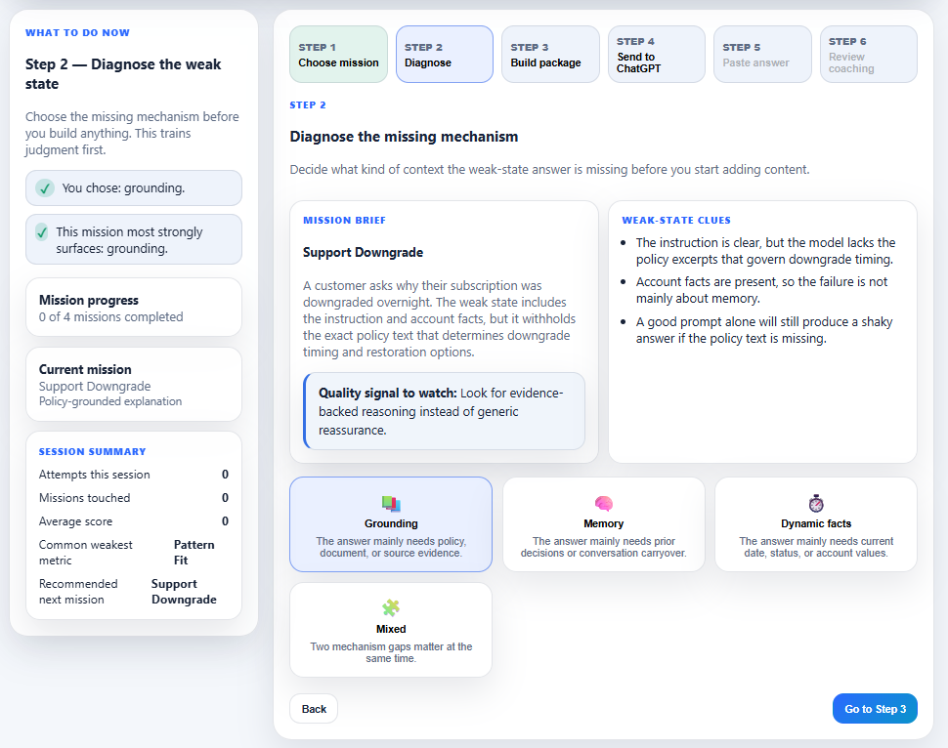
Figure 7. Step 2 trains mechanism judgment first: use the mission brief and weak-state clues to choose the real missing mechanism.

Step 3 — Build package
Step 3 turns diagnosis into action. You choose which mechanism blocks to enable and which evidence items, memory items, or dynamic facts to include. The right mindset here is selective improvement, not maximal stuffing. The lab is teaching you to build the smallest useful package that actually solves the weak-state failure.
Watch the package summary and token use while you work. The app keeps these visible because a good package is not just accurate; it is also lean enough to stay inside a reasonable mission budget.
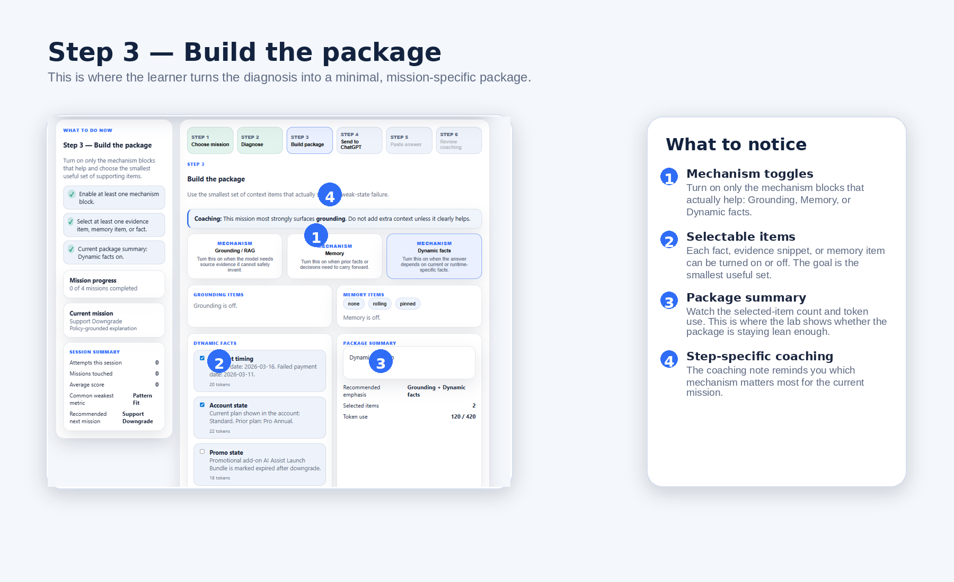
Figure 8. Step 3 in context: turn on only the mechanism blocks that help, select the supporting items that decide the answer, and watch the package summary stay lean.

Step 4 — Send to ChatGPT
Step 4 is intentionally simple. The app creates one combined block, and you click one button: Copy everything to send to ChatGPT. That copied block includes the mission instructions, the context package you selected, and the requested output pattern.
This design keeps the external-model step transparent. You can inspect exactly what will be sent before you leave the app. That makes the learning process easier to trust because you can see the handoff rather than guessing what was hidden behind a button.
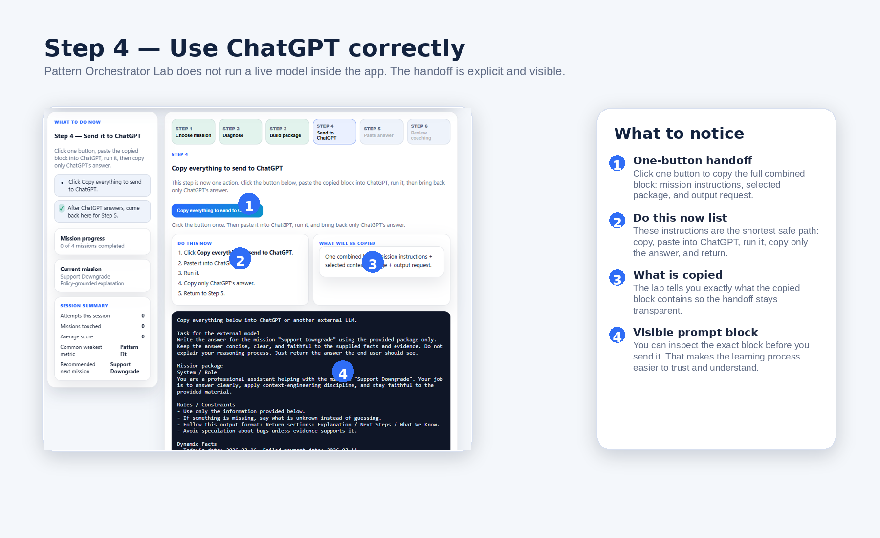
Figure 9. Step 4 makes the external handoff explicit: copy one combined block, run it in ChatGPT, then return with only the model’s answer.

Step 5 — Paste answer
In Step 5, paste only ChatGPT’s answer, then click Analyze pasted output. Do not paste the original prompt block again. Do not paste your own notes unless you want them treated as part of the answer.
The Load sample output button is useful when you want to learn the scoring flow before running an external model. It gives you a safe way to see how Step 6 behaves without leaving the app.
Important behavior: Every time you change the pasted text, the old analysis is cleared. If you edit the answer, click Analyze pasted output again to refresh Step 6.

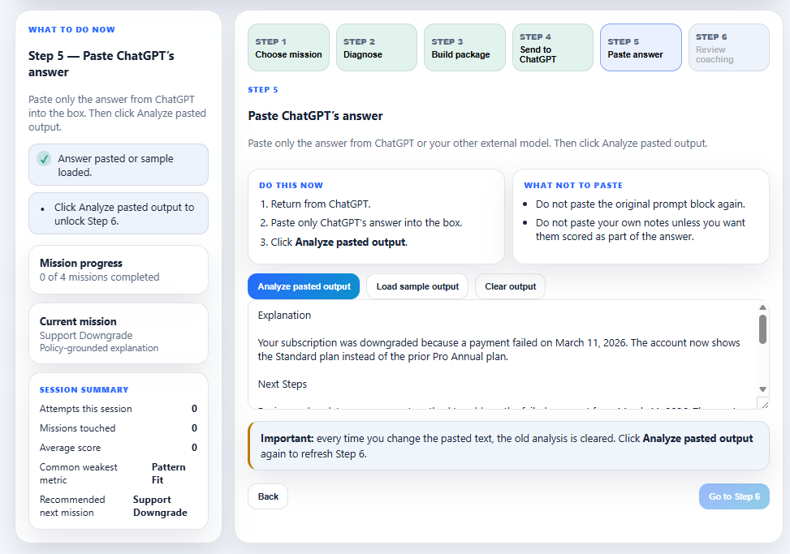
Figure 10. Step 5: paste only the model’s answer, analyze it, and use the sample output option if you want to learn the scoring flow first.

Step 6 — Review coaching
Step 6 is where the lab teaches back. It shows the score band, metric bars, delta highlights, coaching notes, and the next best move. It also records attempts for the current mission so you can compare the current run to earlier work instead of treating the result like a one-shot grade.
Use Step 6 to answer three questions: What improved? What still feels weak? What is the single next change worth trying? That is the fastest way to turn one run into a real learning loop.
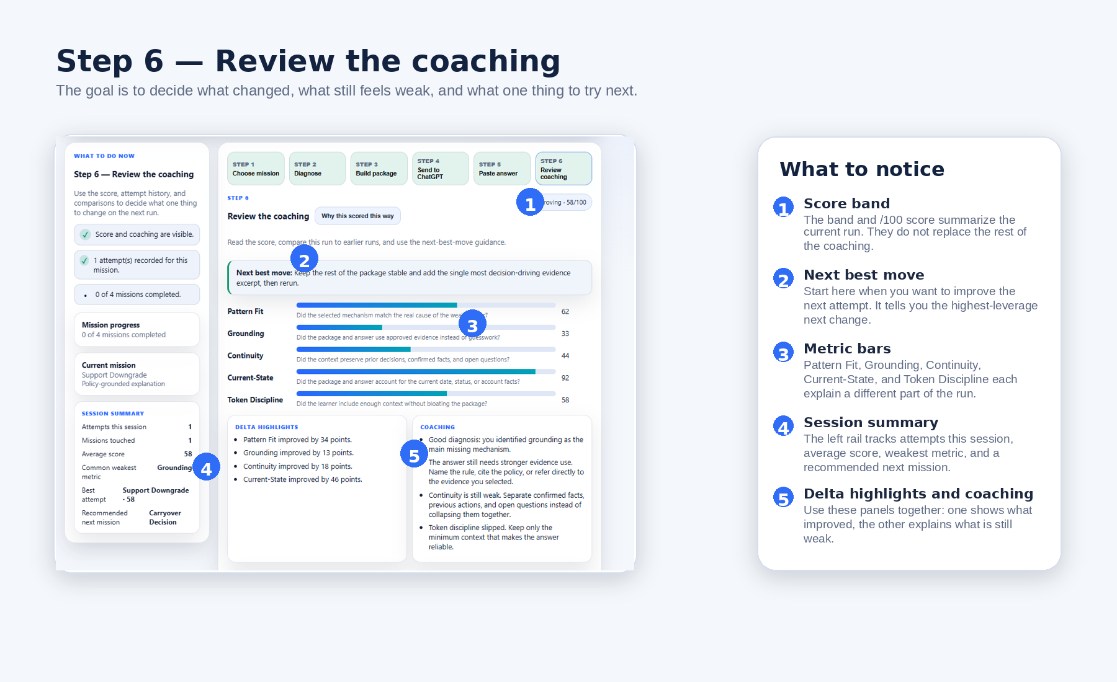
Figure 11. Step 6 is the coaching center: review the score, track the session, and use the next-best-move guidance to plan the next attempt.

5. Mission Types and When to Choose Each One
The app currently includes four missions. Each one teaches the same larger lesson—input quality shapes output quality—but from a different operational angle. That variety helps you see that context engineering is not a niche pattern. The same discipline shows up in customer support, HR policy, operations, and revenue operations.
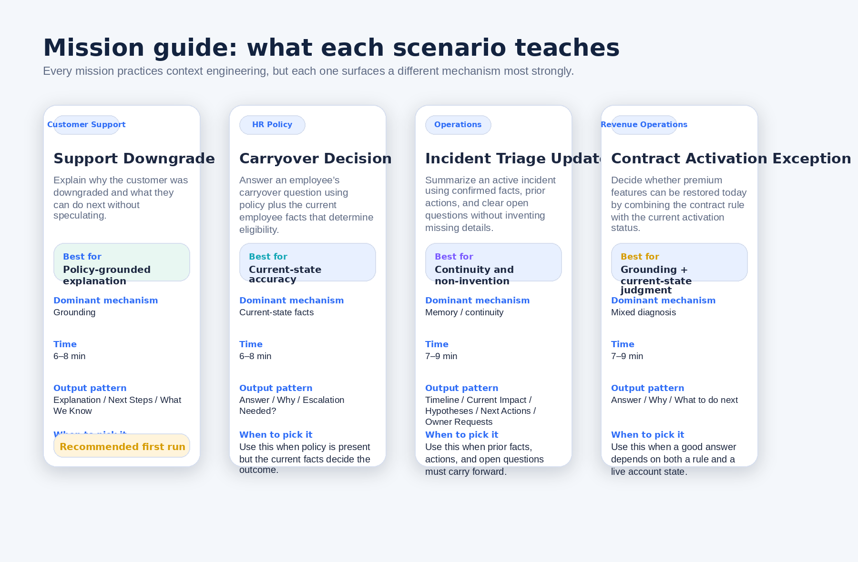
Figure 12. The four current missions in Pattern Orchestrator Lab and the mechanism each one surfaces most strongly.
Mission | Family | Main lesson | Best use
Support Downgrade | Customer Support | Policy-grounded explanation | Best first run; learn grounding
Carryover Decision | HR Policy | Current-state accuracy | Practice dynamic facts
Incident Triage Update | Operations | Continuity and non-invention | Practice continuity and non-invention
Contract Activation Exception | Revenue Operations | Grounding + current-state judgment | Practice mixed diagnosis

6. How to Build a Good Package
A good package is not the biggest package. It is the smallest package that makes the answer reliable. In Pattern Orchestrator Lab, that usually means choosing the right mechanism first and then adding only the evidence, memory, or live facts that actually decide the answer.
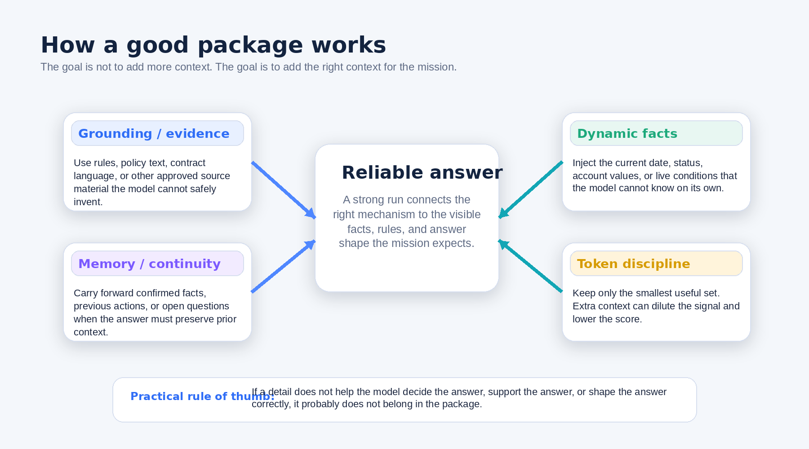
Figure 13. A good package connects the right mechanism to the answer and stays lean enough to preserve signal quality.

How to think about the mechanisms
• Grounding means source evidence the model cannot safely invent: policy text, rule language, contract conditions, or other approved documentation.
• Memory means carryover context: confirmed facts, previous actions, prior decisions, or open questions that must stay visible across the answer.
• Dynamic facts means live or current-state details: today’s date, account status, hire date, active severity level, billing sync state, or similar facts the model could not know on its own.
• Mixed diagnosis means more than one gap matters at the same time. Contract Activation Exception is the clearest example because the answer needs both the rule and the live status.
Plain-language rule: If a detail does not help the model decide the answer, support the answer, or shape the answer correctly, it probably does not belong in the package.

A practical packaging checklist
• Start from the diagnosis, not from the item list.
• Turn on only the mechanism blocks that solve the weak-state failure.
• Choose the decision-driving items first. Add extra context only if it clearly improves reliability.
• Keep an eye on token use. Token Discipline is part of the learning, not an afterthought.
• Use the package summary as a reality check: if the package keeps growing but the mechanism story is still fuzzy, stop and simplify.

7. How to Use ChatGPT Correctly in This Lab
Pattern Orchestrator Lab uses ChatGPT as an external execution step. The app prepares the combined block, but you run that block outside the lab. This keeps the workflow transparent and makes the application compatible with simple static hosting.
The safe operating sequence is straightforward: copy the combined block in Step 4, paste it into ChatGPT, run it, copy only ChatGPT’s answer, return to the lab, paste only that answer into Step 5, and analyze it.
Do this | Avoid this
Copy the combined block from Step 4. | Do not paste the combined block back into Step 5.
Run the copied block in ChatGPT or another external model. | Do not expect the app to call a live model for you.
Paste only the answer into Step 5. | Do not paste your own notes unless you want them scored as answer text.
Use Load sample output if you want to learn the scoring flow first. | Do not treat sample output as proof that your own package is already strong.

What the visible prompt block is for: It shows exactly what the external model receives. That makes the learning process more explainable because you can inspect the task instructions, selected context package, and output request before you run them.

8. How Review Coaching Works
Step 6 is designed to help you improve the next run, not simply to score the current one. It combines several layers of feedback so the result feels explainable rather than arbitrary.
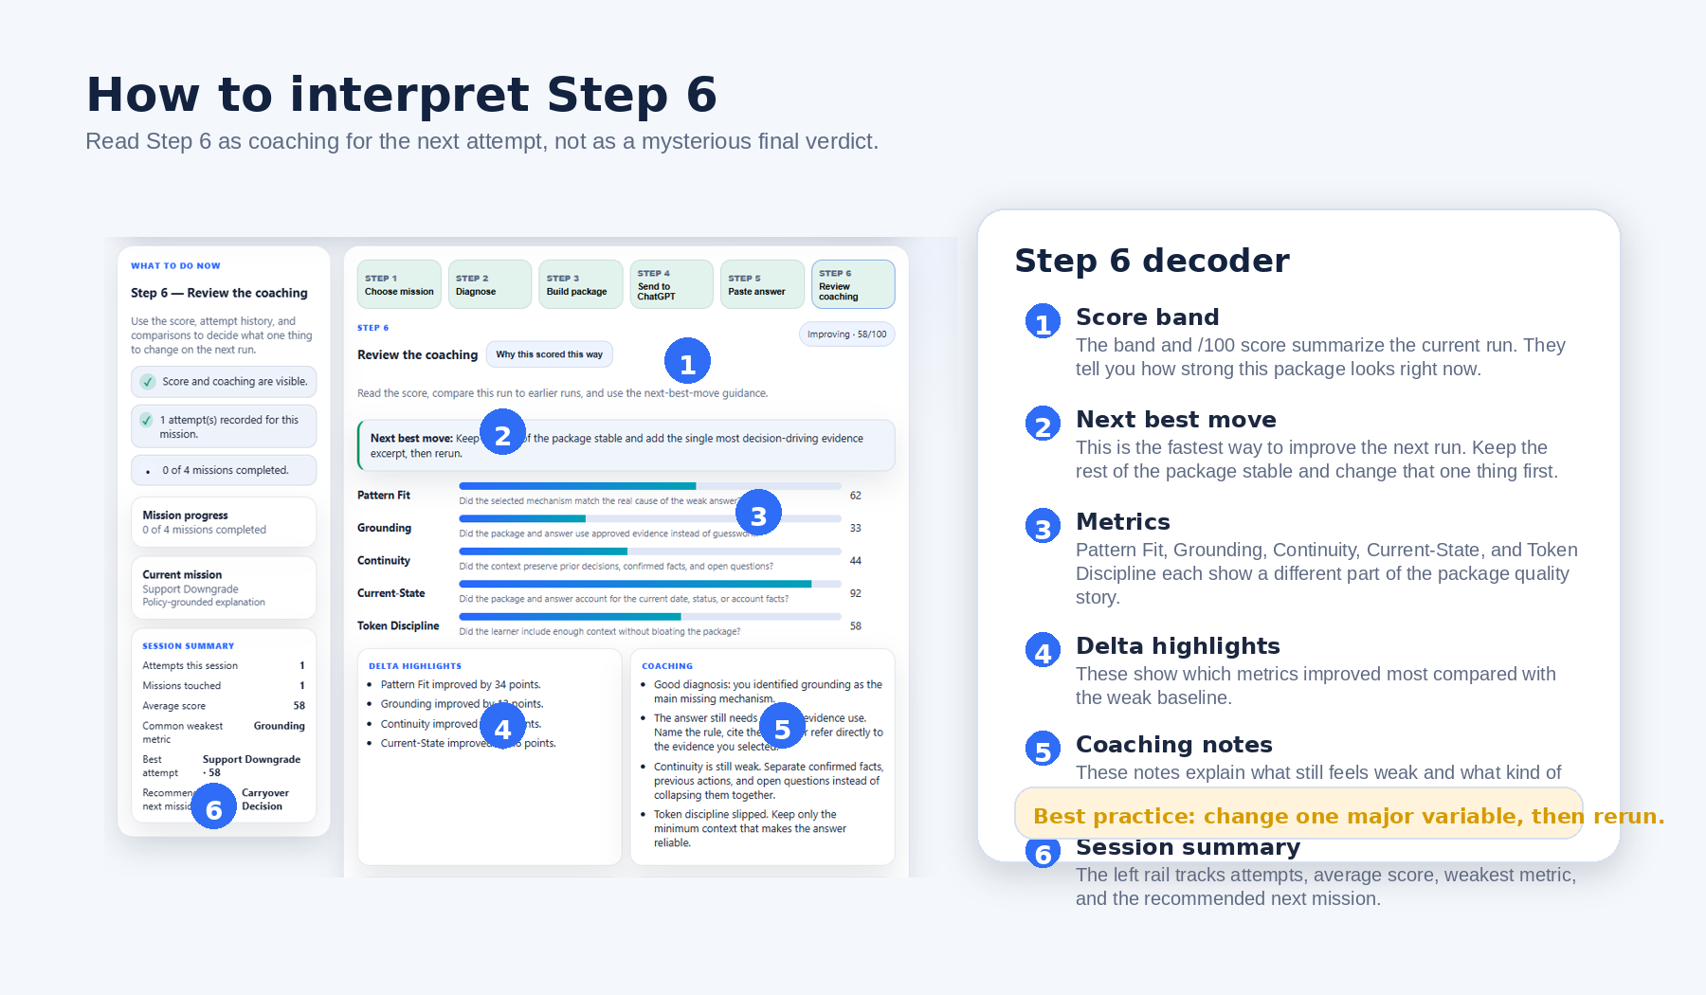
Figure 14. A decoder for Step 6: what the score band, next best move, metrics, and session summary are trying to tell you.
• The score band gives you a quick summary of the current run.
• The next best move tells you the highest-leverage change worth trying next.
• Pattern Fit checks whether you chose the right mechanism for the mission.
• Grounding looks for visible use of approved evidence instead of generic guesswork.
• Continuity looks for preserved prior facts, actions, or open questions when the mission needs them.
• Current-State checks whether the answer actually used live facts such as date, status, or account conditions.
• Token Discipline rewards keeping the package strong without bloating it.
• Delta highlights show how the current run changed relative to the weak baseline.
• Coaching notes explain what still seems weak in plain language.
• Attempt history and session summary help you compare runs and decide where to practice next.

Sentence-level feedback and attempt comparison
Beyond the visible score bars, Step 6 also supports sentence-level coaching and comparison against previous and best attempts. That matters because the lab is trying to help you see which specific parts of the answer carried real evidence, used the right live facts, or stayed too generic. Use those comparisons to confirm whether the answer improved for the right reason, not just because the wording changed.

9. Important Scoring Limitation
Step 6 is intentionally heuristic and explainable. It is not deep semantic AI judgment. The app uses transparent rules, phrase matches, and penalties so you can see why a score moved up or down.
That means the review does not truly understand the answer the way a human reviewer or an LLM judge might. Instead, it checks for the visible signals the mission expects. This is useful for teaching, but it is still approximate.
• Strong answers that use unexpected wording can sometimes score lower than they deserve.
• Weak answers that happen to match the expected phrases can sometimes score higher than they deserve.
• A score is best read as a coaching signal, not as a perfect verdict on answer quality.
In plain English, the lab is asking questions like these:
• Did you choose the right mechanism for the mission?
• Did you include the right kind of context?
• Does the pasted answer visibly use that context?
• Does the answer mention the facts, rules, and continuity signals the mission expects?
• Did the package stay within a reasonable context budget?
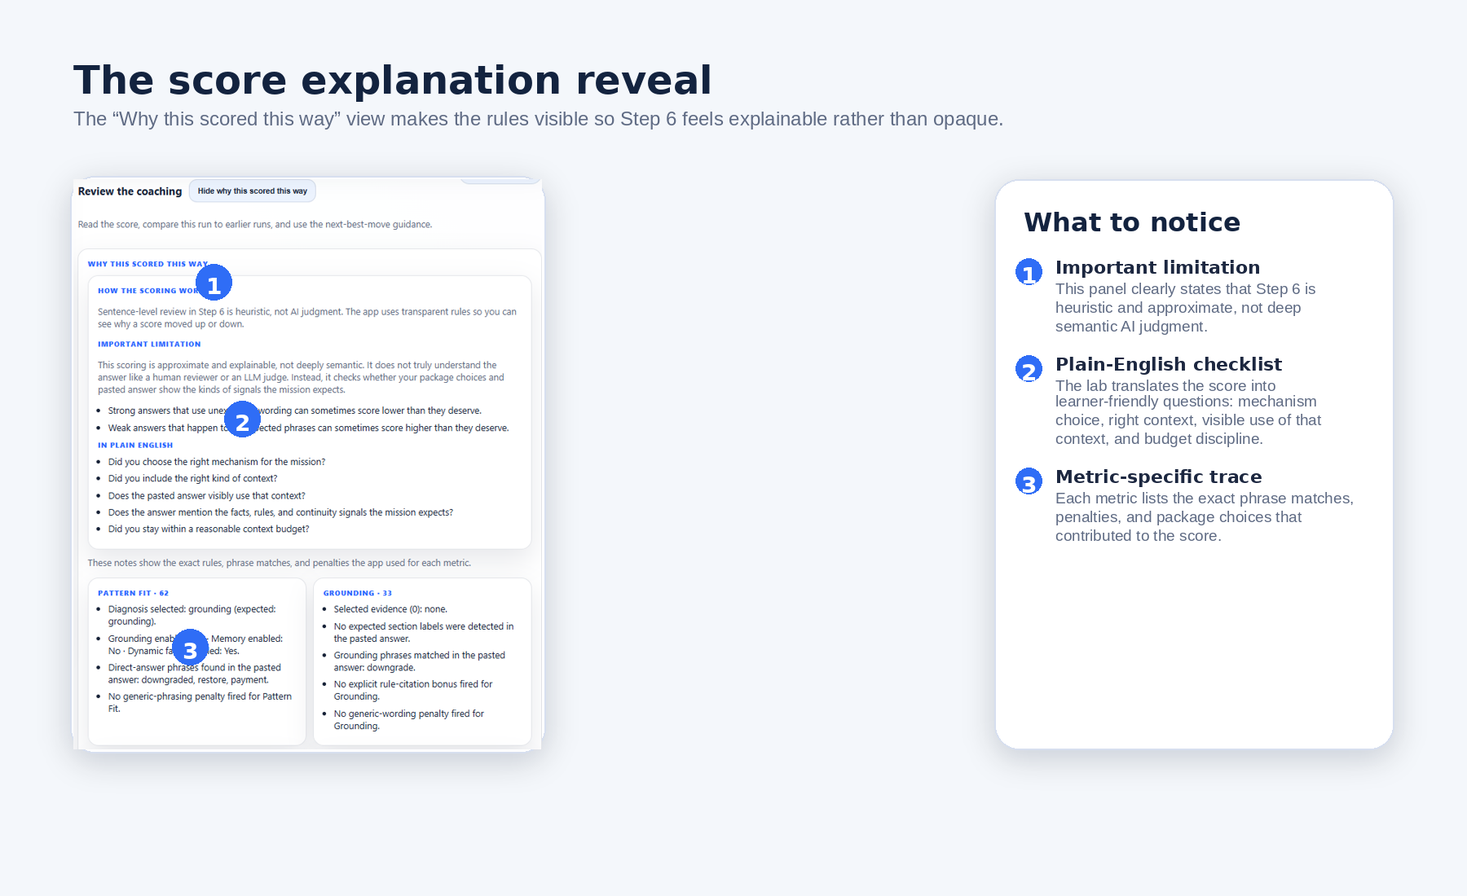
Figure 15. The “Why this scored this way” reveal makes the scoring rules visible and states the limitation clearly: the review is approximate and explainable, not deep semantic judgment.

10. How to Learn More From Each Run
The lab becomes much more valuable when you treat each run as an experiment. A good run is not just one that scores higher. It is one that teaches you which mechanism mattered, which context item made the difference, and whether the answer improved because the package actually got stronger.
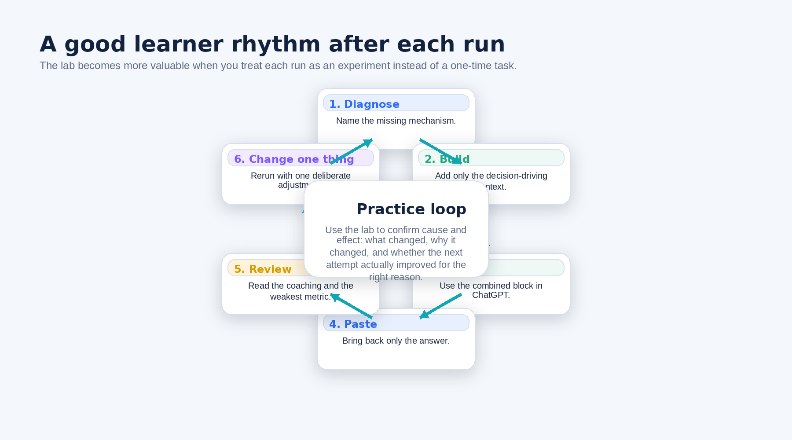
Figure 16. A strong learner rhythm: diagnose, build, run, paste, review, then change one major variable and rerun.
• After each run, name the weakest metric before you start changing the package again.
• Keep the rest of the package stable when you test a new change. That makes cause and effect easier to interpret.
• Use Retry this mission when you want another attempt that still compares against the prior run.
• Use Start over completely when you want a clean reset that clears the mission and its attempt history.
• Use the recommended next mission in the left rail when you want a sensible follow-on scenario.
• Repeat Support Downgrade once after your first run. Repetition often makes the mechanism lesson much clearer.

11. Control Reference / Quick Reference
Control | What it does for the user
Help | Opens the app’s quick-start help page.
Feedback | Opens the feedback page for capturing comments on the experience.
Walkthrough | Reopens the first-run walkthrough overlay.
Dark theme | Switches the visual theme for comfort and readability.
Copy everything to send to ChatGPT | Copies the full combined block for the external-model step.
Analyze pasted output | Runs the local review logic and unlocks Step 6 for the current pasted answer.
Load sample output | Loads a sample answer so you can learn the scoring flow before using an external model.
Clear output | Clears the Step 5 answer box.
Why this scored this way | Opens the rule trace behind the Step 6 metrics.
Retry this mission | Starts a new working attempt while preserving the mission’s attempt history.
Start over completely | Clears the current mission and its attempt history.
Open next mission | Moves you to the next mission after review.

12. Troubleshooting / FAQ
Question | Answer
Which mission should I start with? | Start with Support Downgrade. It has the clearest first-run teaching signal and is the mission the app itself recommends.
Why is Step 6 locked? | Because Step 6 only opens after you paste an answer into Step 5 and click Analyze pasted output.
Why did my score disappear after editing the pasted answer? | Because changing the answer clears the old analysis. Click Analyze pasted output again to refresh Step 6.
What exactly should I paste back? | Paste only ChatGPT’s answer. Do not paste the original combined block again.
Why did a good answer score lower than I expected? | Because Step 6 is heuristic. Strong answers with unexpected wording can under-score if they do not match the visible signals the rubric expects.
Should I turn on every mechanism block? | No. The app is teaching selective packaging. Use only the mechanisms and items that actually solve the weak-state failure.
When should I use Load sample output? | Use it when you want to learn the review flow before running an external model.
What is the difference between Retry this mission and Start over completely? | Retry keeps attempt history for comparison. Start over completely clears the mission and its history.
What if the walkthrough does not open again automatically? | Use the Walkthrough button in the top bar to reopen it whenever you need it.

13. Glossary
Term | Meaning in the app
Mission | A scenario you work through from Step 1 to Step 6.
Mechanism | The kind of context the answer needs most: grounding, memory, dynamic facts, or mixed.
Grounding | Approved source evidence such as policy text, rules, or contract language.
Memory / Continuity | Prior facts, decisions, actions, and open questions that must carry forward.
Dynamic facts / Current-State | Live details such as date, status, account state, or other runtime facts.
Pattern Fit | A Step 6 metric showing whether the mechanism choice matched the real mission need.
Token Discipline | A Step 6 metric showing whether the package stayed strong without becoming bloated.
Combined block | The Step 4 block that includes mission instructions, selected context, and the output request.
Delta highlights | Short notes showing which metrics improved or dropped relative to the weak baseline.
Next best move | The app’s most important suggested change for the next attempt.
Session summary | The left-rail summary of attempts, average score, weakest metric, and recommended next mission.

Final Takeaways / Best Practices
Pattern Orchestrator Lab works best when you use it as a learning lab, not as a speed exercise. The best users do not rush to the highest number. They learn to diagnose the weak state, build a small but effective package, use ChatGPT correctly, and read Step 6 as guidance for the next experiment.
• Start with Support Downgrade, then repeat it once before branching out.
• Diagnose before you build. Mechanism judgment is the core skill the lab is teaching.
• Select the smallest useful package, not the largest package.
• Use the external-model step carefully: copy the combined block out, then paste only the answer back.
• Treat Step 6 as coaching for the next run, especially when the score feels imperfect.
• Change one major variable at a time so the improvement remains explainable.
Bottom line: The strongest way to use Pattern Orchestrator Lab is to ask, after every run: What changed, why did it change, and what one thing should I test next?

