
END-USER GUIDE
Reliable Generative AI
Context Engineering
Video Learning Companion
A practical guide to the 40-video learning path, active recall, spaced review, and applied context-engineering practice.
Guide item | Current application detail
Application version | RCE Video v2.0.2
Learning scope | 5 chapters, 40 videos, 49:48 total runtime
Knowledge checks | 80 low-stakes retrieval checks
Applied practice | 6 source-grounded scenarios in 6 practice modes
Progress storage | Saved in the current browser and device
Local package | Application-only; the 40 videos and 40 figures must be copied into site\media
What this guide helps you do
Install or open the application correctly, choose the right next learning activity, use video progress and personal study tools, complete retrieval checks and scheduled reviews, practice in the applied lab, preserve local learning data, and resolve common problems.

User Guide v1.0 | August 2026

How to use this guide
Read from beginning to end for a complete orientation, or go directly to the section that matches what you are doing in RCE Video.
Section | What it covers
1. Understand RCE Video | Purpose, learning model, scope, and important limitations
2. Get started | Hosted access, Windows 11 local setup, media installation, and first launch
3. Use the learning dashboard | Continue Learning, review queue, applied lab, and whole-course status
4. Follow the five-chapter path | Chapter map, the 40-video matrix, and direct navigation
5. Study a video | Player, study rail, figure, core concept, and video navigation
6. Manage progress and playback | 90% completion, manual completion, resume, focus mode, and navigation
7. Use bookmarks and notes | Timestamped notes, return-to-time behavior, export, and import
8. Complete retrieval checks | Answering, feedback, retries, confidence, and review marking
9. Use spaced review | Quick Review, Chapter Review, queue priorities, and intervals
10. Practice in the applied lab | Six scenarios, six practice modes, drafts, and submissions
11. Interpret lab feedback | Criterion coverage, source grounding, and evaluation limits
12. Protect and reset local data | Browser-local storage, exports, imports, and independent reset boundaries
13. Use mobile and accessibility features | Phone layouts, keyboard access, native controls, and privacy
14. Learn effectively | Recommended study cycle and practical habits
15. Troubleshoot and use quick reference | Common issues, glossary, and control summary

Fast first-run path
1. Open the learning dashboard and use the Intelligent Continue Learning recommendation.
2. Watch the selected video and use the Core concept and supporting figure to reinforce the main idea.
3. Complete both retrieval checks below the video.
4. Choose a confidence level honestly and mark any uncertain item for review.
5. Return later through Quick Review, then open the Applied lab when you are ready to practice the concepts.
Important boundary
RCE Video is a learning companion. Retrieval results and lab feedback do not certify mastery, professional competence, deployment readiness, legal compliance, security, or real-world correctness.

1. Understand RCE Video
RCE Video is a private, mobile-first companion to Reliable Generative AI Context Engineering. It combines short videos, progress visualization, personal study tools, active recall, spaced review, and applied context-engineering practice in one browser-local application.

What the application includes
40 short videos  Eight videos in each of five chapters, with a combined runtime of 49 minutes and 48 seconds. | Five-stage learning map  A connected chapter path that shows sequence, current location, runtime, completion, and applied-lab status.
Personal study tools  Focus mode, timestamped bookmarks, optional plain-text notes, and export/import controls. | 80 retrieval checks  Exactly two source-grounded, low-stakes checks after every video, with immediate feedback and retry.
Local spaced review  Quick Review and five Chapter Review queues using deterministic scheduling. | Six applied scenarios  Source-grounded practice across guided assembly, diagnosis, comparison, improvement, and build-from-scratch work.

What the application does not do
- It does not require an account or send learner activity to a remote learning database.
- It does not provide certification, a mastery score, or professional authorization.
- It does not call an external AI system to grade lab work.
- It does not include advertising, analytics, telemetry, public leaderboards, or social features.
- The application-only package does not contain the 40 MP4 videos or 40 PNG figures.

The core learning model
The application separates four kinds of learning evidence so that one activity is not mistaken for another:
Learning evidence | Meaning
Video progress | How far the learner has reached in the video timeline; completion occurs at 90% or by manual action.
Retrieval history | Responses, confidence, review marks, attempts, and scheduling for the 80 checks.
Applied-lab work | Drafts, submissions, and documented criterion coverage for the six scenarios.
Personal study data | Timestamped bookmarks and optional notes associated with specific videos.
Use the measures together
Video completion shows exposure, retrieval checks support recall, review scheduling supports retention, and lab scenarios support application. None of these alone proves reliable real-world performance.

2. Get started
The correct startup path depends on whether you are opening a hosted deployment or the Windows application package.

Open a hosted version
Open the web address supplied by the publisher or administrator in a current browser. Use the same browser profile and site address when you want existing local progress, bookmarks, review history, and lab work to remain available.

Launch locally on Windows 11
1. Extract the RCE Video ZIP into a normal local folder. Do not run the application from inside the compressed ZIP.
2. Immediately double-click VERIFY-PACKAGE.bat. This checks the release inventory before files are changed.
3. Install the complete site\media folder from a prior working RCE Video release.
4. Double-click CHECK-MEDIA.bat and resolve every missing or mismatched file before continuing.
5. Double-click start-server.bat and keep the terminal window open while the application is in use.
6. Use the localhost address opened by the launcher or printed in the terminal.
7. Press Ctrl+C in the terminal when you are finished and want to stop the local server.

Install the media folder
Method | Procedure
Recommended | Run COPY-MEDIA-FROM-PREVIOUS.bat, enter the full path to a prior working RCE Video folder, and let the helper copy and validate all 80 media files.
Manual | Copy the complete prior site\media folder into the new package's site folder, preserve ch1 through ch5 and the v01-v08 filenames, then run CHECK-MEDIA.bat.
Do not open index.html directly
The included same-origin local server is required for reliable routing, video seeking, and browser security behavior. Opening site\index.html from File Explorer is not the supported local workflow.

What appears at first launch
The learning dashboard loads the course summary, the next recommended action, the spaced-review queue, applied-lab status, the five-chapter map, and the 40-video matrix. On a new browser profile, all videos and scenarios appear as Not started and the review queue is empty.

3. Use the learning dashboard
The dashboard is the central decision page. It tells you what to continue, what needs review, how far you have progressed, and where to practice.
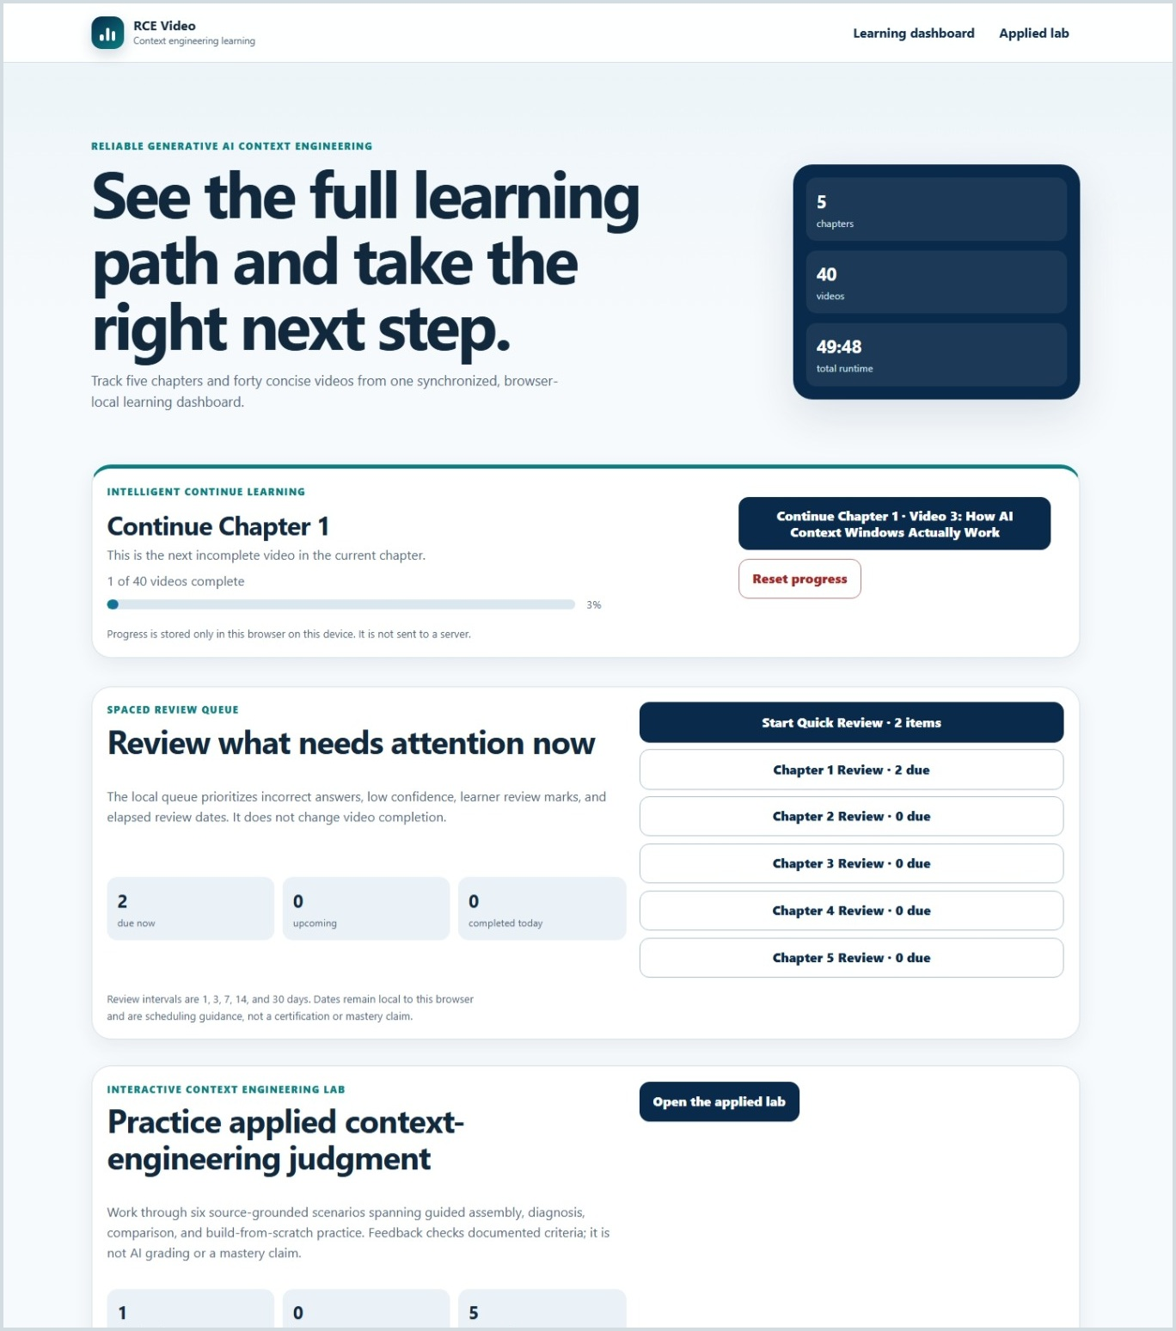
Figure 1. The dashboard combines the next recommended video, spaced review, applied-lab status, and whole-course summary.

Intelligent Continue Learning
The primary recommendation is deterministic. It identifies the exact destination rather than presenting a generic Continue button.
Priority | What the application opens
1 | The most recent valid genuine resume point, when a saved stop exists.
2 | The next incomplete video in the current chapter.
3 | The first incomplete video in the next incomplete chapter.
4 | A course-complete review path beginning with Chapter 1, Video 1.

Dashboard areas
- Continue Learning: displays the current chapter's progress and the precise next action.
- Review what needs attention now: shows due, upcoming, and completed-today review counts, plus Quick Review and chapter-specific review buttons.
- Practice applied context-engineering judgment: shows completed, in-progress, and not-started scenario counts and opens the applied lab.
- Five connected chapter stages: provides a sequenced chapter path with direct chapter access.
- All 40 videos at a glance: provides one direct video node for every title and displays Not started, In progress, or Complete.
Progress is browser-local
The dashboard reflects data stored in the current browser profile for the current site. A different browser, device, private window, or site address may show a separate learning record.

4. Follow the five-chapter learning path
The five-stage map preserves the book's sequence while still allowing direct navigation to any chapter or video.
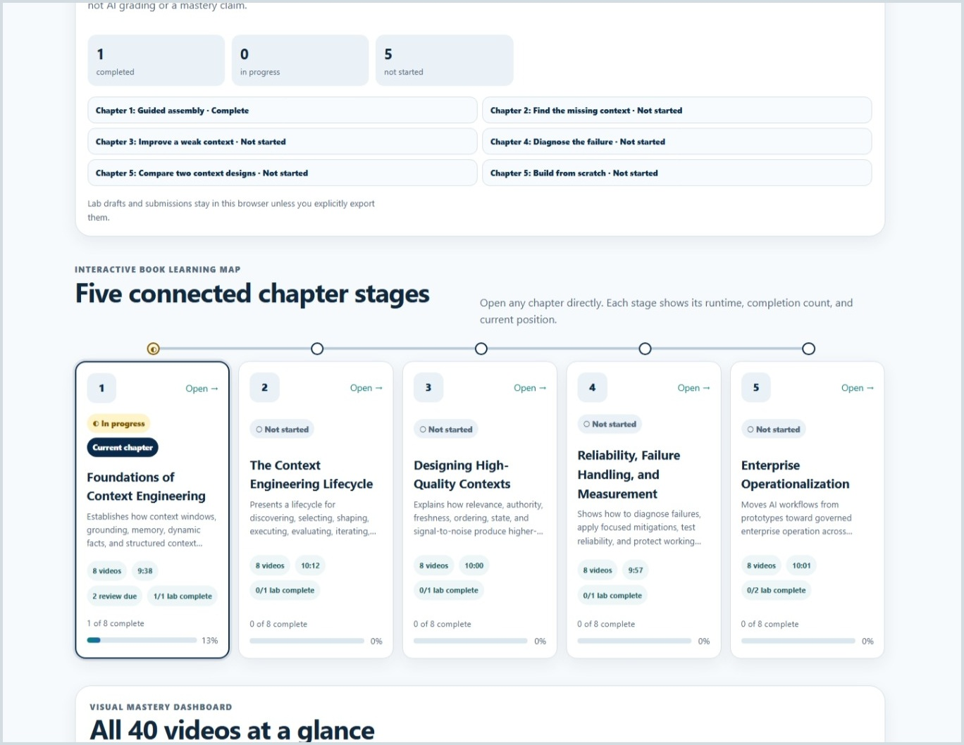
Figure 2. The connected chapter map shows sequence, current location, runtime, video completion, and lab status.
Chapter | Title | Videos | Runtime
1 | Foundations of Context Engineering | 8 | 9:38
2 | The Context Engineering Lifecycle | 8 | 10:12
3 | Designing High-Quality Contexts | 8 | 10:00
4 | Reliability, Failure Handling, and Measurement | 8 | 9:57
5 | Enterprise Operationalization | 8 | 10:01

Use the 40-video matrix
The Visual Mastery Dashboard groups all eight videos under each chapter. Every node carries a text status, so the state does not depend on color alone. Open any node to go directly to that video.
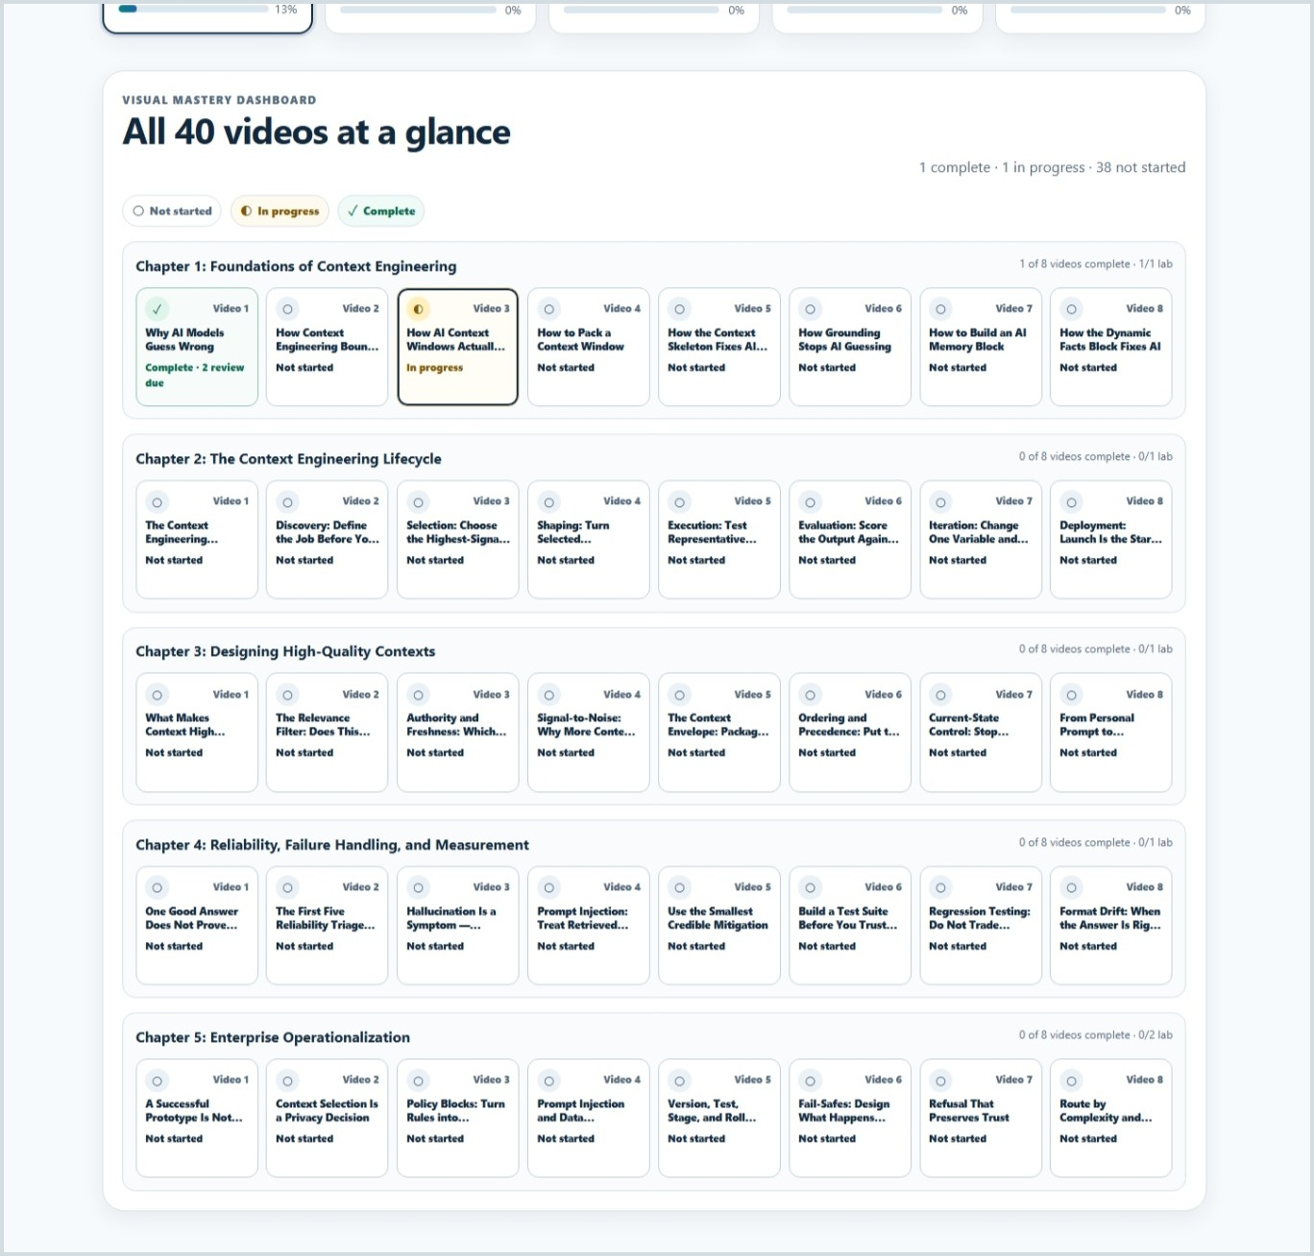
Figure 3. The 40-video matrix provides direct access to every title and shows each video's current status.

Recommended sequence
- Follow the chapter order on a first pass because later chapters build on earlier context-engineering concepts.
- Use direct video navigation for targeted review after you understand the overall learning arc.
- Use the chapter map to distinguish video completion from chapter-specific applied-lab completion.
- Return to incomplete or in-progress nodes before treating a chapter as fully reviewed.

5. Study a video
The video page keeps the player, progress controls, supporting explanation, personal study tools, figure, navigation, and retrieval checks in one learning flow.
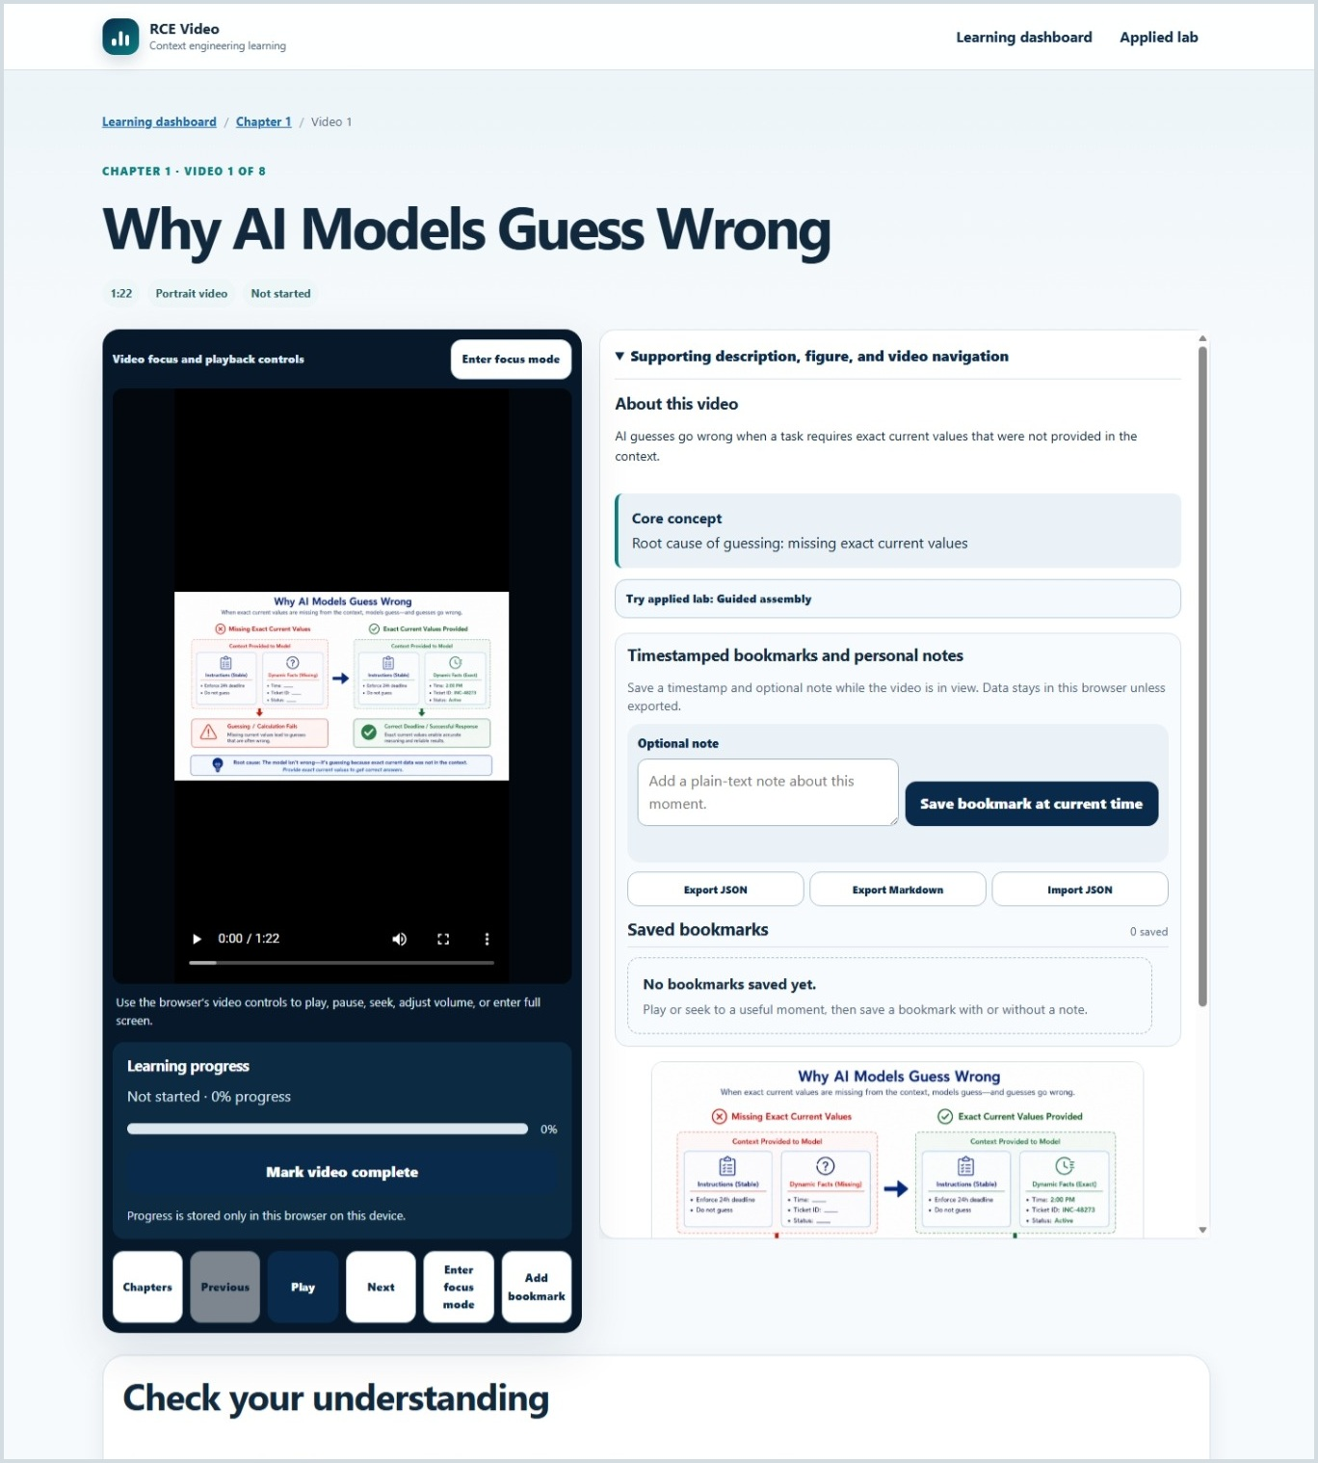
Figure 4. The video page places the native player and progress controls beside the supporting study rail.

Video player and progress area
- Use the browser's native video controls to play, pause, seek, change volume, and enter fullscreen.
- Learning progress reports the furthest valid timeline position reached.
- Mark video complete is available when you want to complete the item manually.
- Chapters, Previous, Play or Resume, Next, focus mode, and bookmark actions remain close to the player.

Supporting study rail
The right-side panel explains why the video matters and supports active study without widening the desktop page. It stacks below the player on phones and narrow tablets.
- About this video: a concise description of the concept.
- Core concept: the single takeaway to retain.
- Applied-lab bridge: a direct suggestion when a related scenario is available.
- Timestamped bookmarks and personal notes: personal study capture beside the player.
- Supporting figure: a visual reinforcement of the video's central idea.
- Video navigation: direct movement to adjacent learning items.
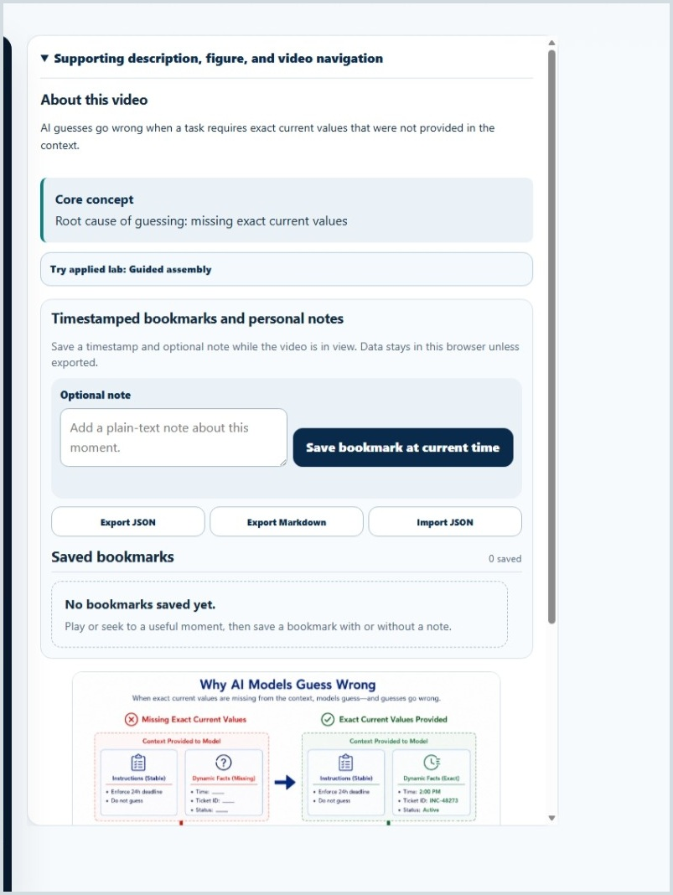
Figure 5. The study rail combines the core concept, related applied practice, bookmarks, notes, and supporting figure.
The media is instructional content
The application package's catalog controls title order, descriptions, figures, durations, and media paths. Do not rename or rearrange the media files in a local installation.

6. Manage progress, resume, focus, and navigation
RCE Video separates the current playback position from the furthest learning progress reached so that reviewing earlier material does not erase progress.

How learning progress works
Behavior | What to expect
Forward viewing or seeking | Advances Learning progress to the furthest valid timeline position reached.
Backward seeking | Changes playback position but does not reduce previously reached progress.
Automatic completion | Occurs when Learning progress reaches exactly 90%.
Manual completion | Mark video complete remains available as an explicit learner action.
Persistence | Progress and saved playback positions normally survive refresh and browser restart in the same browser profile.

Continue Watching and resume
A Continue Watching prompt appears only after a genuine stop. The application freezes one saved stop value when the page opens. Seeking before playback does not create this prompt. Starting playback or choosing Resume or Start Over dismisses the frozen prompt.

Focus mode
- Enter focus mode enlarges the existing player rather than creating a different player.
- Current time, playback state, route, progress, and native controls are preserved.
- Focus mode does not autoplay and does not force fullscreen.
- Use Exit focus mode or press Escape to return to the standard page.

Navigation and the mobile command bar
- Desktop controls provide Chapters, Previous, Play or Resume, Next, focus mode, and bookmark actions.
- On phones, the command bar provides thumb-friendly access to Chapters, Previous, Play or Resume, Next, and More.
- The mobile bar remains in normal flow while native controls are visible and does not cover them.
- Equivalent keyboard-accessible actions are available; gestures are not required.
Completion is not the same as mastery
The fixed 90% threshold and manual completion support learning organization. Completion does not mean the concept has been recalled correctly, applied successfully, or retained over time.

7. Use timestamped bookmarks and personal notes
Bookmarks help you return to a precise moment in a video and attach an optional plain-text note without changing course progress.

Create a bookmark
1. Play or seek to the moment you want to preserve.
2. Enter an optional note in the plain-text note box.
3. Select Save bookmark at current time.
4. Confirm that the item appears under Saved bookmarks.

Work with saved bookmarks
- Jump to the saved timestamp in the same player without automatically starting playback.
- Edit the note when your understanding changes.
- Delete a bookmark that is no longer useful.
- Keep bookmarks and notes even when all video learning progress is reset.

Export and import
Control | Use
Export JSON | Creates a versioned backup suitable for later validated import.
Export Markdown | Creates a readable record of bookmarks and notes.
Import JSON | Validates the file, plans duplicates or conflicts, shows a preview, and changes data only after explicit confirmation.
Plain-text safety
Bookmark notes are stored and displayed as inert plain text. Text that looks like HTML is not interpreted as page content.

Good note-taking practice
- Record why the moment matters, not merely what the speaker said.
- Capture a question, implementation implication, or connection to another chapter.
- Use concise notes so the timestamp remains the primary anchor.
- Export periodically when the notes are important or when moving to another browser or device.

8. Complete retrieval checks
Every video has exactly two low-stakes, source-grounded checks. They support recall and diagnosis without changing video completion.
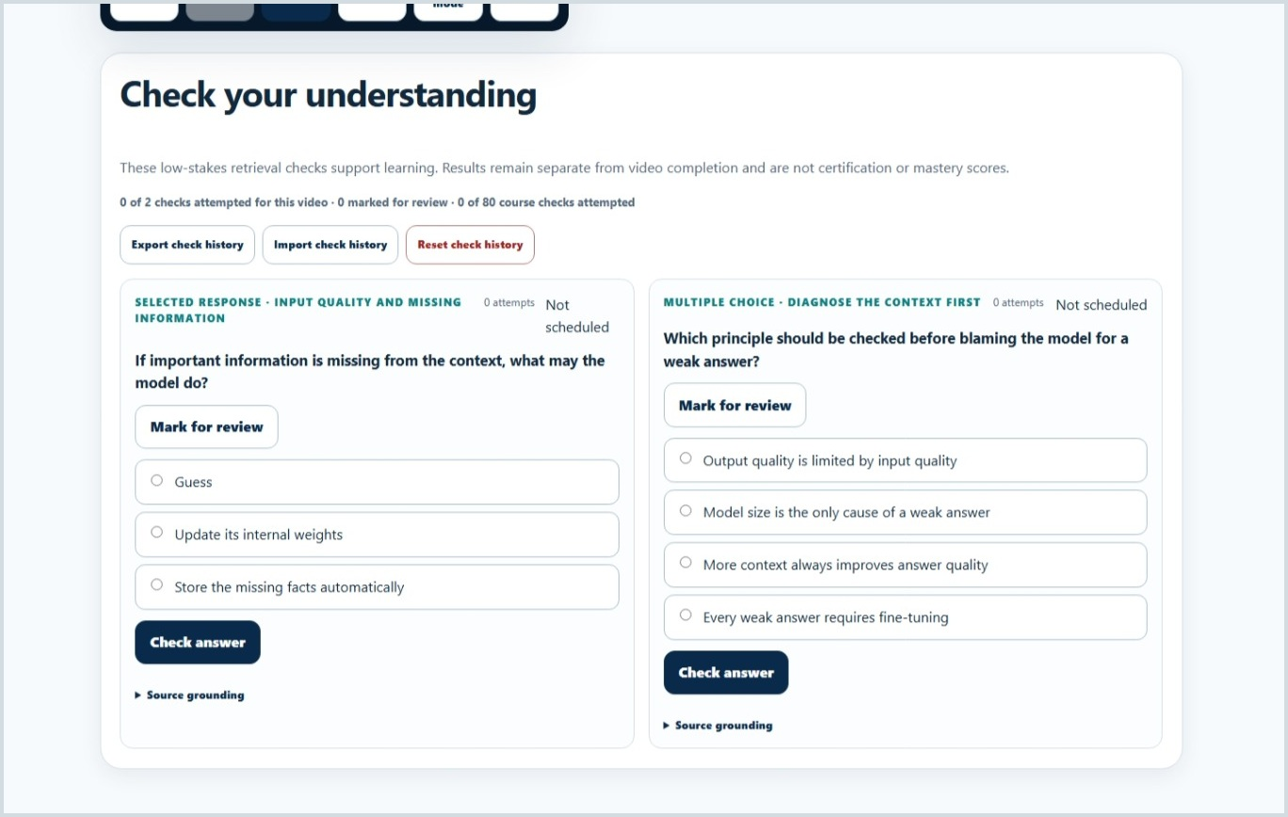
Figure 6. Two retrieval checks appear below each video and remain separate from video completion.

Core check workflow
1. Read the question and select the response that best reflects the video and source material.
2. Select Check answer.
3. Read the immediate correct or incorrect feedback and the source-grounded explanation.
4. Retry when needed; attempts are retained without a penalty score.
5. Choose Low, Medium, or High confidence after responding.
6. Use Mark for review when you want the item to reappear in the review workflow.

How to interpret the check record
Element | Meaning
Attempt history | Preserves prior responses so repeated practice remains visible.
Confidence | A self-report that helps prioritize review; it is not an application-generated confidence score.
Mark for review | A reversible learner flag that places additional priority on the item.
Source grounding | Identifies the approved source basis for the check and explanation.
Check status | Stays separate from the video's Not started, In progress, or Complete status.
Answer honestly before reviewing
The checks are most useful when you retrieve the concept from memory before looking back at the figure, notes, or explanation. A wrong answer is useful diagnostic evidence, not a penalty.

9. Use spaced review
The local review queue resurfaces checks according to response quality, confidence, learner marks, and elapsed time. It does not change video completion.
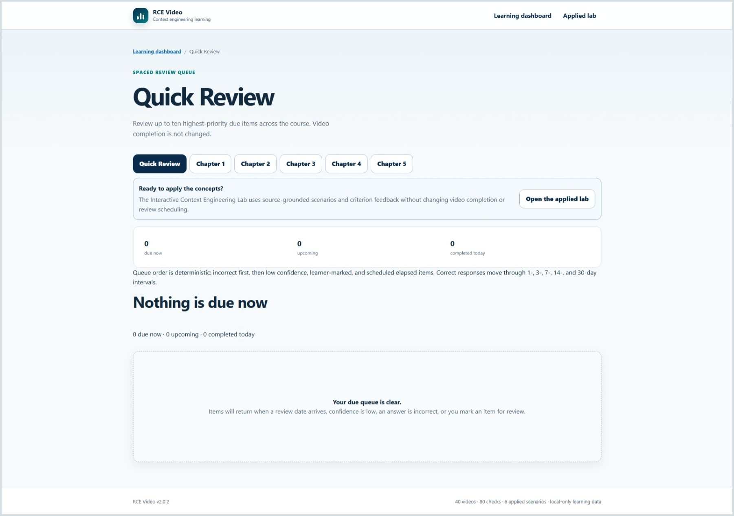
Figure 7. Quick Review presents the highest-priority due items across the course, with separate chapter review routes.

Choose a review mode
Mode | Best use
Quick Review | Review up to ten highest-priority due items across all chapters.
Chapter Review | Concentrate on due items from one selected chapter.

Queue priorities
The queue order is deterministic. It prioritizes items in this order:
1. Incorrect responses.
2. Low-confidence responses.
3. Learner-marked items.
4. Items whose scheduled review date has elapsed.

Review intervals
Correct responses move through a local 1-, 3-, 7-, 14-, and 30-day interval sequence. The dashboard and review page show due now, upcoming, and completed today.
When nothing is due
An empty queue is normal. Items return when a review date arrives, confidence is low, an answer is incorrect, or you mark an item for review.

Review habits that improve retention
- Answer from memory before reopening the video.
- Use confidence honestly; low confidence is a useful scheduling signal.
- After an incorrect response, identify the specific misconception before retrying.
- Use Chapter Review when several related concepts need consolidation.
- Open the applied lab after review when you are ready to use the concepts in a structured scenario.

10. Practice in the Interactive Context Engineering Lab
The applied lab extends the five-chapter learning arc through six source-grounded scenarios and six distinct practice modes.
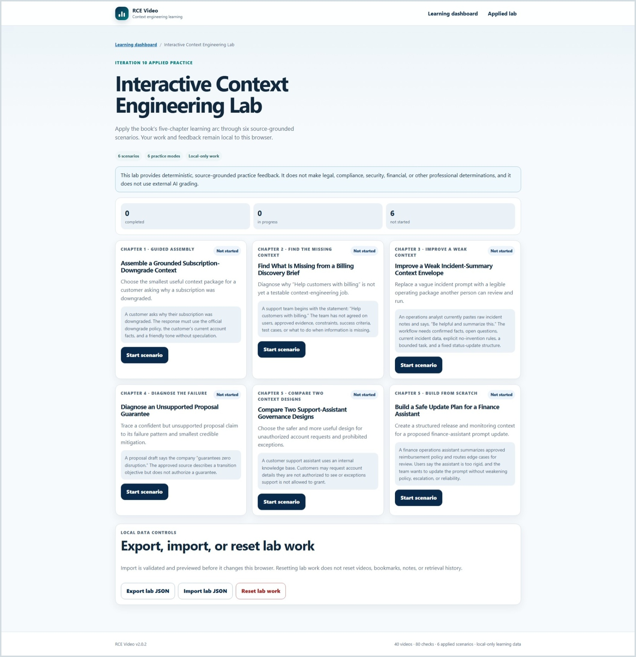
Figure 8. The lab home shows six scenarios, chapter alignment, practice mode, status, and local data controls.

The six scenarios
Chapter and mode | Scenario | Primary learner action
Chapter 1 - Guided assembly | Assemble a Grounded Subscription-Downgrade Context | Choose the smallest useful context package.
Chapter 2 - Find missing context | Find What Is Missing from a Billing Discovery Brief | Identify why a vague job is not yet testable.
Chapter 3 - Improve weak context | Improve a Weak Incident-Summary Context Envelope | Replace a vague prompt with a legible operating package.
Chapter 4 - Diagnose failure | Diagnose an Unsupported Proposal Guarantee | Trace the failure to its cause, mitigation, and regression check.
Chapter 5 - Compare context designs | Compare Two Support-Assistant Governance Designs | Choose the safer and more useful governance design.
Chapter 5 - Build from scratch | Build a Safe Update Plan for a Finance Assistant | Create a structured release and monitoring context.

Lab status and data controls
- Each scenario shows Not started, In progress, or Completed.
- Save Draft preserves work locally without completing the scenario.
- A scenario becomes complete after a submission is recorded.
- Export lab JSON, Import lab JSON, and Reset lab work operate independently from video progress, bookmarks, and retrieval history.
The lab is deterministic and local
The lab does not call an external AI grader. It checks documented criteria using source-grounded rules and stores drafts and submissions in the current browser.

11. Complete a lab scenario and interpret feedback
A scenario page presents the case, the required learner task, mode-appropriate controls, and explicit actions for saving or submitting work.
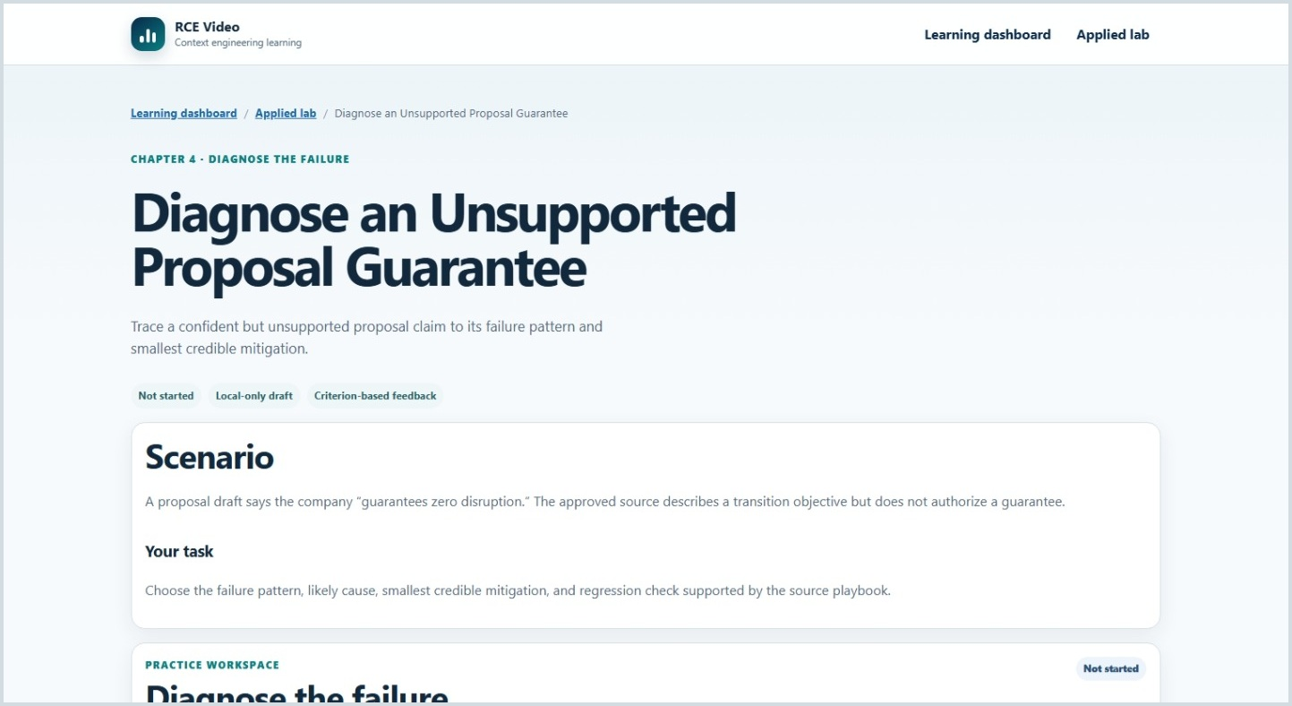
Figure 9. A scenario begins with the chapter, practice mode, case description, task, and local-work status.

Scenario workflow
1. Read the Scenario and Your task sections before selecting or writing anything.
2. Complete the mode-specific workspace. Depending on the scenario, you may assemble, select, diagnose, compare, improve, or build.
3. Select Save draft when you need to pause without submitting.
4. Select Submit for criterion feedback when the response is ready for documented coverage review.
5. Read every criterion result and revise the work when an important element Needs attention.
6. Open Source grounding and feedback limits to understand the source basis and the limits of the evaluation.
7. Use Reset this scenario only when you intend to remove that scenario's local draft and submissions.
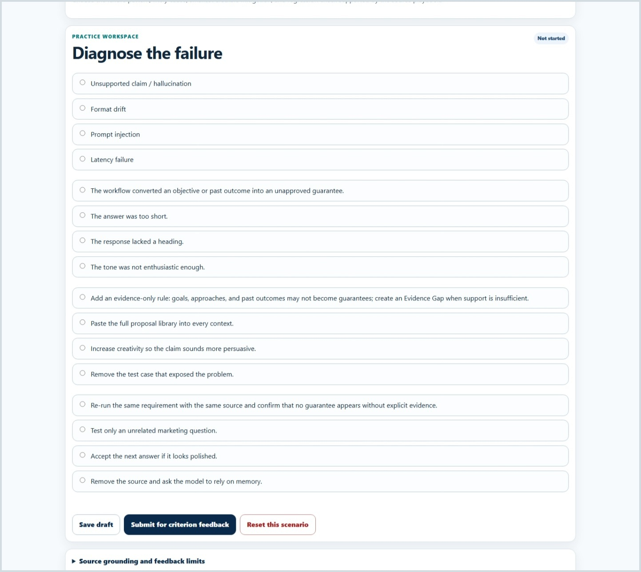
Figure 10. Mode-specific controls support deliberate diagnosis before the learner submits for criterion feedback.

What criterion feedback means
Feedback reports whether documented criteria are represented in the submitted work. It is designed to make the source-supported expectations visible, not to issue a general quality score.
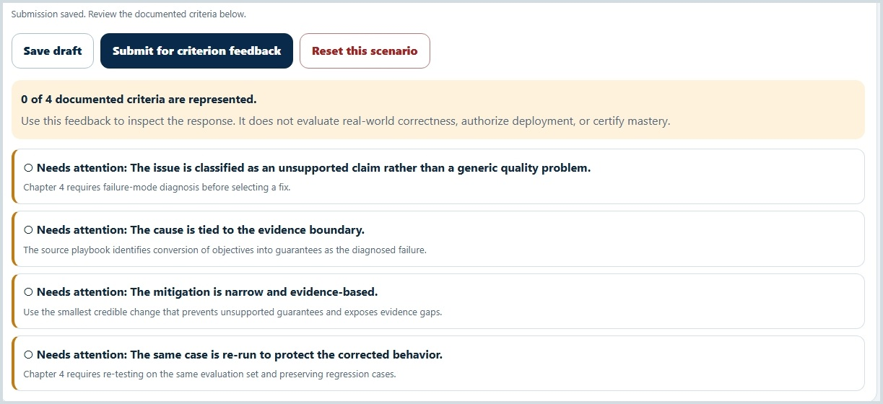
Figure 11. Criterion feedback distinguishes represented elements from items that need attention and states the evaluation limits.

Source grounding and feedback limits
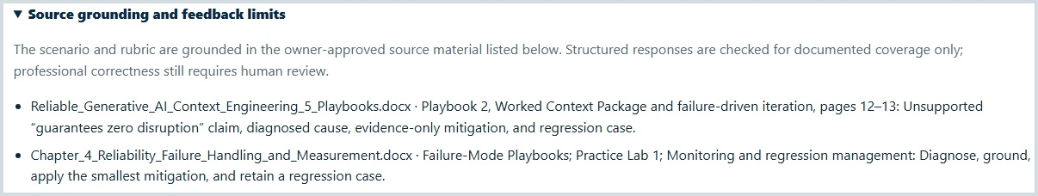
Figure 12. The source-grounding disclosure identifies the approved material behind the scenario and rubric.
- Structured responses are checked for documented coverage only.
- Professional correctness still requires human review.
- The results do not authorize deployment, certify mastery, or make legal, compliance, security, financial, or other professional determinations.
- A polished response can still miss a required criterion; a represented criterion does not prove the real-world plan is safe or correct.

12. Protect, transfer, and reset local learning data
RCE Video stores progress, bookmarks, retrieval history, review schedules, and lab work in the current browser. Explicit exports are the built-in portability and backup mechanism.

Browser-local data boundary
- There are no learner accounts, cloud synchronization, analytics, advertising, or remote grading services.
- Clearing browser site data can remove local learning records.
- Opening the application under a different domain, repository path, browser, browser profile, or device can create a separate local record.
- When persistent storage is unavailable, the application can continue in session memory and displays a warning; session-only data may not survive closing the browser.

Use the correct export for the data you need
Data area | Export/import | Notes
Bookmarks and notes | JSON export/import; Markdown export | JSON is for validated restoration; Markdown is a readable study record.
Retrieval history | JSON export/import | Includes attempts, confidence, review marks, and scheduling data.
Applied lab | JSON export/import | Includes scenario drafts and submissions; import is validated and previewed.

Understand reset boundaries
Reset action | Removed | Preserved
Reset all learning progress | Video completion, watched ranges, saved playback positions, and navigation state | Bookmarks, notes, retrieval history, review schedules, and lab work
Reset check history | Retrieval attempts, confidence, marks, and schedules | Video progress, bookmarks, notes, and lab work
Reset lab work | Lab drafts and submissions | Video progress, bookmarks, notes, and retrieval history
Delete or replace bookmarks | The selected bookmark collection only | Video progress, retrieval history, and lab work
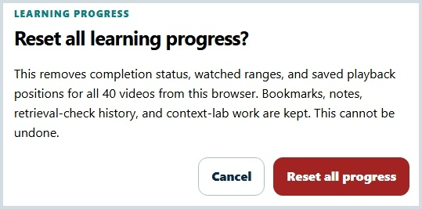
Figure 13. The learning-progress reset dialog states exactly what is removed and what is kept.
Export before major browser changes
Create the relevant JSON exports before clearing site data, changing browsers or devices, moving to a different published address, or performing a rollback that may not expose newer data features.

13. Use mobile, keyboard, accessibility, privacy, and security features
The application is designed for use from approximately 320 CSS pixels upward and preserves normal reading order across phone, tablet, and desktop layouts.

Mobile use
- At phone and narrow-tablet widths, the study rail stacks beneath the player and returns to normal document flow.
- Primary touch targets are approximately 44 CSS pixels where practical.
- Phone landscape keeps controls in normal flow so the command bar does not cover native media controls.
- The chapter path becomes a compact vertical flow and the video matrix remains directly navigable.
- The applied-lab scenario cards and workspaces stack without requiring horizontal scrolling.

Keyboard and accessibility support
- Semantic headings, navigation landmarks, fieldsets, legends, labels, progress elements, status regions, and dialog behavior support structured navigation.
- Video controls, focus mode, bookmarks, retrieval checks, review sessions, and lab modes are keyboard accessible.
- Visible focus treatment, reduced-motion support, forced-colors support, and text labels supplement visual color.
- Native video controls are preserved rather than replaced.
- Feedback receives focus after submission and uses polite status announcements.
Acceptance boundary
Automated browser checks do not substitute for every physical device, screen reader, high-contrast configuration, switch input, voice input, Firefox, Safari/WebKit, or live hosted environment. Organizations should complete their own acceptance testing for required assistive technologies.

Privacy and security
- Learner-authored bookmark notes and lab text are rendered as inert plain text.
- Imports use format and version checks, known identifiers, value limits, previews, and explicit confirmation before changing stored data.
- The application uses a restrictive same-origin Content Security Policy and does not submit forms to remote services.
- Local-only storage prevents server collection by the app, but it does not protect data from another person or malicious software that can access the same browser profile.
- Handle exported files according to your organization's data-handling rules.

14. Learn effectively with RCE Video
The application is most useful when video exposure, retrieval, review, and applied practice are treated as one connected learning cycle.

Recommended learning cycle
Step | Action | Purpose
1 | Watch one video actively | Build an initial mental model without rushing through the chapter.
2 | Record one useful bookmark or note | Capture a key distinction, implementation implication, or unresolved question.
3 | Complete both retrieval checks | Test recall before relying on the explanation.
4 | Report confidence honestly | Give the review queue meaningful information.
5 | Review due items later | Strengthen retention through spaced retrieval rather than immediate repetition alone.
6 | Complete the related lab scenario | Apply chapter concepts in a source-grounded decision or design task.

High-value study habits
- Use Intelligent Continue Learning when you want the most defensible next step.
- Pause before the answer is revealed and explain the concept in your own words.
- Use the supporting figure to clarify relationships, not as a substitute for recall.
- Mark uncertain retrieval items even when the selected answer happens to be correct.
- Revisit one chapter through Chapter Review when concepts are related and easily confused.
- In the lab, explain why a selected context element belongs rather than merely selecting every available option.
- Treat Needs attention as a prompt to inspect a specific criterion, not as a broad judgment of ability.
- Export meaningful work before changing environments.

A practical first-week plan
Session | Suggested activity
1 | Chapter 1 Videos 1-4, both checks after each video, and one or two bookmarks.
2 | Chapter 1 Videos 5-8, then Quick Review or Chapter 1 Review if items are due.
3 | Complete the Chapter 1 guided-assembly lab scenario and inspect every criterion result.
4 | Begin Chapter 2 using Intelligent Continue Learning and preserve any questions as notes.
5 | Review due items before watching new videos; use the chapter map to verify what remains.
Optimize for understanding, not dashboard completion
A smaller number of videos with honest retrieval, spaced review, and applied practice produces more learning value than rapidly marking every item complete.

15. Troubleshoot common problems
Most startup and data questions can be resolved by checking the local-server workflow, media installation, browser profile, and the independent data boundaries.
Problem or question | Resolution
The page is blank or remains on Loading the video library. | Do not open site\index.html directly. Start the included server with start-server.bat, keep the terminal open, and use the localhost address it provides.
A video or figure is missing. | Run CHECK-MEDIA.bat. Confirm the full site\media folder is present with ch1-ch5 and v01-v08 MP4 and PNG files. Do not rename files.
Continue Watching does not appear after seeking. | The prompt requires a genuine stop. Seeking before playback does not create the frozen resume point.
A video is not complete after I watched most of it. | Automatic completion occurs at exactly 90% Learning progress. Continue to 90% or use Mark video complete.
Rewinding reduced my current time but not my progress. | This is expected. Learning progress preserves the furthest valid timeline position reached.
My progress disappeared. | Confirm you are using the same browser profile and exact site address. Check whether site data was cleared, a private window was used, or storage was unavailable.
Nothing is due in Quick Review. | The queue can be clear. Items return when a date arrives, an answer is incorrect, confidence is low, or you mark an item for review.
A retrieval check keeps returning. | Review its attempt history, explanation, confidence, and review mark. Incorrect or low-confidence items receive priority.
My lab submission received Needs attention. | Open each criterion explanation, revise the missing documented element, and resubmit. The feedback checks criterion coverage rather than overall correctness.
An imported JSON file is rejected. | Use the export created by the matching RCE Video data area and version. The application rejects unknown identifiers, invalid structure, and unsafe values before mutation.
Reset all progress did not delete bookmarks or lab work. | This is intentional. Video-progress reset preserves bookmarks, retrieval history, and lab work. Use the specific reset for the data area you intend to clear.

Frequently asked questions
Can I use the app without the book?
The application explains each video and provides source-grounded checks, but it is designed as a companion to the book's five-chapter learning arc.
Does a correct check answer prove mastery?
No. The checks are low-stakes learning supports, and confidence and later review remain important.
Does the lab evaluate free-form work like an AI grader?
No. It uses deterministic, documented criterion checks and explicitly requires human review for professional correctness.
Can I move all data to another device at once?
The application provides separate exports for bookmarks, retrieval history, and lab work. Video progress does not have a single end-user export control documented in this release.
Will a compatible update preserve local data?
The application includes migration logic for supported prior schemas, but exporting important user-created data before major changes remains the safest practice.

Glossary
Term | Meaning in RCE Video
Applied lab | The six-scenario Interactive Context Engineering Lab used for source-grounded practice.
Browser-local | Stored in the current browser profile rather than in an application account or remote learner database.
Chapter Review | A spaced-review mode limited to due items from one chapter.
Criterion feedback | A deterministic report of whether documented scenario criteria are represented.
Focus mode | A reversible enlarged view of the same video player that preserves time, route, progress, and controls.
Intelligent Continue Learning | The deterministic dashboard recommendation for the strongest next learning action.
Learning progress | The furthest valid point reached in a video's timeline.
Mark for review | A reversible learner flag that increases an item's review priority.
Quick Review | A queue of up to ten highest-priority due items across the course.
Retrieval check | One of the two low-stakes, source-grounded recall items associated with each video.
Source grounding | The approved source basis disclosed for a retrieval check or lab scenario.
Visual Mastery Dashboard | The 40-video matrix that shows direct links and Not started, In progress, or Complete status.

Quick reference
Goal | Where to go | Primary action
Continue the course | Learning dashboard | Use the exact Intelligent Continue Learning recommendation.
Open a specific video | Five-chapter map or 40-video matrix | Select the chapter or video node.
Complete a video | Video page | Reach 90% Learning progress or select Mark video complete.
Resume a genuine stop | Dashboard or video page | Use the frozen Resume destination.
Reduce distractions | Video page | Select Enter focus mode; use Exit focus mode or Escape to leave.
Save a learning moment | Study rail | Enter an optional note and select Save bookmark at current time.
Test recall | Below the video | Answer both checks, review feedback, report confidence, and mark uncertain items.
Review due items | Dashboard or review page | Open Quick Review or a Chapter Review.
Practice application | Applied lab | Start a scenario, Save draft, then Submit for criterion feedback.
Understand lab limits | Scenario page | Open Source grounding and feedback limits.
Back up bookmarks | Study rail | Export JSON; optionally export readable Markdown.
Back up retrieval history | Check controls | Export check history JSON.
Back up lab work | Lab home | Export lab JSON.
Clear one data area | Matching reset control | Read the confirmation carefully; reset boundaries are independent.
Final takeaway
Use RCE Video as a connected learning system: watch deliberately, capture useful moments, retrieve before reviewing, return on schedule, and apply the concepts in source-grounded scenarios. The value comes from the learning cycle, not from any single status or score.

