END-USER GUIDE

Signal-to-Noise Studio

A practical, learner-centered guide for using selection discipline to build stronger context packages.
What this guide helps you do
Understand what Signal-to-Noise Studio is teaching, move through a complete mission with confidence, use the external LLM loop correctly, and interpret comparison and review signals without overreading them.

Best use of the guide  Read straight through once for orientation, then come back to the sections that match the screen you are on. | Version note  The uploaded package reports v2.3.0, while the supplied screen captures show a v2.4.0 header pill. This guide reconciles both sources: user-visible labels follow the screenshots, and workflow behavior follows the packaged app files.

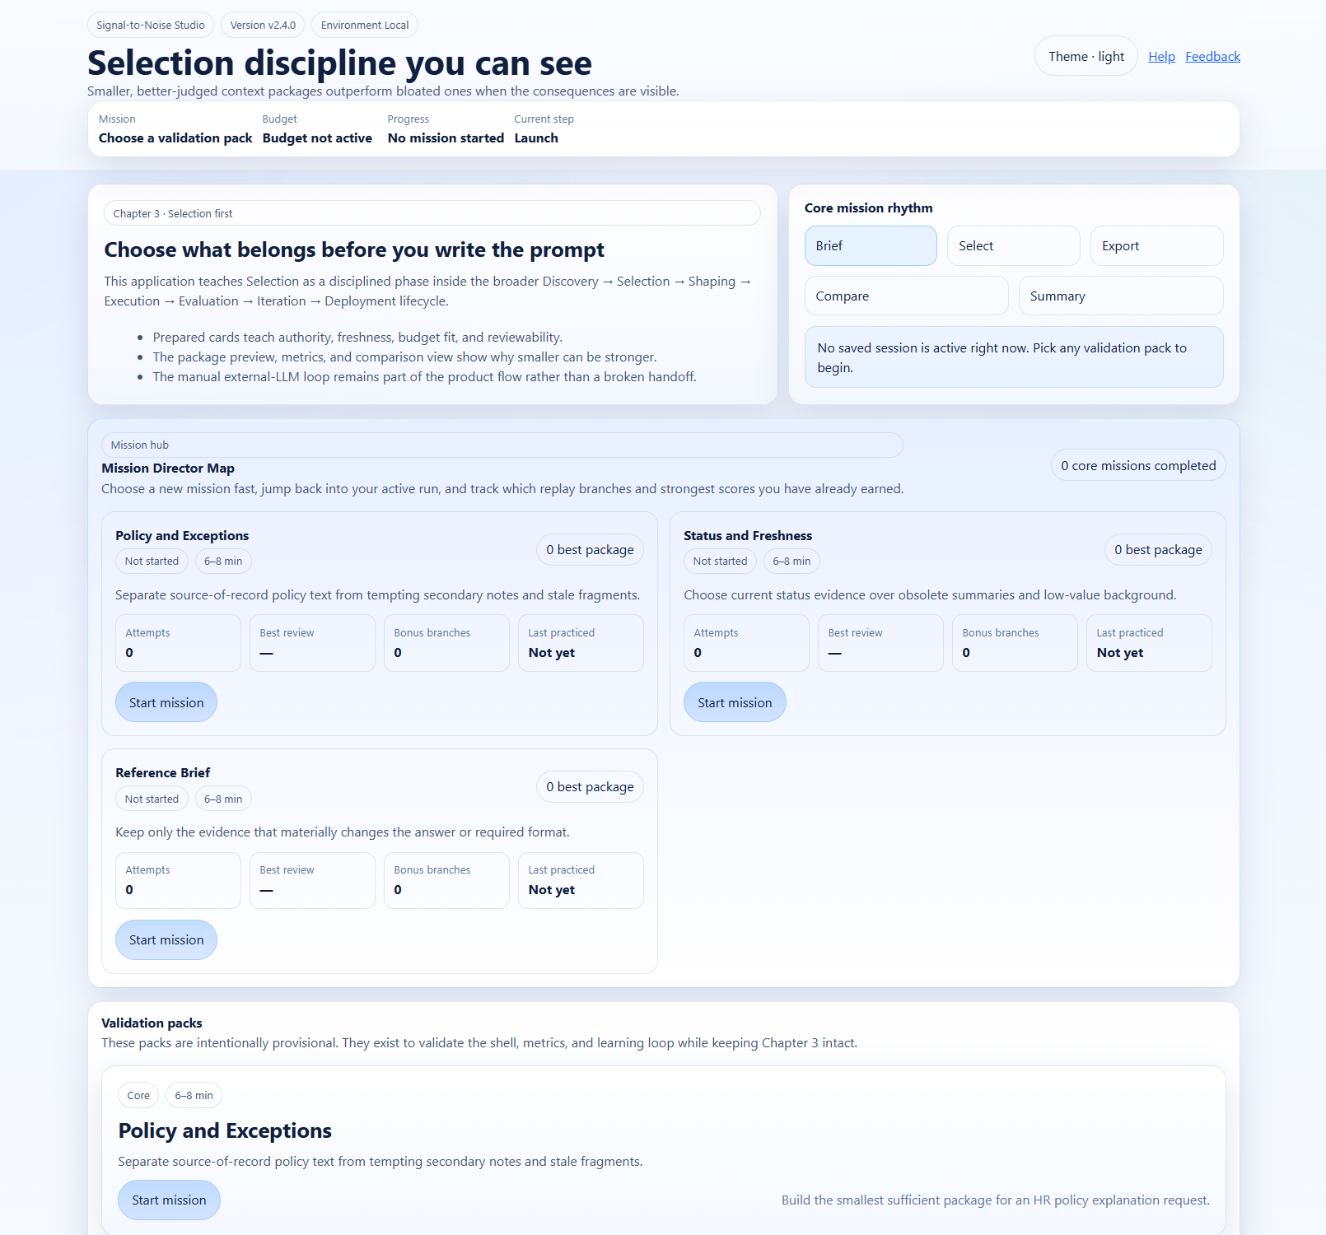
Figure 1. The launch experience combines mission selection, step rhythm, saved-session awareness, and the Mission Director Map.

You should be able to use this guide to:
- choose a validation pack that matches the lesson you want to practice
- understand the six-part product flow and the five core mission steps that follow launch
- classify source cards more deliberately instead of defaulting to "include"
- use the package preview, metrics, and coaching panels as learning tools
- run the external LLM handoff correctly and paste the answer back into the app
- interpret comparison, rubric review, and Answer X-Ray results with the right level of caution
- resume, restart, or replay a mission without losing the learning objective

1. Start here: what Signal-to-Noise Studio teaches
Signal-to-Noise Studio is a static learning application built to practice Selection discipline inside the broader context engineering lifecycle. Instead of asking you to write a prompt from a blank page, it gives you prepared evidence cards and asks you to make reviewable choices about what belongs in the package now, what should be summarized, what should be kept for later, and what should be left out.
The app is teaching one core idea: smaller can be stronger when the package stays sufficient, current, and easy to defend. Stronger results do not come from throwing in every available fragment. They come from selecting the material that materially changes the answer, preserves the right constraints, and stays traceable when the answer is reviewed later.
A useful mindset is to treat each mission like a short lab. Your goal is not to click through every control as quickly as possible. Your goal is to explain why a card earned its place, what tradeoff your action created, and whether the downstream answer stayed faithful to the package you built.
What good performance looks like in this app
You can explain why a source belongs in Include, Summarize, Retrieve Later, or Omit; you can run the external LLM loop cleanly; and you can use the comparison and review surfaces to name what improved, what drifted, and what to tighten next.

2. Get started and choose your first mission
Signal-to-Noise Studio is fully static. If you are opening the packaged application locally on Windows, unzip the folder, double-click start-server.bat, and open http://localhost:8000/ in your browser. If your team has already hosted the app, open the hosted URL instead.
When the app opens, start at the Mission Director Map. The launch screen shows the current mission step rhythm, mission progress, and any saved session state before you begin working inside a mission.
Validation pack | What it is teaching | Use it when…
Policy and Exceptions | Practicing source-of-record discipline for an HR carryover question. | When you want to separate approved policy text from tempting notes, training slides, or stale manager guidance.
Status and Freshness | Practicing freshness and executive-summary judgment. | When you want to choose current status evidence over obsolete summaries and low-value background.
Reference Brief | Practicing compact recommendation-package design. | When you want to keep only the evidence that materially changes the answer or required format.

A practical first mission is Policy and Exceptions because the source-of-record versus stale-fragment tradeoff is especially visible. The difference between approved policy, exception evidence, background summaries, and informal notes is easy to see, which makes the Selection lesson concrete early.
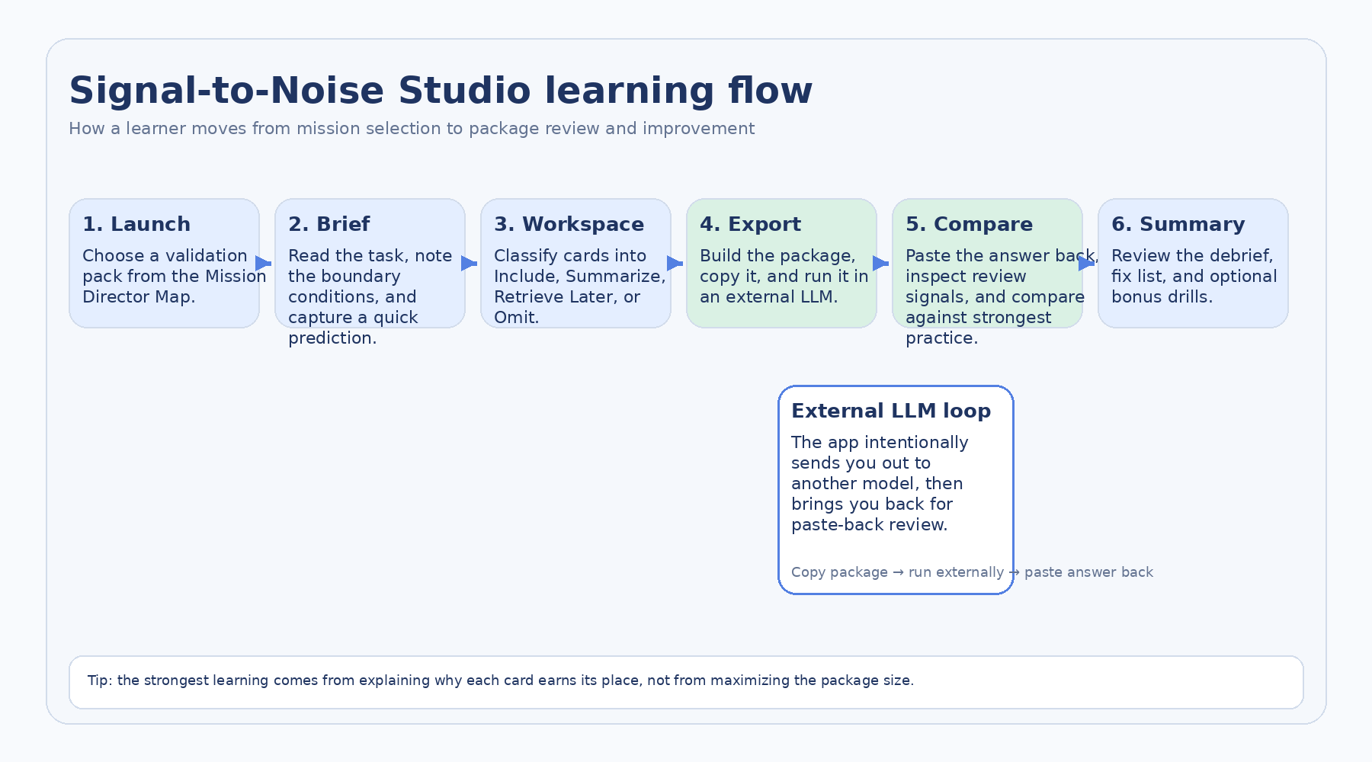
Figure 2. If you count mission selection, the product flow has six parts; once a mission starts, the step rhythm shown in the app becomes Brief → Select → Export → Compare → Summary.

3. Work the launch screen and Mission Director Map
The launch screen does more than list missions. It frames the app as a Chapter 3 Selection-first experience, shows the core mission rhythm, and tells you whether a saved session is available. Use the Mission Director Map when you want to start a new mission quickly, return to an active run, or review how many bonus branches and best scores you have already earned.
Launch-level controls  Use Mission Director Map · Start a new mission to return to the hub. Use Restart fresh when you want to clear the active run and begin again cleanly. | Saved sessions  When the app detects a saved session, it can offer Resume saved session or Clear saved run. This is useful when you leave the app to run the package in another model and come back later.

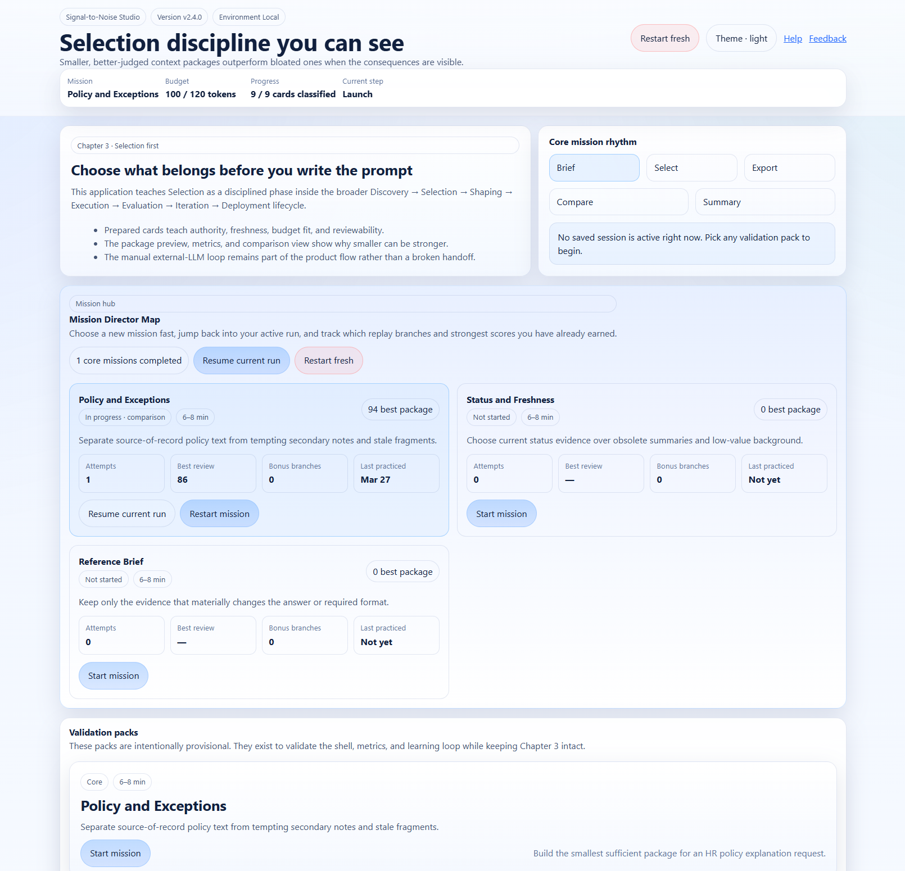
Figure 3. The Mission Director Map can show a practiced mission as in progress, expose Resume current run, and let you restart without guessing where to go next.

4. Start the mission with the Brief screen
The Brief screen defines the job before you touch any source card. It gives you the mission title, the task brief, success criteria, audience, why the task matters, and the dynamic facts that should shape the package. This is the app’s way of forcing Discovery discipline before Selection decisions begin.
The Quick prediction box matters more than it looks. It helps you surface your first instinct about what seems important before you start classifying cards. That makes later review more useful because you can compare your first instinct with the package you actually built.
- Read the mission brief all the way through before looking for "good" cards.
- Use success criteria to judge what is essential versus merely interesting.
- Treat dynamic facts as part of the operating context, not as optional background.
- Write a quick prediction in plain language. It does not need to be perfect to be useful.
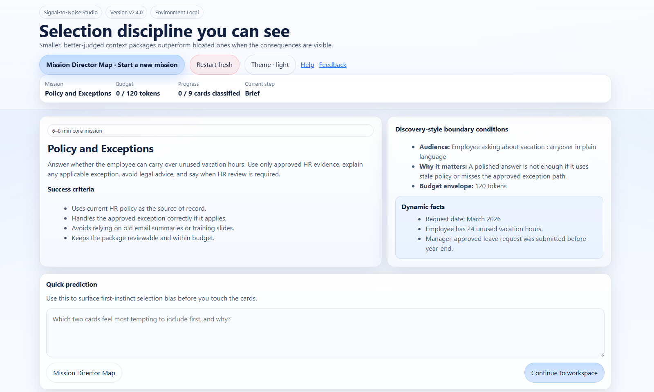
Figure 4. The Brief screen establishes the task, success criteria, boundary conditions, dynamic facts, and a quick prediction before classification begins.

5. Use the Selection workspace deliberately
The Selection workspace is the core of the app. On the left, you review candidate source cards. Below that, you see the curation lanes. On the right, the side rail keeps live metrics, package charts, risk cues, mastery signals, the package preview, coaching, and review readiness in view while you work.
This screen is designed to make consequences visible. Every meaningful action should change at least one of the following: the package composition, the budget state, the coaching, the review-readiness surface, or the downstream answer quality once you test the package externally.
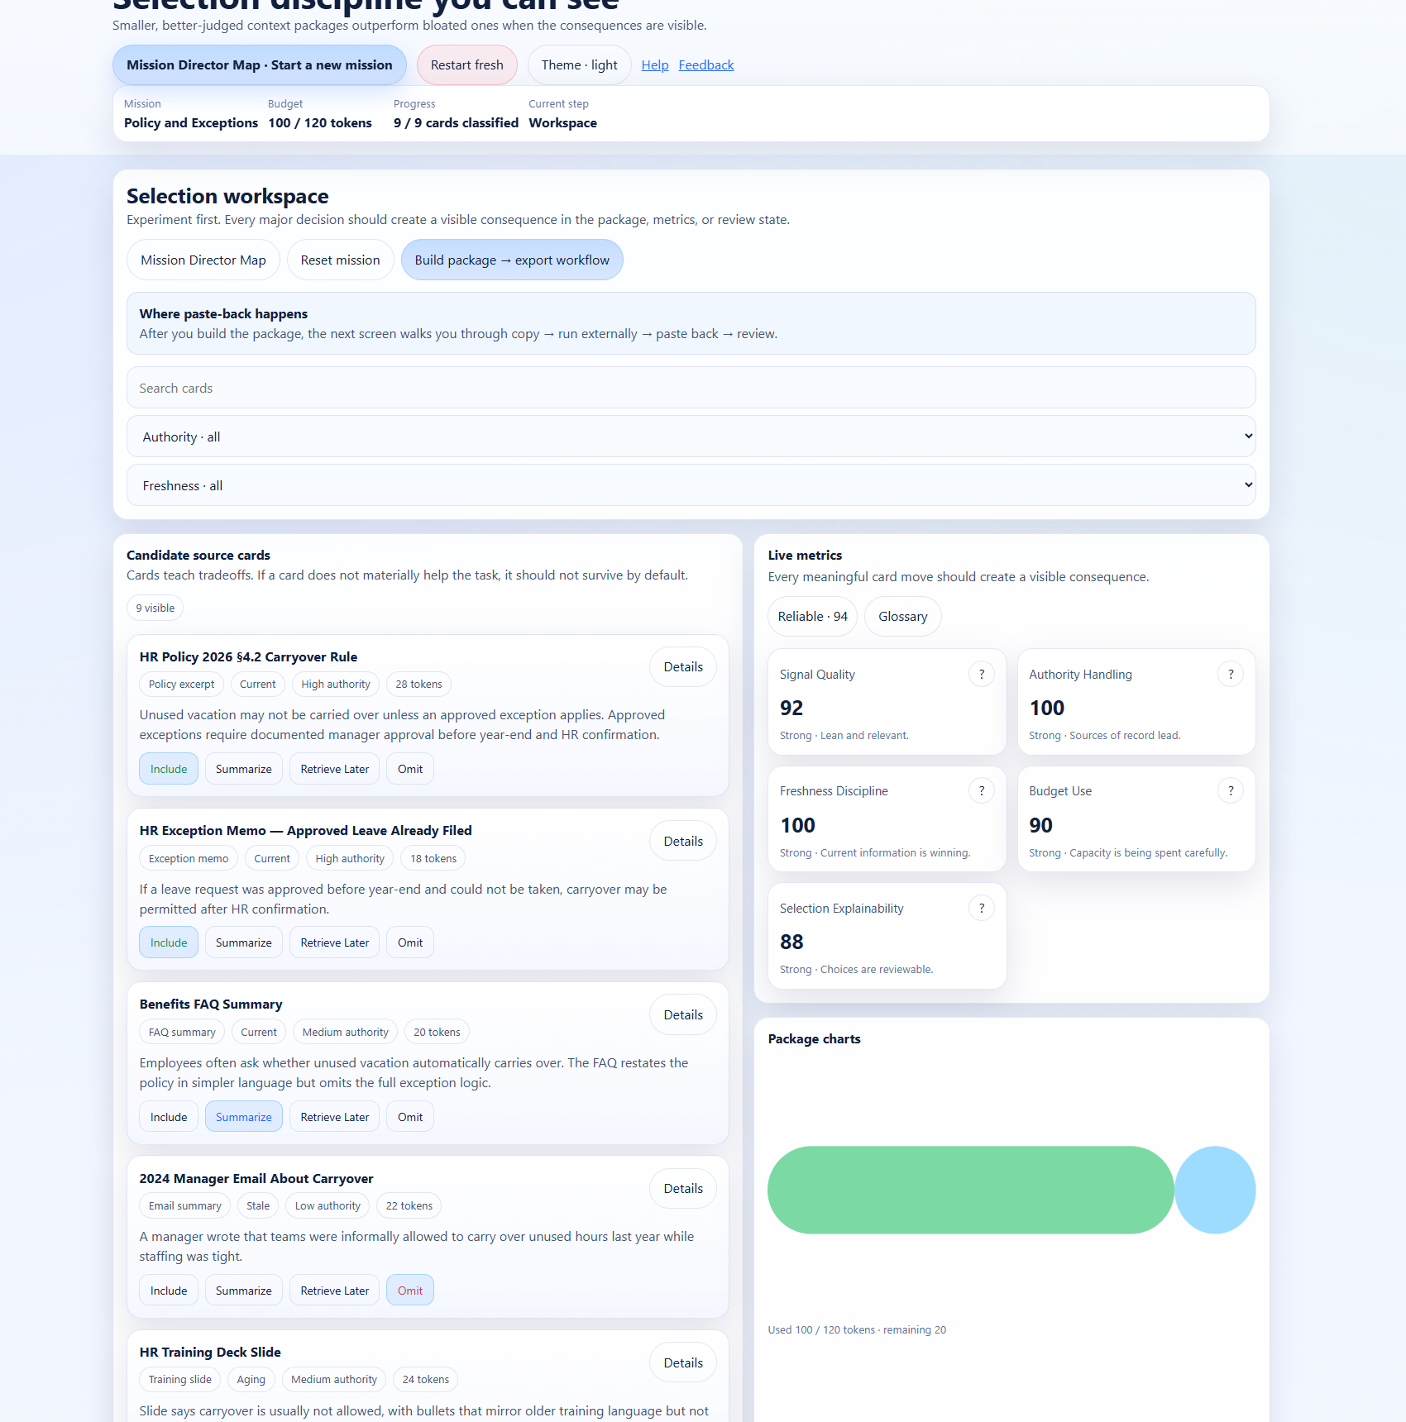
Figure 5. The workspace brings candidate cards, action buttons, filters, live metrics, package charts, and coaching into one working surface.

5.1 Classify source cards
Each card tells you what kind of source it is, how recent it is, how authoritative it is, and how many tokens it will cost if it enters the package directly. That metadata is there to support judgment, not to make the decision for you. A current high-authority card can still be better in Summarize or Retrieve Later if it does not deserve full space in the core package.
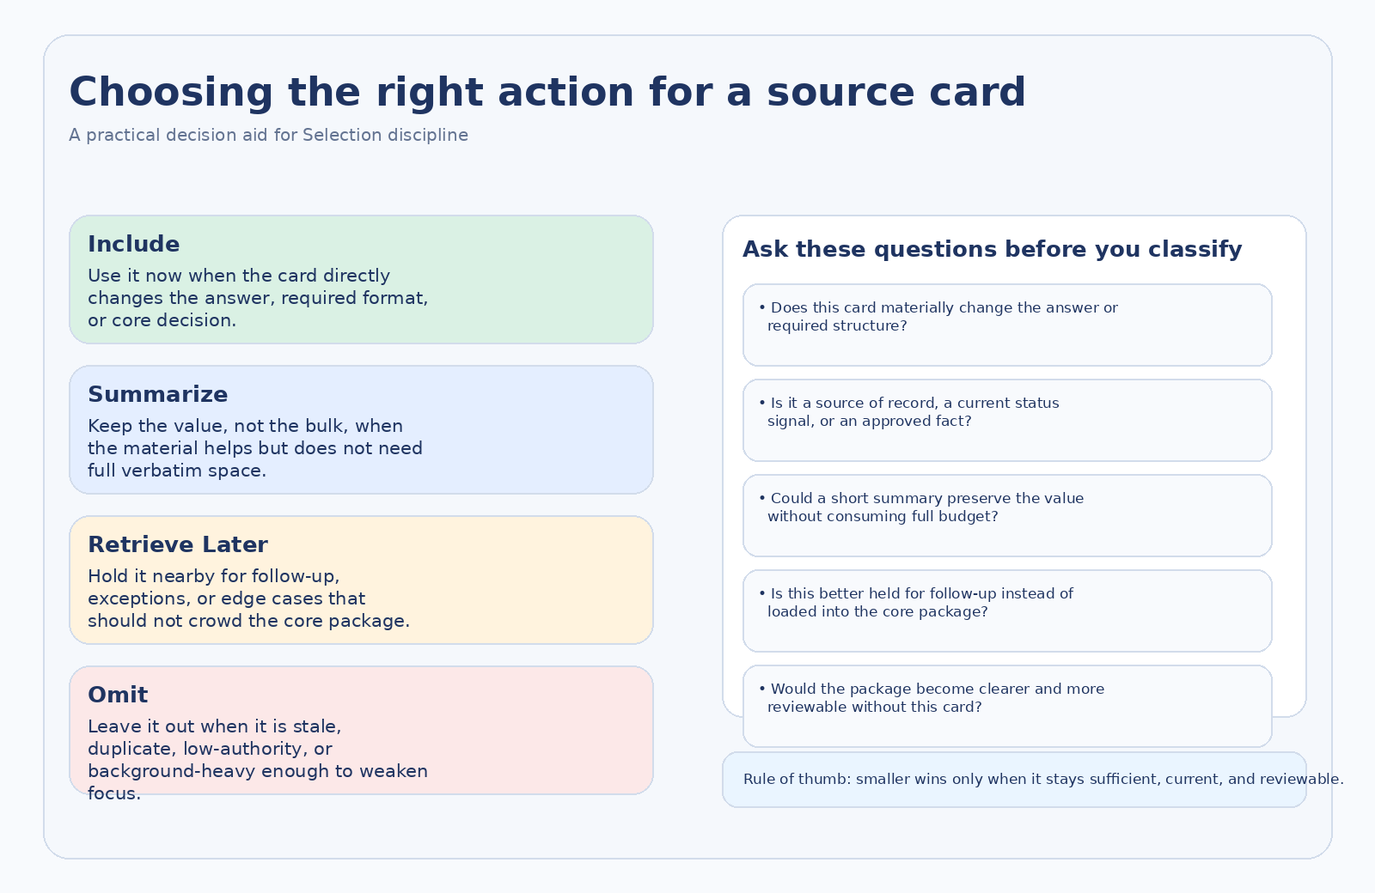
Figure 6. The four actions are different ways of preserving or refusing value. Use them as tradeoff decisions, not as severity labels.

5.2 Use the four curation lanes
The four lanes represent four different relationships to the package. Include is for answer-shaping material that deserves direct space now. Summarize is for information that still matters, but does not need to stay verbatim. Retrieve Later keeps follow-up or edge-case material available without crowding the core package. Omit removes material that weakens focus through staleness, duplication, low authority, or poor relevance.
On phones and tablets, the easiest flow is usually tap-to-classify rather than drag-and-drop. The app was built so every primary action is available as a button. That matters when you are moving quickly or working in a touch interface.
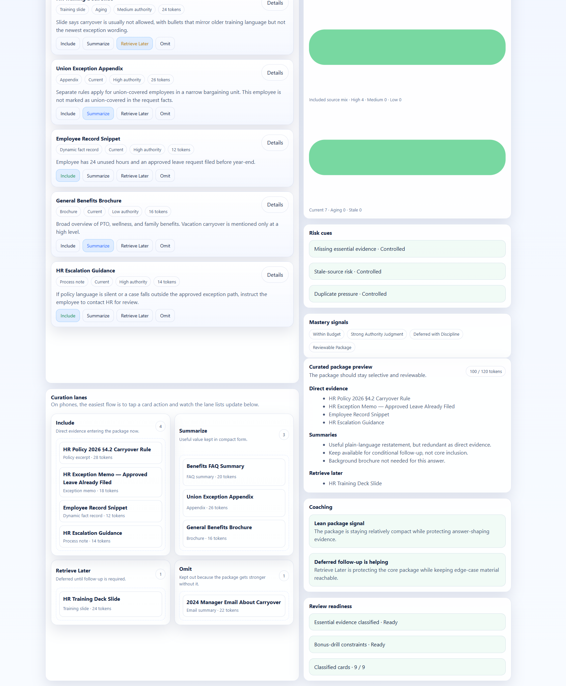
Figure 7. The lower workspace makes the current package legible by lane and pairs it with preview, coaching, and readiness guidance.

5.3 Read the side rail as a teaching tool
Metric | How to interpret it
Signal Quality | Whether the package is becoming leaner, more relevant, and more task-focused.
Authority Handling | Whether sources of record are leading instead of being displaced by weaker commentary.
Freshness Discipline | Whether current information is winning over stale but believable material.
Budget Use | Whether capacity is being spent carefully rather than through under-support or overload.
Selection Explainability | Whether the package choices are reviewable, reusable, and easy to defend later.

Use the category scores and the composite tier as directional coaching, not as a final judgment on quality. The app can show whether your package is trending toward a leaner, fresher, more defensible state, but it still needs your judgment about the task itself.
The Risk cues section helps you spot three common failure patterns: missing essential evidence, stale-source risk, and duplicate pressure. When those are controlled, your package is usually becoming easier to trust and easier to review later.
Best practice
Check the side rail after each meaningful action cluster, not after every tiny click. The goal is to connect decisions to visible consequences without turning the mission into score chasing.

6. Build the package and use the external LLM loop
When the package is review-ready, Build package → export workflow takes you to the Export screen. This is where the app deliberately sends you out to another model and then brings you back for paste-back review. That handoff is not a broken step. It is part of the learning design.
Use Copy package for external LLM to copy the curated package exactly as the app built it. Then run that package in ChatGPT or another external LLM, keeping the package intact. After the model answers, paste the answer back into the textarea labeled Paste the external answer back here.
- Copy the package exactly instead of rewriting it from memory.
- Keep the full answer when you paste it back; partial paste-backs weaken the review.
- Use the answer as evidence. You are testing the package you built, not the model in the abstract.
Where the paste-back step lives
Paste-back is part of the Export screen. It is not a separate app mode. The screen itself walks you through copy → run externally → paste back → review impact.

7. Read comparison, review, and Answer X-Ray carefully
After you paste the answer back, Review impact moves you into the Comparison and debrief stage. This screen keeps the strongest-practice comparison, the review summary, and the observed output note together so you can judge both the package choices and their downstream consequences.
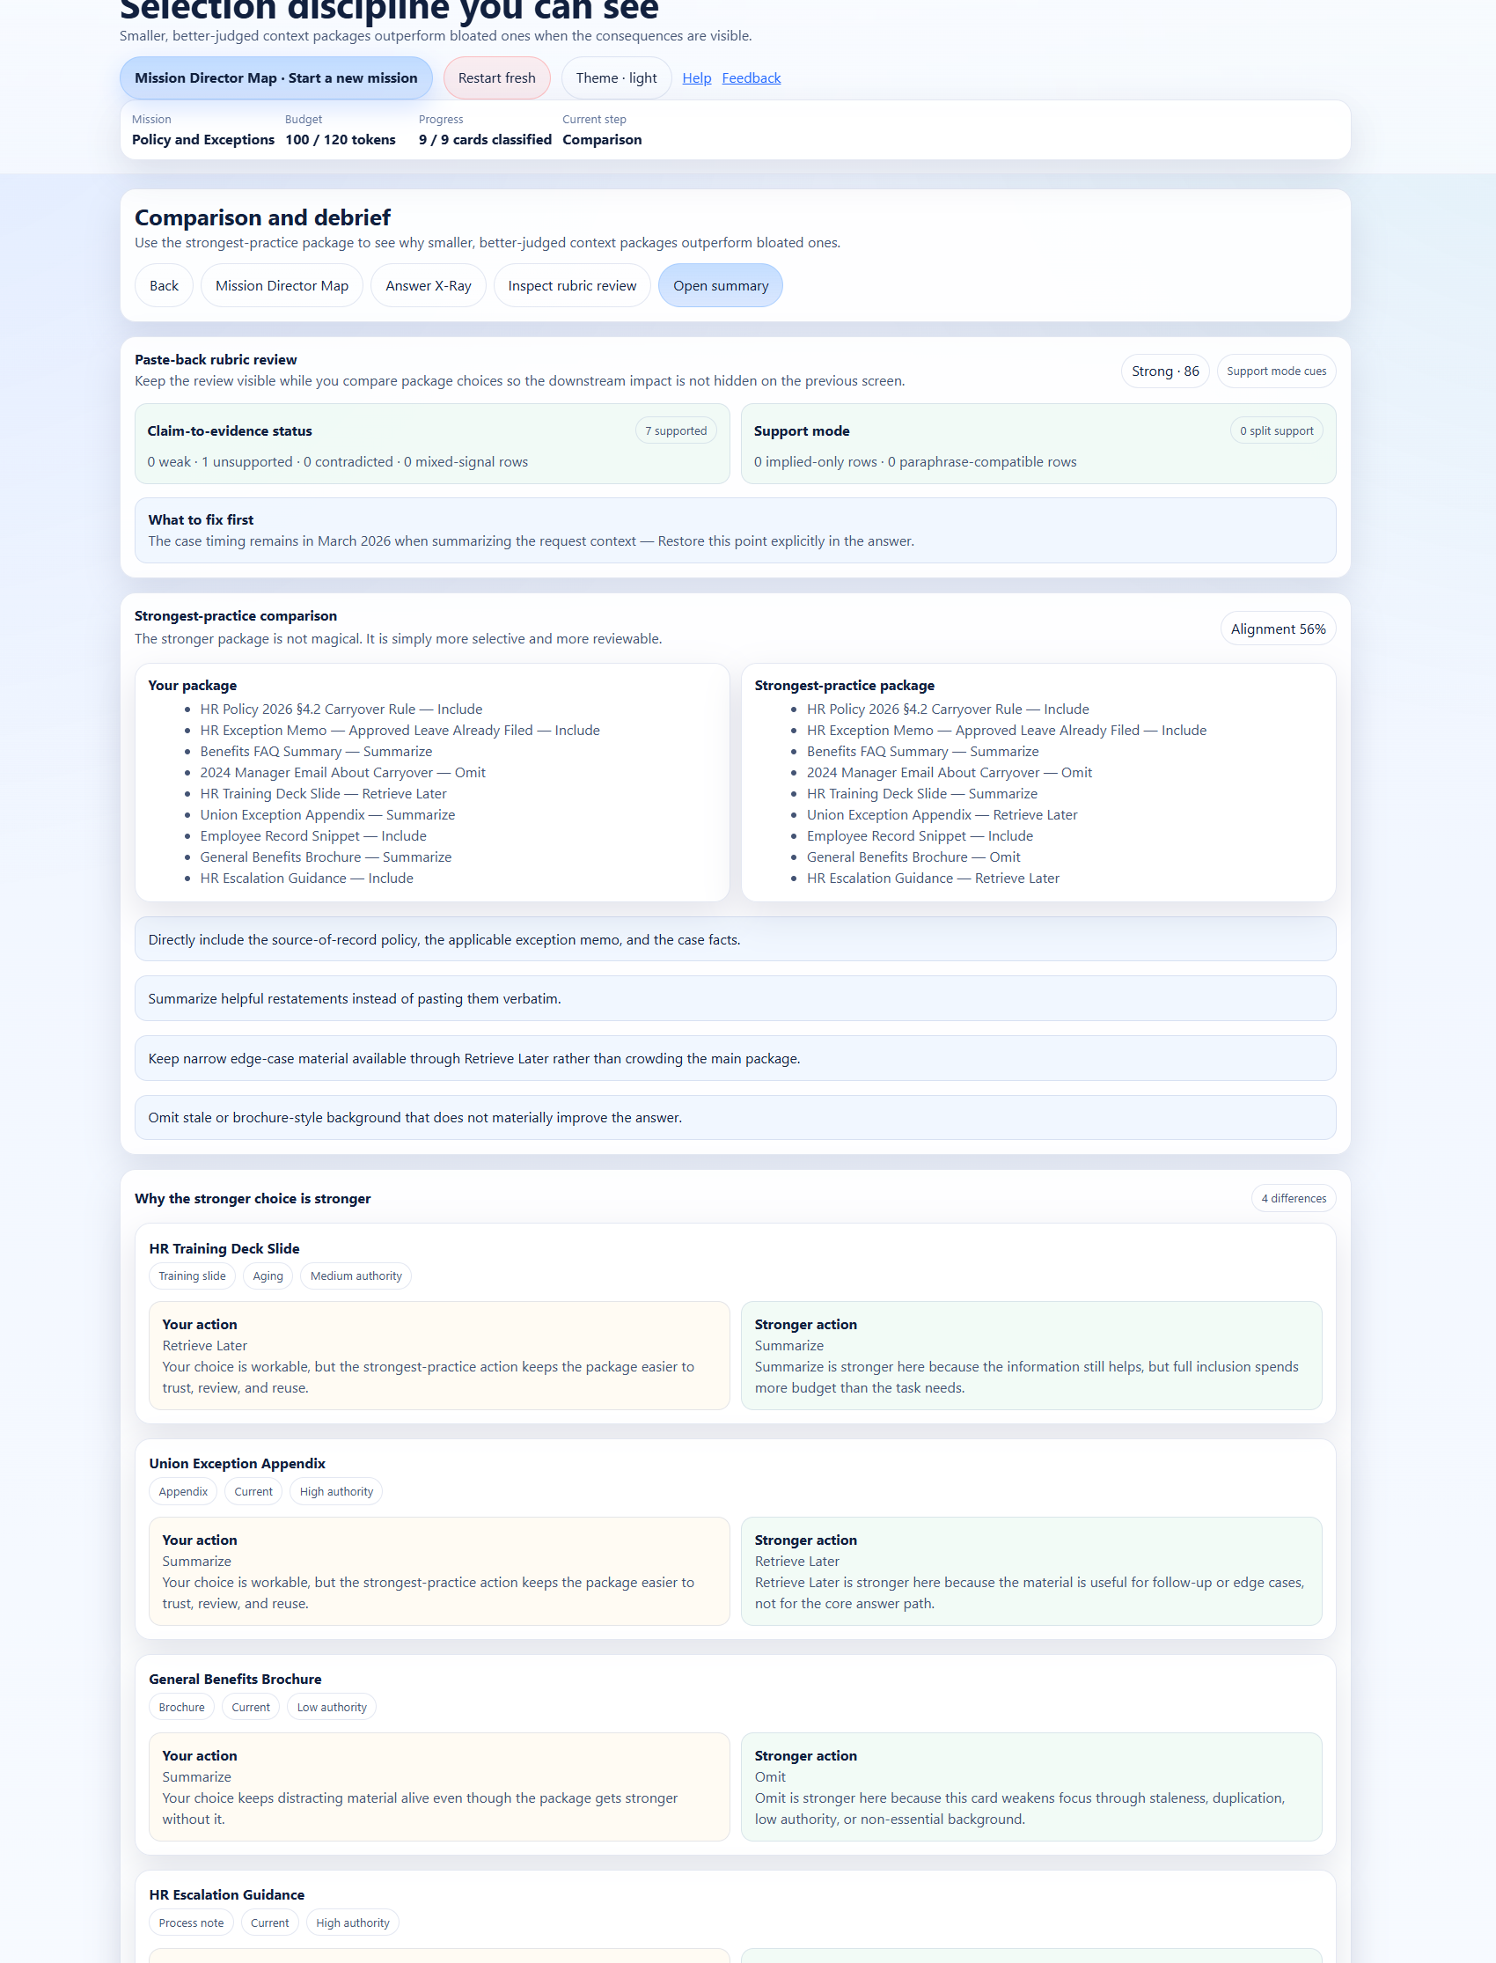
Figure 8. Comparison and debrief keeps the strongest-practice package, difference explanations, and paste-back review context together on one screen.

7.1 What strongest-practice comparison is for
The strongest-practice package is a teaching reference, not a claim that there is only one defensible answer. Use it to see why a smaller, better-judged package is stronger for this mission. The most valuable part of the comparison is usually the explanation under Why the stronger choice is stronger, because that is where the app connects your action to a specific risk and a better alternative.

7.2 What detailed review is for
Open detailed review when you want to inspect more than the summary line. The review surface is designed to show structure detection, evidence carry-through, source traceability, claim-to-evidence status, and rubric dimensions such as requested structure, mission evidence coverage, grounding discipline, uncertainty handling, and concision and reviewability.
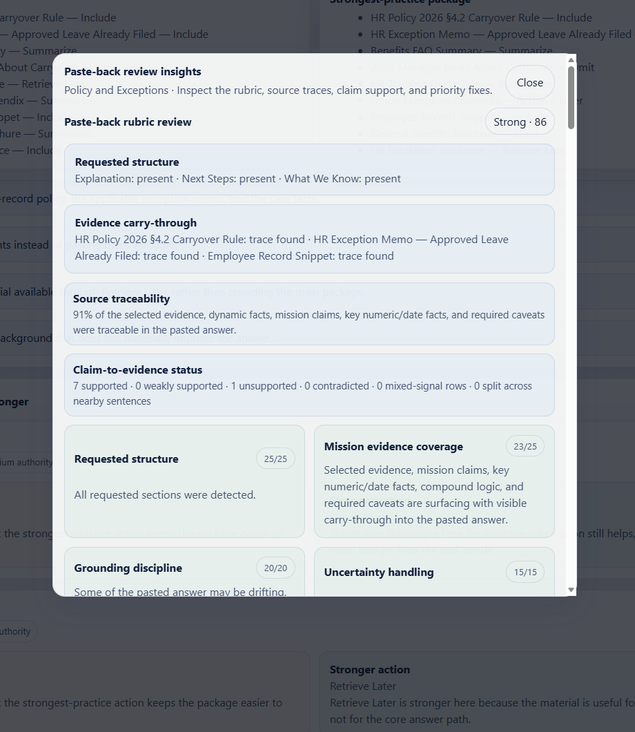
Figure 9. The detailed review modal exposes rubric-level feedback, source traces, and claim alignment so the downstream answer is easier to audit.

7.3 What Answer X-Ray is for
Answer X-Ray reads the pasted answer sentence by sentence and marks regions as supported, watch, contradicted, hard to trace, or neutral. This is one of the app’s most useful teaching surfaces because it lets you see exactly where the handoff stayed grounded and where it drifted.
Use Answer X-Ray to inspect the answer as evidence. Supported regions show where the package carried through cleanly. Watch regions deserve closer reading. Contradicted and hard-to-trace regions are the ones that most often require a package fix or a clearer answer rewrite.
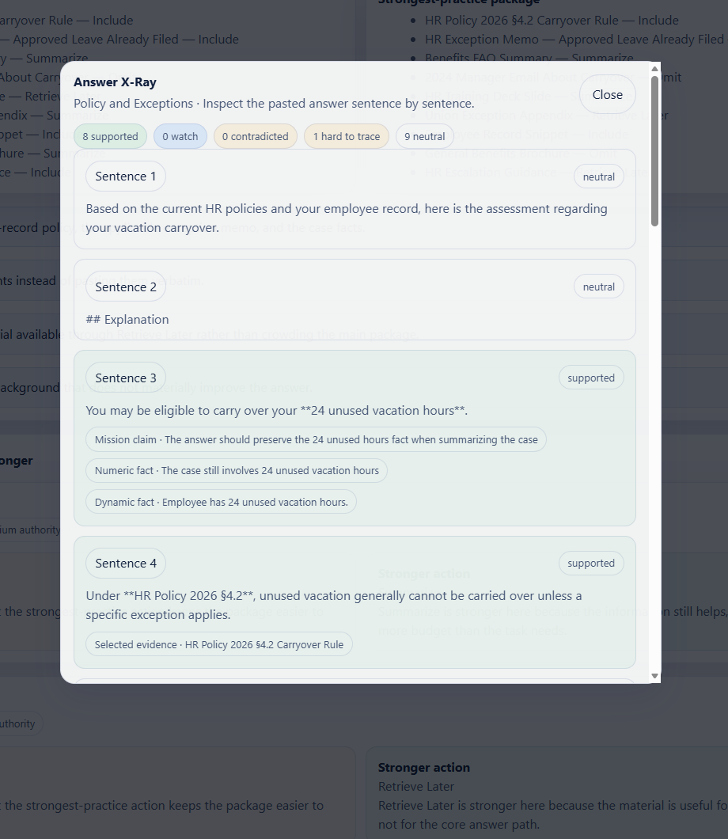
Figure 10. Answer X-Ray separates supported, watch, contradicted, hard-to-trace, and neutral regions so you can read the answer like an audit trail.
Important limitation
The review surfaces are teaching aids. They can surface likely structure carry-through, claim support, contradictions, stale reasoning, and hard-to-trace sentences, but they do not replace human judgment, policy review, or subject-matter approval.

8. Use the Run summary and bonus drills
Open summary when you want the mission-level wrap-up. The Run summary keeps the category scores together, gives you a short debrief, and offers bonus exploration without invalidating core completion. In the uploaded app, the bonus drills shown in the summary include a Stricter Budget Replay and an Authority vs Freshness Drill.
This screen is useful because it turns the mission into an explicit lesson. The debrief can carry forward your quick prediction note, a best next move, bonus-drill status, and a fix list drawn from the paste-back review.
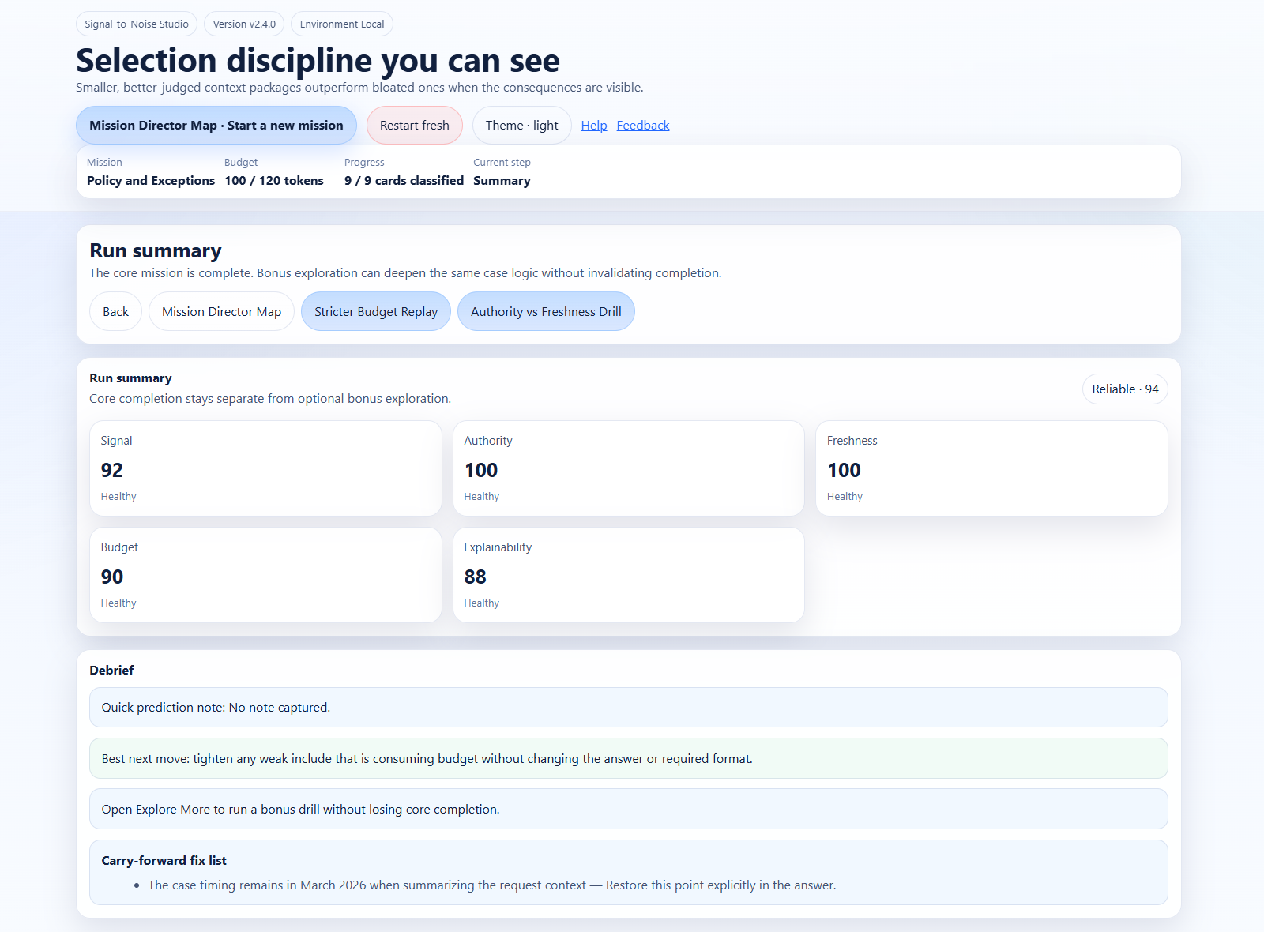
Figure 11. The summary screen separates core completion from optional bonus exploration and surfaces a focused carry-forward fix list.
- Use Stricter Budget Replay when you want to test whether your current package is still strong after the budget tightens.
- Use Authority vs Freshness Drill when you want to practice resisting comfortable but weaker commentary when stronger current evidence is available.
- Use the carry-forward fix list as your next-run checklist rather than as a score explanation.

9. Resume, restart, and persistence behavior
Signal-to-Noise Studio remembers mission state locally in the browser. That makes it practical to leave the app for the external LLM step and return without losing your place. Theme preference is also stored locally.
Control | What it does
Resume saved session | Use it from launch when the app finds a saved run and you want to reopen the last mission.
Resume current run | Use it from the Mission Director Map when a mission is active and you want to return to the last active stage.
Restart fresh | Use it when you want a clean run rather than continuing the saved state.
Restart mission / Start fresh run | Use it from a mission card when you want to replay that mission from the beginning.
Clear saved run | Use it if the app offers a saved-session notice and you want to discard that state.

This matters for end users because the external loop can interrupt the flow. A resumable mission reduces friction and keeps the handoff from feeling like lost work.

10. Tips and best practices
- Use the Brief screen to slow down before classifying cards. A cleaner first read usually produces a cleaner package.
- Do not treat Include as the default. The app is specifically training you to preserve value without overloading the package.
- Treat Summarize and Retrieve Later as positive actions, not as fallback actions.
- Keep an eye on stale but polished materials. They often feel safe while quietly weakening the package.
- Use the strongest-practice comparison to learn principles, not to memorize one fixed answer.
- When the review shows a hard-to-trace sentence, fix the package or the answer so the connection becomes more explicit.
- Repeat one mission until you can explain the difference between a compact sufficient package and an under-supported package.
A simple habit that improves learning fast
After each run, name one card you would classify differently next time and explain why in one sentence. That habit turns the app from a one-time exercise into reusable judgment practice.

11. Troubleshooting and frequently asked questions
Question | Answer
I am not sure which mission to start with. | Start with Policy and Exceptions if you want the clearest first example of source-of-record selection.
The Build package button is unavailable. | Keep classifying cards until the package is review-ready. Use the readiness panel on the right to see what is still missing.
Do I have to drag cards? | No. The app provides buttons for every primary action, and tap-to-classify is usually easiest on mobile.
Can I continue without pasting an answer back? | Yes, but the review and learning surfaces are much stronger when you complete the paste-back step.
The review says a sentence is hard to trace. | That usually means the answer drifted beyond the selected package or the package did not make the point explicit enough.
What should I do when strongest-practice differs from my package? | Read the difference explanation first. The goal is to understand the tradeoff, not just to copy the reference state.
Why are the screenshots showing v2.4.0 while the package says v2.3.0? | That is a source discrepancy in the uploaded materials. This guide uses the screenshots for visible labels and the packaged app files for feature behavior.

12. Glossary
Term | Definition
Context package | The full operating input for a task: task, rules, evidence, dynamic facts, and output expectations.
Token budget | The practical limit on how much text can be included before focus and reliability degrade.
Signal-to-noise ratio | A judgment about whether included text materially helps the answer or merely competes for attention.
Authority | How trustworthy a source is relative to other available sources.
Freshness | Whether a source is current enough for the task being performed.
Retrieve Later | Keep the material available for conditional follow-up instead of loading it into the core package now.
Strongest-practice package | A disciplined, reviewable package that illustrates better selection choices for the same task.

13. Quick reference
Stage | What to do
Launch | Choose a validation pack, review saved-session status, and start or resume a mission.
Brief | Read the task, boundary conditions, dynamic facts, and success criteria. Add a quick prediction.
Workspace | Classify cards into Include, Summarize, Retrieve Later, or Omit. Watch metrics and coaching.
Export | Copy the package, run it in an external LLM, then paste the answer back into the review box.
Comparison | Compare your package against strongest practice and inspect review surfaces.
Summary | Review the debrief, fix list, and optional bonus drills.

Final takeaway
Signal-to-Noise Studio teaches an important operational truth: the answer is limited by the package the model receives. When the package is stale, overloaded, or weakly justified, the answer is more likely to drift. When the package is selective, current, and reviewable, the answer becomes easier to trust and easier to improve.
Recommended next step
Run one mission again and change only one or two classifications on purpose. Then use Comparison, detailed review, and Answer X-Ray to explain what changed and why.

