CHAPTER 2 LEARNING APP
Mastering Your First Mission
A step-by-step guide to the Lifecycle Failure Clinic
An updated, learner-focused edition built from the current Word guide, the supporting prep visuals, and the chapter PDF.
Guide focus  Onboarding + first mission + Discovery | Primary audience  First-time learners | Document type  End-user learning guide
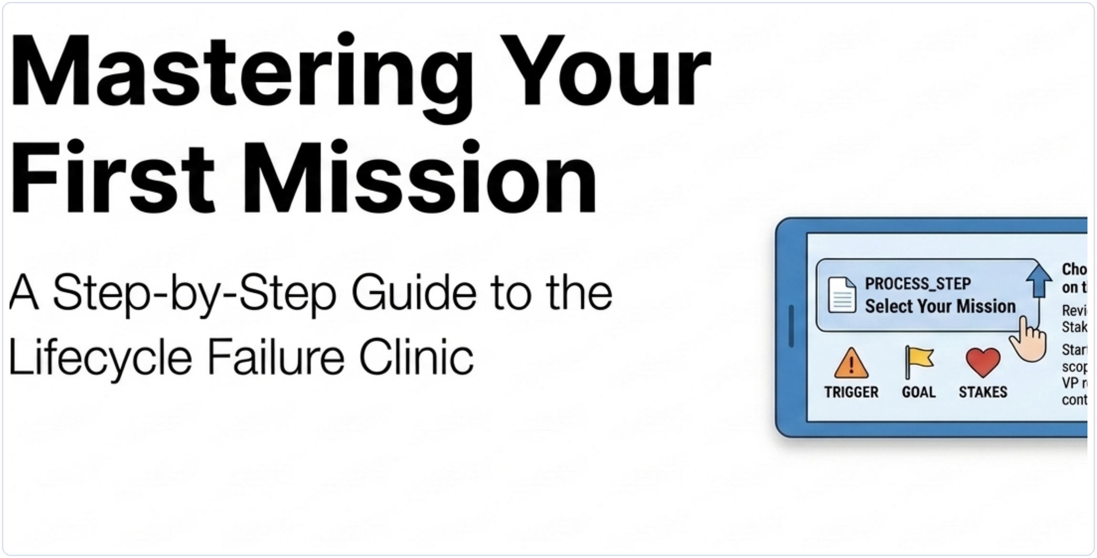
Figure 1. Cover panel adapted from the chapter PDF and paired with the current app guide.
What this guide helps you do
Complete a meaningful first run, understand why each screen exists, and leave with a stronger mental model of how the clinic teaches the Context Engineering Lifecycle.

1. What the application is
Lifecycle Failure Clinic teaches the Context Engineering Lifecycle through realistic enterprise failures rather than abstract definitions alone. Instead of reading about artifacts in isolation, the learner enters a broken AI workflow, diagnoses what went wrong, applies one repair, sees the downstream effect, and then compares that decision to the strongest chapter-aligned answer.
The current application is intentionally structured so that one repaired mission delivers a complete educational loop: understand the problem, make a decision, observe the result, and lock in the lesson. That makes the app approachable for a first run while still giving learners the option to continue deeper if they want more practice.
What this guide covers | What the full application includes
The learner onboarding experience, the first mission path shown in the app, and Phase 1 - Discovery using the HR Policy Q&A Incident screenshots. | Seven lifecycle phases across three missions, with optional continuation after the first completed mission.
The screens, choices, evidence, feedback, and completion flow a first-time learner needs in order to succeed without getting lost. | Additional phases and repeated practice beyond this guide. Those paths are available in the app, but they are not documented here in equal detail.

Learning objectives for this guide
- Explain the purpose of the Discovery phase in the lifecycle.
- Identify the problem the first mission is trying to solve before making a choice.
- Read the evidence, observed output, and target behavior shown on screen and use them to reason about the failure.
- Choose a diagnosis and a repair that address the actual lifecycle weakness rather than the most polished-sounding option.
- Interpret the outcome, comparison, and completion screens as part of one learning loop.
- Recognize that the broader application continues through seven phases and three missions for optional deeper practice.
How to read this guide
Read the guide straight through the first time. If you return later, you can jump directly to the walkthrough page that matches the screen you are using in the app.

2. How the application is organized
The app is built around a simple two-stage flow. First, the learner chooses a case. Second, the learner works through a six-screen Mission Deck for the active lifecycle phase.
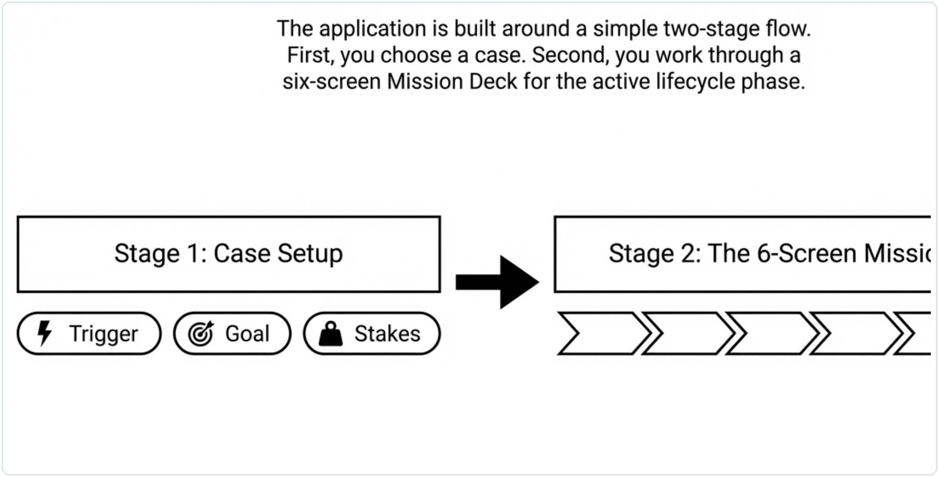
Figure 2. The two-stage model from the PDF: choose a case, then work through the six-screen mission deck.
Stage | What the learner does
Stage 1 | Case Setup. Read the mission cards, compare the trigger, goal, and stakes, and start one mission.
Stage 2 | Mission Deck. Move through six screens: Phase Setup, Diagnose, Repair, Outcome, Learn, and Complete.

The three missions visible on the start screen
Mission | Trigger | What the learner practices
HR Policy Q&A Incident | A VP receives contradictory overtime answers. | Scope discipline, approved-source grounding, escalation boundaries, and policy reliability.
Support Ticket Summarizer Incident | A sev-2 ticket is closed with the wrong handoff. | Signal preservation, urgency handling, ownership context, and operational fidelity.
Onboarding Assistant Incident | A new hire misses a required security approval. | Role-appropriate guidance, branch variation, approvals, and operational readiness.

Quick-start success rule
For a first run, choose one case, complete one full mission, study the strongest answer, and treat the completion screen as a valid stopping point. You do not need to finish every phase before you have learned something meaningful.

3. Starting the first mission
If you want to follow this guide exactly, begin with the HR Policy Q&A Incident. The current home screen below shows the three mission cards that appear before the learner enters Discovery.
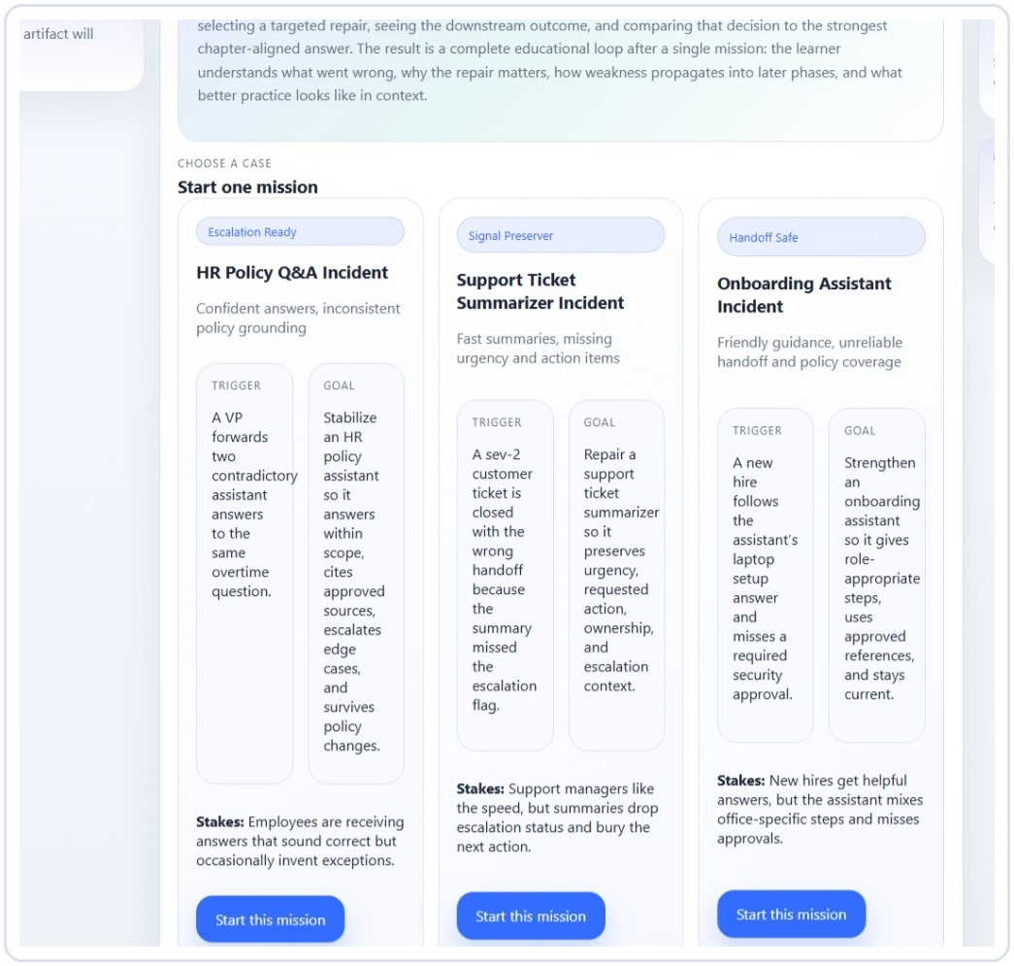
Figure 3. Mission card area cropped from prep.zip. This guide follows the HR Policy Q&A Incident path.
Use the screen this way | What to notice and do
Focus on | Read the trigger, goal, and stakes on the mission cards before clicking anything. Those three items tell you what the case is about, what success should look like, and why the failure matters.
Take this action | Select Start this mission under HR Policy Q&A Incident if you want to match the first mission path used throughout this guide.
Why this matters | The start screen is not just a menu. It frames the problem, sets expectations, and makes the later decision-making screens easier to interpret.

4. Discovery phase walkthrough
The rest of this guide stays inside Phase 1 - Discovery. In the current app, Discovery is the phase where the learner defines the problem clearly enough that later lifecycle work can be trusted. A weak Discovery brief creates hidden reliability debt for everything that follows.
4.1 Screen 1 - Phase Setup
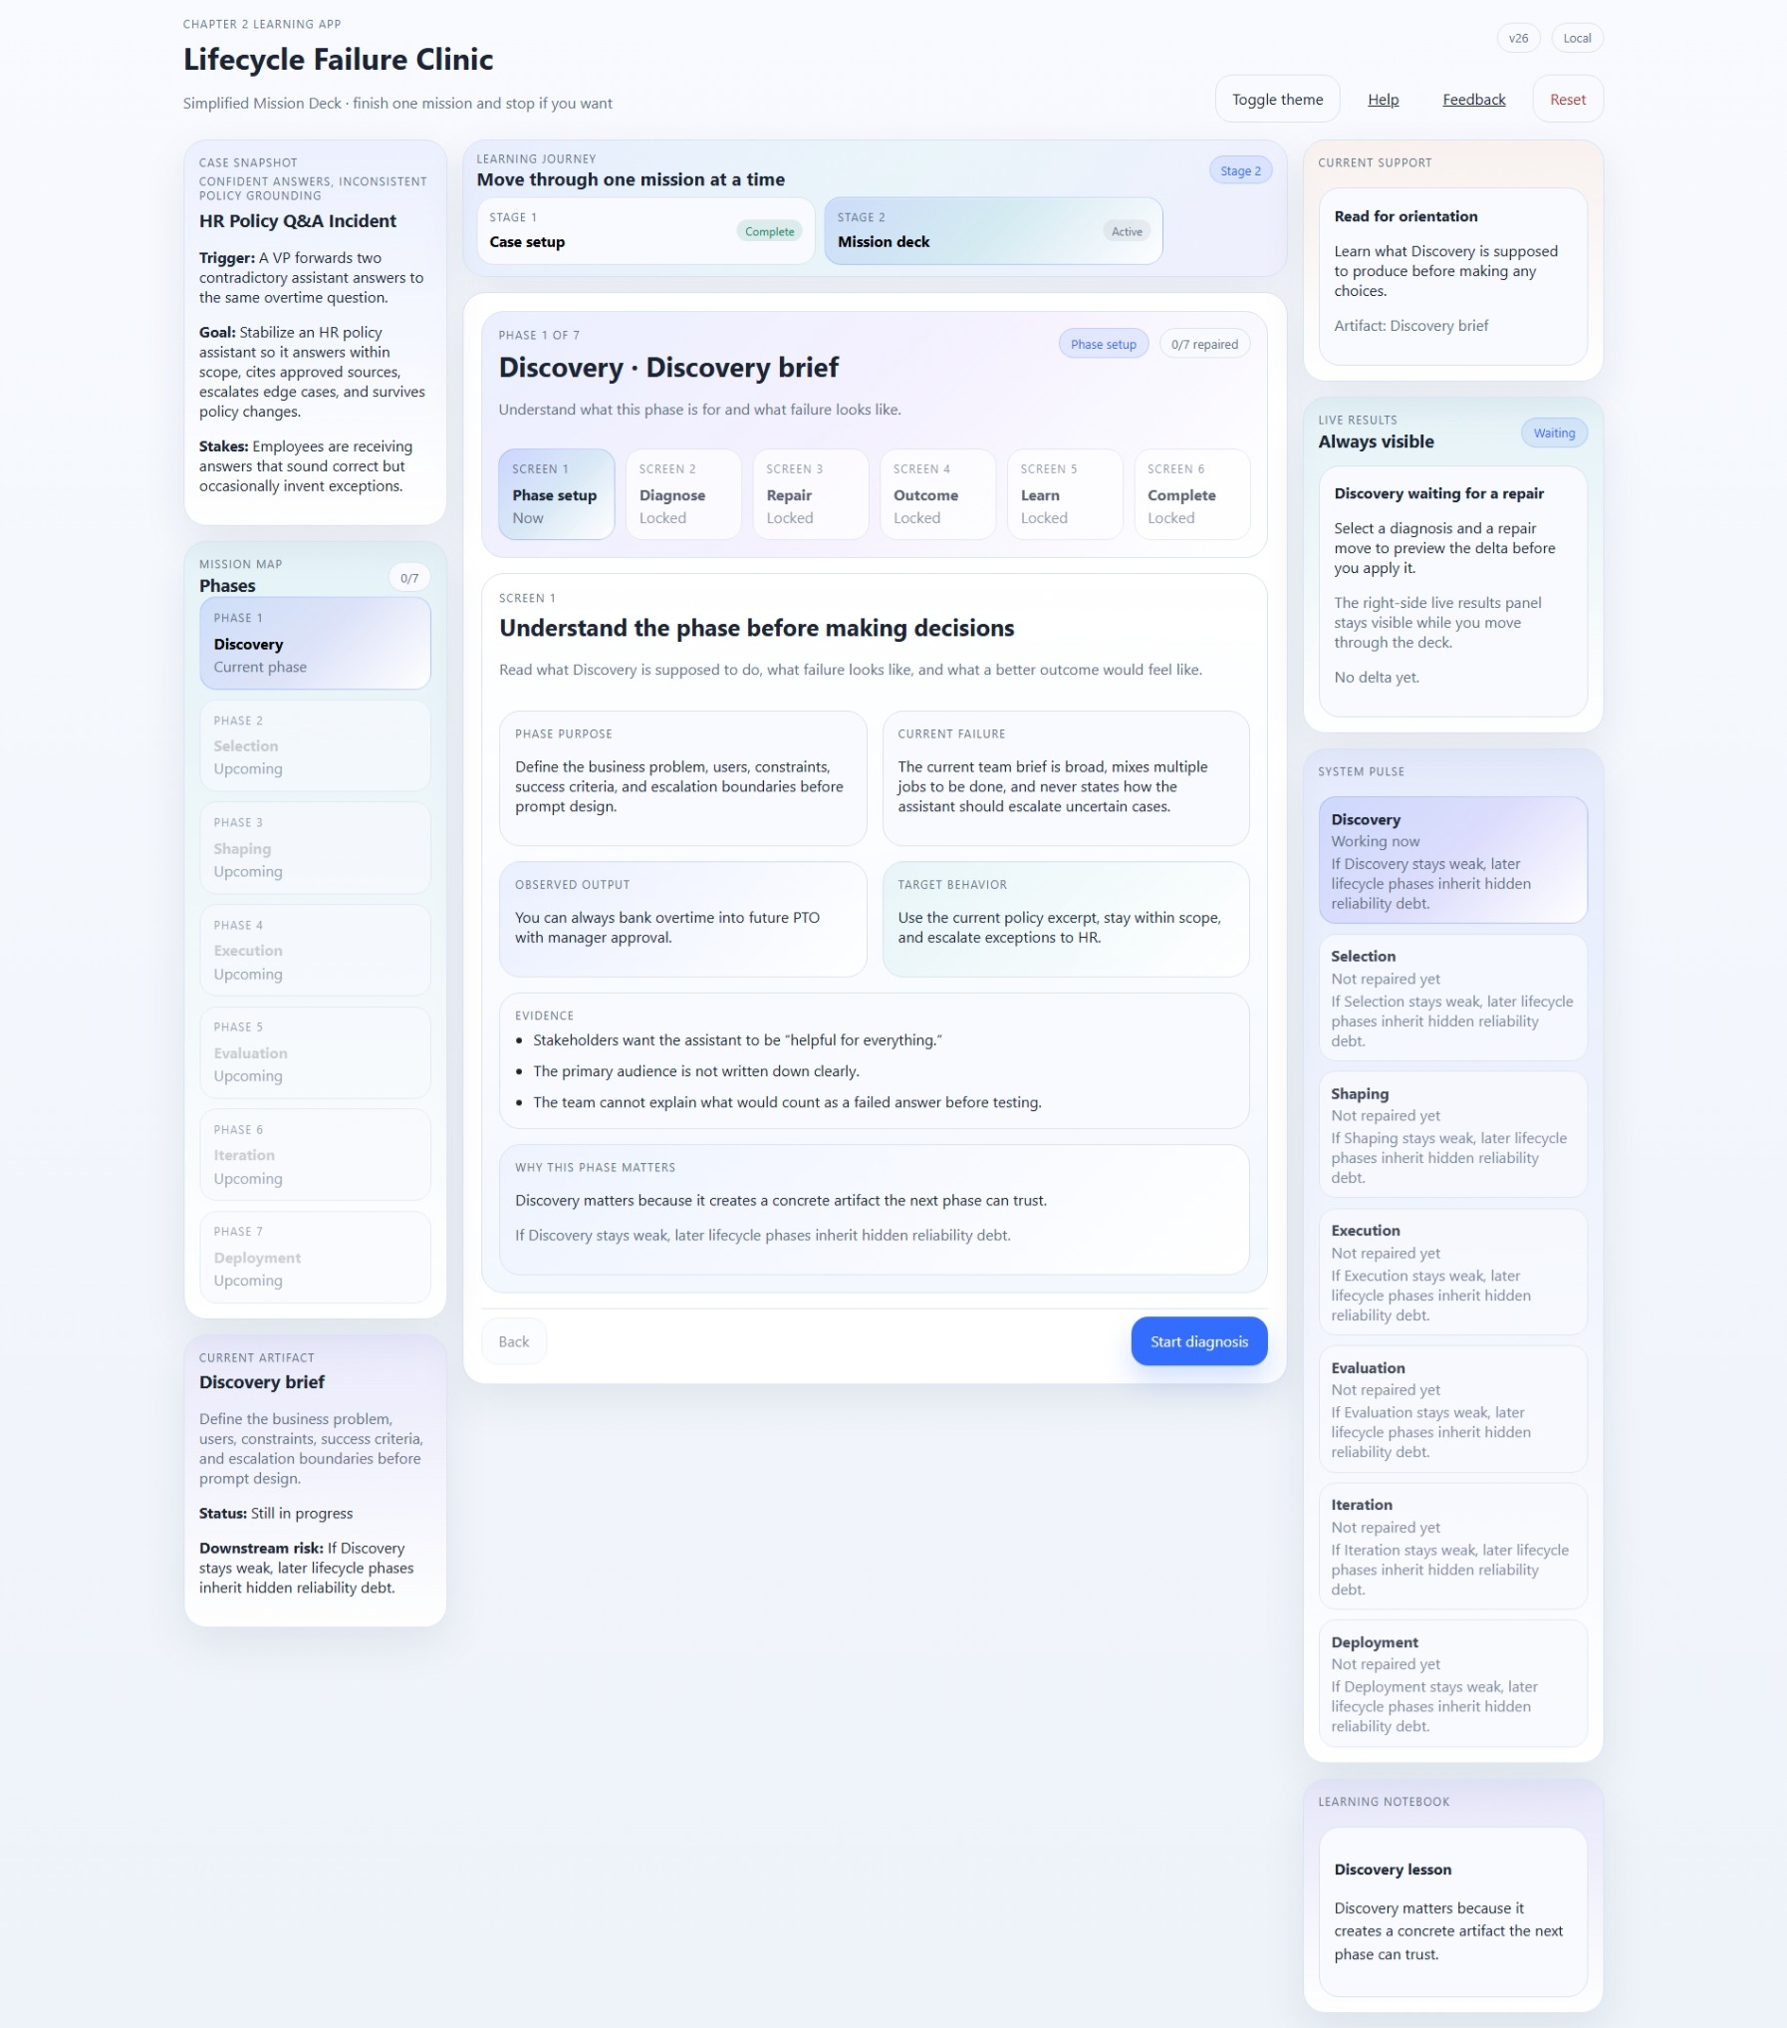
Figure 4. Discovery - Phase Setup screen from prep.zip.
Use the screen this way | What to notice and do
Focus on | The phase purpose, current failure, observed output, target behavior, evidence, and the short Why this phase matters explanation.
Take this action | Read this screen slowly before making a choice. Treat it as your briefing. Notice the difference between what the system is doing now and what a better Discovery artifact would enable.
Why this matters | This screen teaches the learner how to reason from evidence instead of guessing. It establishes the standard the rest of the mission will use.

4.2 Screen 2 - Diagnose
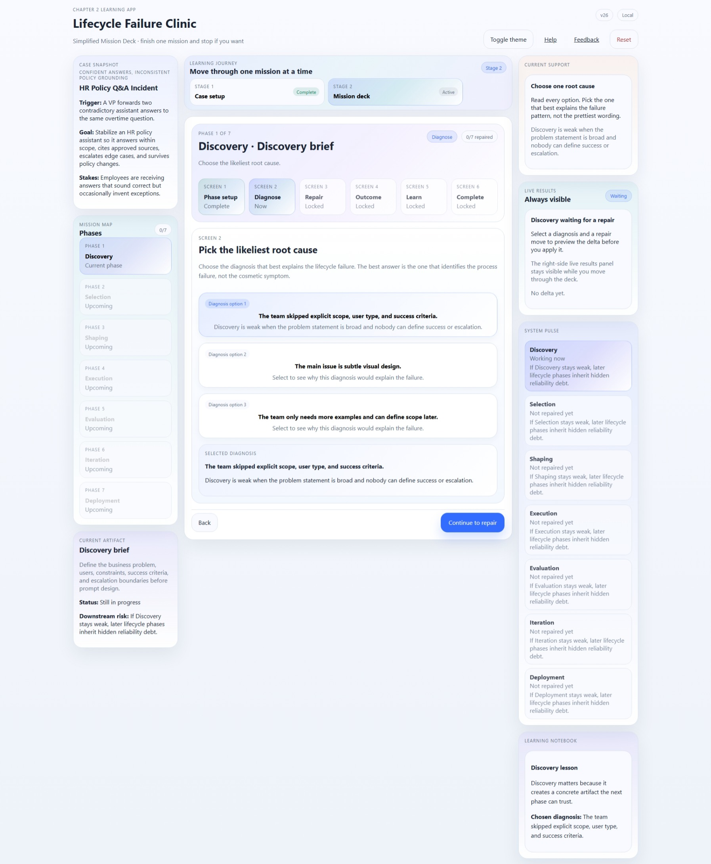
Figure 5. Discovery - Diagnose screen from prep.zip.
Use the screen this way | What to notice and do
Focus on | The diagnosis options and the selected diagnosis panel at the bottom.
Take this action | Choose the option that best explains the process failure, not the option that simply sounds polished. In this mission, the strongest diagnosis is that the team skipped explicit scope, user type, and success criteria.
Why this matters | Diagnosis is the discipline that connects symptoms to an underlying lifecycle weakness. A good diagnosis makes the repair screen much easier to use well.

4.3 Screen 3 - Repair
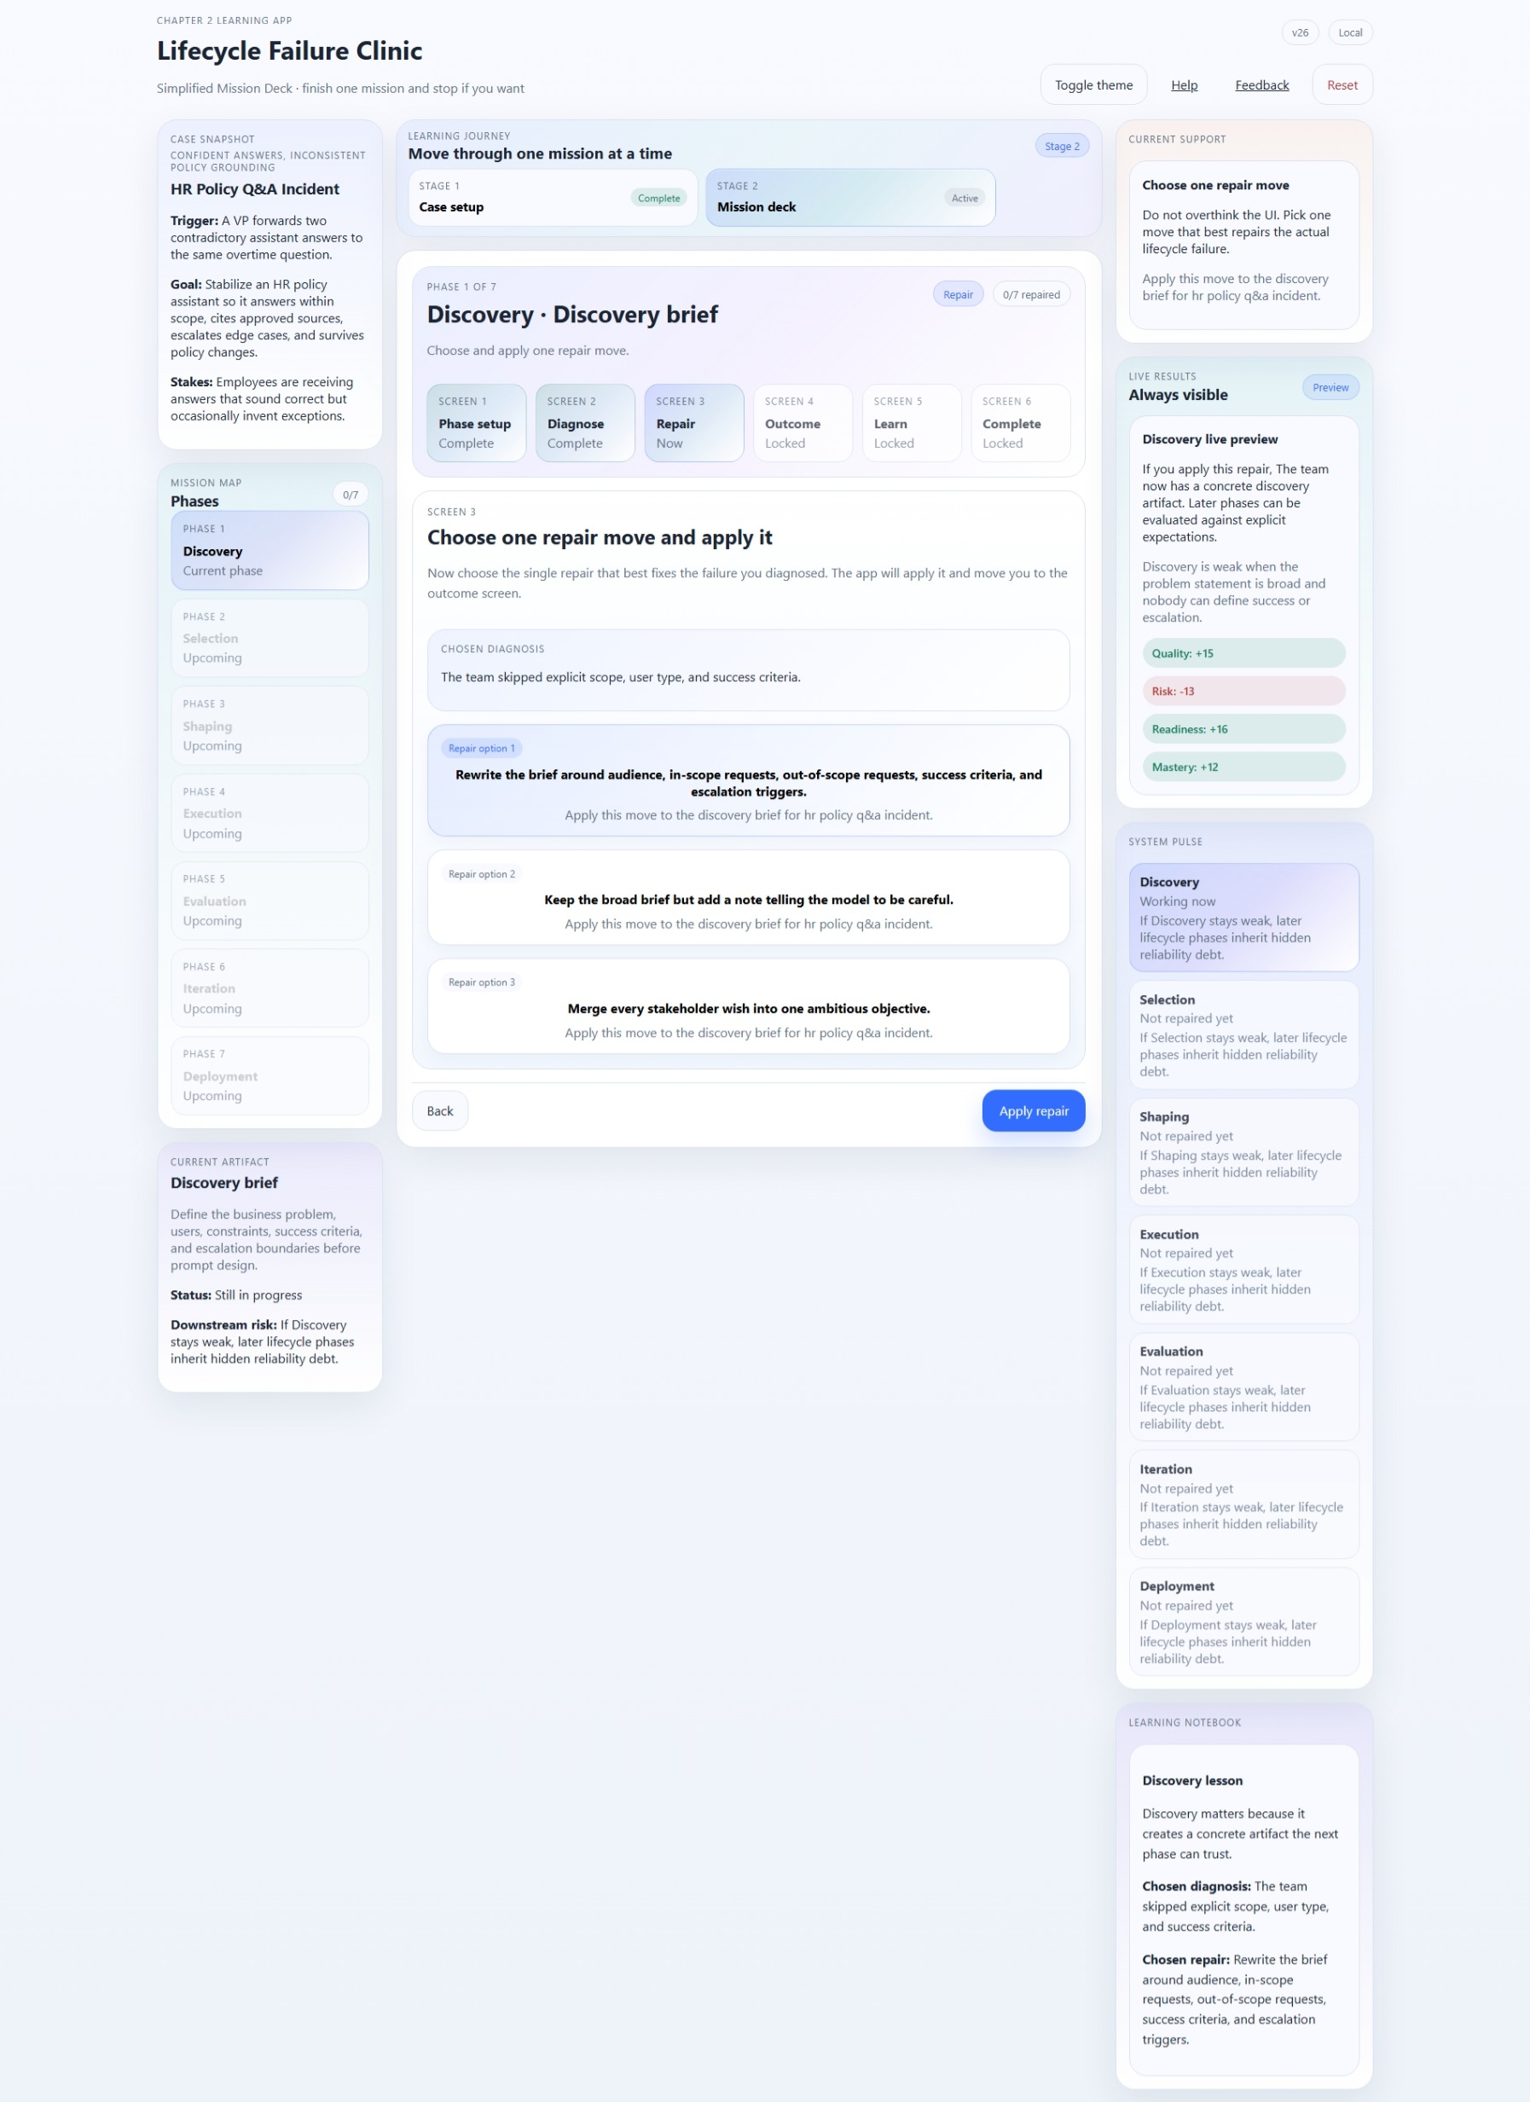
Figure 6. Discovery - Repair screen from prep.zip.
Use the screen this way | What to notice and do
Focus on | The chosen diagnosis, the repair options, and the Live Results panel on the right.
Take this action | Pick one repair move that directly addresses the diagnosed failure. In the current Discovery mission, the strongest move is to rewrite the brief around audience, in-scope requests, out-of-scope requests, success criteria, and escalation triggers.
Why this matters | This is where the learner practices targeted intervention. The goal is not to pick the most ambitious move; it is to pick the move that repairs the actual artifact.

4.4 Screen 4 - Outcome
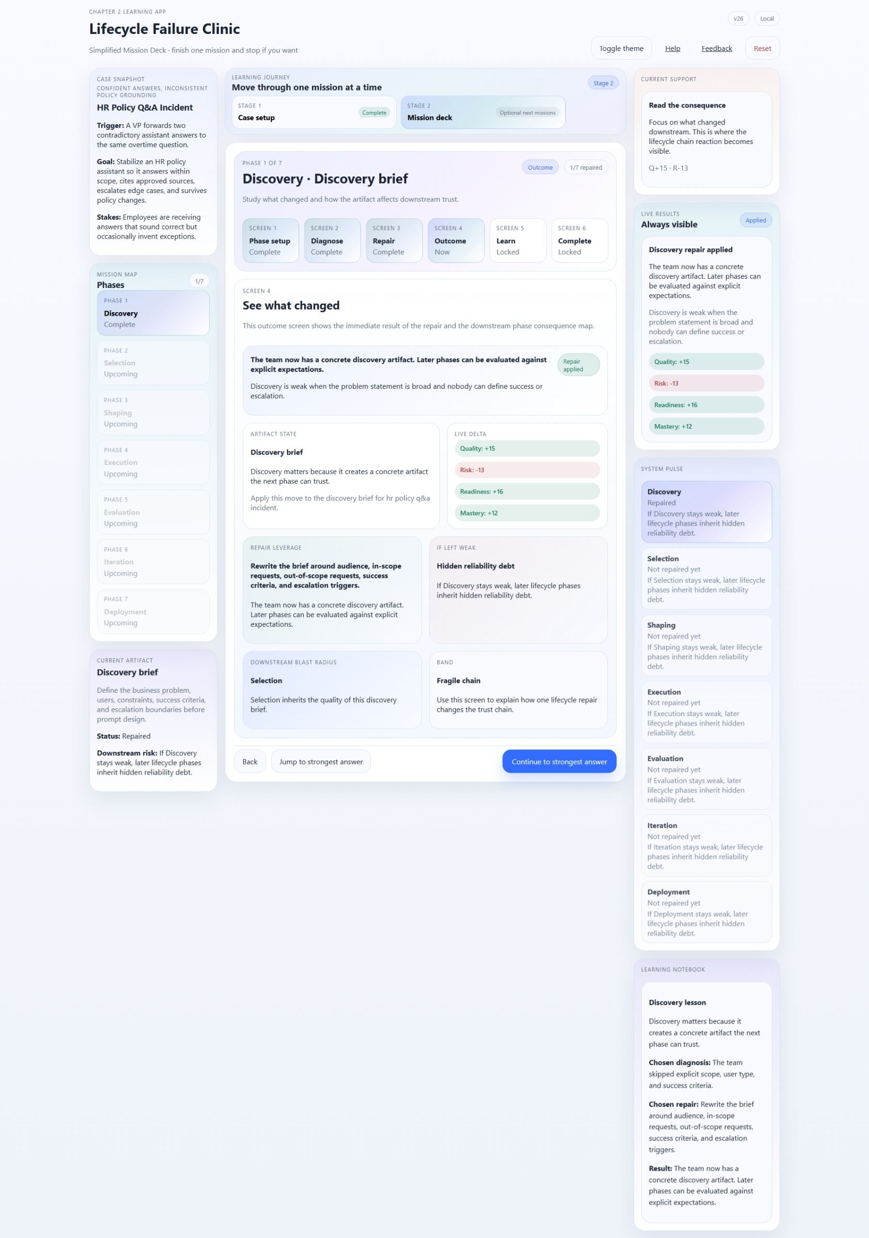
Figure 7. Discovery - Outcome screen from prep.zip.
Use the screen this way | What to notice and do
Focus on | The repair-applied banner, the artifact state, live delta, repair leverage, hidden reliability debt, downstream blast radius, and the consequence band.
Take this action | Pause here and study what changed. Read both the metric movement and the explanation cards. A strong repair should improve the current artifact and make later phases more trustworthy.
Why this matters | This screen turns a decision into a visible consequence chain. It teaches that lifecycle work is cumulative: stronger artifacts make downstream work easier to evaluate and govern.

4.5 Screen 5 - Learn
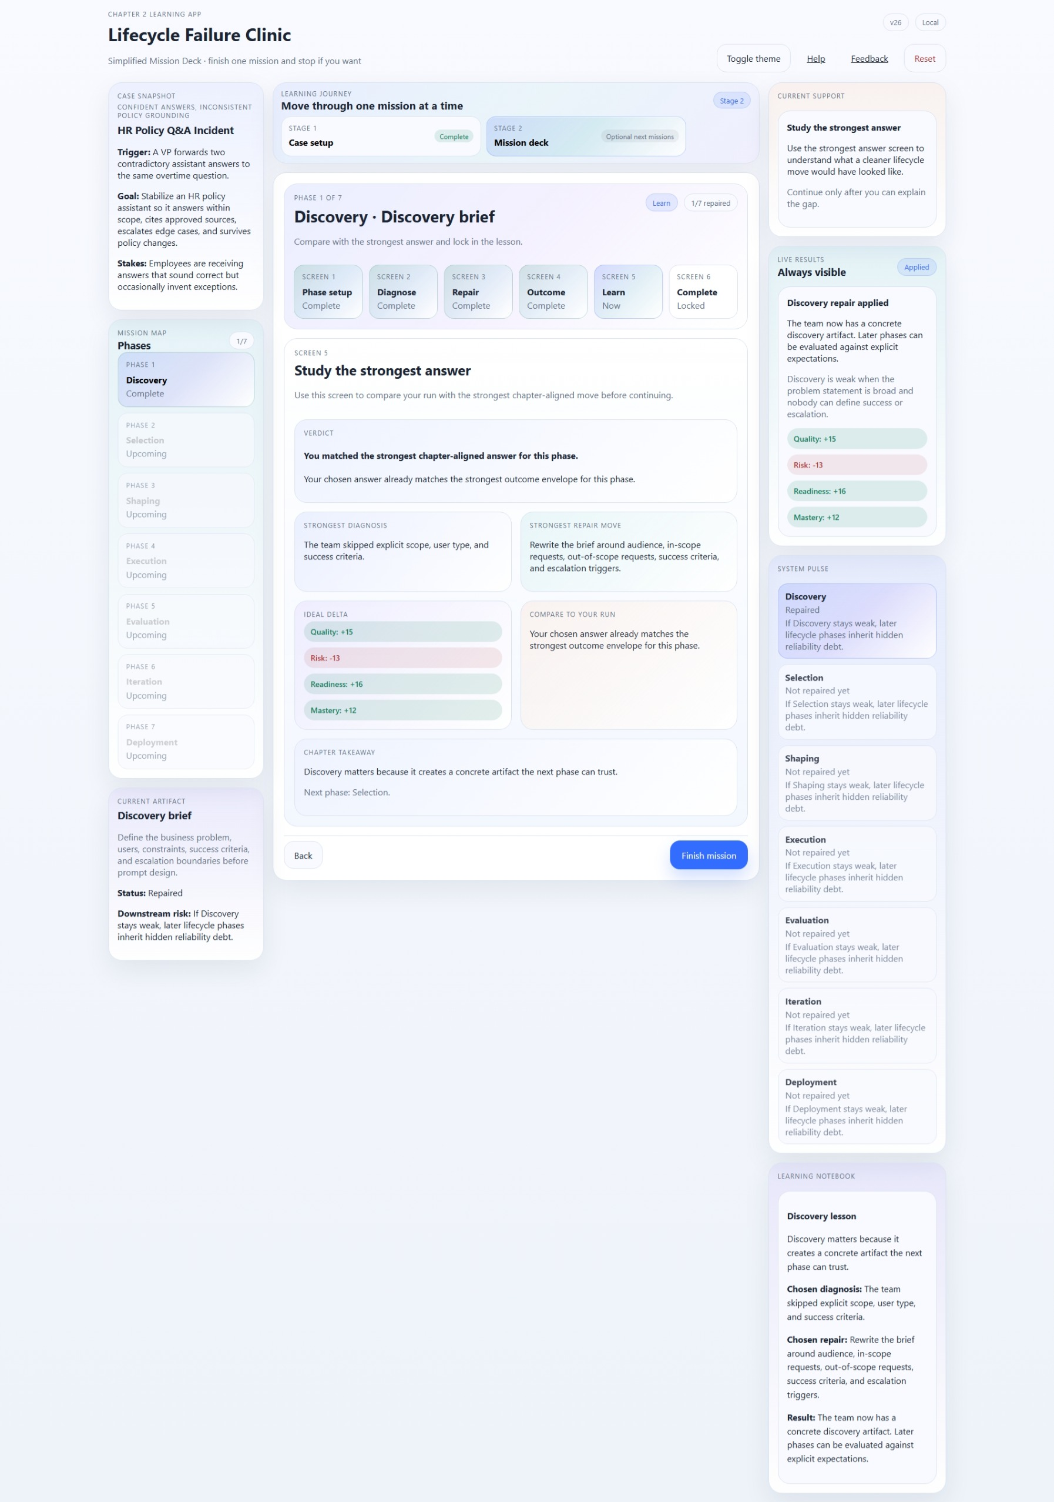
Figure 8. Discovery - Learn screen from prep.zip.
Use the screen this way | What to notice and do
Focus on | The verdict, strongest diagnosis, strongest repair move, ideal delta, and chapter takeaway.
Take this action | Do not rush past this comparison view. Use it to explain the gap between your run and the strongest answer. If your choice already matches the strongest answer, use the screen to confirm why it was strong.
Why this matters | The learning screen is where activity becomes understanding. It anchors the mission in chapter-aligned practice instead of leaving the learner with a disconnected trial-and-error experience.

4.6 Screen 6 - Complete
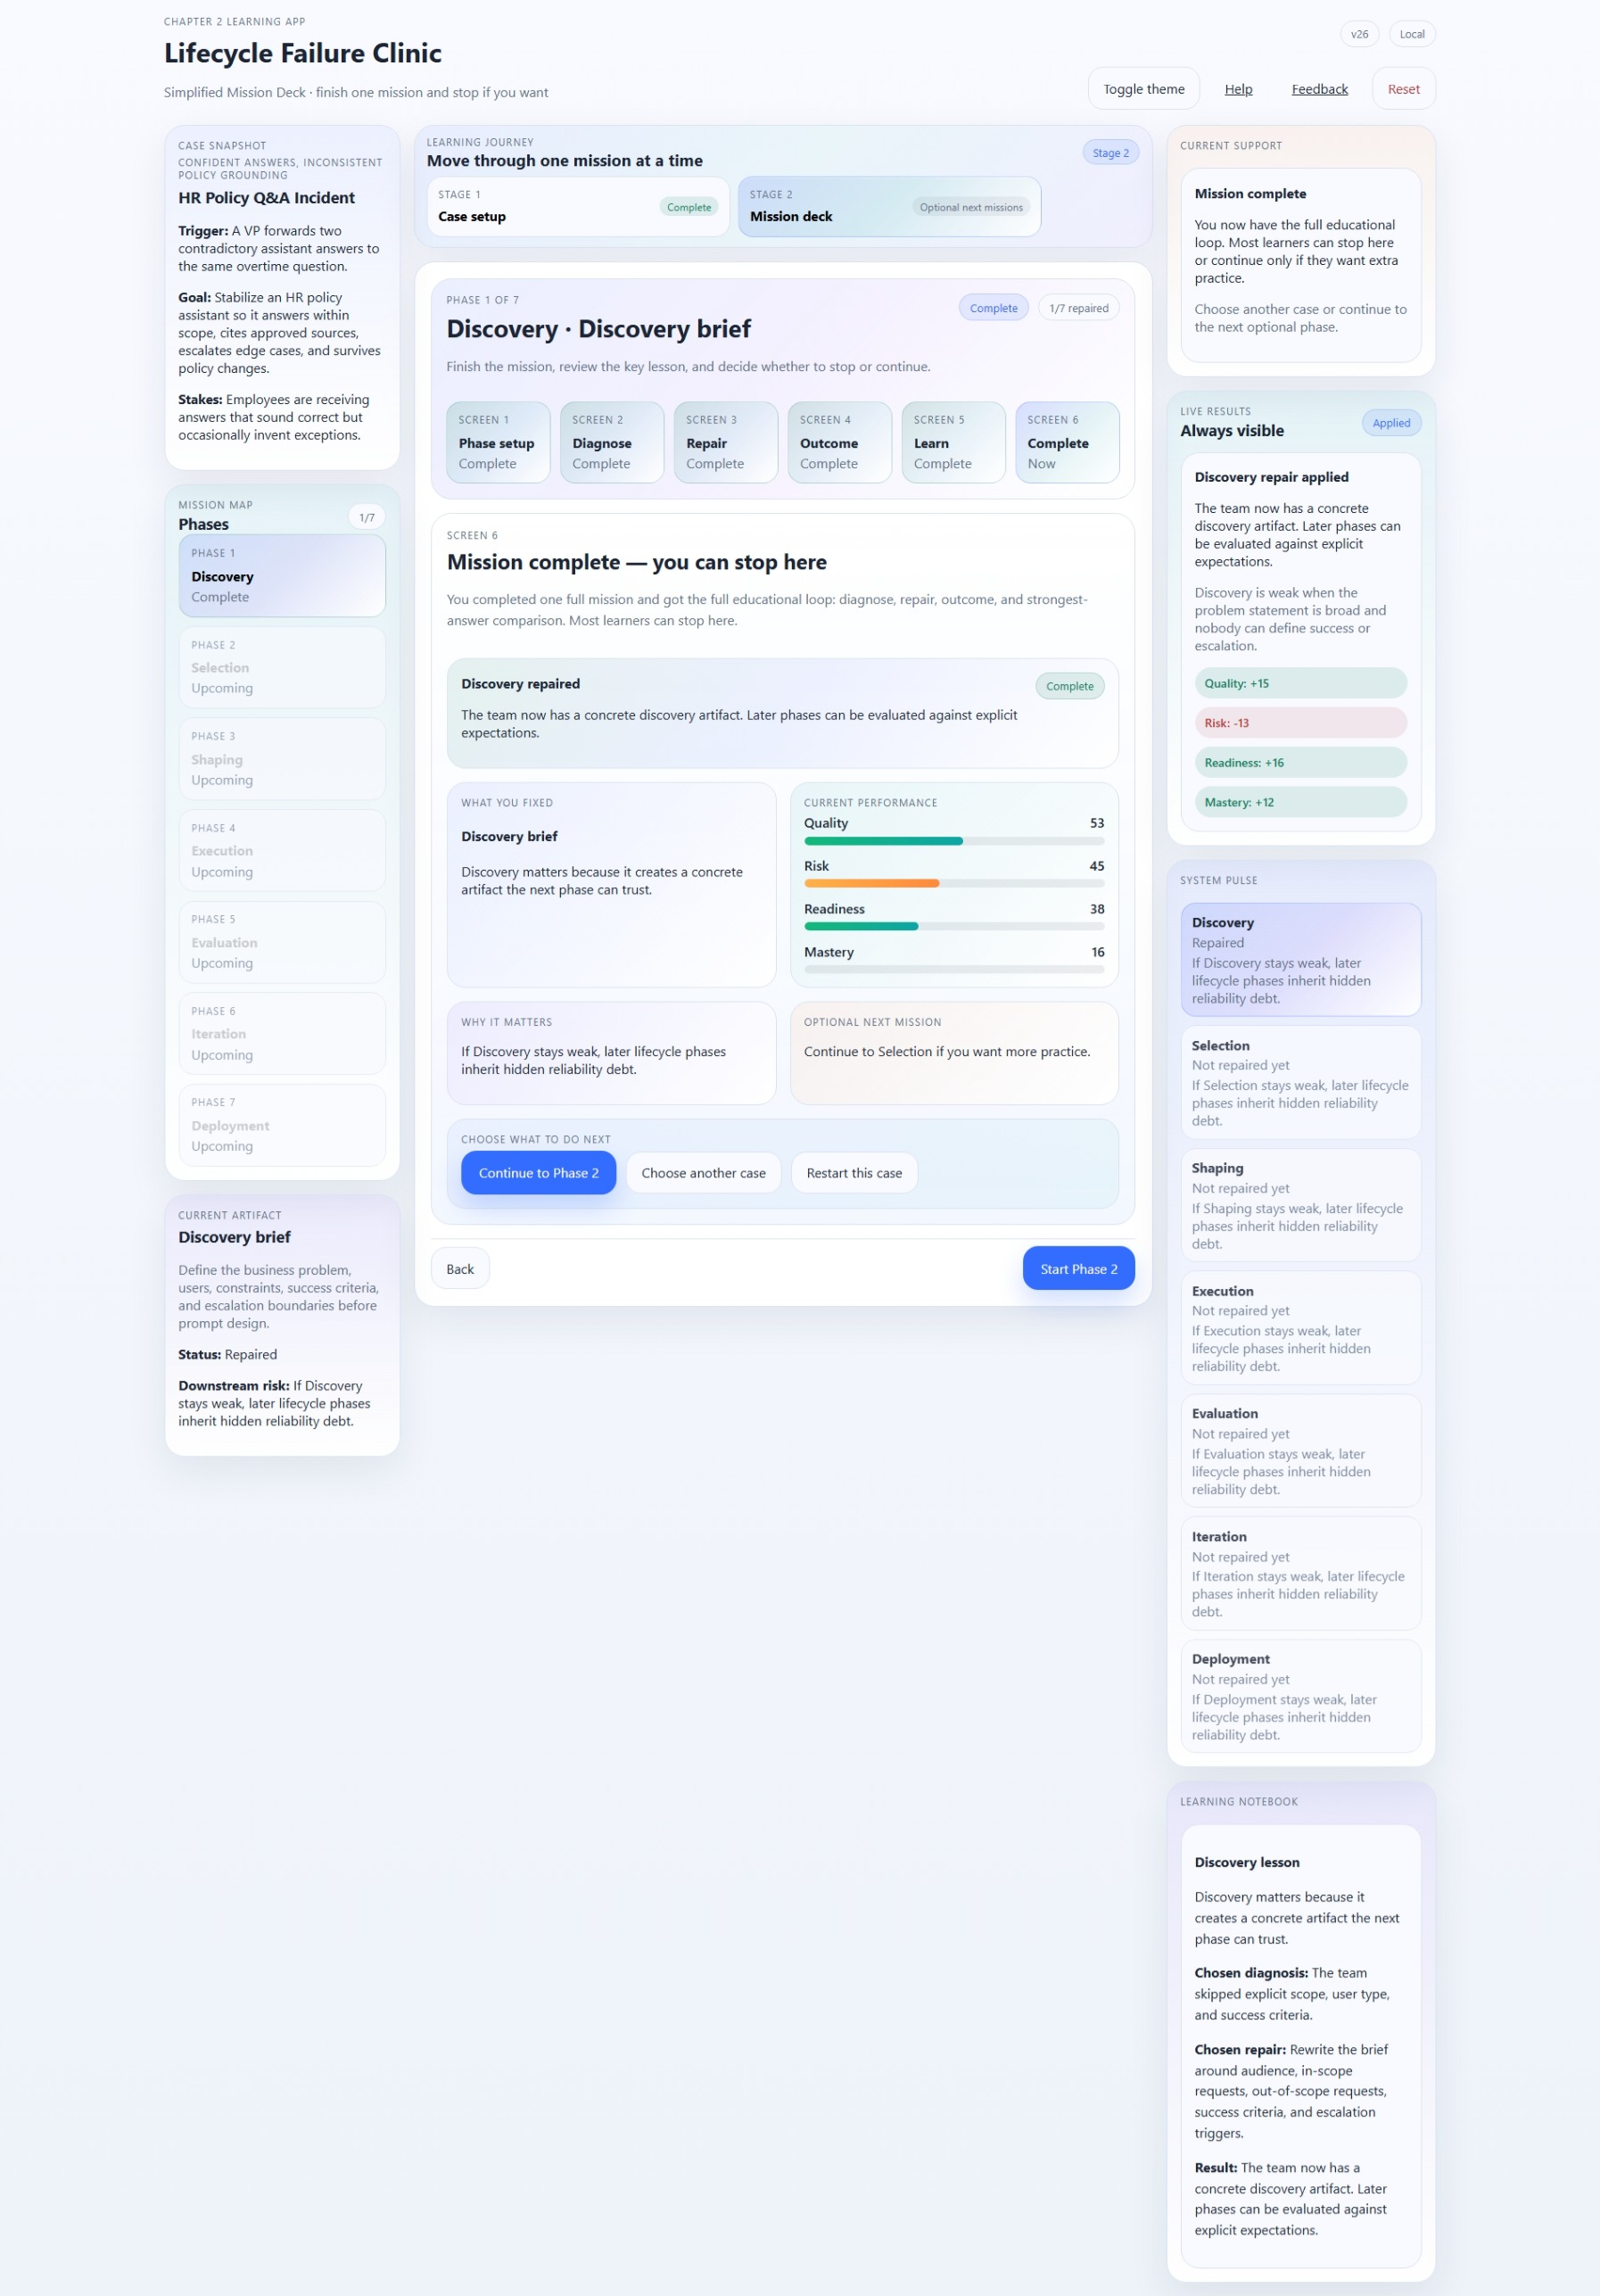
Figure 9. Discovery - Complete screen from prep.zip.
Use the screen this way | What to notice and do
Focus on | The mission-complete message, what you fixed, current performance, the optional next mission prompt, and the stop-or-continue choices.
Take this action | Treat this as a legitimate finish line for a first run. You can continue to Phase 2, choose another case, or stop here after reviewing what was fixed and why it matters.
Why this matters | The completion screen reinforces the design principle of the current app: one repaired mission is enough to deliver a full learning loop.

5. How to interpret guidance, rails, and metrics
Lifecycle Failure Clinic keeps important context visible around the main Mission Deck. That means the learner does not have to rely on memory alone while moving through the decision screens.
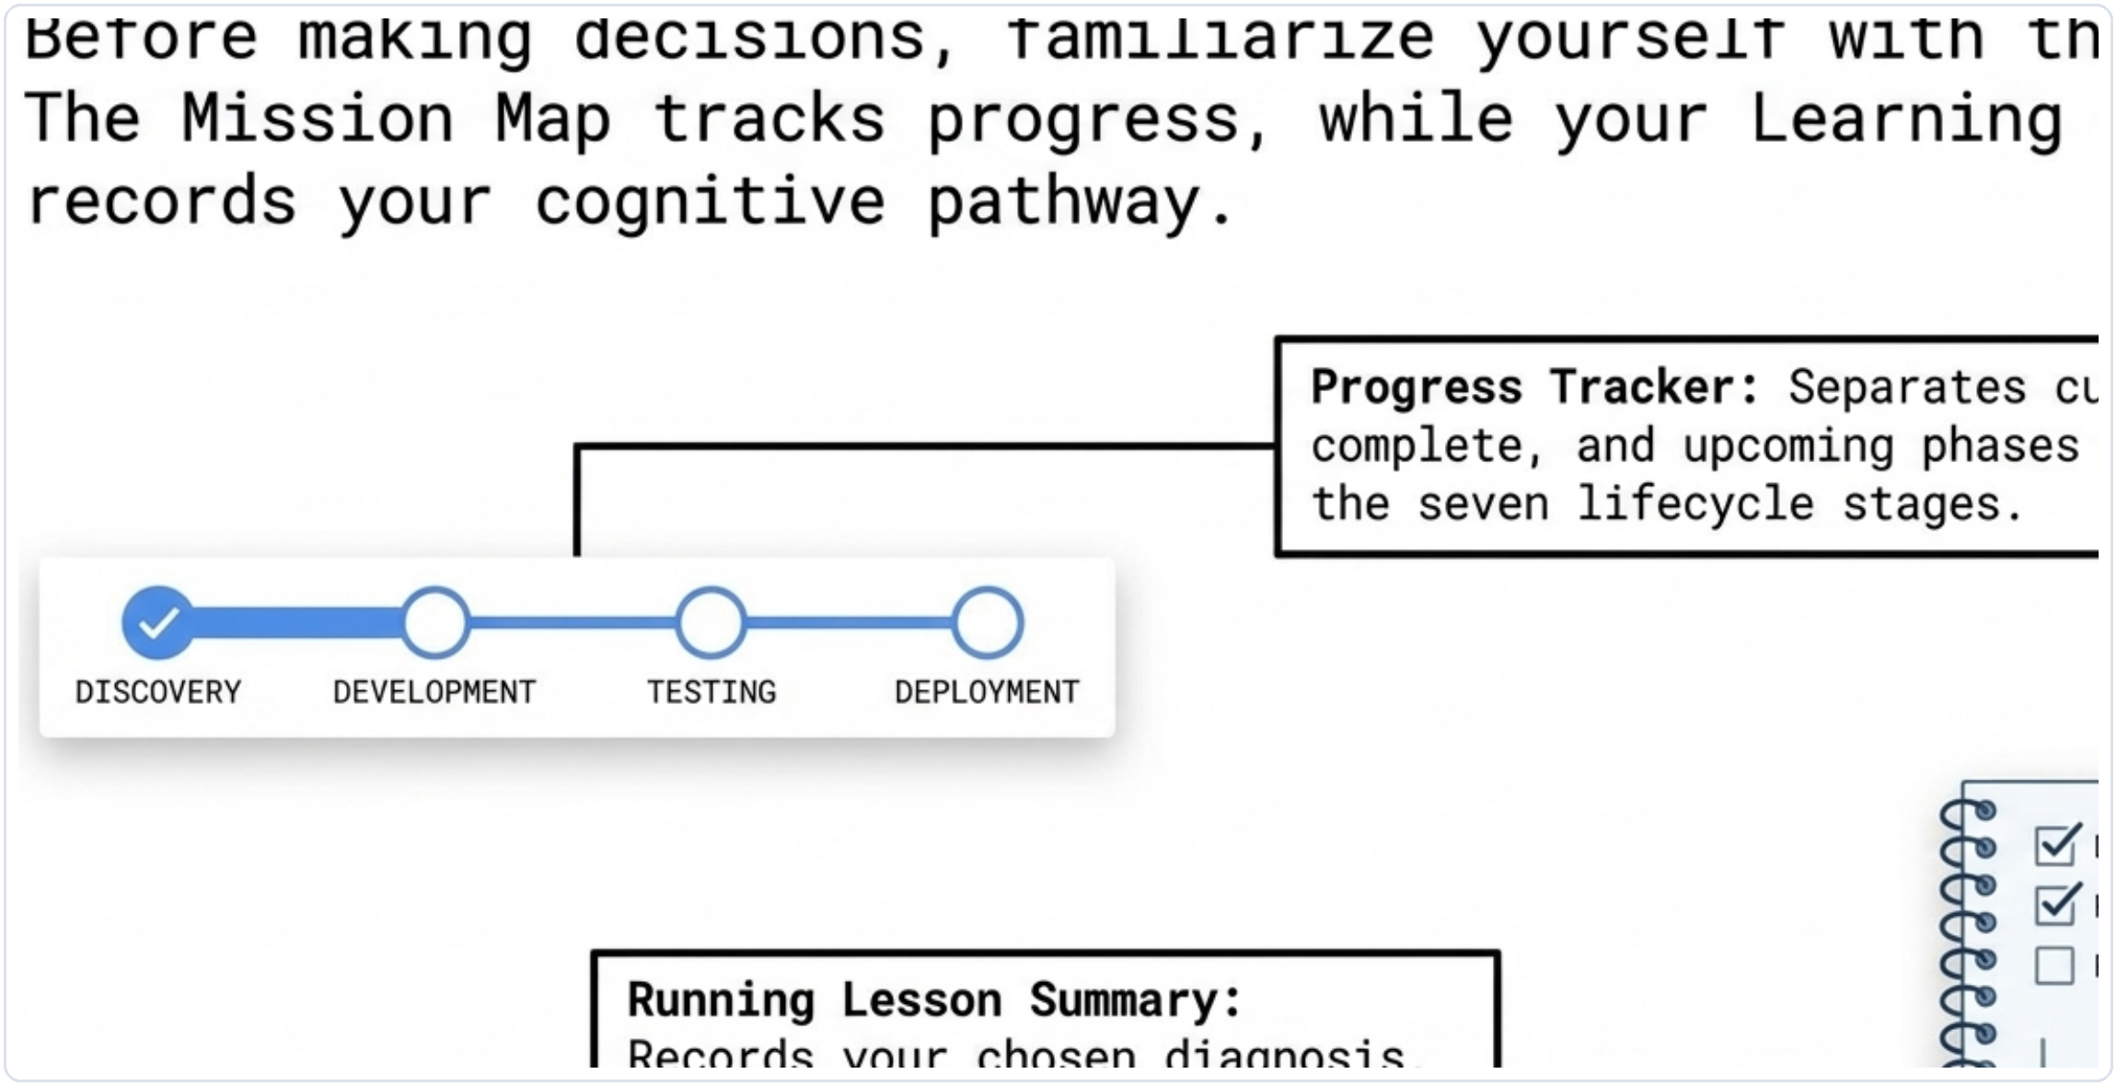
Figure 10. The PDF's rail explainer reinforces how progress tracking and the running notebook support the learner.
Screen area | How to use it as a learner
Case Snapshot | Use it to remember the incident, the goal, and the stakes while you work.
Mission Map | Read it as your progress view across the seven lifecycle phases. Current, complete, and upcoming phases are clearly separated.
Current Artifact | This reminds you what the active phase is supposed to produce and what risk remains if it stays weak.
Current Support | Treat this as lightweight coaching for the current screen. It changes as you move forward.
Live Results | Look here for Waiting, Preview, or Applied states and for the immediate delta after a repair.
System Pulse | This is a compact view of lifecycle health. It shows which phases are repaired and which still carry debt.
Learning Notebook | Use it as your running lesson summary. It records the chosen diagnosis, repair, and result.

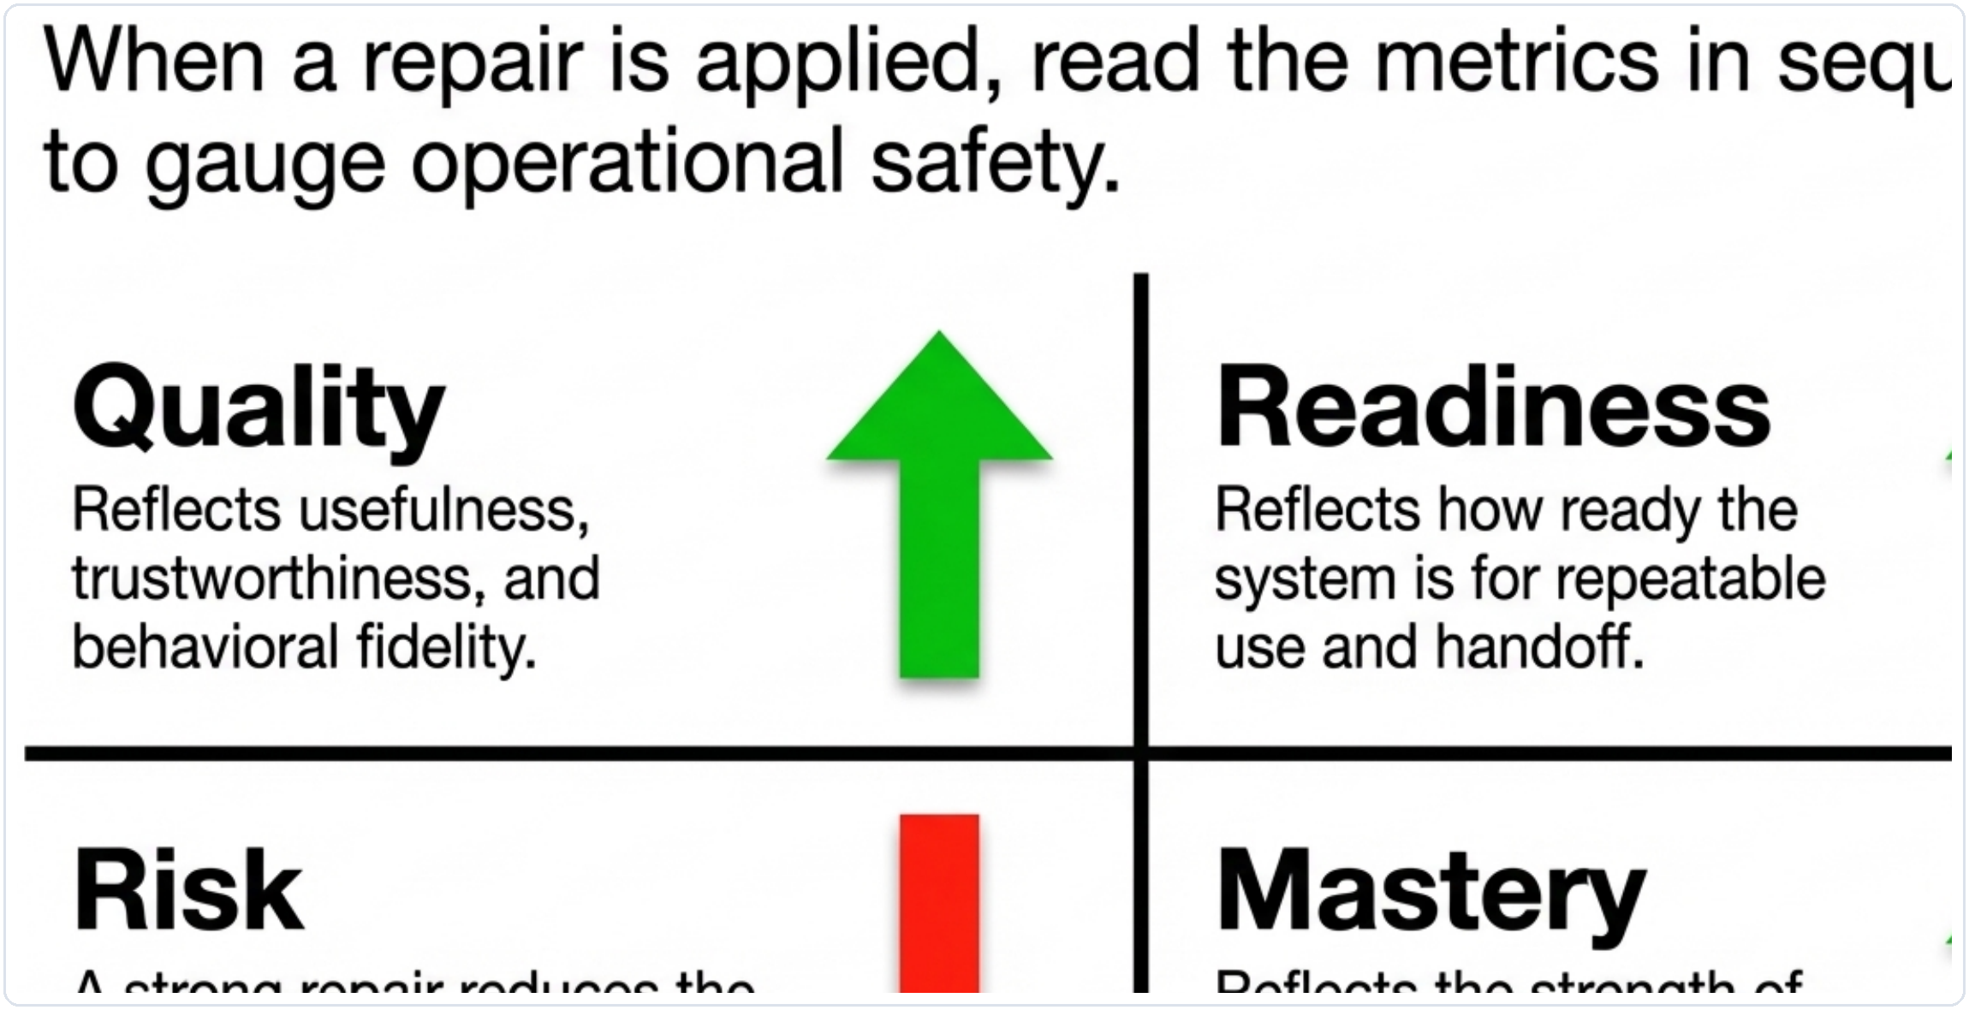
Figure 11. The PDF's metrics panel provides a clear reading order for quality, risk, readiness, and mastery.
Metric | How to interpret it
Quality | Higher is better. This reflects usefulness, trustworthiness, and behavioral fidelity.
Risk | Lower is better. A strong repair reduces the chance of misleading or operationally unsafe behavior.
Readiness | Higher is better. This reflects how ready the system is for repeatable use and handoff.
Mastery | Higher is better. This reflects the strength of the learner's run across the lifecycle.

A practical reading rule
When a repair is applied, read the result in this order: the outcome banner, the metric delta, the explanation cards, and then the strongest-answer comparison.

6. Continuing beyond this guide
Completing the first Discovery mission gives the learner a complete and meaningful first experience. It is a perfectly valid place to stop. The broader application, however, continues through later lifecycle phases and lets the learner practice the same model again across three missions.
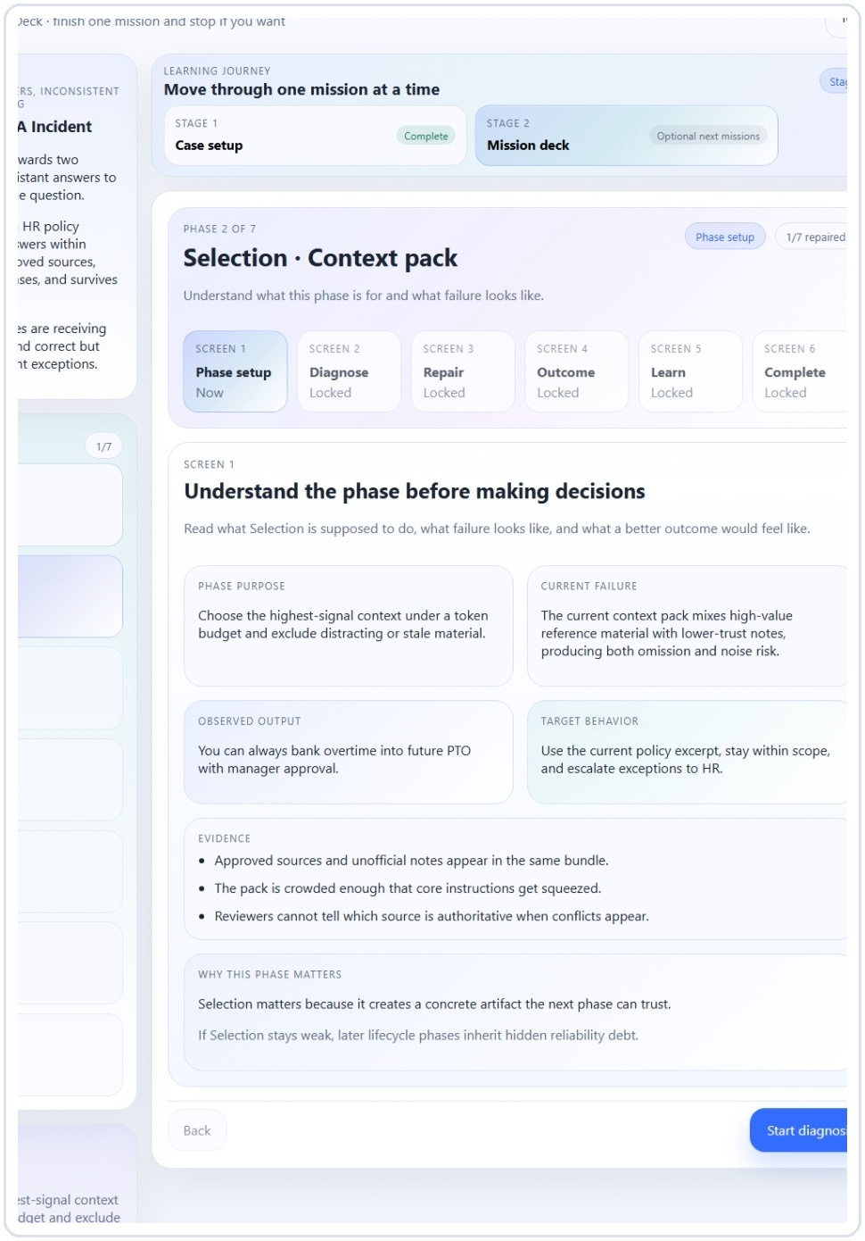
Figure 12. Example of the next optional phase after Discovery: Selection.
Use the screen this way | What to notice and do
Focus on | The Mission Map and phase label show that the app continues into Selection and then the remaining lifecycle phases.
Take this action | Continue only if you want more repetition or deeper pattern recognition. Your first run still counts as successful if you stop here.
Why this matters | The guide protects the learner from feeling that progress only counts when every phase is finished. It centers the best starting experience.

7. First-time success checklist
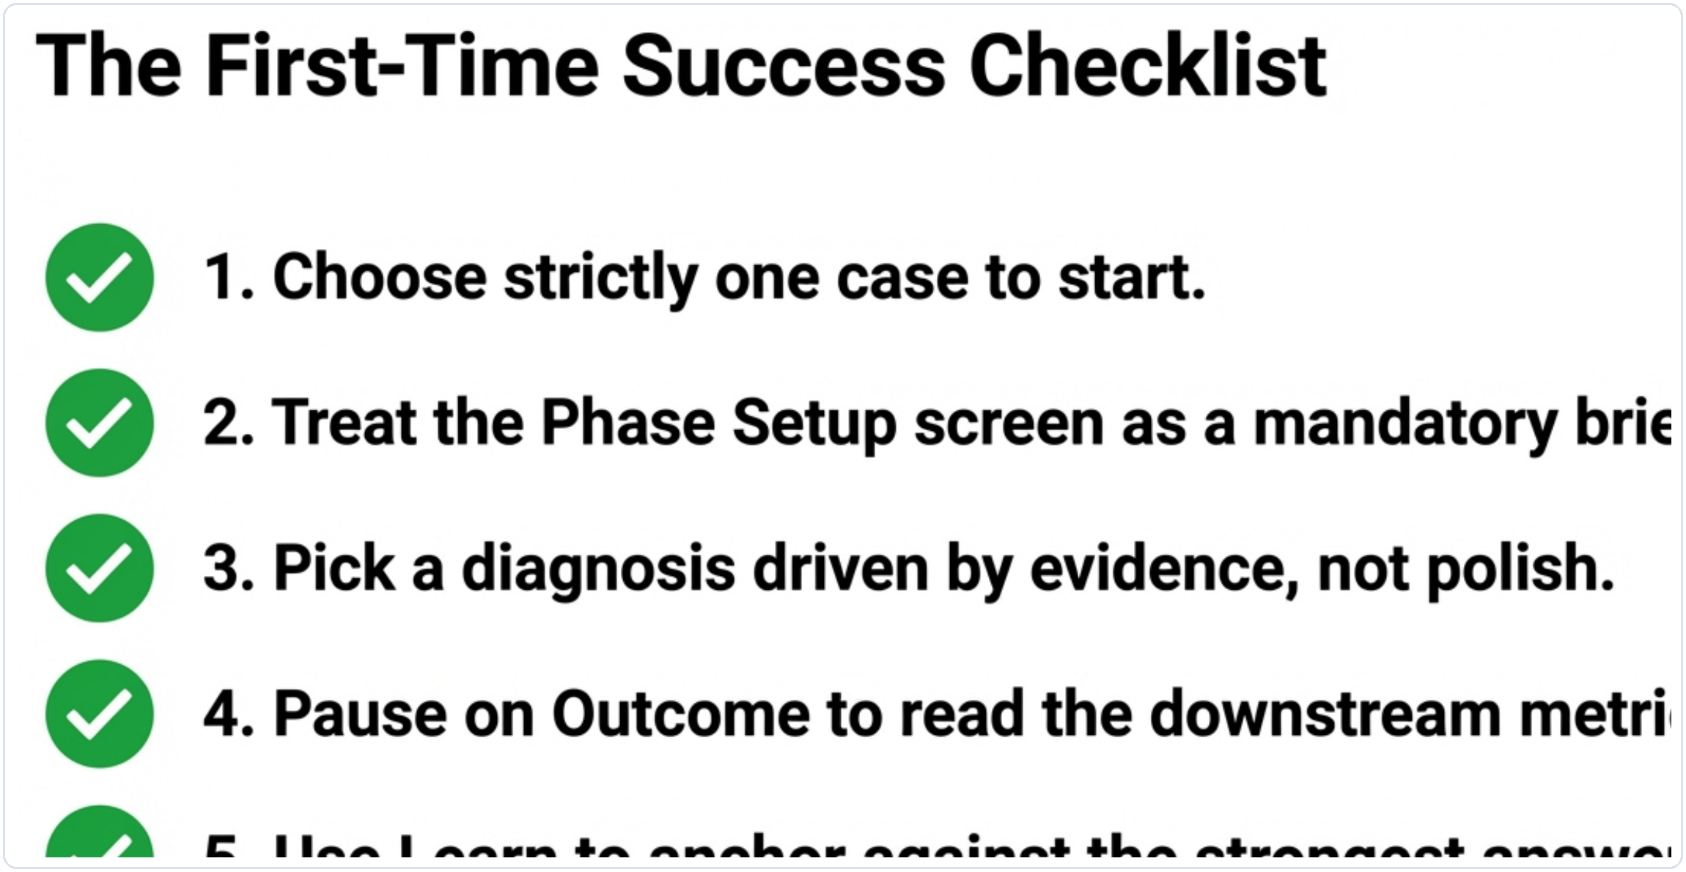
Figure 13. The PDF's success checklist distilled into one last review panel.
- Choose one case rather than trying to understand all three at once.
- Use the Discovery Phase Setup screen as a briefing, not as a screen to skim past.
- Pick a diagnosis that explains the failure pattern, then pick a repair that directly fixes the actual failure.
- Pause on Outcome to read the downstream effect before moving on.
- Use Learn to compare your run with the strongest chapter-aligned answer.
- Treat Complete as a valid stopping point after the first mission.
Final takeaway
The clinic works best when the learner slows down enough to connect evidence, diagnosis, repair, and consequence. One strong run is more valuable than rushing through multiple phases without reflection.

Updated from the existing Chapter 1 guide using prep.zip visuals and the supporting PDF.

