Context Envelope Studio — User Guide
A practical, learner-centered guide to building reviewable context envelopes, testing them in an external LLM, and using each run to strengthen Chapter 3 shaping discipline.
Application version | v1.7.0
Build | ces-v1.7.0-innovation-labs
Designed for | End users and learners working through short Chapter 3 scenario runs
Core session length | Approximately 6–9 minutes per scenario pack
Core sections | ROLE, RULES, REFERENCE, DYNAMIC FACTS, TASK, OUTPUT, and CHECKS
Run model | Manual copy → run in an external LLM → paste the observed output back for review

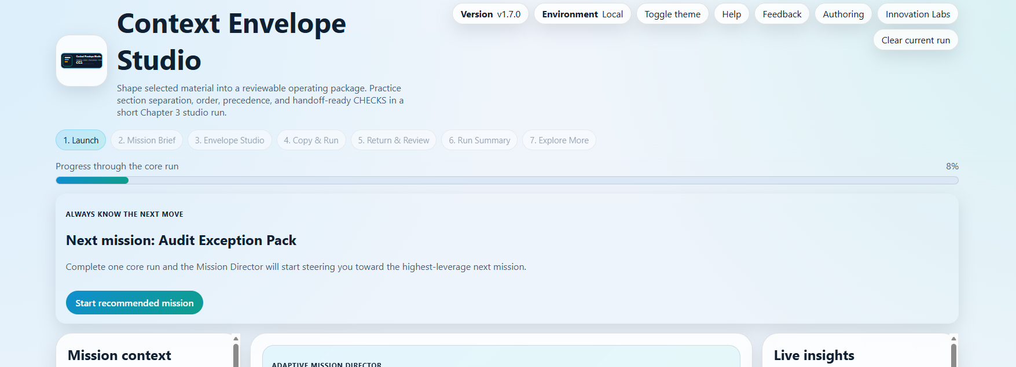
Figure 1. The launch experience shows the stage rail, progress indicator, the global “Always know the next move” coach strip, and the scenario-centered studio shell.
What this guide helps you do
Start confidently, understand the real stage sequence, shape stronger envelopes, use the external-model loop correctly, interpret coaching and metrics responsibly, and decide when optional features are worth your time.

How to use this guide
Read straight through for a complete orientation, or jump to the sections that match the part of the run you are in right now. The guide follows the actual product flow and uses the current CES interface, labels, and optional pages.
Section | What it helps you do
1. Start here | Understand what Context Envelope Studio teaches and what kind of learning experience it is.
2. Get started quickly | Open the application correctly, prepare the tools you need, and understand the main shell.
3. Understand the core run | Follow the real stage sequence from Launch through Run Summary.
4. Work confidently in Envelope Studio | Place cards well, use the build coaching, and make the required decisions.
5. Use an external LLM with CES | Copy the envelope out, test it externally, and bring the observed output back.
6. Read coaching, metrics, and review signals | Interpret readiness, structural feedback, Counterfactual Studio, and Mission Director guidance.
7. Choose the right scenario pack | Pick a scenario based on time, difficulty, and the shaping concept you want to practice.
8. Optional areas and appendix | Use Explore More, Innovation Labs, and the contributor-oriented authoring workspace appropriately.

Best first-use path
Open the app with the provided startup batch file, choose one core scenario pack, read the Mission Brief, complete a full core run through Run Summary, and only then decide whether to open Explore More or Innovation Labs.

1. Start here: what Context Envelope Studio teaches
Context Envelope Studio is a static, mobile-first Chapter 3 learning application for shaping high-quality context envelopes. It is designed to help you practice one of the most important context-engineering skills: turning already selected material into a legible, reviewable operating package instead of a vague prompt blob.
Each run asks you to place authored blocks into seven named sections: ROLE, RULES, REFERENCE, DYNAMIC FACTS, TASK, OUTPUT, and CHECKS. You then decide what source wins when materials conflict, how the answer should be shaped, and what the model should do when required information is missing.
The app does not run a model internally. Instead, CES deliberately treats the external model run as part of the lesson. You copy the finished envelope into an outside LLM, observe what the structure produces, and then paste the output back into the app so CES can connect visible response behavior back to the package you built.
What CES is not
It is not a direct ChatGPT front end, not a server-backed system, and not a hidden automation layer. The build is static by design: no direct LLM integration, no accounts, no server-side storage, and no remote analytics.

The strongest mindset is to treat each scenario as a short lab. You are not trying to click through every control. You are trying to see what the package makes easy, what it hides, what it overstates, and what needs to become explicit before another person—or another run—could trust it.

2. Get started quickly
The application can be run locally on Windows or served from a static host. In the handoff package included with this build, the startup batch file opens CES through a local Python web server rather than through file navigation.
What you need | Why it matters
A normal browser window | CES uses local browser storage for your theme, in-progress run, run history, and local feedback.
The supplied start-server.bat | This is the intended local startup path for the package. In this build it opens the studio on localhost:5501.
An external LLM tab or window | You will copy the envelope into another model, run it there, and return with the observed output.
Basic copy-and-paste access | The core learning loop depends on moving the envelope out and the response back in.

Local run note
For this CES package, keep start-server.bat next to index.html, double-click the batch file, and open the local URL it launches. The current startup file is configured for localhost:5501.

Once CES opens, notice the shared shell before you start a scenario. The header shows the version pill, environment pill, theme toggle, Help, Feedback, Authoring, Innovation Labs, and the Clear current run action. Below that, the stage rail shows the full run path, and the progress bar tracks completion through the core run.

Figure 2. The shared shell keeps version, environment, theme, navigation links, the stage rail, and the progress bar visible from the start.

What you will see first
The launch stage is centered on scenario selection and the Adaptive Mission Director. The Mission Director uses local-only run history to recommend a next mission and highlight the skill area that most deserves practice next. On a first run, it acts as a lightweight orientation aid. After you complete more runs, it becomes more specific.
The left rail summarizes mission context, the center panel presents the Mission Director and scenario cards, and the right rail previews the types of shaping signals you will practice. If you already have an unfinished run stored locally, the launch screen can also present Resume current run for that scenario.

3. Understand the core run before you begin
The CES stage rail reflects the real workflow. The final stage, Explore More, is optional. Everything through Run Summary is the core learning path.
Stage | What happens here | What you do
1. Launch | Choose a scenario and review Mission Director guidance. | Start a new run or resume a saved one.
2. Mission Brief | Study the case, success criteria, lifecycle cue, and prediction choices. | Predict likely shaping failures before you place any cards.
3. Envelope Studio | Build the envelope, make required decisions, and use coaching. | Place cards, set precedence/output/missing-info behavior, and tighten the structure.
4. Copy & Run | Prepare the package for external testing. | Copy the envelope into an outside LLM, run it, and return.
5. Return & Review | Connect the observed output back to the structure. | Paste the response, analyze it, and inspect structural and output review cues.
6. Run Summary | Capture the lesson and decide what to do next. | Review strengths, risks, next steps, learner artifact options, replay, or restart.
7. Explore More | Optional extension branch for a harder tradeoff. | Inspect bonus variations without replacing the completed core run.

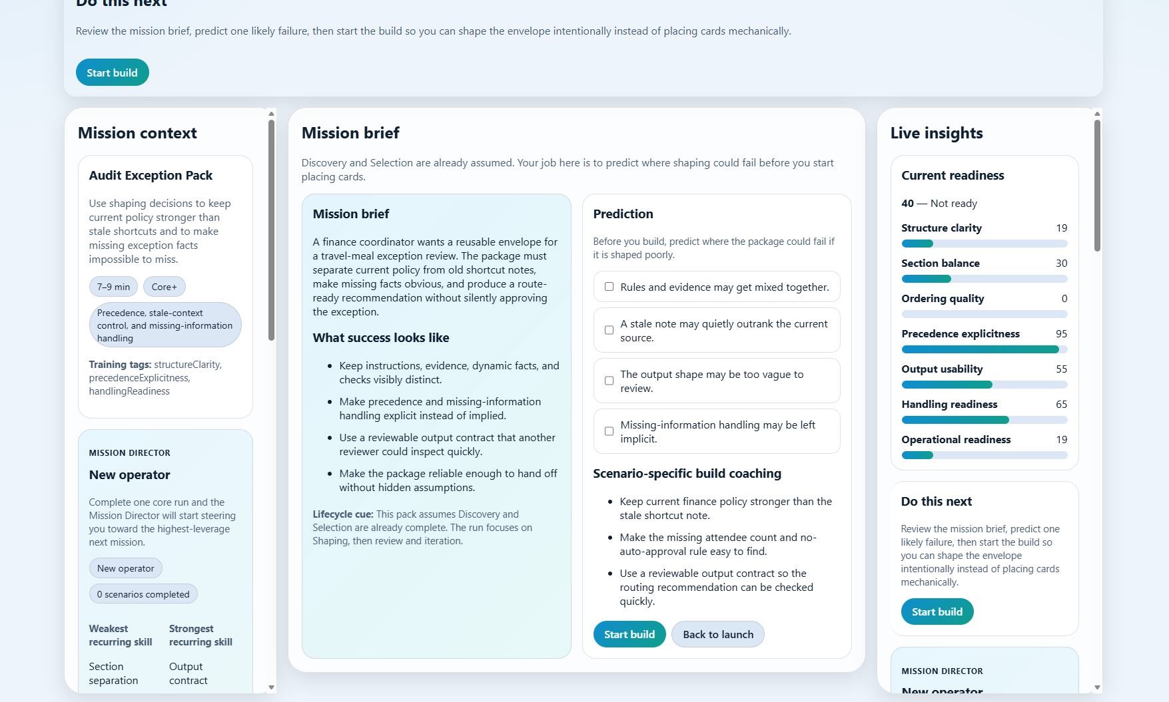
Figure 3. Mission Brief asks you to predict likely failures before the build begins and keeps the case, success criteria, and current readiness visible together.

Why the Mission Brief matters
CES assumes Discovery and Selection have already happened. That is why the Mission Brief does not ask you to invent the problem or gather evidence from scratch. Instead, it asks you to predict where shaping could fail if the package is assembled poorly. This makes the build deliberate rather than mechanical.
Use the prediction step honestly. Even if your prediction is incomplete, you learn more when you commit to a likely failure before the envelope starts to look better.

4. Work confidently in Envelope Studio
Envelope Studio is the center of gravity of the app. This is where you turn authored blocks into a reviewable operating package. CES intentionally gives you live cues, but it does not simply tell you the right answer. You are expected to reason from section purpose, trust level, freshness, and reviewability.
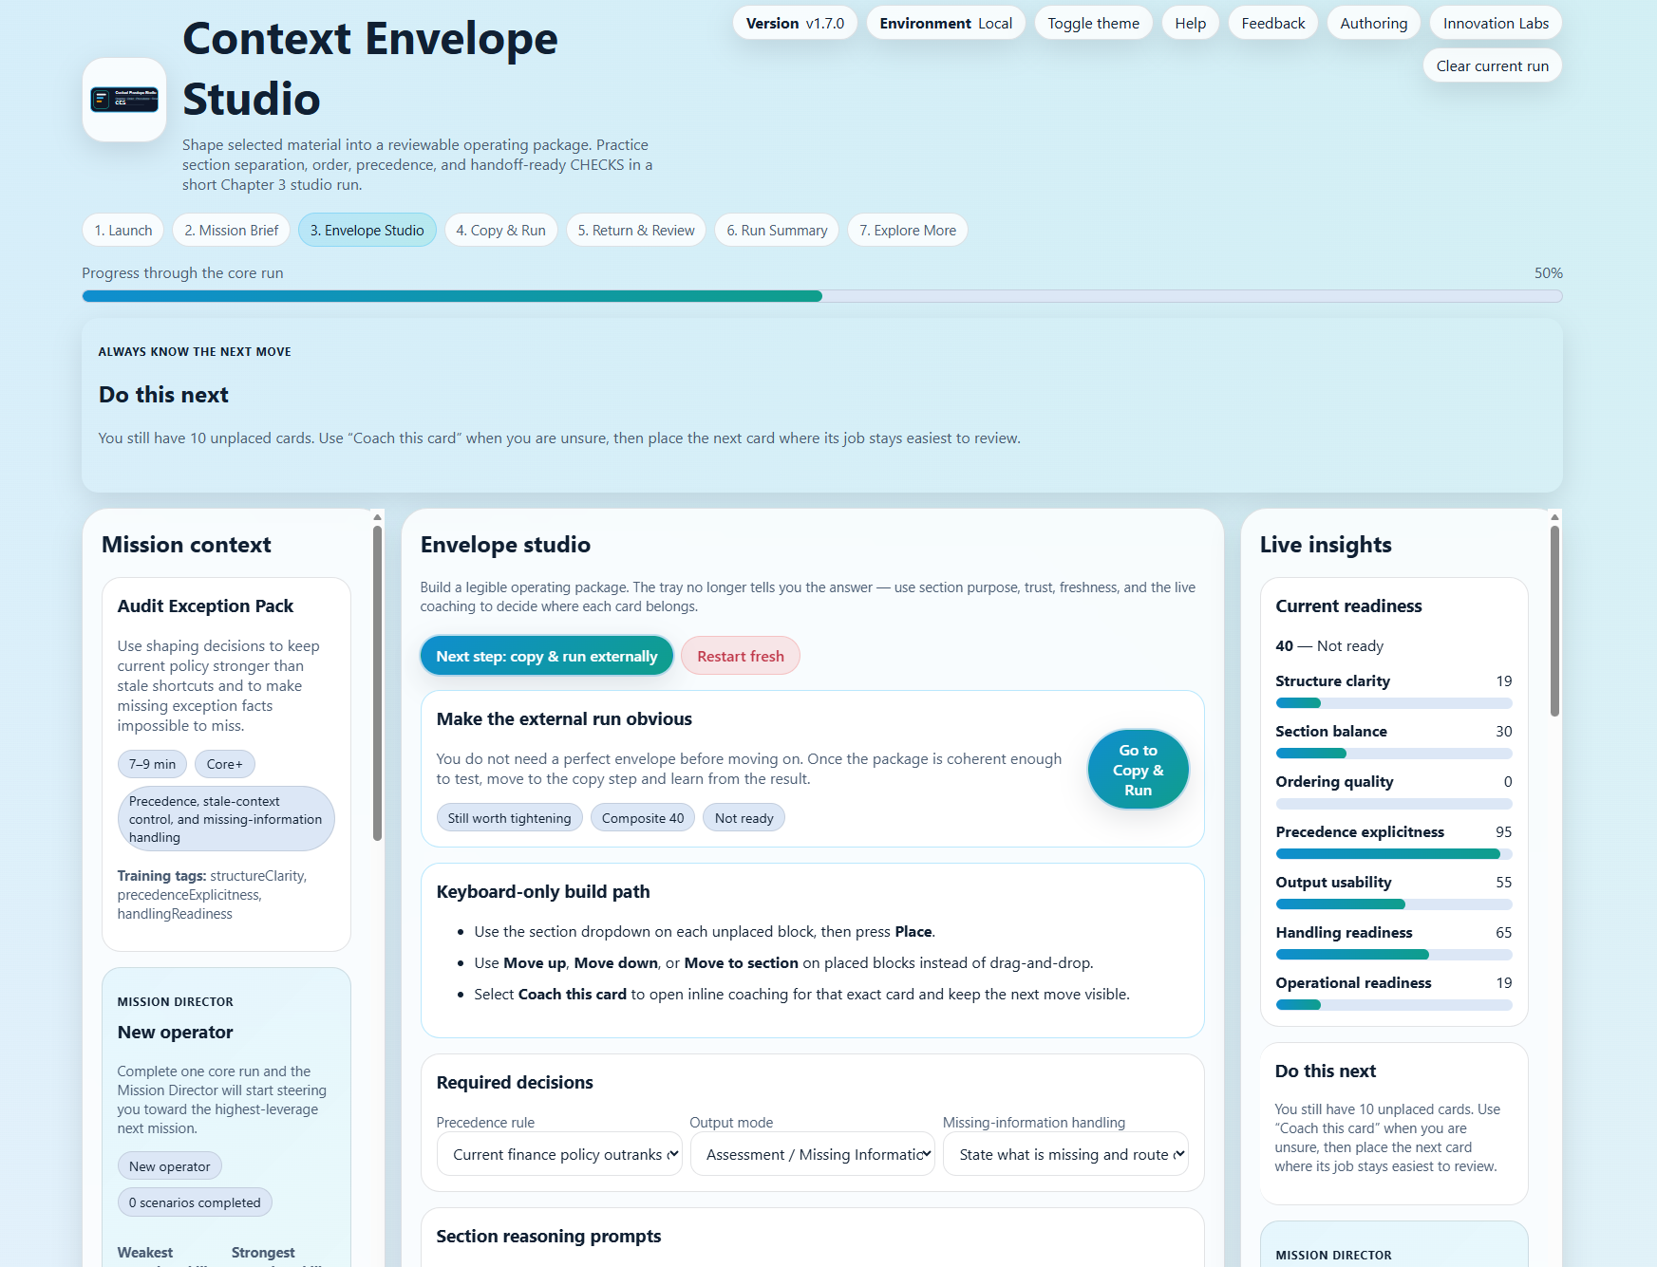
Figure 4. Envelope Studio combines the global coach strip, build controls, required decisions, section reasoning prompts, and the live insights rail.

The seven envelope sections
Section | What belongs there | What to watch for
ROLE | The operating stance the model should take. | Use it to define the job before the evidence and task appear.
RULES | Stable instructions, boundaries, and governing behavior. | Keep constraints visible and avoid burying key rules in other sections.
REFERENCE | Approved source material and record-of-authority evidence. | Keep authoritative sources visible and weaker notes clearly weaker.
DYNAMIC FACTS | Current-run details that can change from one case to the next. | Do not let stale or generic material masquerade as fresh facts.
TASK | The concrete job the model must perform now. | State the current request after the governing materials are visible.
OUTPUT | The answer shape or format reviewers should expect. | Make the result inspectable rather than vague.
CHECKS | Stop conditions, uncertainty rules, and review-protection cues. | Declare what the model should do when facts are missing or conflict remains unresolved.

Required decisions you must make
Every scenario also includes three choices that materially affect how the package behaves.
Decision | What it controls
Precedence rule | What should win if the package contains stronger and weaker sources, older notes, or conflicting material.
Output mode | What shape the answer should take so it stays easy to review and compare across runs.
Missing-information handling | What the model should do when a critical fact, source, or approval is missing.

Do not rush these selections. In CES, a strong answer is not just about where the cards go. It is also about whether the package makes source priority, answer shape, and uncertainty behavior obvious enough for a reviewer to inspect.

How to place cards well
A good placement decision answers one question: where does this block’s job stay easiest to review? The app supports that judgment with three complementary coaching layers.
Coaching layer | How to use it
Coach this card | Open inline coaching for a specific card when you are unsure what its job is or where it belongs.
Section-level coaching | See whether a section is missing an anchor, overloaded, or mixing unlike material.
Global “Do this next” strip | Use the top coach strip to stay oriented and keep momentum through the stage flow.

Keyboard-only build path
You do not have to rely on drag-and-drop. Each unplaced block includes a section dropdown and Place button. Placed blocks expose Move up, Move down, Move to section, and Remove controls.

The live envelope preview near the bottom of the studio is especially useful. It lets you see the package as another system—or another reviewer—would see it, rather than only as scattered cards inside the editor.

5. Use an external LLM with CES
CES treats the external model run as a first-class learning step. Once the envelope is coherent enough to test, move to Copy & Run. The copy stage explains what to watch for and shows the exact package that will be sent externally.
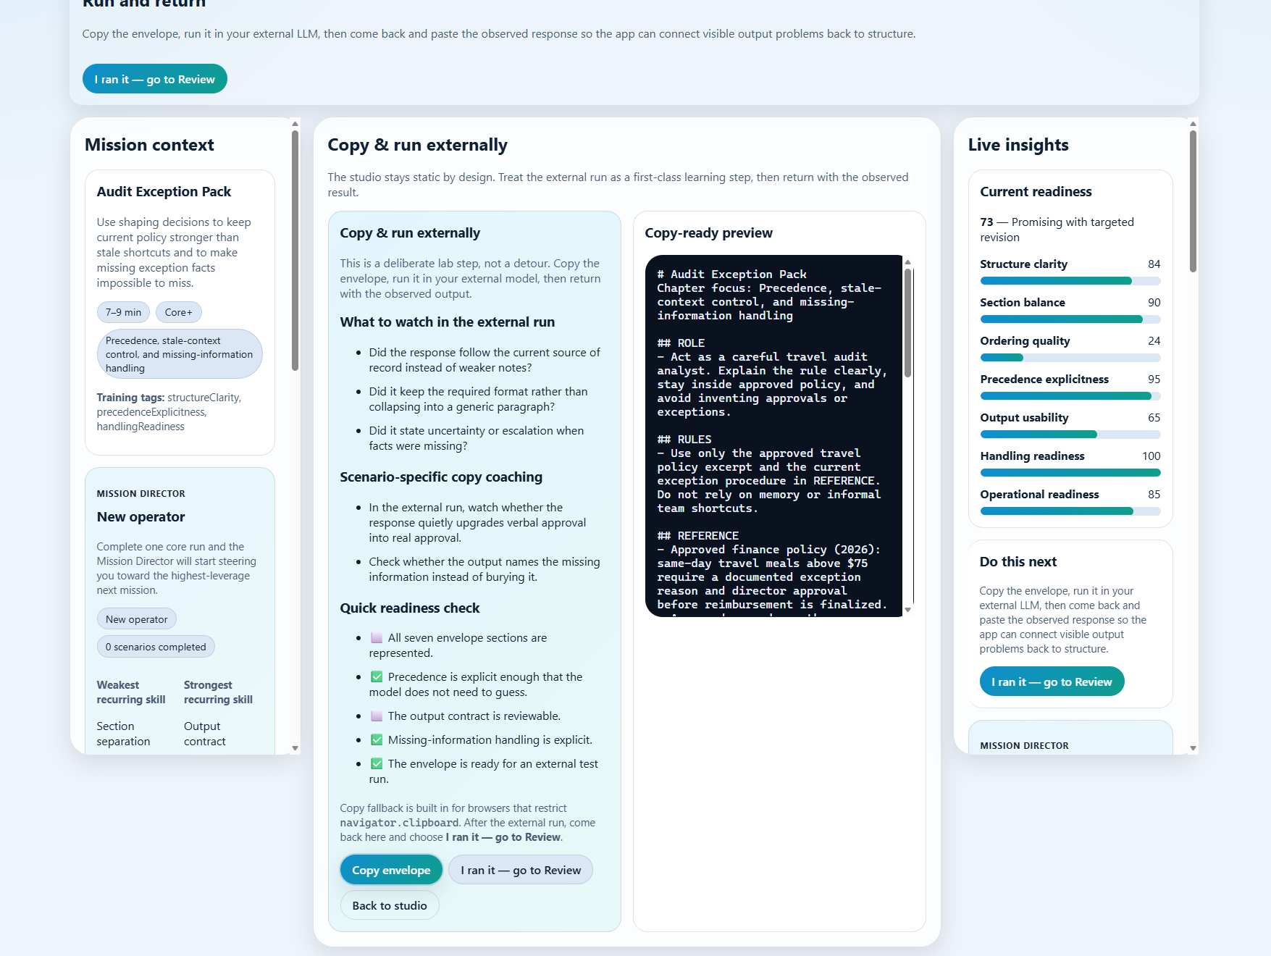
Figure 5. Copy & Run explains what to watch for in the external result and shows the copy-ready envelope preview beside the readiness cues.

The correct copy-run-return loop
Step | What to do
1. Build enough structure | Complete the seven sections as well as you can and make the required decisions.
2. Open Copy & Run | Use Go to Copy & Run or the stage rail when the package is ready to test.
3. Copy the envelope | Use Copy envelope. If browser clipboard restrictions interfere, use the fallback or manual copy.
4. Run it outside CES | Paste the envelope into your external LLM and submit it there.
5. Observe the result carefully | Look for evidence use, format quality, uncertainty handling, escalation behavior, and whether weaker notes were incorrectly upgraded.
6. Return to CES | Come back to Return & Review and paste the observed output into the review box.
7. Analyze the result | Use Analyze output and compare what the answer did with what the package made easy or hard.

Important
The external run is not a workaround for missing app functionality. It is part of the teaching model. CES is designed to help you connect package structure to model behavior in a way you can review and explain.

What to watch for in the external answer
A strong external result is not merely fluent. It should follow the stronger source instead of weaker notes, keep the requested output shape, and make uncertainty or escalation visible when the package says that missing information matters.
A weak result often sounds superficially confident while quietly flattening the output structure, hiding uncertainty, or letting stale material behave like authority. Those are exactly the kinds of shaping consequences CES is built to surface.

6. Read coaching, metrics, and review signals responsibly
The right rail and review stages are designed to keep cause and effect visible. They help you understand what the package is likely to do, what it actually did, and what the next-highest-leverage revision would be.
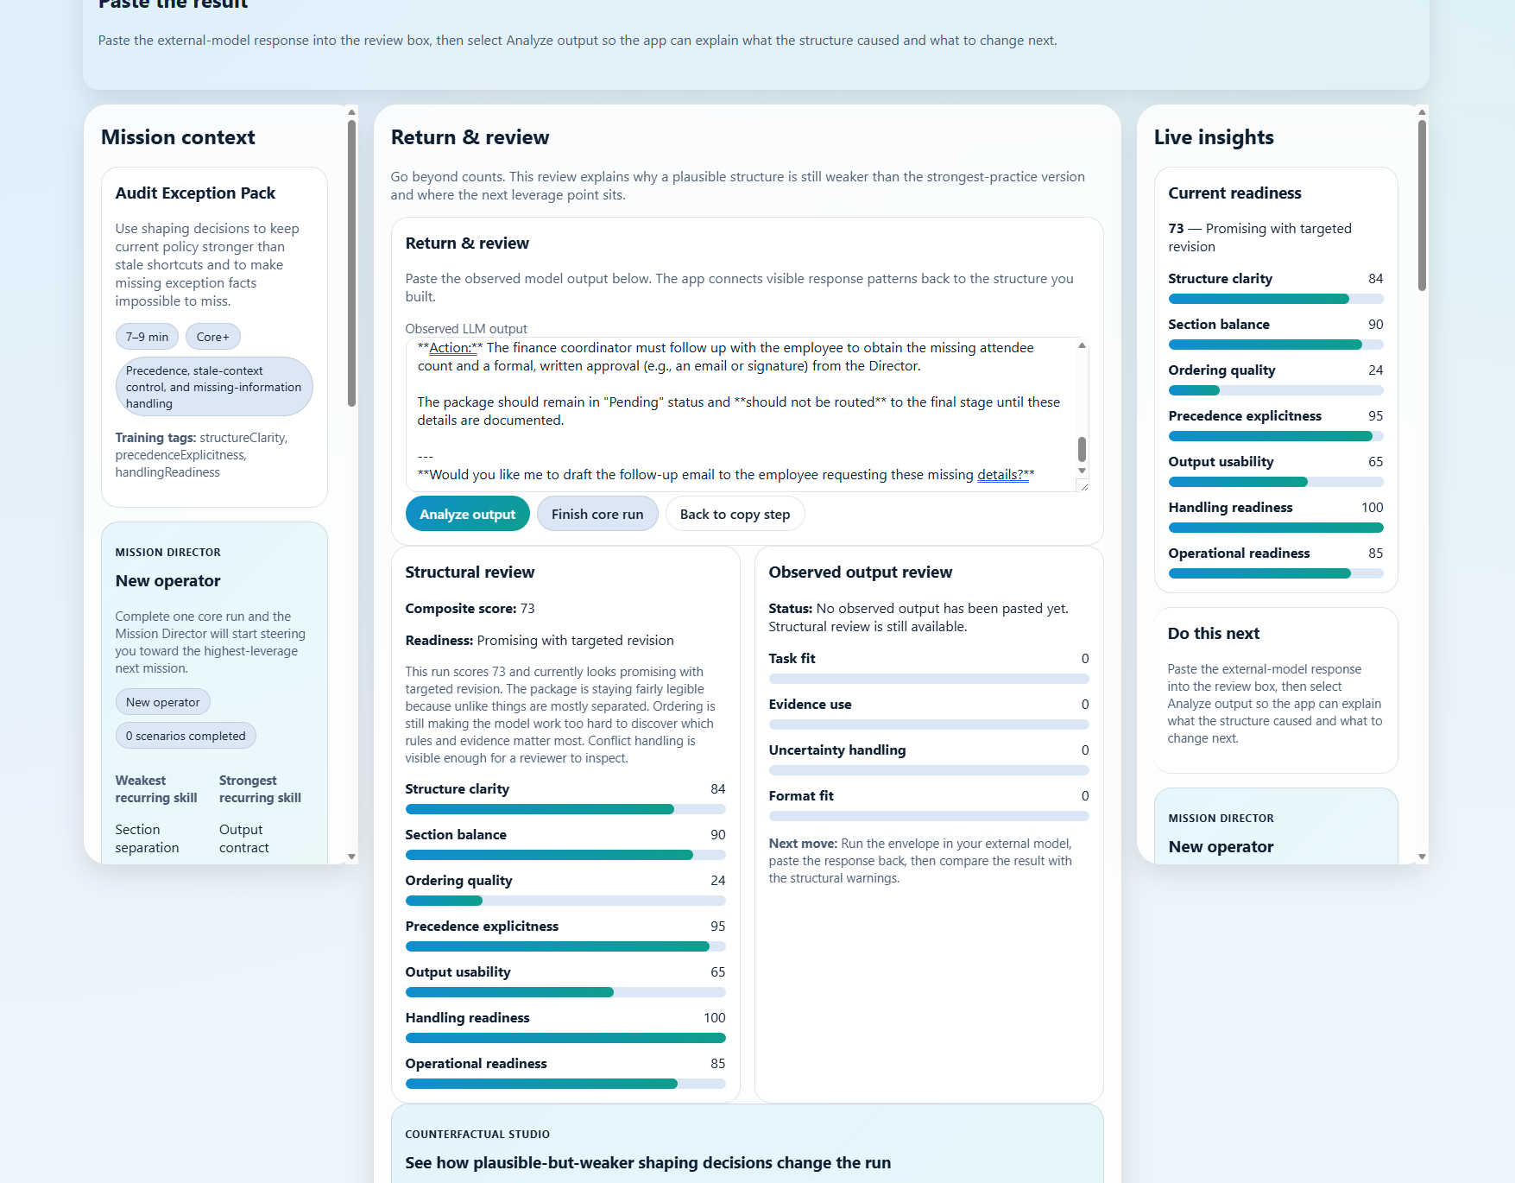
Figure 6. Return & Review combines the pasted external response, structural review, observed output review, and the beginning of Counterfactual Studio in one stage.

What the live metrics mean
Metric | What it represents
Current readiness | A composite summary of how usable the current envelope looks for a short-run external test.
Structure clarity | Whether unlike things are staying distinct and the package remains legible.
Section balance | Whether sections are present and not overloaded for a short-session envelope.
Ordering quality | Whether the sequence helps the model find the governing logic before the task and output request.
Precedence explicitness | Whether the package clearly states what source wins when materials conflict.
Output usability | Whether the answer contract is explicit and reviewable.
Handling readiness | Whether missing-information behavior is operationally safe and visible.
Operational readiness | Whether the package is structured for repeated use, handoff, and inspection.

Readiness is useful, but it should never replace reasoning. CES can tell you that a package is promising, but the most valuable lesson still comes from understanding why the score moved, what section is exposed, and what change would improve the package next.

Structural review versus observed output review
CES separates two kinds of evaluation. Structural review is available even before you paste a model response back. It judges the package itself. Observed output review only becomes meaningful after you paste the external result into the review box.
The output review is heuristic rather than authoritative. The current build checks for scenario-specific response signals such as required phrases, preferred phrases, uncertainty handling, and format markers. That makes it useful for learning and comparison, but it does not replace human judgment.
How to use scores well
Treat the metrics and output review as coaching signals. They are strongest when they help you explain why the package worked or failed, not when they tempt you to chase a higher number without understanding the structure.

Mission Director and Counterfactual Studio
Mission Director uses local run history to recommend the next scenario and identify the skill area that is currently weakest across your recent work. It appears on the launch stage, in the side rails, and again in the Run Summary.
Counterfactual Studio is different. It helps you compare your current envelope to strongest practice and to one or more plausible-but-weaker variants. The goal is not to memorize a single perfect answer. The goal is to see how seemingly reasonable shaping decisions still degrade reviewability, evidence use, or uncertainty handling.
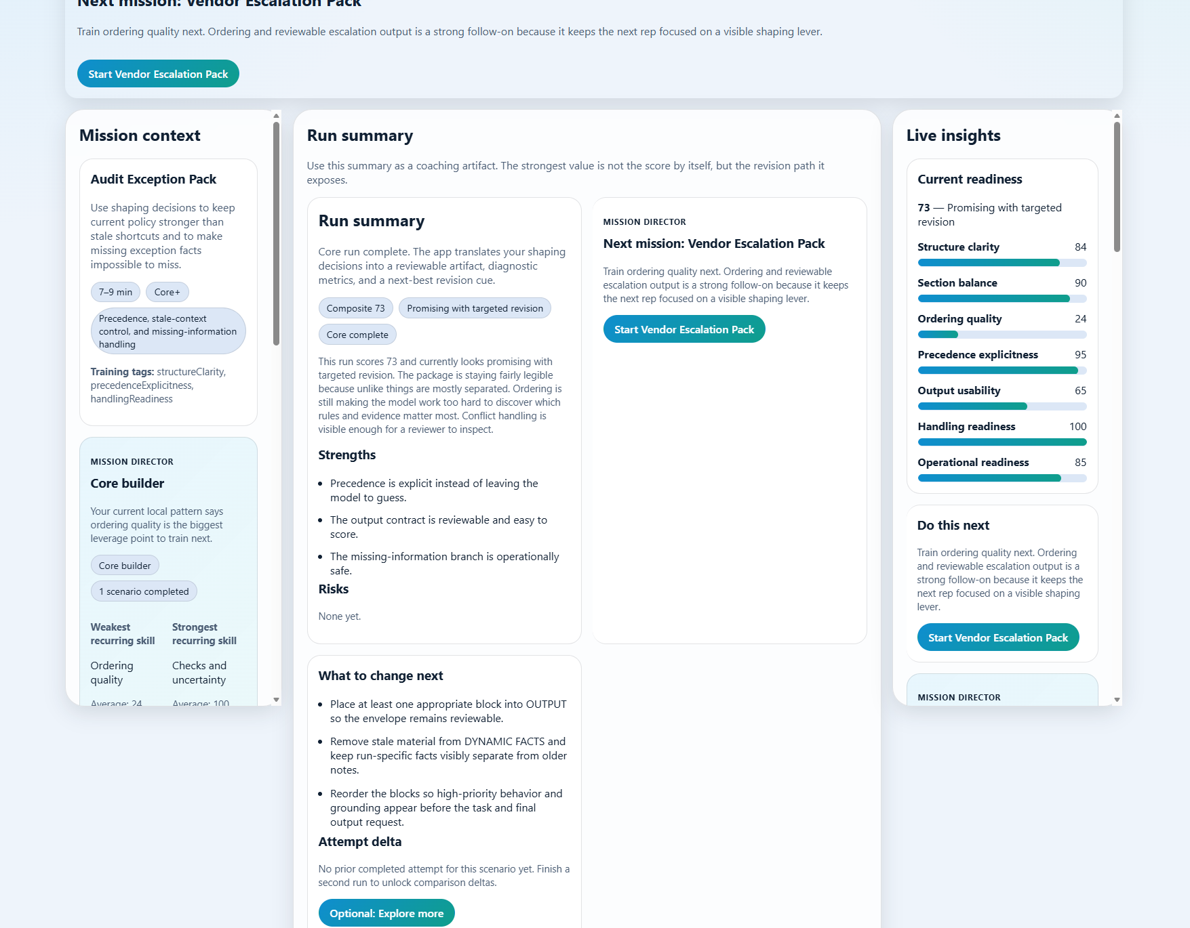
Figure 7. Run Summary translates the completed attempt into strengths, next changes, replay options, learner artifact actions, and the next mission recommendation.

Learner artifacts, replay, and restart
Run Summary gives you several useful end-of-run actions. You can copy the learner artifact, print the learner artifact, replay the same pack, or restart fresh. Replay helps when you want an apples-to-apples second attempt on the same scenario. Restart fresh is better when you want to wipe the current run and begin again cleanly.

7. Choose the right scenario pack for the lesson you want
CES currently includes seven authored scenario packs. The launch screen shows their timing, difficulty, and the chapter concept each one highlights. Use that information to decide whether you want a shorter core repetition or a more demanding practice run.
Scenario pack | Time | Difficulty | Primary chapter concept
Policy Answer Pack | 6–8 min | Core | Section separation and output contract
Escalation Response Pack | 7–9 min | Core+ | Precedence and missing-information handling
Process Handoff Pack | 6–8 min | Core | Operational readiness and CHECKS
Status Brief Pack | 6–8 min | Core | Dynamic facts and stale-context control
Vendor Escalation Pack | 7–9 min | Core+ | Ordering and reviewable escalation output
Audit Exception Pack | 7–9 min | Core+ | Precedence, stale-context control, and missing-information handling
Cross-Team Handoff Variation Pack | 7–9 min | Core+ | Operational readiness, handoff clarity, and strongest-practice comparison

If you want the shortest path into the app, choose one of the packs labeled Core and timed at 6–8 minutes. If you want a slightly more demanding run with more visible tradeoffs around precedence or missing-information handling, choose one of the Core+ packs.
After you have completed a few runs, it often makes sense to follow the Mission Director recommendation rather than picking randomly. That helps you turn repeated use into targeted skill building instead of general familiarity.

8. Optional areas: Explore More, Innovation Labs, and the authoring appendix
Everything through Run Summary is the core learner experience. The areas below are optional by design and should not be treated as required steps for every run.
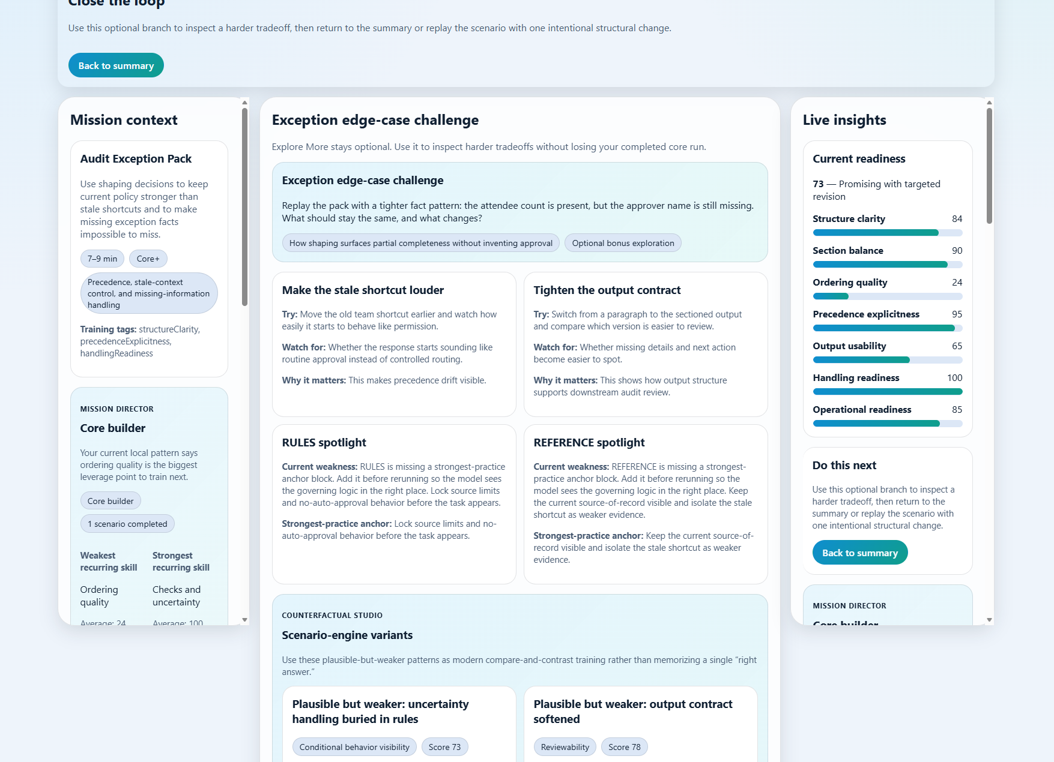
Figure 8. Explore More stays separate from the core run and lets you inspect a bonus variation without losing the completed summary.

Explore More
Explore More appears after the core run and extends the lesson with a harder tradeoff, spotlight cards, and scenario-engine variants. It is useful when you already understand the main run and want one more targeted experiment. It is not the place to start if you are still trying to understand the main scenario.
The key advantage of Explore More is that it keeps core completion intact. You can stress-test the package, inspect a bonus branch, then return to Summary or replay the same scenario with one intentional structural change.

Innovation Labs
Innovation Labs lives on its own separate page and remains optional. The build currently includes nine modular lab features organized across three categories.
Category | Included labs
Education | Teachable Doppelgänger • Productive Failure Time Machine • Calibration Market
Visual | Claim-Evidence Constellation • Context MRI • Session Hologram Replay
Context Engineering | Authority Firewall Simulator • Trajectory Auditor • Prompt Card + Claim Ledger

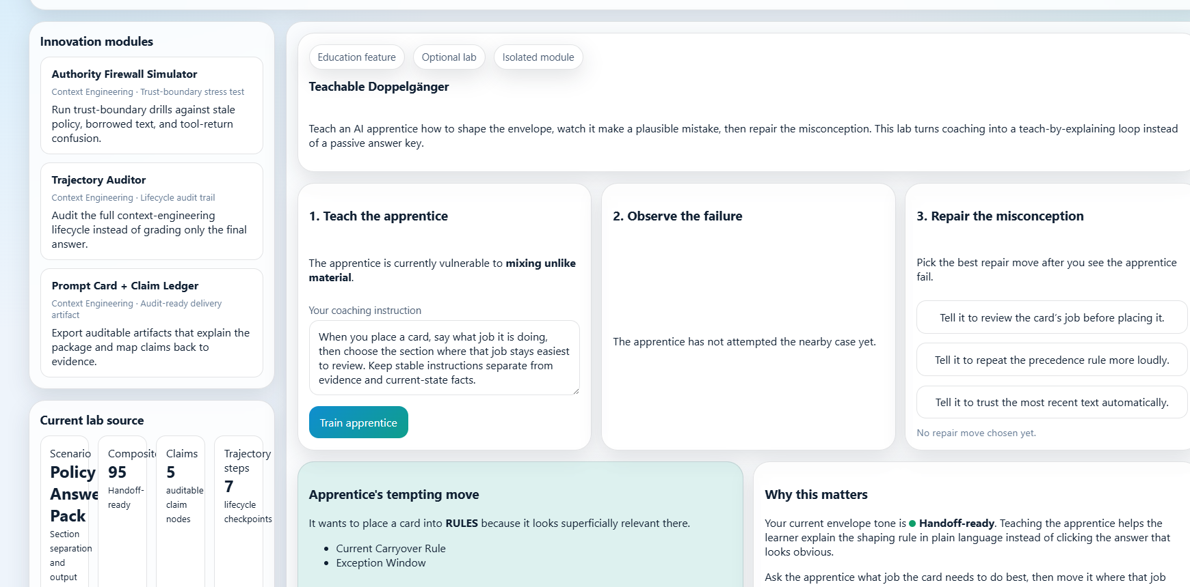
Figure 9. Innovation Labs is a separate optional runtime that hosts modular experiments without crowding the main studio flow.
Because the labs page is separate, you can use it when you want additional experiments without disrupting the clean core-run path. This is helpful when you want teach-by-explaining practice, visual evidence exploration, or context-engineering stress tests after the main lesson is already clear.

Appendix A. Scenario authoring workspace (contributor-oriented)
The Authoring Workspace is not part of the normal learner path. It is intended for contributors who want to start from a proven scenario, generate scaffolds, validate a draft, and export JSON without adding any server dependency or direct model integration.
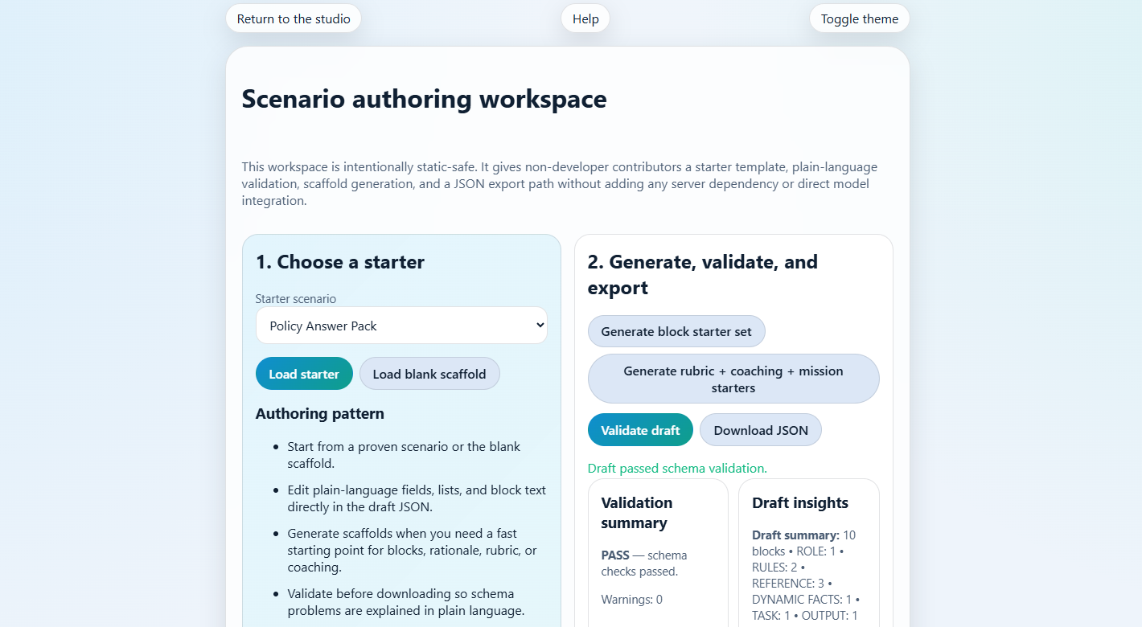
Figure 10. The Authoring Workspace is a separate static-safe page for contributors, not a required learner step in the core studio run.
Authoring workspace capability | What it supports
Starter loading | Open a proven scenario or a blank scaffold.
Scaffold generation | Generate block starter sets, rubrics, coaching, and mission starters.
Validation | Check the draft against the scenario schema and surface plain-language issues.
Engine preview | Preview authoring signals such as mission tags and counterfactual count.
JSON export | Download the draft as a local JSON file for review and versioning.

9. Troubleshooting and FAQ
Question or issue | What to do
The app opens as file navigation instead of a local site. | Use the supplied startup batch file instead of opening index.html directly through file:// navigation.
Copy envelope did not work. | Try the clipboard fallback or manual copy. Some browser profiles restrict navigator.clipboard.
Print learner artifact did not open. | Allow popups in the browser and try Print learner artifact again.
My progress or history disappeared. | CES stores state locally in the browser. Highly restricted or private browsing modes can prevent local persistence.
I do not see Resume current run. | That action only appears when a saved in-progress run exists for the current scenario.
Should I use Explore More on my first attempt? | Usually no. Finish the core run first, then use Explore More for one deeper contrast or replay.
Do I need Innovation Labs to complete CES? | No. Innovation Labs is optional and lives on its own separate page.
How should I interpret a low score? | Use it as a diagnosis, not a verdict. Look at section emptiness, ordering, precedence, output contract, and missing-information handling first.

10. Glossary and quick reference
Term | Meaning in CES
Context package | The full operating input for a task: role, rules, evidence, dynamic facts, output requirements, and the current request.
Context envelope | A deliberate structure that separates ROLE, RULES, REFERENCE, DYNAMIC FACTS, TASK, OUTPUT, and CHECKS.
Signal-to-noise ratio | A judgment about whether included text materially helps the answer or merely competes for attention.
Precedence | The explicit statement of what should win if sources, rules, or facts conflict.
Stale context | Old information that stays in the package and quietly overrides newer facts or requirements.
Operational reliability | The ability of a workflow to produce acceptable outputs repeatedly, not just once in a demo.
Representative test case | A realistic input used to evaluate whether the current package works on normal, edge, and failure-prone cases.
Mission Director | The local-only coaching layer that recommends a next mission and surfaces the weakest recurring skill in recent run history.
Counterfactual Studio | A compare-and-contrast view that shows your current envelope, strongest practice, and plausible-but-weaker variants.
Learner artifact | A locally generated summary artifact that captures the run, metrics, and revision cues for review or printing.
Explore More | An optional post-summary branch that lets you inspect a bonus challenge without replacing the completed core run.
Strongest practice | The scenario’s reference arrangement for section placement and decision choices; useful as a comparison anchor rather than as something to memorize blindly.

Quick control reference
Control | What it does
Start new run | Begins a fresh attempt for the selected scenario pack.
Resume current run | Returns to the saved in-progress run for the current scenario.
Clear current run | Clears the active stored run from the current browser context.
Coach this card | Opens targeted card coaching before or after placement.
Go to Copy & Run | Moves you from the studio into the external-test step.
Analyze output | Reads the pasted external answer and generates heuristic output-review cues.
Copy learner artifact | Copies the generated summary artifact for sharing or reflection.
Print learner artifact | Opens the local print view for the generated artifact.
Replay this pack | Starts another attempt on the same scenario for comparison.
Restart fresh | Resets the current run without switching scenario packs.

Final takeaway
Context Envelope Studio teaches a simple but durable idea: output quality is constrained by input structure. When the package keeps role, rules, evidence, current facts, task, output contract, and checks visibly separate, the model has a far better chance of behaving in a way that another person can inspect and trust.

