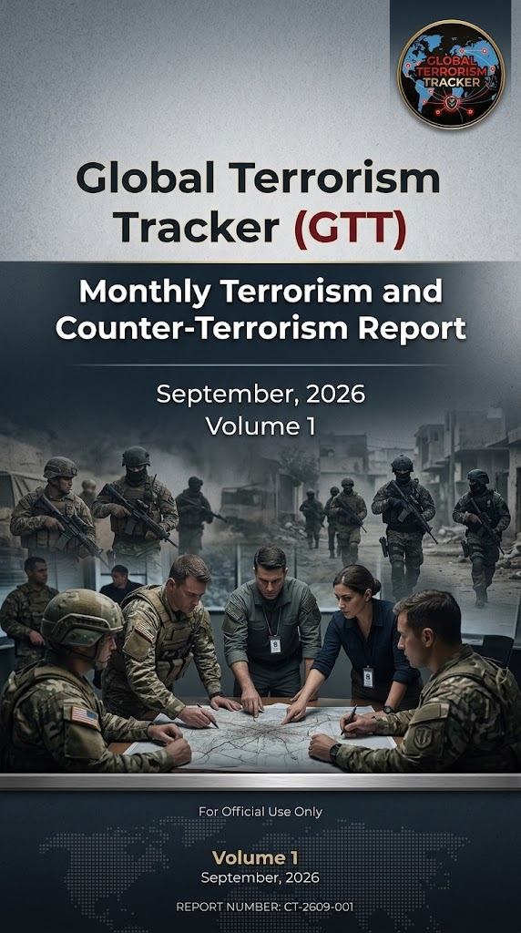
ABOUT US
GTT-Global Terrorism Tracker documents and analyses terrorism and security developments around the world through structured reporting, incident tracking, and analytical coverage. The platform provides monthly reporting on terrorist incidents and security operations, alongside analytical coverage of major incidents and developments in terrorism and security.

Copyright © 2026. All Rights Reserved

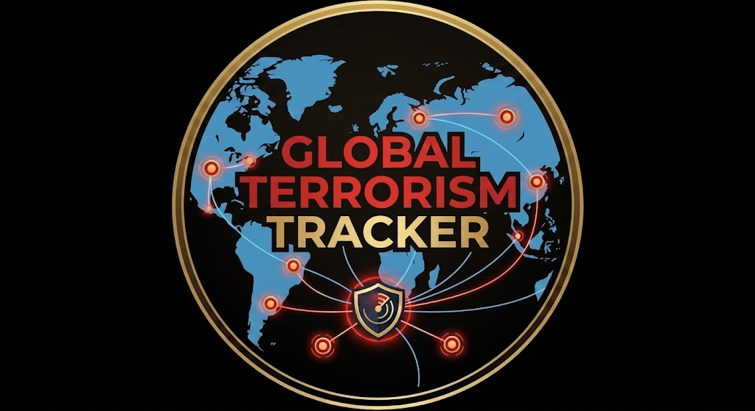
Published by: Syeda Farani Fatima
Edited by: Syeda Farani Fatima

Contents
Executive Summary 4
Most Active Terrorist Organisations 4
Geographic Distribution of Terrorist Attacks 5
South Asia 6
Middle East and North Africa 6
Sub-Saharan Africa 6
Isolated Incidents 6
Daily Incident Dynamics 7
Major Counter-Terrorism (CT) Operations 7
Emerging Technological Trends & Tactics in Warfare 8
War Crimes & Targeted Civilian Attacks 9
Recommendations for Global Counter-Terrorism Policy 9

Executive Summary
The strategic environment of global security throughout September 2026 was defined by a highly volatile operational landscape. State actors maintained offensive postures to neutralise persistent threat networks across war zones and porous border regions. Simultaneously, non-state actors adapted to state security pressure by combining conventional hit-and-run guerrilla tactics with emerging commercial technologies. This operational dynamic generated severe strategic friction, as high-intensity military campaigns increasingly blurred the line between legitimate anti-terror targeting and indiscriminate actions resulting in war crimes and severe civilian harm.
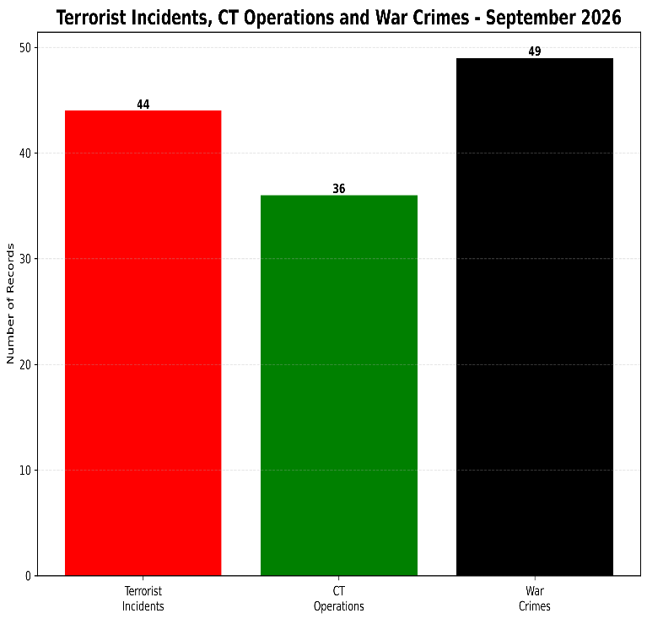
During September 2026, the Global Terrorism Tracker (GTT) recorded a total conflict volume of 129 distinct recorded events, comprising 44 terrorist incidents, 36 counter-terrorism operations, and 49 war crimes. This resulted in an aggregate casualty toll of 1,230 individuals, divided into 561 terrorist casualties, 466 civilian casualties, and 203 military/security casualties. An evaluation of key theatre sectors reveals distinct regional operating environments: South Asia served as the primary violent epicentre characterised by heavy borderland skirmishes; the Middle East experienced a dual friction of high-intensity insurgent engagements and urban maritime/cross-border strikes; Eastern Europe saw persistent targeting of civilian energy infrastructure; and Sub-Saharan Africa remained vulnerable to sweeping rural massacres and coordinated raids on state military infrastructure.

Most Active Terrorist Organisations
Group | Region | Tactics | Incident Count
Tehreek-e-Taliban Pakistan (TTP) | South Asia (Pakistan/Afghan Border) | Checkpost strikes, Polio team ambushes, VBIEDs | 6
Baloch Liberation Army / Baloch Liberation Front (BLA/BLF) | South Asia (Pakistan/Balochistan) | Majeed Brigade suicide attacks, Highway abductions, Convoy ambushes | 5
Hamas | Middle East (Palestine/Gaza) | Militant engagements, Tactical command defense | 3
Houthis (Ansar Allah) | Middle East (Yemen/Saudi Border/Red Sea) | Ballistic missile strikes, Cross-border UAV attacks, Maritime disruption | 3
Jama'at Nusrat al-Islam wal-Muslimin (JNIM) | Sub-Saharan Africa (Mali/Burkina Faso) | Coordinated airbase/military school raids, Supply convoy ambushes | 2
Al-Shabaab | Sub-Saharan Africa (Somalia) | VBIED / Suicide bombings at public venues | 2
ISIS / ISKP | Global / Middle East / South Asia | Infiltration plots, IED attacks, Propaganda generation | 2
Allied Democratic Forces (ADF) | Sub-Saharan Africa (DR Congo) | Nighttime village massacres, Civilian abductions | 2

In urban centres, high-profile combined arms operations were exemplified by JNIM's assault on a military training school and international airport in Bamako, Mali, which resulted in 77 total fatalities (20 civilians, 50 military personnel, and 7 terrorists), along with 100 injured, and Al-Shabaab’s lethal suicide VBIED attack targeting a public tea shop in Mogadishu, Somalia.
In Gaza, Hamas centred its operational capacity on tactical command, defence, and localised engagement with advancing state forces. Beyond localised land campaigns, the Houthis (Ansar Allah) projected power across the Saudi border and Red Sea shipping lanes using ballistic missiles and long-range UAVs
In Pakistan, the BLA Majeed Brigade conducted highway blockades and passenger abductions on the N-25 corridor while deploying its first female suicide bomber against a military convoy in Kech, Pakistan. In contrast, the TTP executed low-intensity check post raids, landmine strikes, and targeted ambushes against police escorts guarding polio vaccination teams in Noshki, Balochistan.
In the Democratic Republic of Congo, the ADF executed night raids on rural villages in Ituri and North Kivu, utilising massacres and abductions to erode local governance. Transnational networks, such as ISIS/ISKP, maintained persistent pressure through checkpoint IED detonations in Herat and covert propaganda and infiltration plots globally.

Geographic Distribution of Terrorist Attacks
Mapping incident frequency enables security analysts to identify where non-state groups maintain structural advantages versus areas where state containment strategies actively suppress operational capability.

South Asia
South Asia emerged as the global epicentre for non-state extremism in September 2026, driven primarily by activity within Pakistan, which accounted for 12 recorded terrorist attacks (27.3% of the global total). The concentration of violence along the Pak-Afghan border and within Balochistan underscores the persistent challenge posed by cross-border insurgent sanctuaries and deeply rooted ethno-nationalist and religious militant networks targeting state security infrastructure and economic transit routes.

Middle East and North Africa
The Middle East and North Africa (MENA) represented the second largest cluster of terrorist activity, characterised by cross-border missile strikes and maritime security disruptions. Saudi Arabia recorded 7 attacks (15.9%), primarily stemming from cross-border long-range unmanned aerial vehicle (UAV) and ballistic missile strikes launched by Yemen-based Houthi militants targeting southern regional energy facilities, power grids, and military installations. Additional attack clusters occurred across Palestine (3 attacks / 6.8%), Yemen (2 attacks / 4.5%), Syria (1 attack / 2.3%), Iran (1 attack / 2.3%), and the Palestine/Israel border (1 attack / 2.3%).

Sub-Saharan Africa
In Sub-Saharan Africa, rural attack patterns were distributed across Nigeria (3 attacks/6.8%), Somalia (3 attacks/6.8%), Mali (2 attacks/4.5%), DR Congo (2 attacks/4.5%), and Burkina Faso (2 attacks/4.5%), where insurgent factions targeted civilian transport convoys, isolated villages, and state military posts.

Isolated Incidents
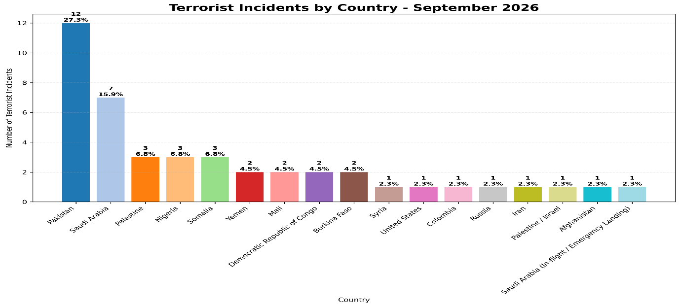
Isolated global incidents were recorded in the United States (1 attack / 2.3%, specifically attributed to the San Diego Mosque shooting indictment), Colombia (1 attack / 2.3% involving ELN drone strikes on military compounds), Russia (1 attack / 2.3% via drone strikes on industrial facilities), Afghanistan (1 attack / 2.3% via an ISKP checkpoint IED in Herat), and Saudi airspace (1 attack / 2.3% stemming from an in-flight hijacking attempt on an Israel-bound airliner).

Daily Incident Dynamics
Tracking daily attack tempos assists defence analysts in anticipating operational cycles and identifying recovery windows following major state intelligence operations.
Throughout September 2026, the global terrorist incident maintained an overall average of approximately 1.47 attacks per day across the 30-day monitoring period. Operational activity fluctuated markedly throughout the month, with primary activity peaks on September 1, September 13, and September 15, with each day recording 4 distinct terrorist attacks globally. Secondary activity spikes occurred on September 9, September 19, September 24, September 28, and September 29, each registering 3 incidents per day.
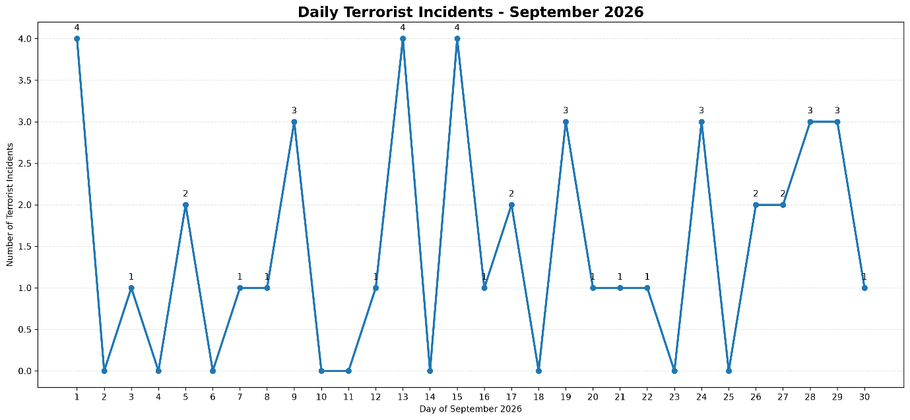
Operational lulls-periods recording 0 terrorist attacks- were observed on September 2, 4, 6, 10, 11, 14, 18, 23, and 25, frequently followed by high-tempo state counter-terrorism operations or major non-state offensive pushes. These lulls reflect tactical reset periods during which non-state cells replenish munitions, evade military sweeps, and reorganise leadership structures following state counter-strikes.

Major Counter-Terrorism (CT) Operations
Counter-terrorism operations serve as a vital mechanism for state forces seeking to degrade non-state leadership nodes and disrupt active operational plots before their execution. As contextualised in the monthly conflict metrics (36 CT operations), state militaries and law enforcement bodies executed targeted interdictions worldwide to neutralise combatants and secure vulnerable populations.
In September 2026, state security forces conducted 36 major counter-terrorism operations worldwide, resulting in the neutralisation of 561 terrorists. Furthermore, counter-terrorism interventions led to the successful rescue of 38 hostages who were abducted by non-state factions. Key hostage recovery operations included the liberation of 23 abductees during a high-stakes clearance operation along the N-25 highway corridor near Kalat, Pakistan, and the rescue of 15 hostages during jungle clearance operations in Borno and Kaduna states, Nigeria.
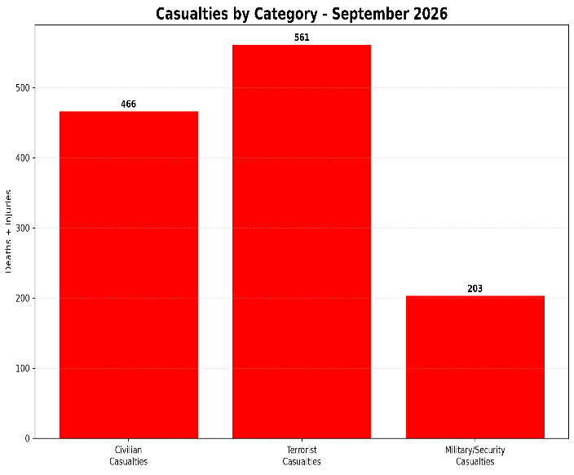
At the execution level, state operations demonstrated high tactical efficacy while driving non-state operational shifts. In Pakistan, the Inter-Services Public Relations (ISPR) and Counter-Terrorism Departments (CTD) carried out Intelligence-Based Operations (IBOs) across Mastung, Kalat, Panjgur, Chagai, and Khyber Pakhtunkhwa. Notably, the ISPR sweep along the N-25 highway near Kalat directly affected the recovery of the 23 abducted passengers while eliminating 5 militants. Crucially, intense state counter-terrorism pressure, such as ISPR's elimination of 48 militants in Balochistan over 72 hours, forced non-state networks to adapt strategically.
In the Middle East, US CENTCOM partner raids in Anbar Province, Iraq, neutralised 14 ISIS operatives, while a precision drone strike in Idlib, Syria, eliminated a senior Hurras al-Din commander.
In West Africa, the Nigerian Defence Headquarters (DHQ) Operation FANSAN YAMMA forces conducted forest clearance sweeps across Zamfara, Kaduna, and Borno, directly securing the rescue of 15 hostages alongside the arrest of key weapons couriers.
Groups, such as the BLA Majeed Brigade, pivoted toward softer asymmetric targets, expanding civilian highway abductions along the N-25 corridor and employing female suicide bombers against military convoys in Kech. These evolving tactical dynamics underscored the necessity for state forces to adapt to the rapid technological evolution of non-state warfare.

Emerging Technological Trends & Tactics in Warfare
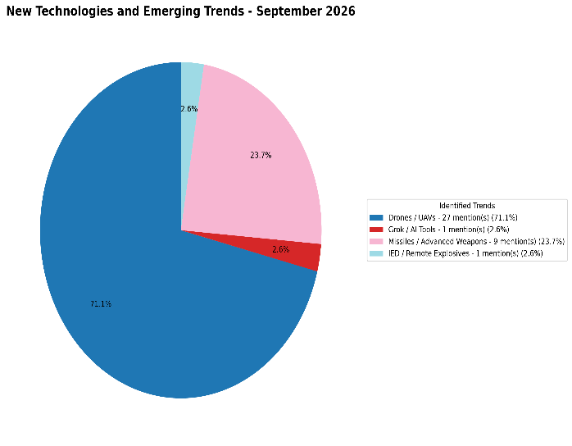
An empirical analysis of technological trend data identified across conflict records in September 2026 revealed a heavy concentration of commercial aerial and advanced weapon systems. Drones and Unmanned Aerial Vehicles (UAVs) dominated technological trends, accounting for 27 distinct mentions (71.1% of identified technological occurrences). Missiles and Advanced Ordnance represented the second most prevalent category with 9 mentions (23.7%), while Grok/AI Tools and IEDs/Remote Explosives accounted for 1 mention each (2.6% respectively).
Tactical integration data highlight a growing reliance on first-person view (FPV) drones and loitering munitions, observed extensively along Eastern European frontline sectors and along the Pak-Afghan border to target border outposts and critical infrastructure. Parallel to aerial systems, non-state groups increasingly leverage commercial generativ e AI platforms, with distinct operational bifurcations: Yemeni Houthi networks specifically exploited Anthropic AI models to assist in engineering and guided missile design, whereas Boko Haram and ISWAP cadres in West Africa leveraged platforms like ChatGPT and Grok to automate multi-language propaganda dissemination and streamline operational planning. The deployment of these advanced stand-off capabilities directly contributed to an increase in civilian casualties and severe violations of international humanitarian law.

War Crimes & Targeted Civilian Attacks
The human cost of conflict during September 2026 was exacerbated by targeted civilian attacks and structural violations of international humanitarian law. Synthesising the metric of 49 recorded war crimes resulting in 466 civilian casualties (deaths and injuries), a significant proportion of harm stemmed from indiscriminate strikes on protected civilian zones and medical infrastructure.
In Sudan, Rapid Support Forces (RSF) artillery bombardments directly struck the Al-Saudi Hospital in El Fasher, North Darfur, killing 18 civilians and damaging critical emergency wards. In Myanmar's Rakhine State, the Military Junta Air Force executed a direct airstrike on a crowded public marketplace in Kyauktaw, resulting in 50 civilian deaths and dozens of severe burn injuries.
In the Gaza Strip, fragile truce periods were repeatedly compromised by direct military strikes on civilian transport vehicles, residential quarters, and commercial taxis, resulting in multiple localised mass-casualty events.
Concurrently, in Eastern Europe, long-range aerial and missile bombardments systematically targeted civilian energy grid stations, municipal water infrastructure, and residential apartment complexes across Ukrainian urban centres and Russian border communities.

Recommendations for Global Counter-Terrorism Policy
To counter the primary threat vectors identified in September 2026, international security stakeholders and defence ministries must immediately prioritise procuring and deploying mobile, multi-layered anti-UAV electronic warfare (EW) jamming infrastructure along high-risk border corridors, critical energy assets, and remote military forward operating bases. Furthermore, international policy frameworks must mandate hardened structural protections, automated early-warning systems, and specialised security protocols for healthcare infrastructure and humanitarian supply escorts operating within active conflict zones, ensuring strict accountability mechanisms for non-state and state entities violating international humanitarian law.
