Hi gtu001,  
  
你好，更换数据线是不会导致定位问题的，建议你重新设置下基站，并重新摆放下基站的位置和距离（应与头显保持1.5米的距离），按照如图所示

Sorry for the inconvenience.

Please check the following instructions and perceive whether it could solved your issue.

Hi gtu001,  
  
线其实和定位没有关系，定位是和头显的定位小板以及基站位置等有关系。线是输出视频信号和供电

的。

​你可以更新下新固件和最新版的pitool试试看。

Call Service:

**United States**

(714)581-9199

**Europe**

+46840304731

**Japan**

+815032050856

**Tracking issue related**

**1.Different channels for base stations:**

Please ensure you have set different channels for each base station.

 VIVE 1.0:

 - If there is only one base station in your hands, please set as channel b;

 - If there are two base stations in your hands, please set one is channel b and another is channel c.

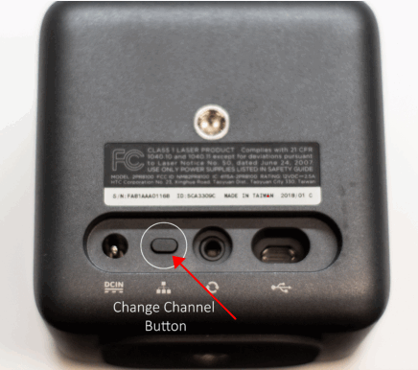

 VIVE 2.0 / Index:

 - You could set 16 different channels for VIVE 2.0 or Index base station.

For base station channel, you could poke the hole at the back of base station to change them to different channels.

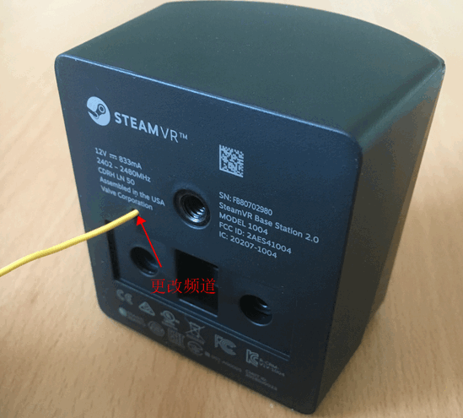

 You can see the channel status of base stations at the steamvr status window.

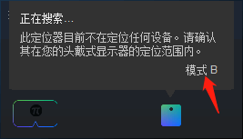

**2.Pitool setting:**

Please ensure you have chosen the item " lighthouse " in Pitool setting as below.

If you do not have base station, you could choose 9-Axis for seated mode games.

**3. Position of base station**

**Please make sure the distance is more than 1.5m between the headset and base station when you are playing the game, or**

**the traching will be lost. Please ensure the height of the base station is about 2m as well.**

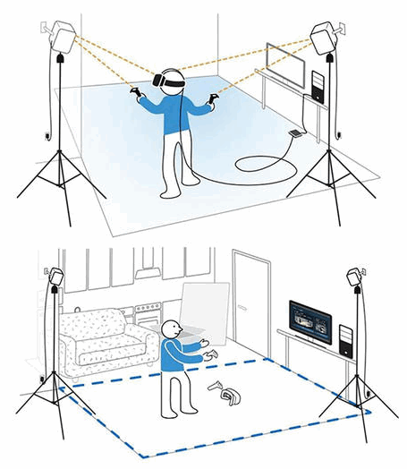**4. Delete configuration files**

**When you find the headset is not tracked, delete the file from**

C:\ProgramData\pimax\runtime\config\lighthouse (Don’t worry. They’ll be

 recreated automatically when you restart the service in the next steps)

Click "restart service" on the Pitool as below:

[pitool界面头盔显示未定位，手柄灯塔未就绪如何解决？](https://cn.pimaxvr.com/faq)

首先拿起头盔（请用手拿头盔的绑带，避免挡住头盔的内置接收器），正对着灯塔左右甩动数次，如果仍然未解决请删除config文件夹“C:\ProgramData\pimax\runtime\config”后重启Piservicelauncher服务项

Now, please check whether the headset is tracked.

**5. Lighthouse console - LHR device**

Make sure the tracking board inside the headset (LHR-XXX) is detected by the lighthouse console:

      Launch the program of "lighthouse_console.exe" under "C:\Program Files\Pimax\Runtime".

If there is no LHR-xxx receiver found as below, please consider to reset the tracking board to fix it.