SEG 2105 Assignment 5

One line problem statement
Having a shared grocery list between members of the family has became impractical with today’s advances in technology.

Short paragraph describing the requirements (just like the requirements outline I used for the manufacturing plant controller, the airline system, or assignment 4; although keep your system simpler than these)
This application is about a grocery list accessed by users.
The list can have many entries.
Each entry has a boolean property “checked”, a creator username and the username of the one who checked it (in the case where checked is true) and an id.
Each user has an username and can add an entry, edit, check, uncheck and delete it. The users will access the grocery list by connecting to a server which stores the entries in a database.

List of use cases or user stories (typically 2-5). Each of these should be 1-5 lines or so.

Case 1: Connecting and quitting the application
Actors: any user
Goals: view all entries in the list and disconnect at the end of use
Preconditions: the server has to be started and connected to the database
Summary: Allows users to connect to the application and view all the entries in the list and their state. At the end, the user exits the application
Related use cases: none
Steps:
- User connects to the application | - User is requested to enter a username
- User enters a username and confirms | - The grocery list appears
- User exits the application by pressing the “close” button
Postconditions: none

Case 2: Adding an entry
Actors: any user
Goals: add an entry to the grocery list
Preconditions: the server has to be started and connected to the database. The user has to be connected to the system (case 1, step 4)
Summary: Allows users to add an entry to the grocery list.
Related use cases: case 1
Steps:
- The user inputs an entry description in the description box, at the bottom of the list. | - The user confirms the entry. The entry appears at the bottom of the list.
Postconditions: none.

Case 3: Editing an entry
Actors: any user
Goals: edit an entry in the grocery list
Preconditions: the server has to be started and connected to the database. The user has to be connected to the system (case 1, step 4). There has to be a minimum of one entry in the list.
Summary: Allows users to edit an entry in the grocery list.
Related use cases: case 1
Steps:
- The user selects an entry. | - The user changes the description of the entry.
- The user confirms the new description. The entry gets updated.
Postconditions: none.

Case 4: Checking an entry
Actors: any user
Goals: Check an entry in the grocery list
Preconditions: the server has to be started and connected to the database. The user has to be connected to the system (case 1, step 4). There has to be a minimum of one unchecked entry in the list.
Summary: Allows users to check an entry in the grocery list.
Related use cases: case 1
Steps:
- The user checks the checkbox of an entry. The entry appears in italic font at the bottom of the checked entries.
Postconditions: none.

Case 5: Deleting an entry
Actors: any user
Goals: Delete an entry in the grocery list
Preconditions: the server has to be started and connected to the database. The user has to be connected to the system (case 1, step 4). There has to be a minimum of one entry in the list.
Summary: Allows users to delete an entry in the grocery list.
Related use cases: case 1
Steps:
- The user selects and entry. | - The user removes the entry from the list by clicking pressing a button.
Postconditions: none.

Case 6: Unchecking an entry
Actors: any user
Goals: Uncheck an entry in the grocery list
Preconditions: the server has to be started and connected to the database. The user has to be connected to the system (case 1, step 4). There has to be a minimum of one checked entry in the list.
Summary: Allows users to uncheck a checked entry in the grocery list.
Related use cases: case 1
Steps:
- The user unchecks the checkbox. The entry appears in normal font at the bottom of the unchecked entries.
Postconditions: none.

A couple of paragraphs describing the architecture: What technologies and programming languages are you going to use? What will the client do, what will the server do?
For this project, we will use Java as a programming language, along with the OCSF server. We will also use a database a Postgres database from Heroku to store the entries. For the GUI design, we will be using the WindowBuilder Eclipse plugin.
When the server is started, it will connect to the database and listen for user connections. When the server receives a connection from a client, it asks the user for a username and will fetch the content of the database and show it to the client. The server can receive upload, edit, check, uncheck and delete commands from the user. It will send the new message or update to the server, depending on the command received.
When the client connects to the server, he/she will be prompted to enter a username. They will then be able to see the contents of the grocery list. The client can add, edit, check, uncheck and delete entries. Each command will be sent to the server as a request.

First draft of the UML class diagram (system domain model). Minimum 3 classes; suggested absolute maximum 10 classes.
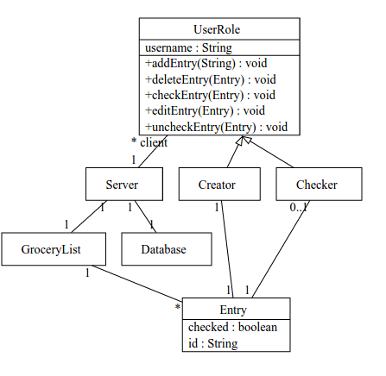

List of messages you expect to transmit to the server from the client and from the client to the server. (half a page)

Messages from the client to the server

- client sends the command to add an entry, along with its description
- client sends the command to edit an entry, along with the Entry id
- client sends the command to check an entry, along with the Entry id
- client sends the command to uncheck an entry, along with the Entry id
- client sends the command to delete an entry, along with the Entry id

Messages from the server to the client

- server displays updated grocery list after processing command from client

