Software Design Lab 2
Build Maze Game with Creational Patterns
Goal:
Practice Factory Method Pattern, Abstract Factory Pattern, and Prototype Pattern
Requirements:
- Adding the Red Maze Game and Blue Maze Game feature in addition to the basic function. The Red Maze Game will have pink rooms, red walls and purple doors. The Blue Maze Game will have light gray rooms, brown door and blue Walls.
- Modify the maze game you accomplished in lab 1 to use Factory Method pattern.
- Compile the new program to show basic, red or blue maze games.
- Modify the maze game you accomplished in lab 1 to use Abstract Factory pattern.
- Compile the new program to show basic, red or blue maze games.
- Modify the abstract factory maze game to add a prototype pattern
- Compile the new program to allow the users to specify the colors of maze component.

Instructions
This lab has the following stages:
Hint: in order to change colors of the doors, rooms, etc, you need to
- Import Color library using :
import java.awt.Color;
- Override the getColor() method defined in MapSite.java. For example, if you want a wall to be blue, the code should look like:
public Color getColor() {
return Color.BLUE;
}

Stage 1: Apply Factory Method Pattern
- Select a working directory
- Copy and paste the basic maze game in lab 1 to the working directory
- Modify the basic maze game according to the Factory Method UML model:
  - Modify the SimpleMazeGame class into a MazeGameCreator class, add factory methods and change the main method accordingly
  - Run the new program
- Add a Red Maze Game Feature
  - Add necessary red maze game classes, such as a new pink room class.
  - Add a new RedMazeGameCreator class
  - Change the main method to accept a “red” parameter
  - Run the new program with “red” option
- Add a Blue Maze Game Feature
  - Add necessary blue maze game classes, such as a new light grey room class.
  - Add a new BlueMazeGameCreator class
  - Change the main method to read both “red” and “blue” parameters
  - Run the new program with both “red” and “blue” options

Stage 2: Apply Abstract Factory Pattern
- Select a working directory
- Copy and paste the basic maze game in lab 1 to the working directory
- Modify the basic maze game program according to the Abstract Factory UML diagram:
  - Modify the SimpleMazeGame class into a MazeGameAbstractFactory class, and change the main method accordingly
  - Create a MazeFactory interface
  - Run the new program
- Add a Red Maze Game Feature
  - Add necessary red maze game classes.
  - Add a new RedMazeFactory class
  - Change the main method to read a “red” parameter
  - Run the new program with “red” option
- Add a Blue Maze Game Feature
  - Add necessary blue maze game classes.
  - Add a new BlueMazeFactory class
  - Change the main method to read both “red” and “blue” parameters

Stage 3: Apply Prototype Pattern
Now you need to extend the abstract factory project stage 2 by adding a new concrete factory that takes instances of maze components as parameters, and return their cloned copy.
- Select a working directory
- Copy and paste the abstract factory maze game in stage 2 to the working directory
- Clean the bin directory
- Create a new prototype factory class that takes instances of maze components (room, wall, and door) as input, and create their cloned copy.
Note: to implement the concrete prototype factory, you have two options to create a cloned copy: using the Cloneable interface and implement the interface for every element, or using serialization.
- Revise the main() function to accept more parameters. Example parameters can be:
Red //create a red maze with two rooms.
Large.maze red //read from large.maze and create a red mazegame
Small.maze wall=blue door=green room=pink //read from small.maze and create a maze with Blue wall, Green door and Pink room.
- Run the new program

Note: you should improve your lab 1 to follow proper design principles before you start lab 2. If you have improved your code from lab 1 significantly, for example, used better data structure, then write one paragraph to explain what you have done.

Appendix A: Maze Game Factory Method Pattern
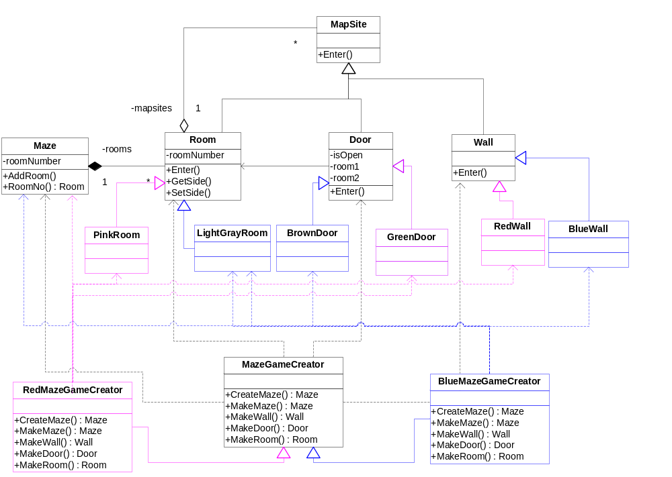
Appendix B: Maze Game Abstract Factory Pattern

