1.分别用逐步搜索法、二分法、比例求根法、牛顿法、弦截法求下列方程的根，并分别画出几种方法所求根的收敛速度对比图（即画出相对误差随迭代步数的变化趋势图）

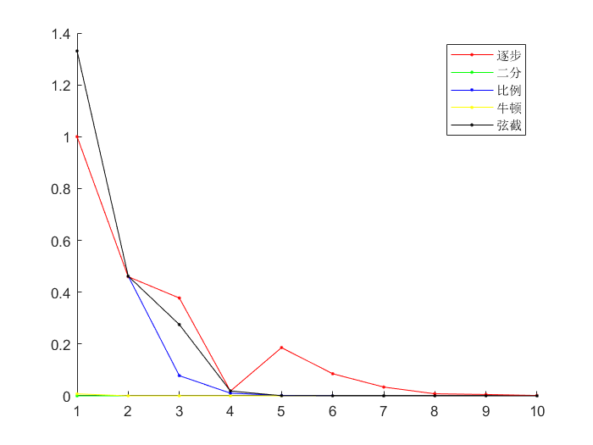f(x)=cos(x)−x

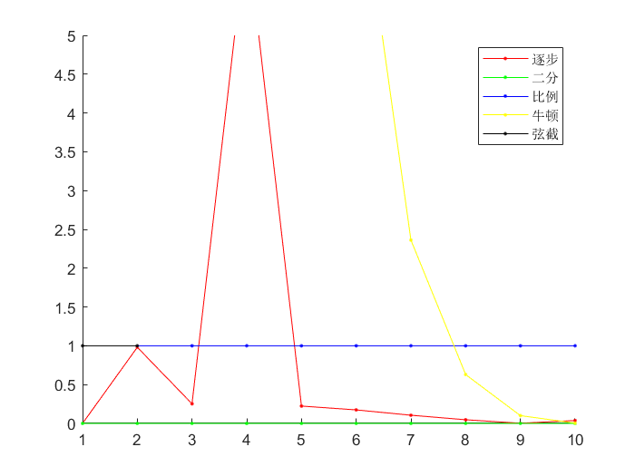

$$f\left(x\right)=x^{12}-1$$

代码过长，见T1.m

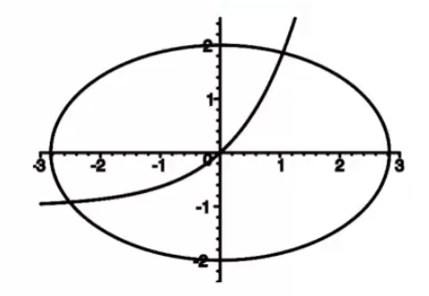2.解下列方程组

$$\left\{\begin{aligned}x^{2}+2*y^{2}-8=0 \\ y-e^{x}-1=0\end{aligned}\right.$$

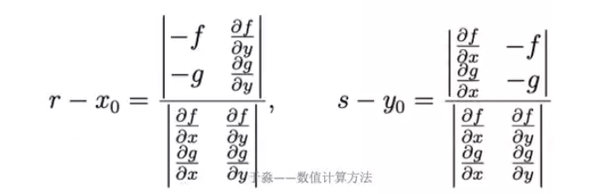

选取初值点(-2,-1)与(-1,-2)开始迭代,解得

$$\left\{\begin{aligned}x_{0}=1.0498 \\ y_{0}=1.8571\end{aligned}\right.$$

$$\left\{\begin{aligned}x_{1}=-2.5122 \\ y_{1}=-0.91891\end{aligned}\right.$$

代码

clc, clear

x = optimvar('x', 2);

eq1 = x(1)^2 + 2 * x(2)^2 - 8 == 0;

eq2 = x(2) - exp(x(1)) + 1 == 0;

prob = eqnproblem;

prob.Equations.eq1 = eq1;

prob.Equations.eq2 = eq2;

x0.x = [1 2];

[sol, fval, exitflag] = solve(prob, x0);

exitflag

disp(num2str(sol.x))

f = @(x, y) x^2 + 2 * y^2 - 8;

g = @(x, y) y - exp(x) + 1;

syms x y

fx = matlabFunction(diff(f(x, y), x));

fy = matlabFunction(diff(f(x, y), y));

gx = matlabFunction(diff(g(x, y), x));

gy = matlabFunction(diff(g(x, y), y));

x = -2; y = -1;

step = 10;

**for** i = 1:10

A1 = [-f(x, y) fy(y); -g(x, y) gy()];

A2 = [fx(x) -f(x, y); gx(x) -g(x, y)];

B = [fx(x) fy(y); gx(x) gy()];

x = x + det(A1) / det(B);

y = y + det(A2) / det(B);

**end**

disp(num2str(x))

disp(num2str(y));