COMPUTER SCIENCE 349A

Handout Number 2

Measures of error (pages 56-59 of the 6th edition of the textbook; pages 59-62 of the 7th edition)

If p denotes the true (exact) value of some quantity, and 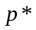 denotes some approximation to p, then

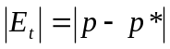

is called the absolute error, and

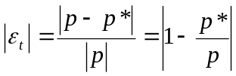 (if 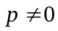)

is called the relative error.

Absolute error is not a meaningful measure of error unless you know the magnitude of p, the quantity you are approximating. For example,

if 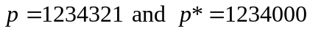, then 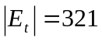 seems large, although is quite accurate and agrees with p to 4 significant digits;
if , then 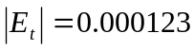 seems small, although is not very accurate and agrees with p to only 1 significant digit.

Relative error, which is always meaningful, in fact indicates the number of correct significant digits in an approximation .

Example
Consider 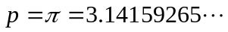

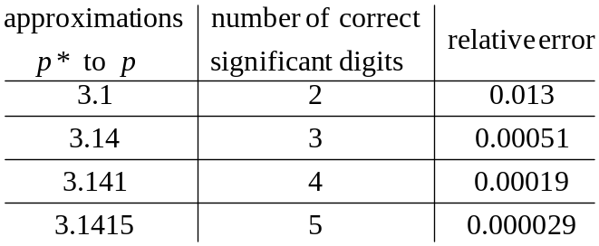

Definition of the number n of significant digits in an approximation to a value p:
If 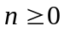 is the largest integer such that
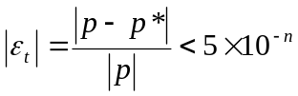,
then approximates p to n significant digits.

Thus, if you know the magnitude of the relative error, then you know how many correct significant digits your approximation has.

Note: in order to compute the relative error, you need to know the true (exact) value p. In any real application, the exact answer p will be unknown.

Approximation of the relative error in an iterative algorithm
In this course and in many applications, iterative algorithms are used to compute a sequence
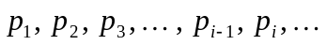
of approximations to a value p. If p is unknown, then the relative error in any current approximation  is approximated using the previous approximation 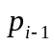:

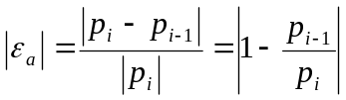.

See (3.5) on page 57 of the 6th edition; page 60 of the 7th edition.

A result given on page 58 of 6th edition (page 61 of the 7th): if 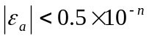, then the approximation is accurate to at least n significant digits.

EXAMPLE 3.2 (pages 58-59 of the 6th edition; pages 61-62 of the 7th))

Compute a sequence of approximations to 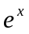using the first few terms in the infinite series
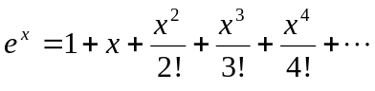
For example, let

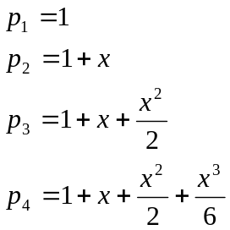

and so on.

Results using 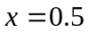 (note that the true value 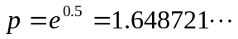 is used to compute 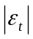):

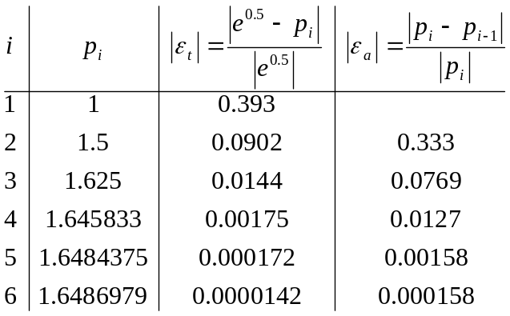

Note that the value of , which can only be computed if you know the true (exact) answer p, indicates the number of correct significant digits in each computed approximation : for example,
0.0144 < 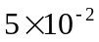 and 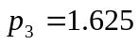 has 2 correct significant digits
0.000172 < 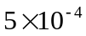 and 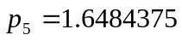 has 4 correct significant digits

In practice, if a sequence of approximations 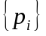 to some unknown value p is computed using an iterative algorithm (we will use several such algorithms in this course), then the exact relative errors cannot be computed. However, the relative error in each approximation can be approximated by computing 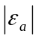. As given in (3.6) and (3.7) on page 58 of the 6th or page 61 of the 7th ed. if , then is accurate to at least n significant digits. Note that this holds true for the results in the above table. For example, when 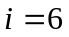,
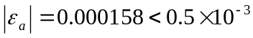,
implying that 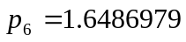 has at least 3 correct significant digits (in fact, it has 4).

