COMPUTER SCIENCE 349A

Handout Number 3

Two methods of representing a real number p in floating-point: rounding and chopping.

Example
Let 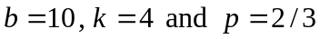.

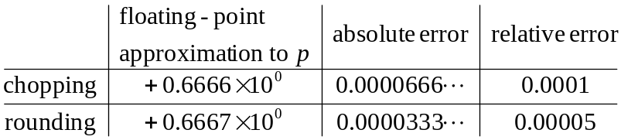

Note that the above absolute errors are round-off errors (that is, they are the difference between a real number p and a floating-point approximation to p).

Question: What is the maximum possible relative error in the k-digit, base b, floating-point representation 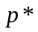 of a real number p?

With chopping:
Every real number p lies in some interval 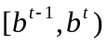 for some integer t.
The distance between 2 floating-point numbers in this interval is 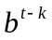.
Therefore, the absolute error satisfies
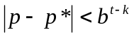.
Thus, the relative error satisfies
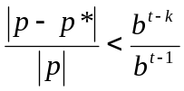 since 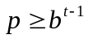
which implies that
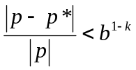.

See (3.9) on page 68 of the 6th edition (page 71 of the 7th edition). The quantity 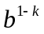 is called the unit round-off (or the machine epsilon). Note that it is independent of t and the magnitude of p. The number 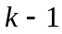 indicates approximately the number of significant base b digits in a floating-point approximation to a real number p.

Example
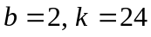 (a 32 bit word)
The unit round-off is 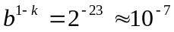, implying that in such a floating-
point system, a real number has about 23 correct binary digits or 7 correct decimal
digits.
With rounding
Similar to above, except now the absolute error satisfies
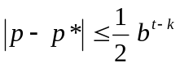.
Thus, the relative error satisfies
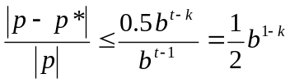,

which is the unit round-off in this case. See (3.10) on page 68 of the 6th ed. or page 71 of the 7th ed.

FLOATING-POINT ARITHMETIC (pages 70-73 of the 6th ed. or pages 73-76 of the 7th ed.)

-- a simulation of real arithmetic
-- Notation: we’ll use the symbol 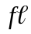. For example, if x denotes a real number, then 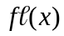 denotes its floating-point representation. Similarly, if a and b are floating-point numbers, then

denote the floating-point sum, difference, product and quotient, respectively, of a and b.

The implementation of these floating-point operations (in either software or hardware) depends on several factors, and includes, for example, a choice regarding

-- rounding or chopping
-- the number of significant digits used for floating-point addition and subtraction.

For simplicity, we’ll consider only “idealized” floating-point arithmetic, which is defined as follows. Let • denote any one of the basic arithmetic operations 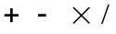, and let x and y denote floating-point numbers. 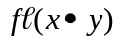 is obtained by performing exact arithmetic on x and y, and then rounding or chopping this result to k significant digits.

Note 1: although no actual digital computers or calculators implement floating-point arithmetic this way (it’s too expensive, as it requires a very long accumulator for doing addition and subtraction), idealized floating-point arithmetic

-- behaves very much like any actual implementation
-- is very simple to do in hand computations, and
-- has accuracy almost identical to that of any actual implementation.

Note 2. If is applied to an arithmetic expression containing more than one arithmetic operation, then each of the arithmetic operations must be replaced by its corresponding floating-point operation. For example,

and
.

Each operation is computed according to the rules of idealized floating-point arithmetic, that is, the exact value of the result is rounded or chopped to k significant digits before proceeding with the rest of the computation. Note that we’ll compute 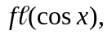 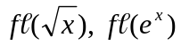 and so on this way.

Note 3: with idealized floating-point arithmetic, the maximum relative error in is the same as the maximum relative error in converting a real number z to floating-point form. Thus, for a single floating-point , the relative error is very small: it is 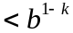 (with chopping) or 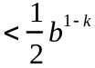 (with rounding). However, the relative error in a floating-point computation might be large if more than one floating-point operation is performed. For example, compute 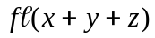 when

using base b =10, precision k =4, rounding idealized floating-point arithmetic.

Since the exact value 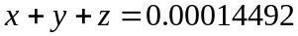, the relative error is

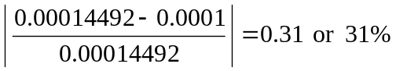.

Note, however, that this large relative error can be avoided by changing the order in which these 3 numbers are added together. Consider the evaluation of

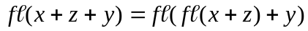.
We obtain
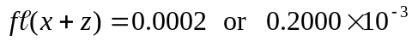
,

which has a relative error of only 0.000138 or 0.0138%.

