COMPUTER SCIENCE 349A

Handout Number 4

SUBTRACTIVE CANCELLATION (pages 73-76 of the 6th edition; pages 76-79 of the 7th edition)

Subtractive cancellation refers to the loss of significant digits during a floating-point computation due to the subtraction of nearly equal floating-point numbers.

Note that if is an approximation to  and is an approximation to 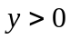, and if for example agrees with x to 8 significant digits and agrees with y to 8 significant digits, then
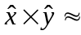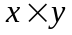
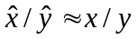
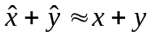
and these values will agree to about 8 significant digits. However, this may not be true for subtraction: it is possible that none of the significant digits in 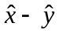 and 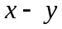 agree.

The following examples illustrate subtractive cancellation, and show how it can be avoided in each of these cases.

Example 1.
The evaluation of
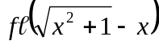
will be inaccurate if x is large and positive. For example, using 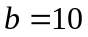, 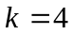, idealized rounding floating-point arithmetic and x = 65.43, we obtain the following (where 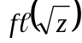 is computed using idealized floating-point arithmetic; that is, the exact value of 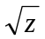 is rounded to 4 significant digits).

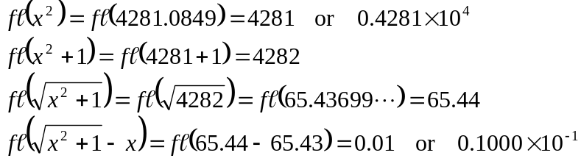
However, the true (exact) value of 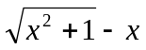 is 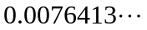 . The relative error in is about 0.31 or 31%.

To avoid the subtractive cancellation above and to obtain an accurate floating-point result, note that

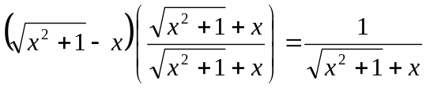.

The latter expression gives an extremely accurate result in floating-point arithmetic when
x = 65.43 (and indeed for all “large” positive values of x).

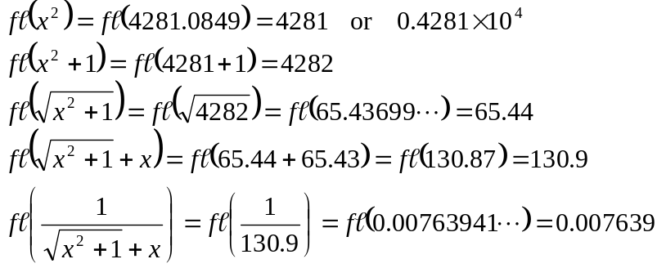

which has a relative error of 0.0003 or 0.03%.

Example 2.
The evaluation of
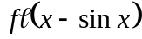
will be inaccurate if x is close to 0. For example, using , , idealized chopping floating-point arithmetic and x = 0.01234, we obtain the following (note that the argument for sine is in radians).

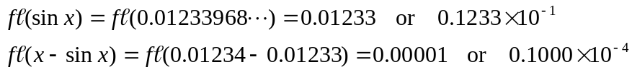

However, the true (exact) value of 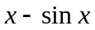 is 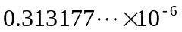, giving a relative error in the computed approximation of

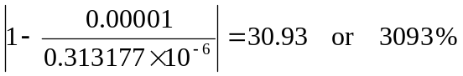.

To avoid the catastrophic loss of significant digits in this example, use the Taylor series approximation for 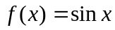 expanded about 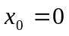 (see Chapter 4 of the textbook):

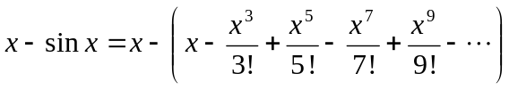.

Thus, if x is close to 0, a very good approximation to is, for example,

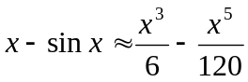

With x = 0.01234 as above, we obtain

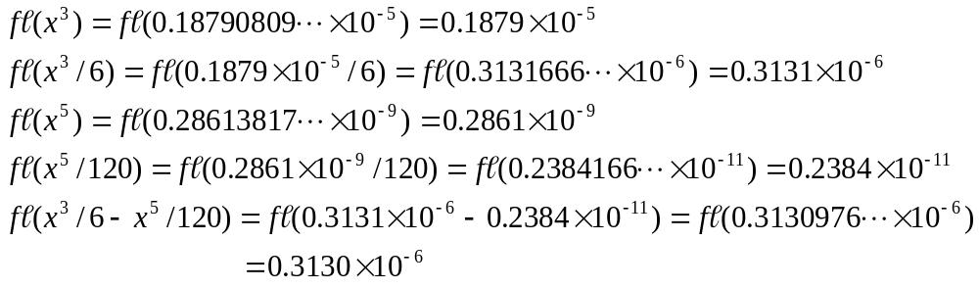

which has a very small relative error of

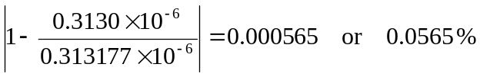

Example 3.
The evaluation of
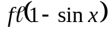
will be inaccurate if  is close to 1; for example, if 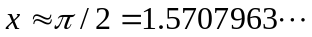 (radians).
For example, this floating-point computation will be inaccurate if 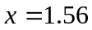. The cancellation of significant digits in this case can be seen since 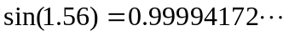.

To avoid such a loss of significant digits whenever x is close to 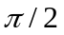, note that

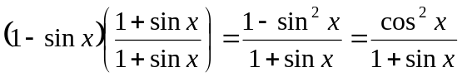

Evaluation of this expression in floating-point arithmetic when x is close to will not result in any large loss of significant digits. For example, with x = 1.56 we obtain (using rounding) the following, which is very close to the true value of 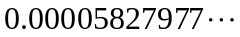.

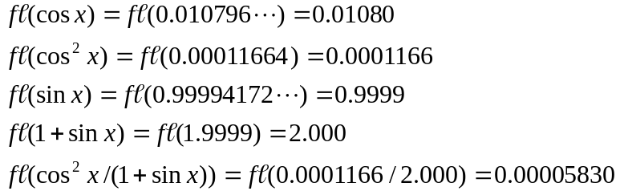

Example 4.
Provided that 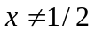 or 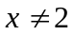,

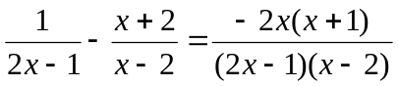.

However, if evaluated in floating-point arithmetic, these two expressions may give very different results; that is, if we let

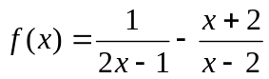 and 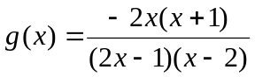,

then for some values of x, 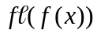 and 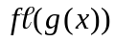 may differ greatly.
In each of the following cases, assume that our usual floating-point system with 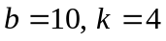 and rounding is used.

Case (i).
Suppose that x is an exact valid floating-point number (in whatever floating-point system you are using) and that x is close to (but not equal to) . Then the evaluation of will be very inaccurate since

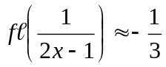 and 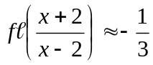

so that is computed as the difference of two almost equal numbers, which will result in a loss of significant digits due to subtractive cancellation. However, this does not occur in the evaluation of when x is close to .
For example, if 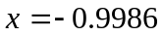, then you can verify the following. The exact value is 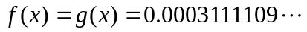; 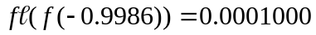 or 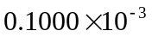 is very inaccurate; 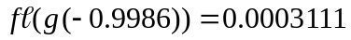 is very accurate.

Case (ii).
Suppose that x is an exact valid floating-point number (in whatever floating-point system you are using) and that x is close to (but not equal to) 2. Then the evaluation of both of and will be very accurate because there is no subtractive cancellation in either expression. Although 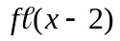 occurs in the denominator of each expression, if x is an exact valid floating-point number, then there is no round-off error in ; that is, is exactly equal to the value of 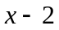. (To see this, consider values such as 1.997 or 2.023 .) Thus, 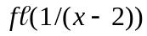 will be very accurate (as the round-off error in a single floating-point division is small). Since the value of is also very large relative to all other parts of the expressions for  and , the values of both and will be very accurate.
For example, if 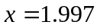, then you can verify the following. The exact value is 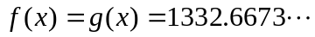; 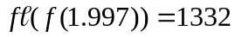 and 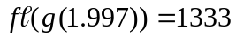 .

Case (iii).
Suppose that x is NOT a valid floating-point number and that x is close to 2. For example, if suppose that x = 2.001234 . Then both of and will be very inaccurate because they both are computed using the value of 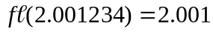 rather than the exact value of x. In such a case, note that the value of
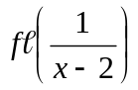 and the exact value of 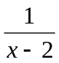

will differ greatly. For example, using x = 2.001234,

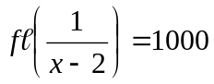 whereas 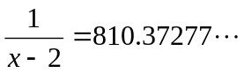.

Using x = 2.001234 , the exact value is 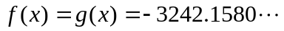. Using , you can verify that 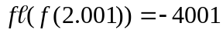 and 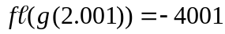, both of which are very inaccurate.

