COMPUTER SCIENCE 349A

Handout Number 5

Taylor’s Theorem is the fundamental tool for deriving and analyzing numerical approximation formulas in this course. It states that any “smooth” function (one with a sufficient number of derivatives) can be approximated by a polynomial, and it includes an error (remainder) term that indicates how accurate the polynomial approximation is. Taylor’s Theorem also provides a means to estimate the value of a function  at some point 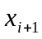 using the values of and its derivatives at some nearby point .

Taylor’s Theorem (page 79 of the 6th edition; page 82 of the 7th)
Let 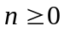 and let a be any constant. If and its first 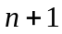 derivatives are continuous on some interval containing x and a, then

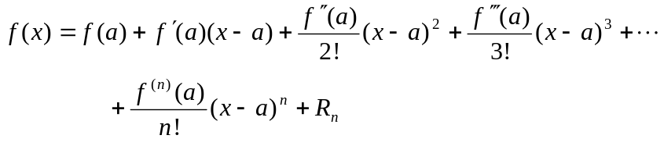

where the remainder (or error) term is

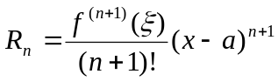

and is some value between x and a. Note that
is a polynomial of degree n in x, and is called the Taylor polynomial approximation of degree n for expanded about a. 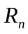 is the truncation error of this polynomial approximation to .

Example 1
Determine the Taylor polynomial approximation of order 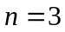 for 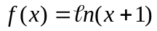 expanded about 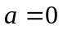.

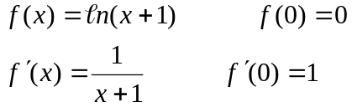

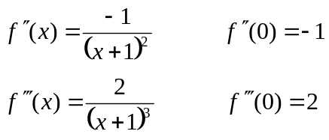
Thus
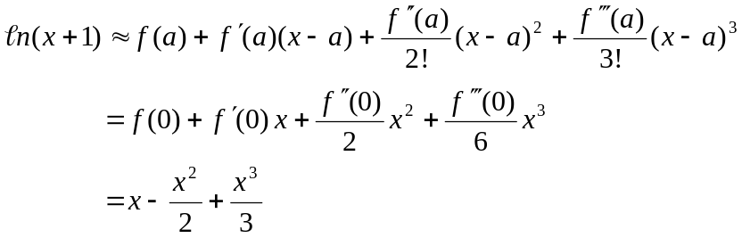
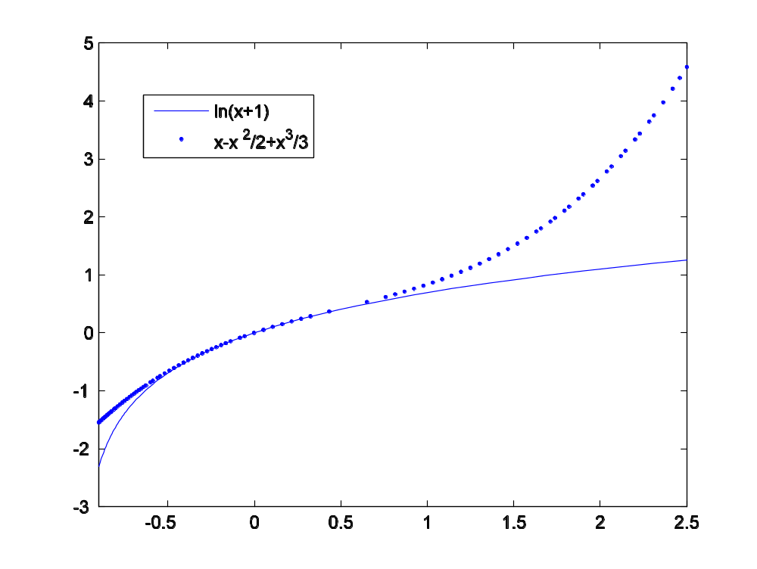

How accurate is this polynomial approximation? Let 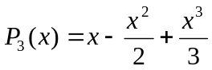. Since 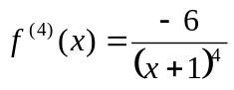, for each value of x there exists a value such that

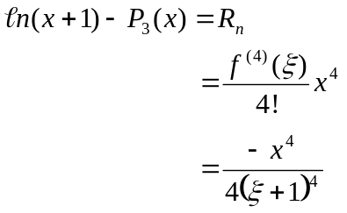

where is some number between x and .
For example, if 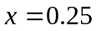 then

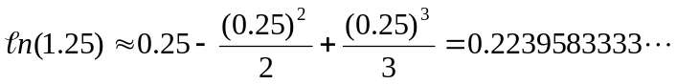

and the truncation error of this approximation is

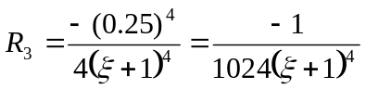 for some value of such that 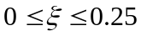 .

It is not possible to determine the value of that gives the exact value of , but it is possible to determine an upper bound for this truncation error:

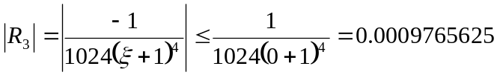

This gives a guaranteed upper bound for the truncation error in the above approximation to 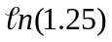. Note that the actual (absolute) error is

.

Rather than just using a Taylor polynomial approximation to estimate the value of
a function at one specified point, it is more common to use the polynomial approximation for an entire interval of values of x. In such a case, it is also desirable to be able to determine the accuracy (that is, an upper bound for the error). For example, suppose that

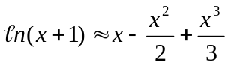 for any value of 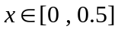.
Then, for any value of ,
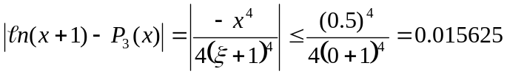

since 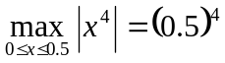 and, as lies between 0 and x, 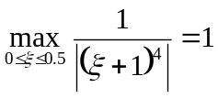.

Example 2
Let 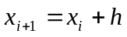 so that 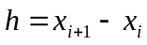. Then Taylor’s Theorem for expanded about and evaluated at 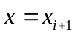 is (see (4.7) on page 80 of the 6th ed.; page 83 of the 7th)

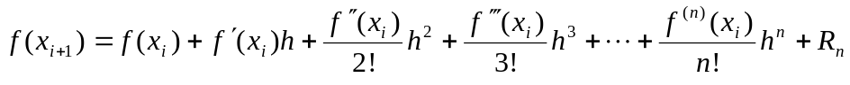.

Letting 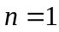, this gives
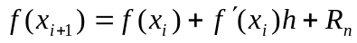
which implies that

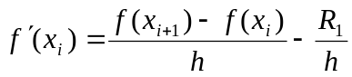, where 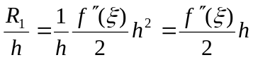.

See page 86 of the 6th ed; page 89 of the 7th . This gives the first derivative approximation

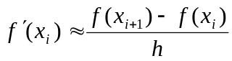

that was used in Chapter 1; it also gives the truncation error of this finite difference approximation to the derivative, namely 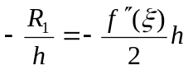. As this is some constant times h, we say that this truncation error is 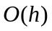.

Example 3
The Taylor polynomial approximation for 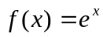 expanded about is

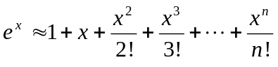.

It is clear from
that the truncation error of any Taylor polynomial approximation is small when x is close to a (note that 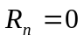 when ) and will increase as x gets further away from a. Also, as n increases, the Taylor polynomial approximations become better and better approximations to , provided of course that 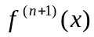 is bounded on some interval containing x and a. These points are illustrated in the following graph.

