COMPUTER SCIENCE 349A

Handout Number 6

CONDITION OF A PROBLEM

Definition A problem whose (exact) solution can change greatly with small changes in the data defining the problem is called ill-conditioned.

data {} exact solution { }
defining a problem
exact arithmetic

perturbed problem,
data { } = { } exact solution { }
with small exact arithmetic

If there exist small 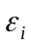 such that { } are not close to { }, then the problem is
ill-conditioned.

If 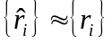 for all small , then the problem is well-conditioned.

Example Consider the 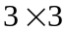 system of linear equations 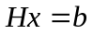:

.

Using the exact 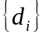 given above in the matrix H and the vector b, the exact solution is
.

However, if the entries of H and b are rounded to 3 significant decimal digits to give the following perturbed problem :

then the exact solution (to 5 significant digits) is

.

Thus, the problem of solving is ill-conditioned.

Note. The condition of a problem has nothing to do with floating-point arithmetic or round-off error; it is defined in terms of exact computation. However, if a problem is ill-conditioned, it will be difficult (or impossible) to solve accurately using floating-point arithmetic.

Another approach to analyzing the condition of a problem if the first derivative of the quantity  being computed can be determined: see pages 100-101 of the 7th edition; pages 97-98 of the 6th.
By the Taylor polynomial approximation of order 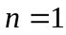 for expanded about ,
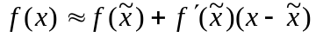,
which implies that

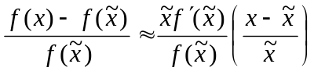.

If is some small perturbation of x, then the left hand side above is the relative change in as x is perturbed to. Thus,

relative change in 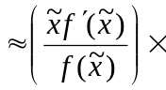relative change in x

The quantity 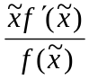 is called a condition number for the computation of. If this number is “large”, then is ill-conditioned; if this number is “small”, then is well-conditioned.

Example 4.7 (page 101 of the 7th edition; page 98 of the 6th)
For values of x close to 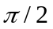, the computation of
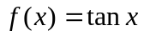
is ill-conditioned. The condition number is
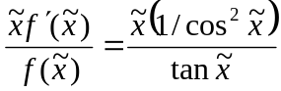,
and for example, for 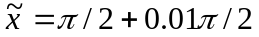, this condition number is

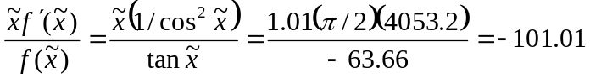 .

Interpretation: for values of x close to , the relative change

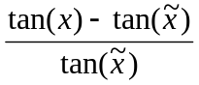 is approximately 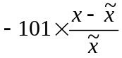.

This means that the computation of for values of x close to is ill-conditioned. For a well-conditioned problem,

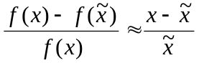,

that is, the condition number is approximately equal to 1.

