COMPUTER SCIENCE 349A

Handout Number 7

STABILITY OF AN ALGORITHM

Textbook (page 100 of the 7th ed.; page 97 of the 6th): a computation is numerically unstable if the uncertainty of the input values is greatly magnified by the numerical method. The following is a more precise definition.

Definition. An algorithm is said to be stable (for a class of problems) if it determines a computed solution (using floating-point arithmetic) that is close to the exact solution of some (small) perturbation of the given problem.

given problem,
specified by computed solution
data {} floating-point {}
computation

perturbed
problem, data exact solution
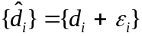 exact {}
computation
with 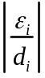 small

If there exist data 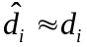 (small 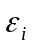 for all i) such that 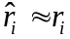 (for all i), then the algorithm is said to be stable.

If there exists no set of data {} close to {} such that 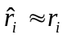 for all i, then the algorithm is said to be unstable.

Meaning of numerical stability: the effect of uncertainty in the input data or of the floating-point arithmetic (the round-off error) is no worse than the effect of slightly perturbing the given problem, and solving the perturbed problem exactly.

