COMPUTER SCIENCE 349A

Handout Number 8

THE BISECTION METHOD (Section 5.2: pp. 127-135 7th ed; pp. 124-131 6th ed)

-- can be used to compute a zero of any function  that is continuous on an interval 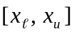 for which 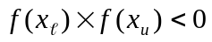.

Consider 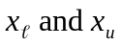 as two initial approximations to a zero, say 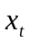, of . The new approximation is the midpoint of the interval , which is 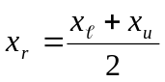.

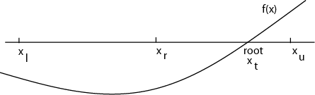

If 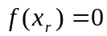, then 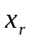 is the desired zero of . Otherwise, a new interval that is half the length of the previous interval is determined as follows.
If 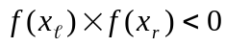 then 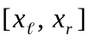 contains a zero, so set 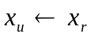. Otherwise, 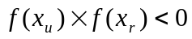 (necessarily) and 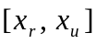 contains a zero, so set 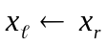.

The above procedure is repeated, continually halving the interval , until is sufficiently small, at which time the midpoint will be arbitrarily close to a zero of .

Convergence criterion
As this is an iterative algorithm that computes a sequence of approximations

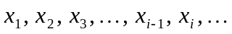

to a zero , recall from Section 3.3 that

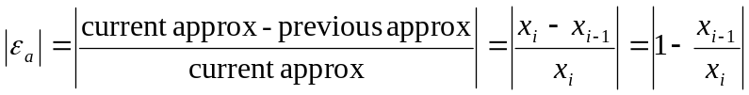

is a good approximation to the actual relative error 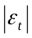 in , and can be used to determine the accuracy of .

Note that each approximation is equal to 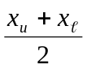 and the previous approximation 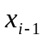 is either 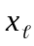 or 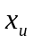. Therefore,

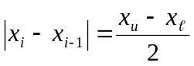 and thus 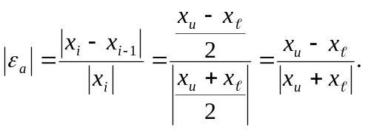
See (5.3) on page 132 in the 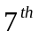 ed.; page 129 in the 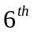 ed.

How many iterations n are required to obtain a desired accuracy?
Suppose you want the absolute error , and that the length of the initial interval is 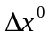.

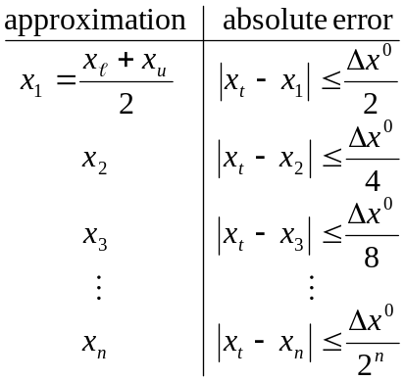

Therefore,
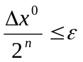 implies that 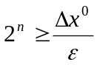 and 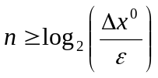
(see (5.5) on page 132 of the 7th ed. or page 129 of the 6th ed.) or

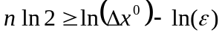 and 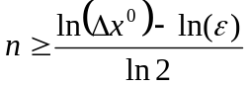.

Example
If initially 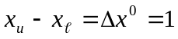 and 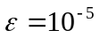, then the above formula gives 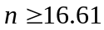 . Thus, 17 iterations would guarantee that the absolute error of the computed approximation to a zero of is 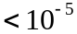.

An algorithm for the Bisection method

function root = Bisect ( 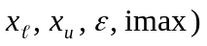
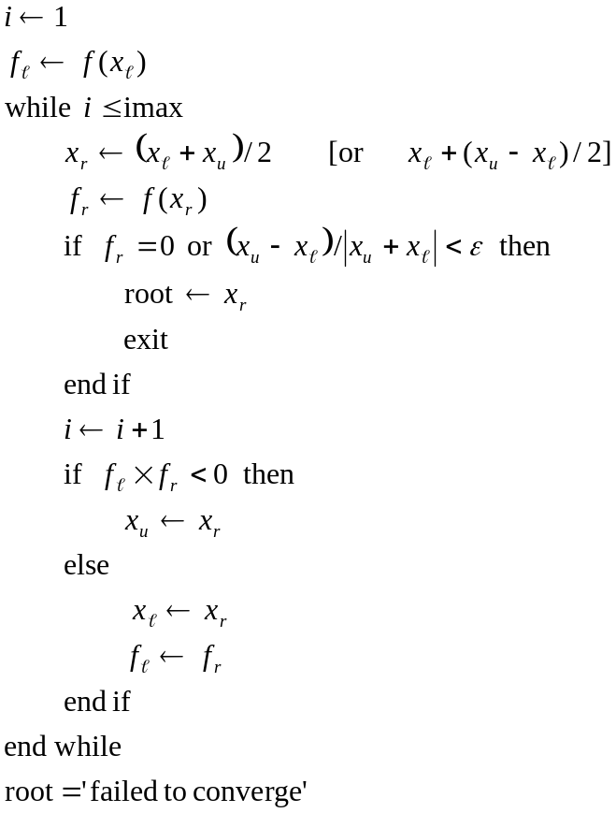

Example
Use the Bisection method to solve Problem 5.17 on page 143 in the 7th ed. (Problem 5.17 on page 140 in the 6th ed.). The volume of liquid in a spherical tank is given by

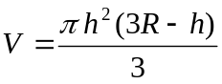

where h is the depth of water in the tank and R is the radius of the tank. If 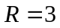, to what depth must the tank be filled so that it contains 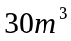 of water?

Solution
Compute a root h of the equation 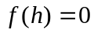, where 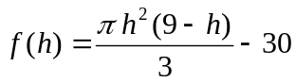. Since 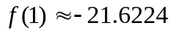 and 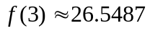, the Bisection method can be used with 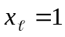 and 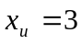. If the above algorithm is run in MATLAB with 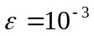, then the following results are obtained.

iteration approximation
1 2.0000
2 2.5000
3 2.2500
4 2.1250
5 2.0625
6 2.0313
7 2.0156
8 2.0234
9 2.0273
10 2.0254

Note: the exact answer is 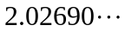.

Advantage of the Bisection method relative to other methods: if is continuous and if appropriate initial values and can be found, then the method is guaranteed to converge

Disadvantages
- converges slowly (requires more iterations than other methods)
- it may be difficult to find appropriate initial values
- it cannot be used to compute a zero of even multiplicity of a function ; that is, if
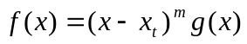 where m is a positive even integer and
