COMPUTER SCIENCE 349A

Handout Number 9

An illustration of order of convergence when 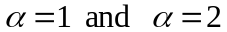. The limit of each sequence is 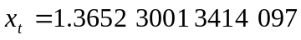 .

Note: in the following computed approximations, the underlined digits are correct.

Example 1

Computed approximations Linear convergence 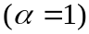 _____________________ ______________________
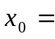 1.5
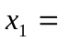 1.2869 53768 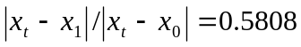
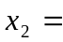 1.4025 40804 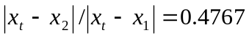
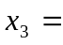 1.3454 58374 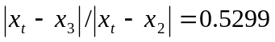
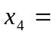 1.3751 70253 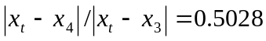
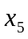 = 1.3600 94193 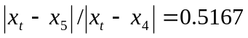
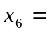 1.3678 46968 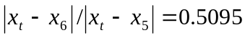
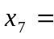 1.3638 87004 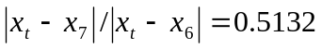
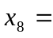 1.3659 16734 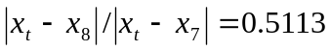
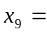 1.3648 78217 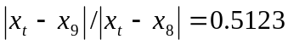
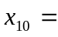 1.3654 10062 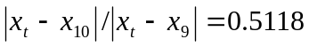

constant 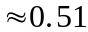

that is, 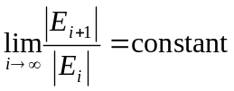

Note that the above ratios 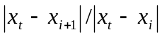 can be computed only if you know the exact zero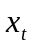. In practice these ratios are never computed; they are given here to illustrate the definition of “order of convergence” (that is, how these ratios determine the kind of slow convergence in the first column above, where the number of correct significant digits increases by some constant amount with each successive iteration).
Example 2

Computed approximations Quadratic convergence (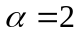)
_____________________ __________________________

1.5
1.3733 3333 3333 333 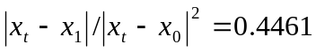
1.3652 6201 4874 627 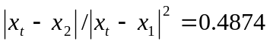
1.3652 3001 3916 147 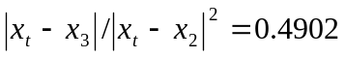
constant 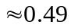

that is, 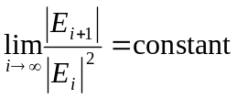
and this reflects the approximate
doubling of the number of correct
significant digits with each
iteration

