COMPUTER SCIENCE 349A

Handout Number 10

QUADRATIC CONVERGENCE OF NEWTON'S METHOD
The following result is proved on p. 153 of the 7th ed. (p. 150 of the 6th ed.)

Theorem If Newton's method is applied to 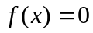 producing a sequence 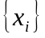 that converges to a root 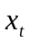 and if 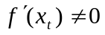, then the order of convergence is 2.

If 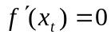 and Newton's method converges to a root , then we will see later that the order of convergence is NOT quadratic.

Example 1. An illustration of quadratic convergence of Newton’s method. Here 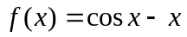. This was computed in MATLAB, so at most 16 correct digits are possible. The underlined digits are all correct.

i  no. of correct digits
______ _________________________ ________________

0 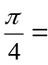 0.7853 98 1

1 0.7395 361 3

2 0.7390 8517 81 7

3 0.7390 8513 3215 1611 14

4 0.7390 8513 3215 1607 16

Example 2. The following illustrates the possible effect of a poor initial approximation with Newton's method, yet the eventual characteristic quadratic convergence. Here Newton's method is used to compute a root of 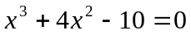 with 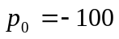. Partial results are as follows.

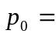 -100
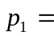 -67.12
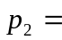 -45.21

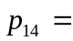 -2.54
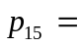 -3.14
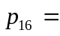 -2.80

no. of correct digits

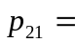 1.9405
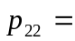 1.4793 1
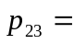 1.3711 2
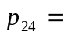 1.36525 4
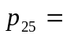 1.3652 3001 1 9

For some graphical situations where Newton’s method can exhibit poor convergence, see page 156 of the 7th ed. (p. 153 of the 6th ed.).

The following result, which is not stated in the textbook but is alluded to on page 155 of the 7th ed. (page 152 of the 6th ed.), gives conditions that guarantee convergence of Newton’s method.

Theorem
Suppose that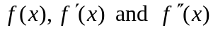 all exist and are continuous on some interval [a, b], that 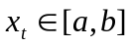 is a root of , and that . Then there exists a value 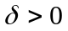such that Newton's method converges for all initial approximations .

Note that in general there is no way to determine such a value . This theorem only says that for all such functions , such a value exists. Even if the value of is extremely small, there is an interval of values around the root such that if  (the initial approximation) lies in this interval, then Newton's method will converge.

Thus the interpretation of the above theorem is that Newton's method always converges if the initial approximation is sufficiently close to the root .

