COMPUTER SCIENCE 349A

Handout Number 11

ORDER OF CONVERGENCE OF THE SECANT METHOD
AND BISECTION METHOD

The Secant method iterative formula is

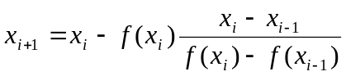.

Therefore, if 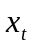 denotes an exact zero of ,

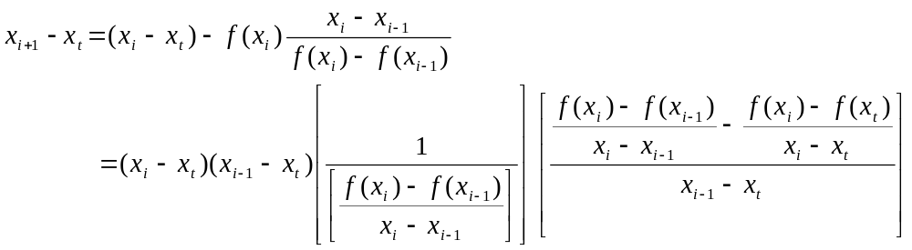

By the Mean Value Theorem, the first large square bracket term above is equal to 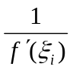, for some value 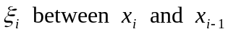.

The term in the second large square bracket above is equal to 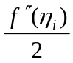, for some value 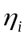 in an interval spanned by 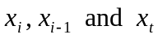 as this is a “second divided difference” -- see page 97 of the 7th ed. (page 94 of the 6th ed.).

Thus, with the usual notation that 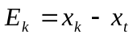 denotes the error of the k-th approximation 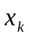, the above can be written as

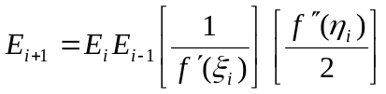
or
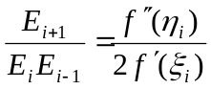.
Thus
(1) 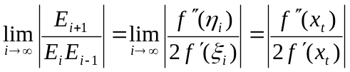.

This gives a relationship between 3 successive errors of the computed approximations using the Secant method. However, this does not indicate the order of the Secant method, which requires that the errors of 2 successive approximations be related by

(2) 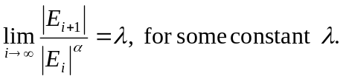

The following analysis shows how to rewrite (1) in a form (2). From (1), it follows that for sufficiently large values of i,

(3) 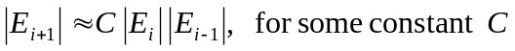.

From (2), it follows that for sufficiently large values of i,

(4) 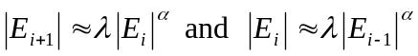.

Substituting (4) into (3) gives

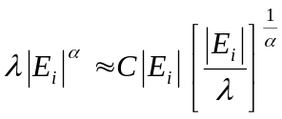,
which implies that
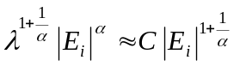 .

From this it follows that

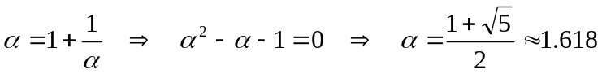,

which is the order of the Secant method.

Note: this value is known as the “golden ratio”, and occurs in many diverse applications.

ORDER OF CONVERGENCE OF THE BISECTION METHOD

An alternate definition of linear convergence (similar to the definition given in class except that it does not involve a limit) is

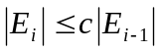 or 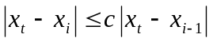

for some constant c such that 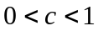.

Applying this inequality recursively gives

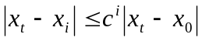.

From Page 2 of Handout Number 8, for the Bisection Method we had

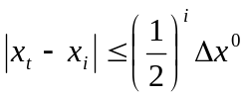, where 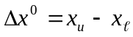

and 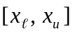 is the initial interval. This implies linear convergence with the above definition, and 

