COMPUTER SCIENCE 349A

Handout Number 12

MULTIPLE ROOTS AND THE MULTIPLICITY OF A ZERO
(Section 6.5 in both the 7th and 6th ed.)

If Newton's method converges to a zero 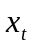 of , a necessary condition for quadratic convergence is that 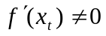. We now relate this condition on the derivative of to the multiplicity of the zero .

Definition (not in the textbook)
If is a zero of any analytic function , then there exists a positive integer m and a function 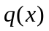 such that

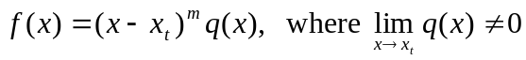.

(In particular, if 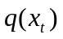 is defined, note that 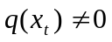.) The value m is called the multiplicity of the zero .

If 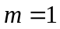, then is called a simple zero of .

Example 1
Consider
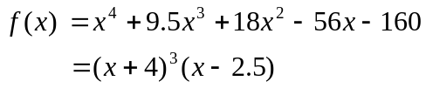

The zero at .
The zero at .

Example 2
Consider
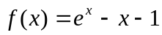.

Since , 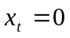 is a zero of . This zero has multiplicity 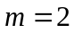 since

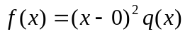 with 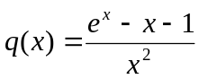

and (using l’Hospital’s rule) 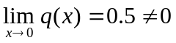.

Theorem (not in the textbook)
Suppose that 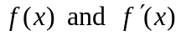 are continuous on some interval 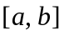, and that
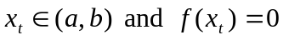. Then is a simple zero of if and only if .

Proof.
(i) Suppose first that is a simple zero of . Then

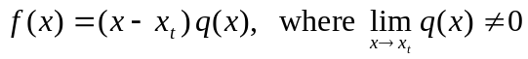.

Therefore,
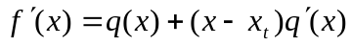
and thus
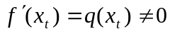.

(ii) For the converse, suppose that . Then by Taylor's Theorem expanded about 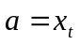,

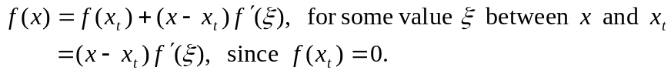

Thus, 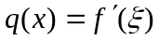 and 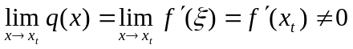. Hence is a simple zero (that is, the multiplicity is ).

The following result follows directly from the above Theorem and our previous result about quadratic convergence of Newton’s method.

Corollary
If Newton’s method converges to a simple zero of , then the order of convergence is 2.

In order to determine whether or not Newton’s method converges quadratically to a zero of , you only need to know whether the multiplicity of is 1 or is 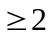. The following result is more general than the above Theorem, and enables you determine the exact multiplicity of a zero.

Theorem (not in the textbook)
Suppose that and its first m derivatives are continuous on some interval that contains a zero of . Then the multiplicity of is m if and only if
but 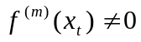.

Example 3
Consider
.

Since , is a zero of with multiplicity 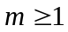.

Since 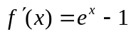 and 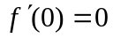, is a zero of with multiplicity 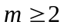.

Since 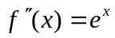 and 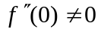, is a zero of with multiplicity .

The significance of the multiplicity concerning root-finding algorithms (see pages 166-167 of the 7th ed. or pages 164-165 of the 6th ed.)
- Bracketing methods, such as the Bisection method, cannot be used to compute zeros of even multiplicity.

- Newton’s method and the Secant method both converge only linearly (order of convergence is 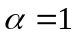) if the multiplicity m is .

- If the multiplicity of a zero is known (in practice this is very unlikely), then the following modification of Newton’s method is quadratically convergent:
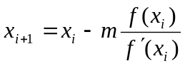.

- A quadratically convergent algorithm for computing a zero of any (unknown) multiplicity of a function is obtained by applying Newton’s method to the new function

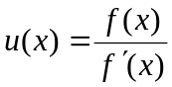

rather than to . This is true since if 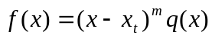 and , then

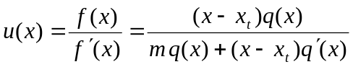
has a simple zero 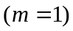 at . By evaluating 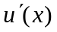, this new algorithm can be written as

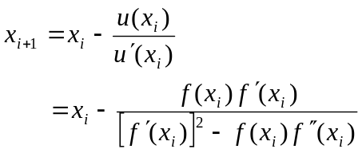

See (6.16) on page 167 of the 7th ed. or on page 165 of the 6th ed.

See also Example 6.10 on page 167-168 of the 7th ed. (Example 6.10 on pages 165-166 of the 6th ed.). This example illustrates linear convergence of Newton’s method when the multiplicity is 2, and then quadratic convergence of the above formula (6.16) for this same zero.

