COMPUTER SCIENCE 349A

Handout Number 13

HORNER’S ALGORITHM
(NESTED MULTIPLICATION, SYNTHETIC DIVISION)

Given a polynomial 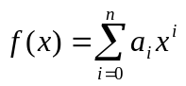 and a value , this algorithm is used to efficiently evaluate 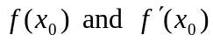. To illustrate the basic idea, consider the case 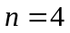:

- 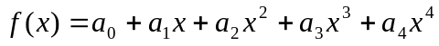

can be rewritten in the form

- .

Evaluation of (1) at 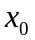 requires 7 multiplications and 4 additions, whereas (2) requires only 4 multiplications and 4 additions.

The general case (for a polynomial of order n):
form (1) requires 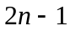 multiplications and n additions,
form (2) requires n multiplications and n additions.

An algorithm to evaluate 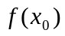, assuming that is written in the “nested” form, as in (2):

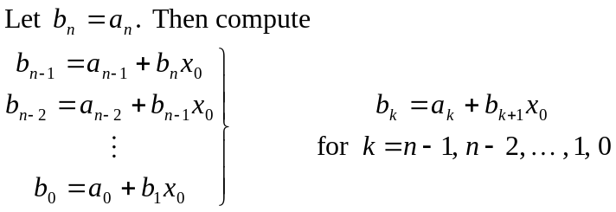

Then 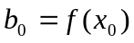.

NOTE that execution of this algorithm requires exactly n multiplications and n additions.

Development of an algorithm to evaluate 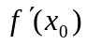:
Let 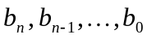 be defined as above, and now define

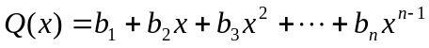.

Then
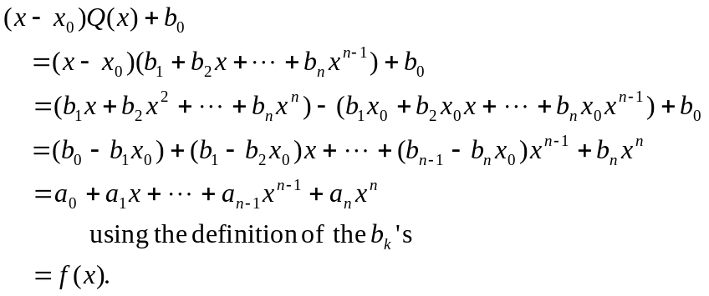

Differentiating this with respect to x gives

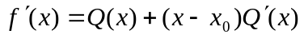,
which implies that
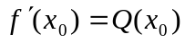.

Thus, to evaluate , one first needs to evaluate as above, which gives the coefficients 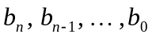, and then evaluate 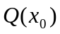. The most efficient way to evaluate , of course, is to use the nested form for the polynomial 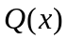. The following algorithm evaluates both 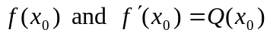, using nested multiplication to evaluate both of the polynomials.

HORNER’S ALGORITHM
Given values 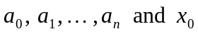, compute:

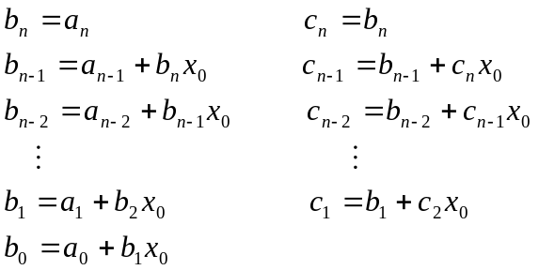

Then
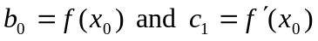.

EXAMPLE
Let and

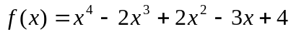.

Using Horner’s algorithm to evaluate 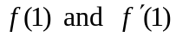:

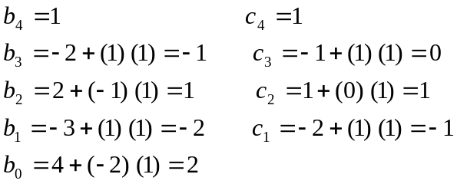

giving 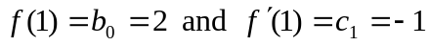.

Note that the explicit form of 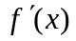, namely

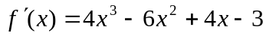,

is not obtained; only the value of 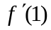 is computed. Since depends on the value of , which is equal to 1 above, all computations must be re-done in order to evaluate at a different value of x.

