COMPUTER SCIENCE 349A

Handout Number 14

ZEROS OF POLYNOMIALS USING NEWTON'S METHOD WITH

HORNER’S ALGORITHM, AND POLYNOMIAL DEFLATION

Outline of a procedure to compute a zero of a polynomial  using Newton's method and Horner’s algorithm:

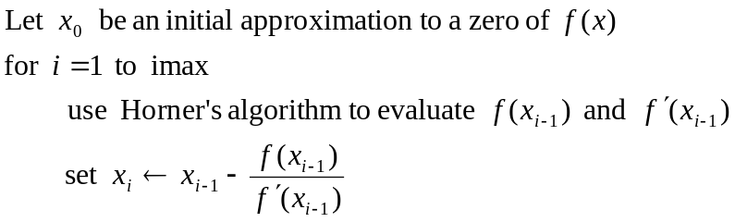
if 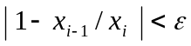 exit
end
output failed to converge in imax iterations

Polynomial Deflation. Suppose that the values 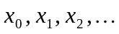 computed above converge in N iterations. Then 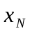 is the final computed approximation to some zero, say 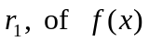. Now the final computation in the above procedure with Newton's method (after N iterations) is
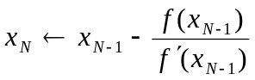 .

If 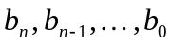 are the values computed by Horner’s algorithm to evaluate 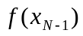 -- that is, in the last step of the above procedure (when 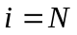), then from page 2 of Handout Number 13 it follows that

- 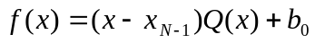,

where
(2) 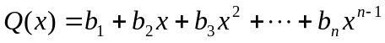.

On letting 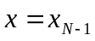 in (1), we obtain

Therefore, from (1),
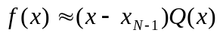
and consequently
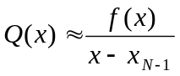.
That is, the polynomial 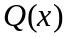 defined in (2) above is the deflated polynomial; it is a polynomial of degree 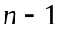 whose zeros are equal to those of , except for the zero at 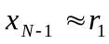. Note that the coefficients 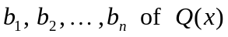 are determined from the last application (when ) of Horner's algorithm in the procedure at the beginning of this handout.

***********************************

SUMMARY of the above procedure to compute an approximation 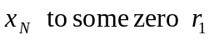 of a given polynomial :

Choose an initial approximation .

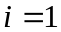: use Horner's algorithm to evaluate ,
so that 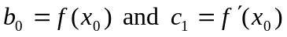;
compute 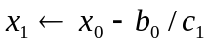 . (Newton's method)

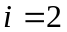: use Horner's algorithm to evaluate 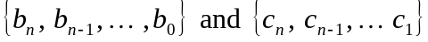,
so that 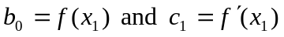;
compute 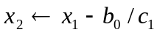. (Newton's method)
: use Horner's algorithm to evaluate ,
so that 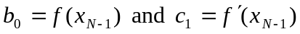;
compute 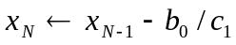. (Newton's method)

Assuming that the procedure has converged, that is, 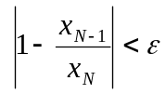, then is
taken as the computed approximation to a zero of , and the associated deflated polynomial is 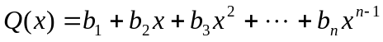, where the coefficients 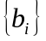 are those from the step above.

Example. An illustration of the application of Newton’s method and Horner’s algorithm to compute a zero of a polynomial . .

With 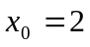, Horner’s algorithm gives

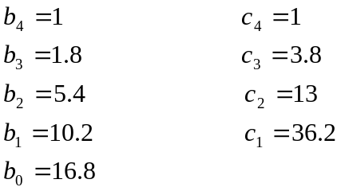

and Newton’s method gives 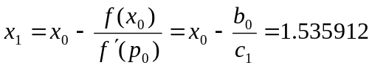

With 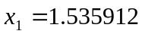, Horner’s algorithm gives

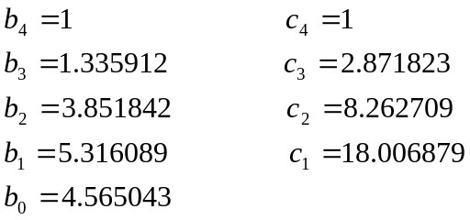

and Newton’s method gives 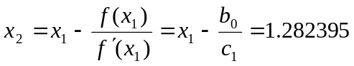

With 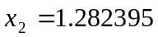, Horner’s algorithm gives

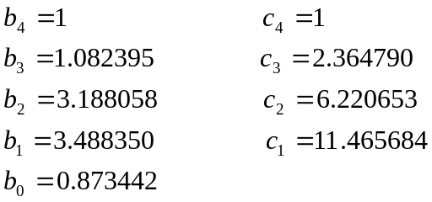

and Newton’s method gives 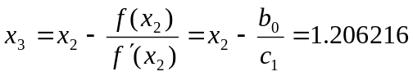

With 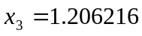, Horner’s algorithm gives

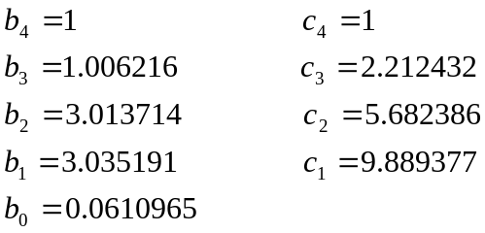

and Newton’s method gives 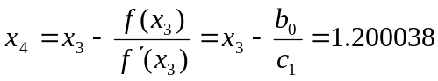

With 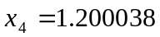, Horner’s algorithm gives

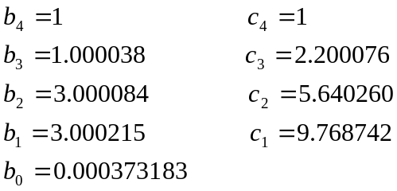

and Newton’s method gives 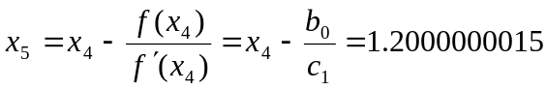

If the computations were terminated at this point, 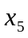 would be the computed approximation to the root 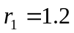, and the corresponding approximate deflated polynomial would be

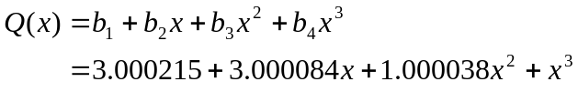

Note that the exact deflated polynomial is 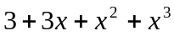. Note also that the sequence of values 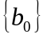 converges to 0 as 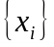 converges to a root .

************************************************************************

Note: if several zeros of are approximated as above, and several deflations are carried out giving a sequence of deflated polynomials of degrees 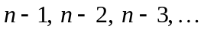, then the successive computed zeros tend to become less and less accurate.

For example, consider from the above example, the computed approximation

to the deflated polynomial. The exact roots (to 8 significant digits) of 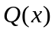 are

,

whereas the corresponding exact roots of are

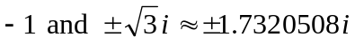.

If a zero of is computed using Newton’s method and Horner’s algorithm, it will not give a very accurate approximation to a zero of (because is not the exact deflated polynomial and because of truncation/roundoff errors in computing this zero). In order to improve its accuracy, use the technique of "root polishing"; this is mentioned on page 182 of the 7th ed. of the textbook (page 180 of the 6th ed.).

Root Polishing
Apply Newton’s method to the approximate deflated polynomial , giving a value .
The value approximates some root 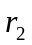 of , but will not be fully accurate.
Use as the initial approximation for Newton’s method applied to. This will converge very quickly (1 or 2 iterations) to the fully accurate root (as is very close to ).

