COMPUTER SCIENCE 349A
Handout Number 15

NAÏVE GAUSSIAN ELIMINATION (Section 9.2)

Notation for a system of n linear equations in n unknowns: 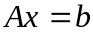, where

A is an nonsingular matrix
and
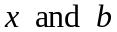 are (column) vectors with n entries.

Equivalently,

Given data A and b, the problem is to determine x.

Examples and motivation: see, for example, the Case Studies in Chapter 12 of the textbook.

Theoretical basis for the Gaussian elimination algorithm. You can apply any of the following three elementary row operations to :

(i) multiply any equation 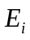 by a nonzero constant

(ii) replace equation by

(iii) interchange any two equations and 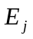

in order to reduce A to upper triangular form. This triangular system is easily solved for x using back-substitution.

The Gaussian elimination algorithm consists of two parts:

(i) forward elimination -- the reduction of the coefficient matrix A to upper
triangular form

(ii) back-substitution -- solving this "reduced" upper triangular system for x.

Numeric Example with 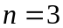.

The given linear system is

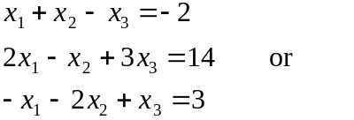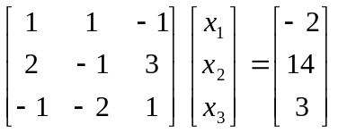.

The augmented matrix 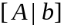 is

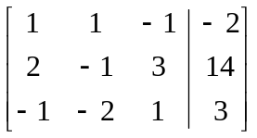;

it contains all of the data for this linear system and is all that needs to be stored in memory.

In this example, the coefficient matrix A can be reduced to upper triangular form using only the second type of elementary row operation.

The forward elimination:

Using the multipliers 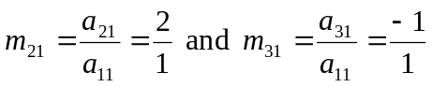 , do two elementary row operations

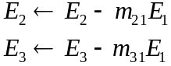
to obtain

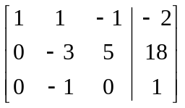 .

(Note: in memory, these arrays will overwrite A and b, so we'll still refer to these arrays as A and b.)

Next, using the multiplier 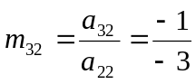 , do one elementary row operation

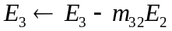
to obtain
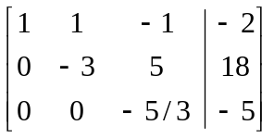,

completing the reduction of A to upper triangular form.

The back-substitution:

that is, the solution is 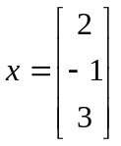.

In order to derive an algorithm for the above numeric procedure, let's consider the symbolic analogue of the above numeric example (still when ).

Given the augmented matrix

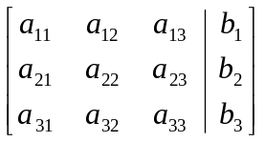,

compute the multipliers 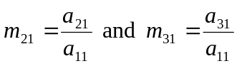, and do the two elementary row operations

to obtain

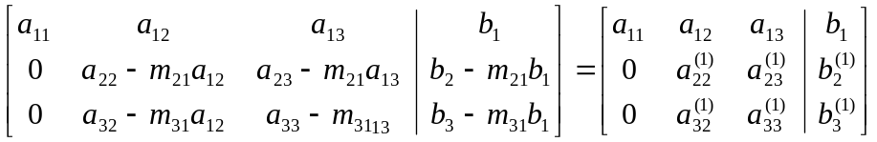 .

This first step for the general case is given in equations (9.14) on page 249 of the 6th ed. or page 253 of the 7th ed. (where a prime is used instead of the superscript 1 to indicate the new entries in this first derived system).

Now compute the multiplier 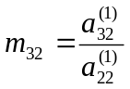 and do the elementary row operation

to obtain
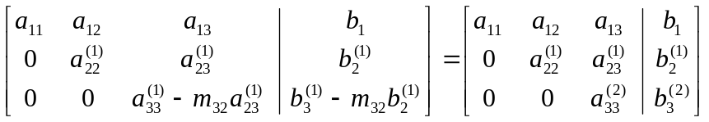 .

The back-substitution is then

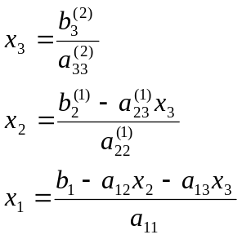

Notes.

1. When programming this, the computed entries overwrite those in A and b, so the superscripts are not necessary.

2. It is not necessary to compute and store any of the 0 entries that are created in the reduction of A to upper triangular form (as they are not used in the back-substitution). Frequently the multipliers are stored in the lower triangular part of A ; that is, 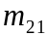 overwrites 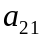, 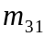overwrites 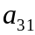, and so on.

3. The entries 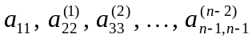 are called the pivots. They are the denominators in the computation of the multipliers. These 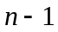 values must be nonzero, or the forward elimination will fail.

THE “NAÏVE” GAUSSIAN ELIMINATION ALGORITHM

(forward elimination)

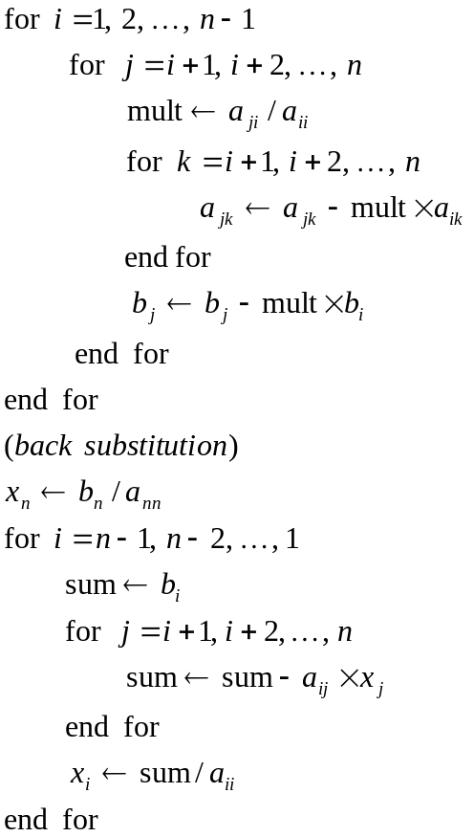

Notes.

1. The above algorithm (which is very similar to the pseudocode on page 250 of the 6th ed. or page 254 of the 7th ed.) is also called Gaussian Elimination without pivoting. It uses only elementary row operations of the second type.

2. The above algorithm will fail (divide by 0) if any of the pivots 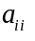 in line 3 is zero. This will happen, for example, for the following (nonsingular) coefficient matrices:

