COMPUTER SCIENCE 349A
Handout Number 16

GAUSSIAN ELIMINATION WITH PARTIAL PIVOTING
(Section 9.4)

The Naïve Gaussian elimination algorithm will fail if any of the pivots 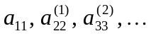 is equal to 0. Mathematically speaking, the algorithm only requires that the pivots be nonzero. However, as the algorithm fails when a pivot is exactly equal to 0, it often gives very poor numerical results (using floating-point arithmetic) when a pivot is close to 0.

Example
Consider the 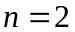 linear system with augmented matrix

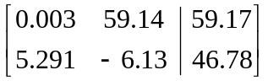 .

The exact solution is
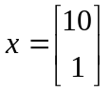.

However, using 4 decimal-digit floating-point rounding arithmetic and Naïve Gaussian elimination, a very inaccurate solution is computed:

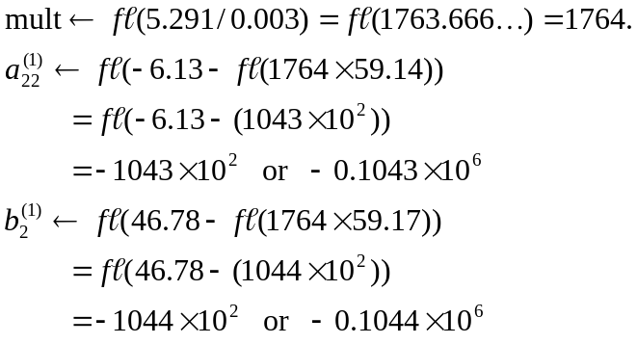

That is, the reduced linear system (in which the coefficient matrix has been reduced to upper triangular form) is

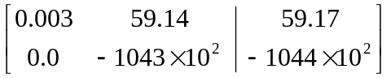.

From this, back substitution gives a computed solution of

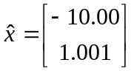.

Analysis of the above example. The source of the extremely inaccurate computed solution is the large magnitude of the multiplier (1764), which is much larger than the numbers in the given linear system. This multiplier is large because the pivot 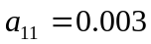 is very small (relative to other numbers in the linear system).

Consequently, in the floating-point computation of 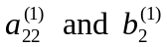, the numbers 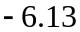 and 46.78 are so small that they are lost (or discarded) in the 4-digit floating-point computation.

The partial pivoting strategy is designed to avoid the selection of a small pivot, and thus to avoid the computation of unnecessarily large multipliers (relative to other numbers in the linear system):

at step k of the forward elimination (where 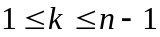), choose the pivot to be the largest entry in absolute value from

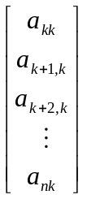.

If this largest entry is 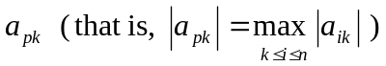, then rows k and p of the augmented matrix are interchanged. (If 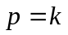, then no interchange is done.)

With the partial pivoting strategy, note that all multipliers are in absolute value.

Note also that a row interchange is a Type 3 elementary row operation (thus, the linear system obtained by applying Gaussian elimination with partial pivoting is equivalent to the given linear system).

The following is an algorithm for Gaussian Elimination with partial pivoting:

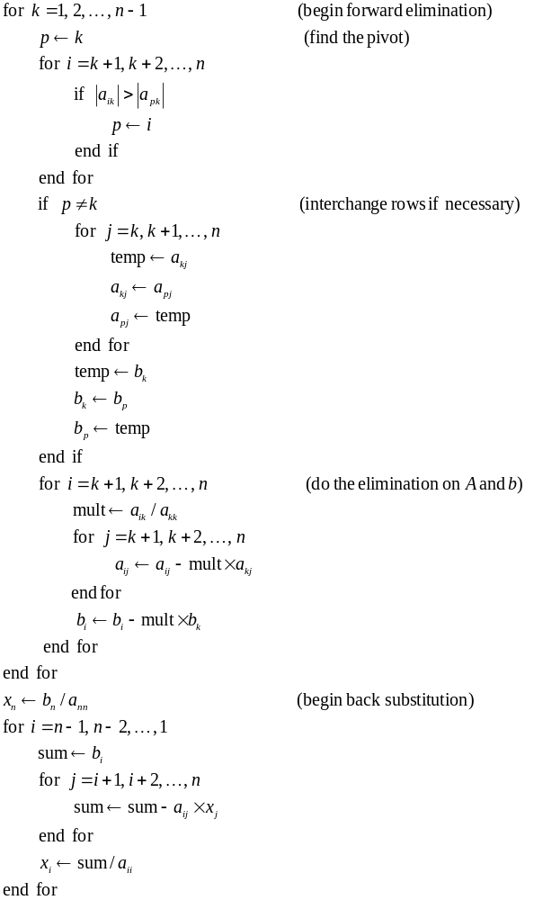

NOTE: the above algorithm is similar to that given in the textbook in Figures 9.4 and 9.5 together (on pages 254 and 266 in the 7th ed.; pages 250 and 262 in the 6th ed.).

Example: Gaussian Elimination with partial pivoting.

Suppose that the given augmented matrix is

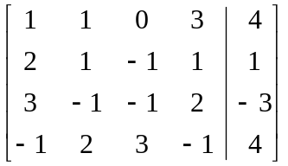.

Step 1 of the forward elimination with 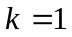: the row index of the pivot is 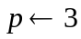, so rows 1 and 3 are interchanged to give

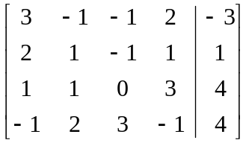.

The elimination on rows 2, 3 and 4 gives

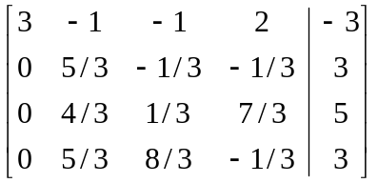.

Step 2 of the forward elimination with 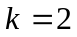: the row index of the pivot is 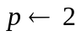. Since , no row interchange is done. The elimination on rows 3 and 4 gives

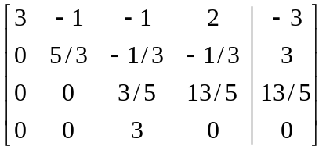

Step 3 of the forward elimination with 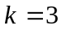: the row index of the pivot is 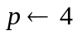, so rows 3 and 4 are interchanged to give

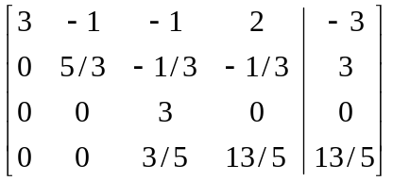.

The elimination on row 4 gives

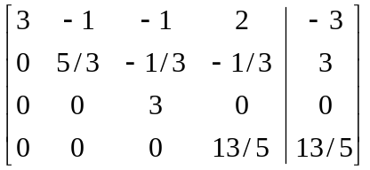,

which completes the forward elimination.

Back substitution now gives the solution

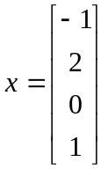.

Determinant of A (see page 263 in the 7th ed.; page 259 in the 6th ed.)

The reduction of A to upper triangular form by Naïve Gaussian elimination uses only the Type 2 elementary row operation

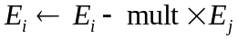.

This row operation does not change the value of the determinant of A . So, if no rows are interchanged,
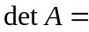det ( equivalent upper triangular form of A )
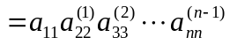

since the determinant of a triangular matrix is equal to the product of its diagonal entries.

However, if Gaussian elimination with partial pivoting is used to reduce A to upper triangular form, each row interchange causes the determinant to be multiplied by . Thus, if m row interchanges are done during the reduction of A to upper triangular form, then

