COMPUTER SCIENCE 349A
Handout Number 18

STABILITY AND CONDITION :
SYSTEMS OF LINEAR EQUATIONS

STABILITY OF ALGORITHMS FOR SOLVING 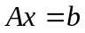

Given a nonsingular matrix A, a vector b and some algorithm for computing the solution of , let denote the computed solution using this algorithm. The computation is said to be stable if there exist small perturbations E and e of A and b, respectively, such that is close to the exact solution y of the perturbed linear system

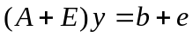.

That is, the computed solution is very close to the exact solution of some small perturbation of the given problem.

KNOWN RESULTS

Gaussian elimination without pivoting may be unstable. For example, if there exists a pivot which is very small relative to other entries in the coefficient matrix, then the computed solution may be very inaccurate and the computation may be unstable.

In practice, Gaussian elimination with partial pivoting is almost always stable. That is, for almost all practical problems it is stable. However, it is known to be unstable for certain “contrived” examples, which do not occur in practical problems, and it has recently been shown to be unstable for a few problems that arose in practical applications. Despite this, it is the best choice for an algorithm to solve .

A much more stable version of Gaussian elimination uses complete pivoting, which uses both row and column interchanges. However, as this algorithm is much more expensive to implement and since partial pivoting is almost always stable, complete pivoting is seldom used.

CONDITION OF

A given problem is ill-conditioned if its exact solution is very sensitive to small changes in the data 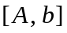. That is, if there exist small perturbations E and e of the given data A and b, respectively, such that the exact solution 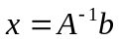 is not close to the exact solution y of the perturbed linear system , then the linear system is ill-conditioned. If such perturbations E and e do not exist, then is well conditioned.

EXAMPLE

Consider the Hilbert matrix H whose (i , j ) entry is

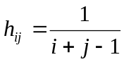 .

For example, if 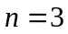, then

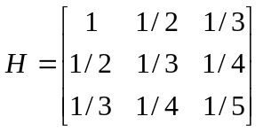.

The exact solution of the linear system

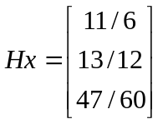 is 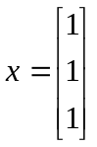.

However, if the data [H , b ] defining this linear system is perturbed (by rounding it to 3 significant digits):

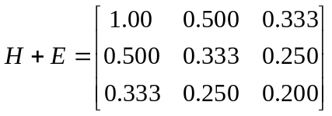 and 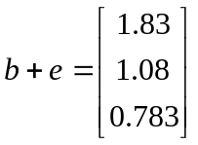,

then the exact solution of this small perturbation 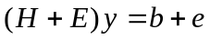 of the given system 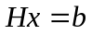 is
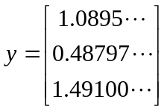.

Thus, the linear system is ill-conditioned.

