COMPUTER SCIENCE 349A

Handout Number 19

Section 18.2 POLYNOMIAL INTERPOLATION

Let 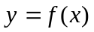 be any given function. For any value of 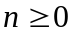 and any given values 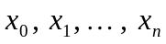, let 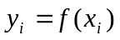. The polynomial interpolation problem is to determine a polynomial 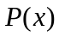 of degree less than or equal to n for which

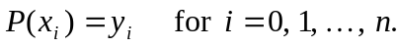

The set of 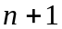 data points 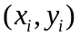 may be the only functional values known (that is,  is a discrete function, which could occur for example with experimental data) or may be a known continuous function and the data points are a finite sample of values with .

If z is some value between 2 of the given values and if 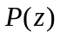 is computed as an approximation to, then this approximation to is said to be determined by polynomial interpolation.

On the other hand, if z lies outside of the interval containing all of the values and if is computed as an approximation to , then this approximation to is said to be determined by polynomial extrapolation.

Note that an interpolating polynomial and the Taylor polynomial both determine polynomial approximations to. However, in general they are very different approximations to. Note that an interpolating polynomial uses the information

to determine the polynomial approximation, whereas the Taylor polynomial uses the information

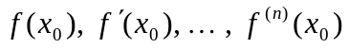

to determine the polynomial approximation.

