COMPUTER SCIENCE 349A

Handout Number 20

EXAMPLES: LAGRANGE INTERPOLATING POLYNOMIAL

1. The case 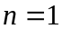 is called linear interpolation, and consists of constructing a straight line through 2 points .

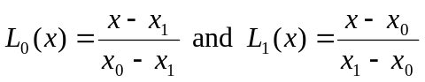

and thus

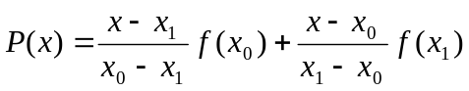 .

Note that 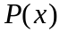 is clearly a linear (first order) polynomial in the variable x, and that

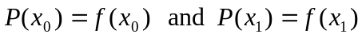,

which verifies that is the desired interpolating polynomial.

2. A complete elliptic integral is defined by

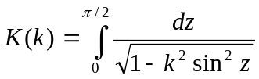 .

The following values can be obtained from numerical tables:

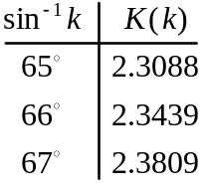

Construct the quadratic (order 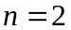) interpolating polynomial for this data, and use it to estimate the value of 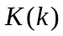 when 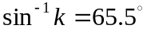.

SOLUTION: with 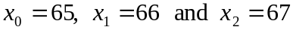, we obtain

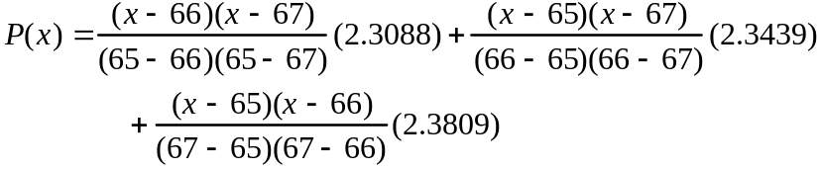

and evaluating this at 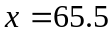 gives the following approximation to 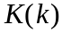 when  

