COMPUTER SCIENCE 349A

Handout Number 21

Section 18.3
The coefficients of the interpolating polynomial can be determined by solving a system of linear equations. Given a function  and distinct points 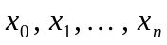, let 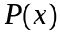 be the unique polynomial of degree 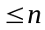 for which 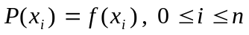.

Example. Consider the case n = 2 . Let 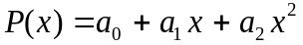.
Then 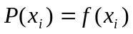 for i = 0, 1, 2 implies that

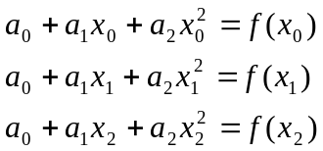

or in matrix/vector notation,

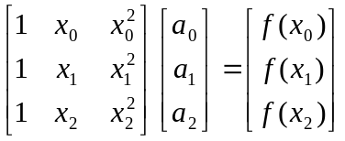.
This is a system of 3 linear equations in the 3 unknowns 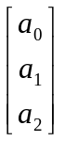.

For example, if 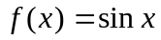 and 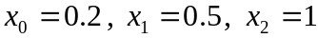 (in radians), then the coefficients 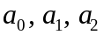 of the interpolating polynomial are determined by solving the following linear system:

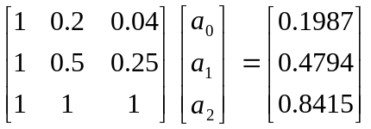

Relative to other methods, the disadvantages of this approach are
(i) such linear systems may be ill-conditioned
and
(ii) it's difficult and expensive to change the degree of the interpolating polynomial.

