COMPUTER SCIENCE 349A

Handout Number 22

USE OF THE ERROR TERM OF POLYNOMIAL INTERPOLATION

PROBLEM: produce a table of values of 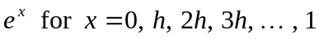 , such that linear interpolation between successive values in the table will yield an approximation with an absolute error 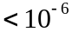.

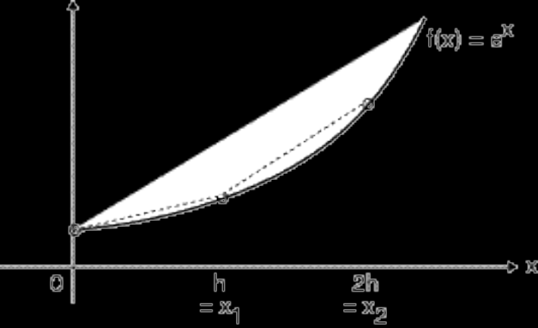

Let 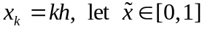 and suppose that j is such that 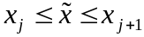.

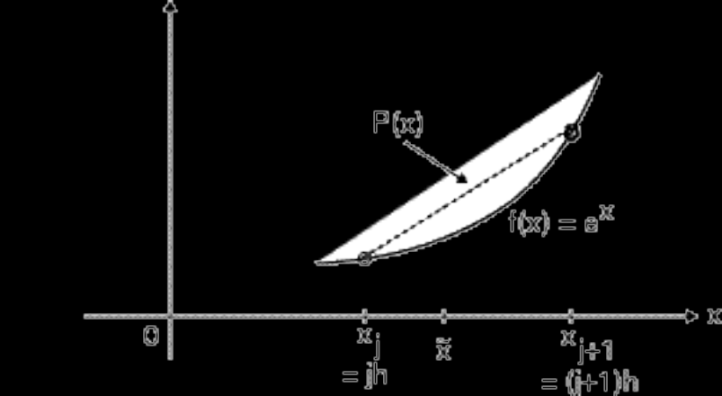

So, our problem can be stated as follows: if we estimate 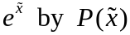, determine a value of h so that the error in this approximation, which is 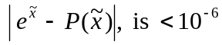 for all values of 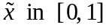.

Solution: The error term for polynomial interpolation with 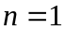 (linear interpolation) gives

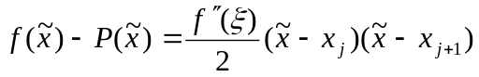,

and for our problem we have . From above,

(*) 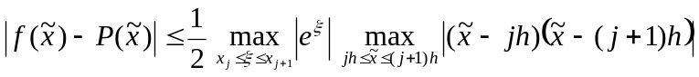 .

The right-hand side of this expression is an upper bound for the absolute value of the error of the linear interpolation, and we need to determine h so that this upper bound is for all choices of 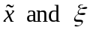. To do this, we need to determine the values of the two maximums above.

Clearly,
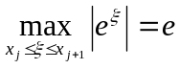 ,

since for

To determine the other maximum, use calculus: let

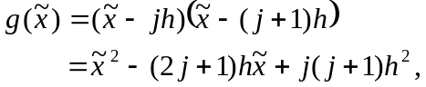

and set 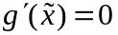, which gives

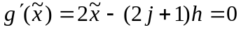,

which implies that
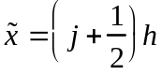 .

Alternatively (without using calculus), clearly the maximum of this quadratic in must occur at the midpoint between its two zeros, and the midpoint between 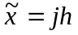 and 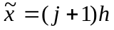 is .

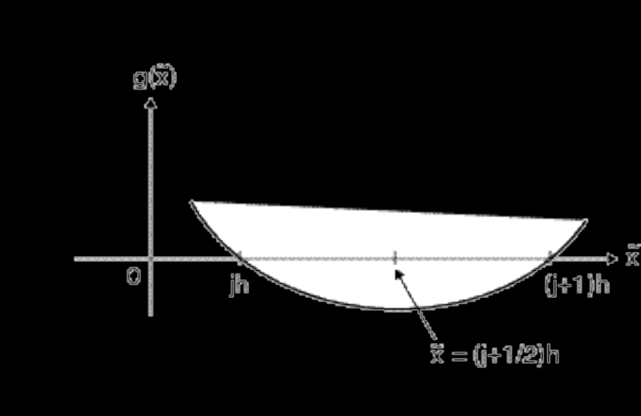

So 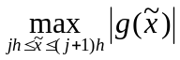 occurs when , which gives a maximum of

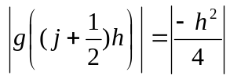 .

Therefore, from (*) above,

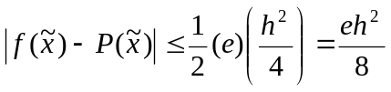 .

As we want this upper bound on the error of the linear interpolation to be , we require that 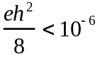, which implies that 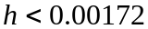 . Thus, for example, a good choice for h would be 0.001 .

Conclusion: if you generated and stored a table of 1001 values of 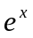 and did linear interpolation between any two adjacent values in the table to determine an approximation to for any value of x that is not in this table, then this approximation is guaranteed to have an absolute error 

