COMPUTER SCIENCE 349A

Handout Number 23

THE RUNGE PHENOMENON

The following example is the classical example to illustrate the oscillatory nature and thus the unsuitability of high order interpolating polynomials. It is due to Runge in 1901.

Consider the problem of interpolating

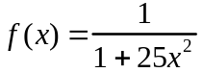

on the interval 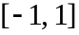 at 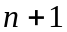 equally-spaced points by the interpolating polynomial 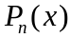. In the figure below, the graphs of 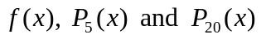 are shown.

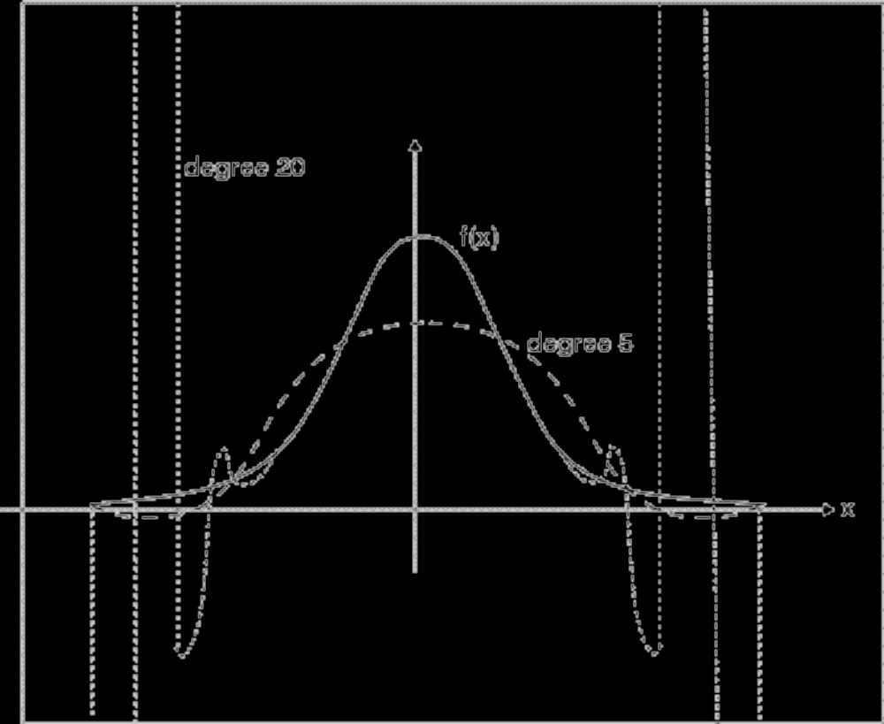

Runge proved that as 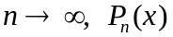 diverges from  for all values of x such that 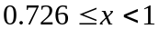 (except for the points of interpolation ). The interpolating polynomials do approximate well for 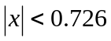 .

One way to see that the difference between 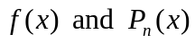 becomes arbitrarily large as n becomes large is to consider the error term for polynomial interpolation

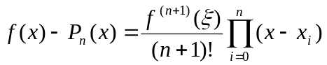.

As it can be shown that 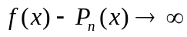 (at some points x in ).

Note: if the points of interpolation are not constrained to be equally spaced, then it is possible to choose the points of interpolation so that 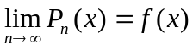. However, there is no known rule that indicates how to choose appropriate points of interpolation to guarantee such convergence of the interpolating polynomials for arbitrary continuous functions .

