COMPUTER SCIENCE 349A
Handout Number 24

CUBIC SPLINE INTERPOLANTS

The following definition is the same as given in points 1-5 on pages 515-516 of the 6th ed. or pages 517-518 of the 7th ed., but is more precise.

Definition

Given data

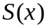 is a cubic spline interpolant for  if

(a) is a cubic polynomial, denoted by 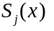, on each subinterval
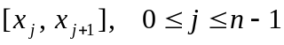

(b) 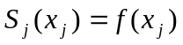, for 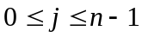 and 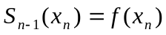

(c) 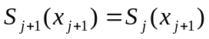, for 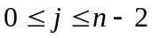

(d) 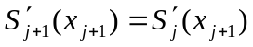, for

(e) 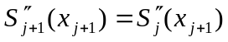, for

and (f ) either one of the following hold:

(i) 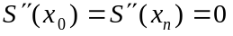
--- the free or natural boundary conditions
or
(ii) 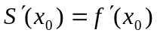 and 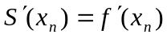
--- the clamped boundary conditions

Note: for any, there exist an infinite number of cubic splines satisfying conditions (a) - (e). The reason:
There are n cubic polynomials to specify, each one is defined by 4 coefficients, giving a total of 4n unknowns to be specified.
However, condition (b) gives 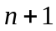 conditions to be satisfied, and (c), (d) and (e) each give 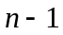 conditions to be satisfied.
Thus, there are 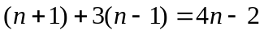 conditions (equations) to be satisfied in 4n unknowns.

But if either (i) or (ii) is also required to be satisfied, then there are 4n conditions in 4n unknowns and there exists a unique cubic spline interpolant satisfying (a) – (f ).

If  satisfies conditions (a), (c), (d) and (e), then (by the definition given in class) it is a spline function with 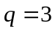; that is, is a cubic polynomial on each of the subintervals 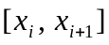, and each of , 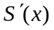 and 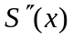 is continuous on 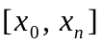. Condition (b) implies that interpolates the data 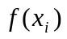, and condition (f) gives a unique spline.

The boundary conditions (i) and (ii)
If satisfies (i), it is called a natural cubic spline. Physically, such a spline corresponds to the shape of a long flexible rod that is constrained to pass through the points 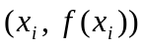. See Figure 18.15 on page 511 of the 6th ed. or page 513 of the 7th ed. Mathematically, a natural cubic spline is the unique function possessing minimum curvature (the rate of change of the tangent vector to a curve) of all functions that interpolate the data and have a square integrable second derivative.

If satisfies the clamped boundary conditions (ii), then these specified first derivative values at the end points usually make this spline a more accurate approximation to the data . But, of course, it requires this additional information about .

Other boundary conditions are also possible. MATLAB allows two different types of boundary conditions: the clamped boundary conditions and the not-a-knot boundary conditions.

