COMPUTER SCIENCE 349A
Handout Number 25

CUBIC SPLINE INTERPOLATION

Example: the case 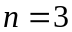.

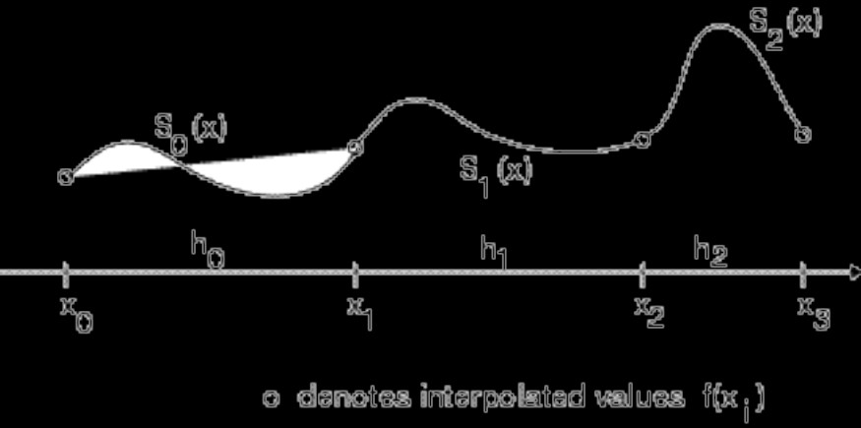

Condition (b) in the definition of a cubic spline interpolant implies that

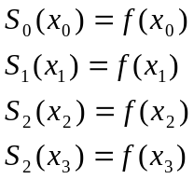

Condition (c) implies that

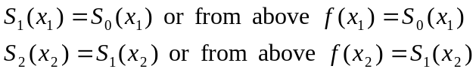

Condition (d) implies that

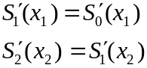

Condition (e) implies that

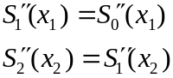

Computation of a cubic spline
An algorithm is given in the text on page 519 in the 6th ed. or page 521 in the 7th ed., which is based on the derivation given on pages 516-518 in the 6th ed. or pages 518-520 in the 7th ed. The computation of the coefficients of a cubic spline can be reduced to solving a system of 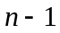 linear equations in unknowns. We will not consider this algorithm and derivation from the textbook. Instead, we will use the software provided in MATLAB (which uses an algorithm similar to that in the textbook) to compute a cubic spline.

One important consideration is the form of the cubic polynomials, which is as follows (when 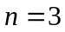):

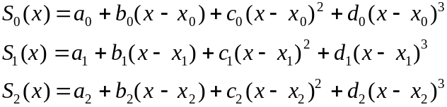

The problem is to determine the unknowns

so that conditions (b), (c), (d), (e) and one of the conditions in (f ), as given in Handout #24, hold. Note that the first part of condition (b) implies that

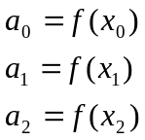

The computation of the remaining unknowns is more complicated, and in general requires the solution of a system of linear equations.

SPLINE EXAMPLES from the posted Sample Exam Questions

5.5 Determine values for the parameters 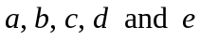 so that

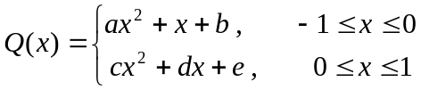

is a quadratic spline function that interpolates , where

.

Show all of the equations that the unknowns must satisfy, and then solve these equations.

SOLUTION

Let

Then
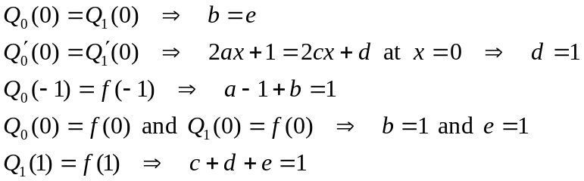

Solution:
Thus,
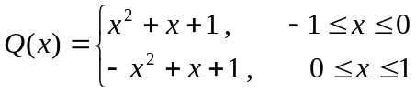

5.6 Determine 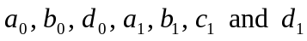 so that

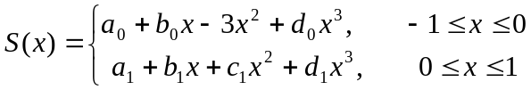

is the natural cubic spline function such that

.

Clearly identify the 8 conditions that the unknowns must satisfy, and then solve for the 7 unknowns.

SOLUTION

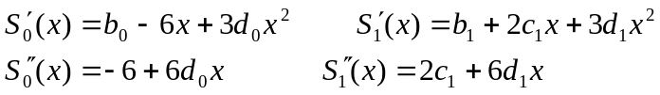

The 8 conditions are

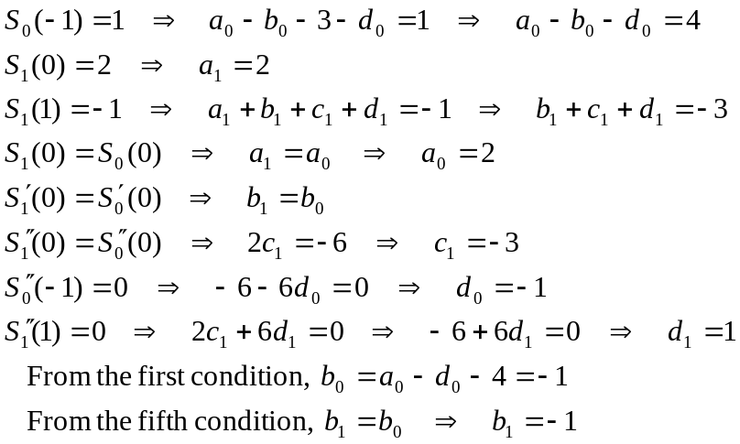
Thus
