COMPUTER SCIENCE 349A
Handout Number 26

NEWTON-COTES CLOSED QUADRATURE FORMULAS

The case 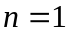 (Section 21.1 of the textbook):

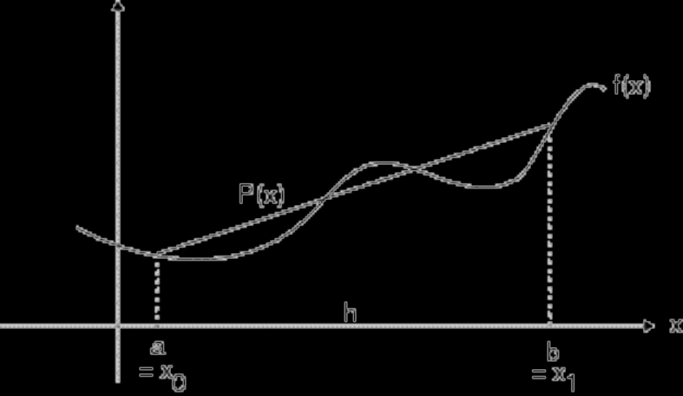

Here 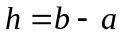. The (linear) interpolating polynomial is

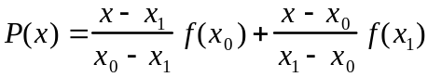 .

The quadrature formula for approximating 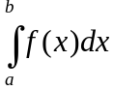 is obtained by integrating 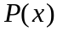:

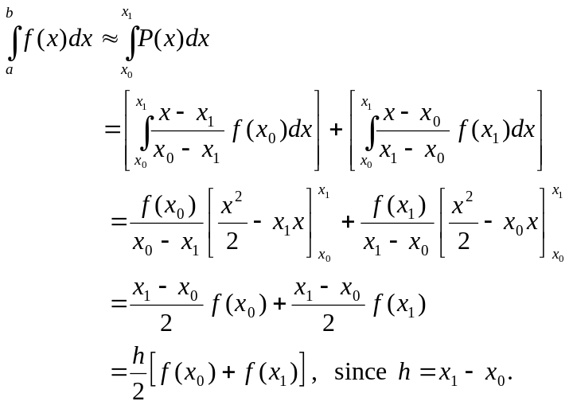

This is the trapezoidal rule. Its error term can be obtained by integrating the error term of the Lagrange form of the interpolating polynomial, which for is
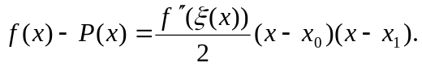
Note that does depend on x; for each value of x in [a, b], there is a different value for which the above expression gives the value of 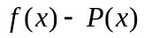. Integrating this gives

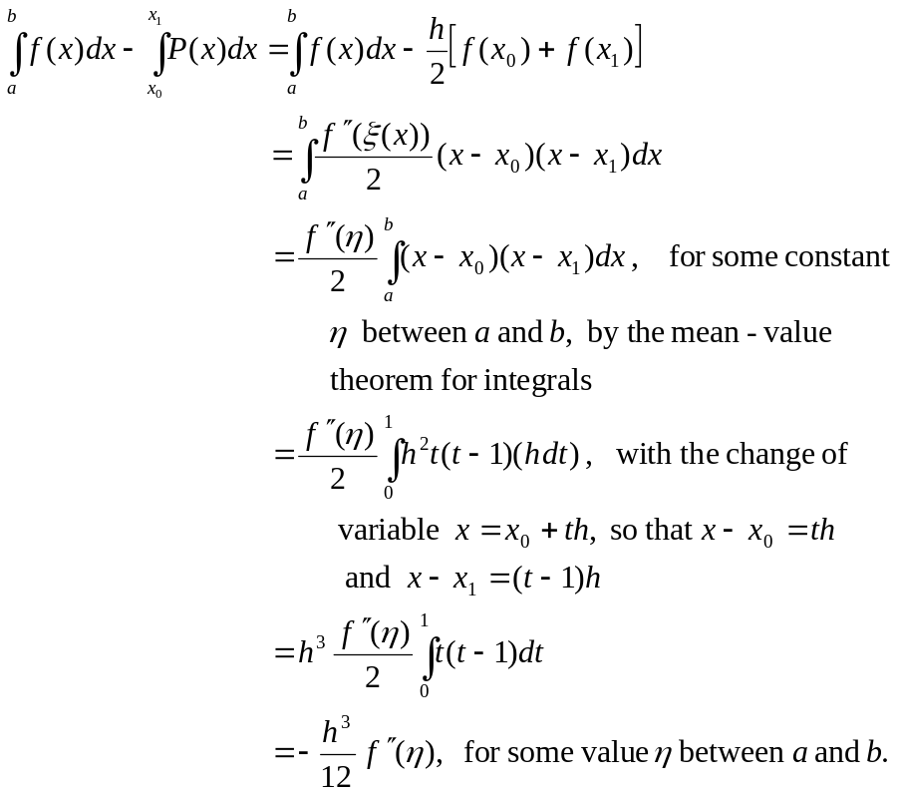

See (21.6) on page 605 of the 6th ed. or page 607 of the 7th ed., where . This error term is the truncation error when is approximated by 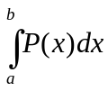.

The case 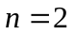 (Section 21.2.1 on page 613 of the 6th ed. or page 615 of the 7th ed.):

The quadratic interpolating polynomial is
.

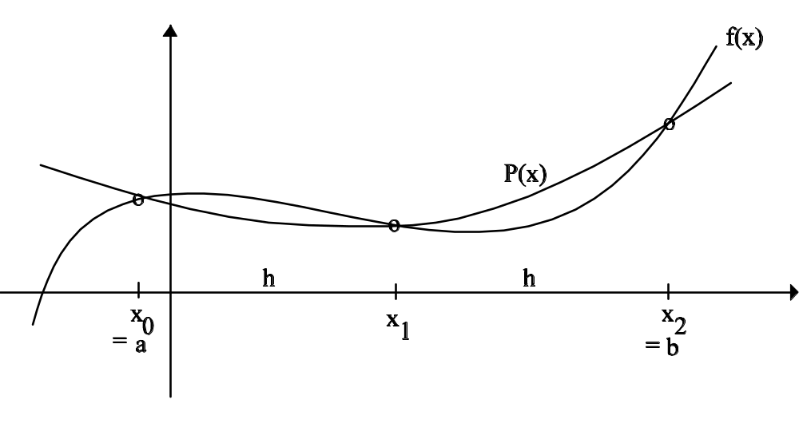
As in the case 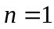, the quadrature formula for approximating is obtained by integrating : 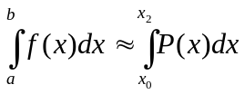

This gives
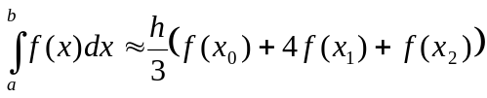,

where now 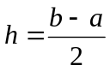. This is called Simpson’s rule (or as in the textbook, Simpson’s 1/3 rule), and its truncation error is given by

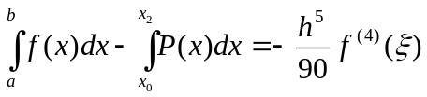, for some value 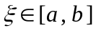.

See pages 614-615 of the 6th ed. or pages 616-617 of the 7th ed.

The Newton-Cotes closed quadrature formula for 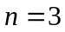, in which  is approximated by a cubic polynomial that interpolates it at four equally-spaced points, is

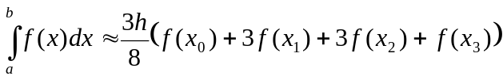, where 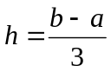,

which is called the Simpson’s 3/8 rule. See Section 21.2.3 on page 618 of the 6th ed. or page 620 of the 7th ed.

