COMPUTER SCIENCE 349A

Handout Number 27

DEGREE OF PRECISION OF A QUADRATURE FORMULA

The degree of precision of a quadrature formula is a measure of its accuracy or power. It is an integer number that indicates the degree (or order) of the set of all polynomials that the quadrature formula will integrate exactly. The larger the degree of precision, the more accurate or powerful is the quadrature formula because it will integrate exactly a larger set of polynomials, and this is a very good indicator that it will therefore integrate non-polynomial functions more accurately.

Definition
If a quadrature formula 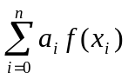 computes the exact value of 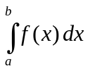 whenever  is a polynomial of degree 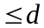, but
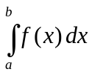
for some polynomial of degree 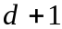, then the degree of precision of the quadrature formula is d.

Note. If is a polynomial of degree d, then 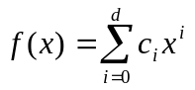 and
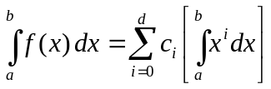.
Consequently, a quadrature formula computes exactly if and only if it computes each of
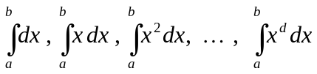

exactly. That is, the degree of precision is d if and only if the quadrature formula computes the exact value of the integral when 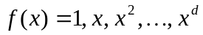, and it is not exact when 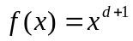.

Example 1.

Consider the trapezoidal rule

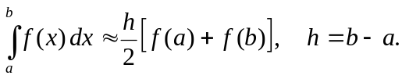

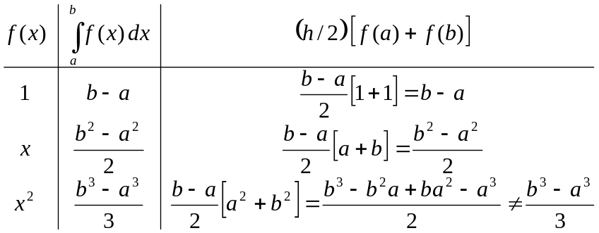

Thus, the degree of precision of the Trapezoidal Rule is 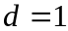.

Note. The degree of precision is also clear if you know the error term for the quadrature formula. For example, since the error term for the Trapezoidal Rule is 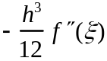, for some value 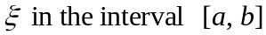, this error term is exactly equal to 0 if and only if 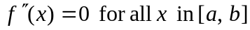. This is true if and only if 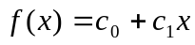. That is, the Trapezoidal Rule computes the exact value of the integral of a polynomial if and only if is a polynomial of degree (that is, the degree of precision is ).

Example 2.

Consider Simpson's rule.

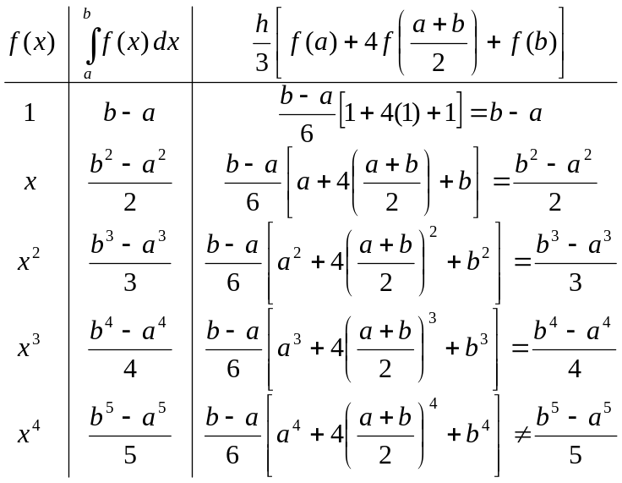

Thus, the degree of precision of Simpson's rule is 3 (which again can be seen from the form of its error term, which is 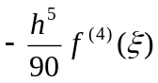 ).

Note. The degree of precision 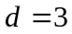 of Simpson’s rule is larger than expected since it is obtained by integrating a quadratic interpolating polynomial. This means that if 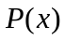 is a quadratic polynomial that interpolates any cubic polynomial
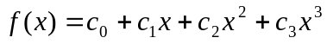
at the points a, b and 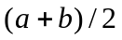, then
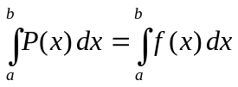 exactly.

This larger-than-expected value of the degree of precision occurs for Newton-Cotes closed quadrature formulas for all even values of n, making these formulas more accurate and preferable to the quadrature formulas for odd values of n.

