COMPUTER SCIENCE 349A
Handout Number 28

COMPOSITE (Multiple-Application) SIMPSON'S RULE (Section 21.2.2)

Each application of Simpson's rule requires 2 subintervals on the interval of integration and 3 quadrature points, say 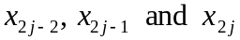:

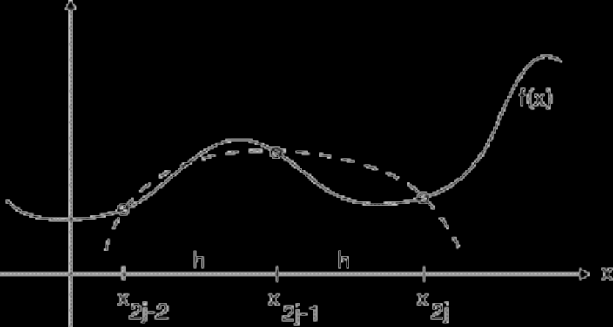

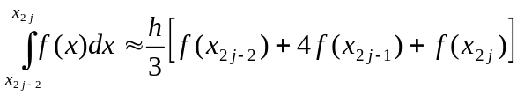

Thus, m applications of Simpson's rule on 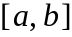 require that be subdivided into an even number of subintervals. In the following, we will assume that is subdivided into 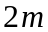 subintervals, each of length

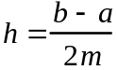 ,

and the corresponding 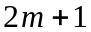 quadrature points will be denoted by 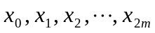.

The case 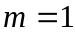: just one application of Simpson's rule (or, we could call this the "noncomposite" Simpson's rule).

The case 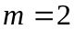: two applications of Simpson's rule require 5 quadrature points and 4 subintervals of , each of length 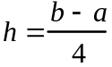 .

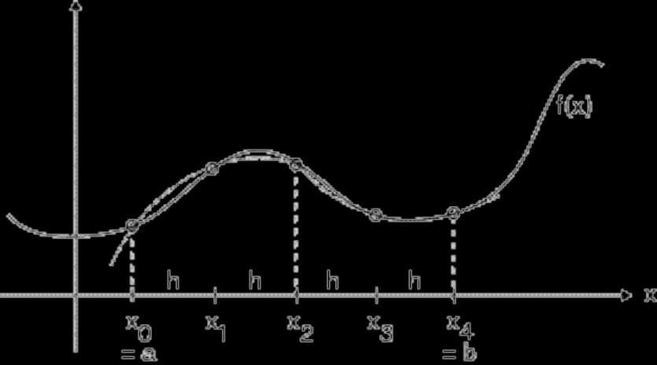

Letting 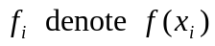, this approximation becomes

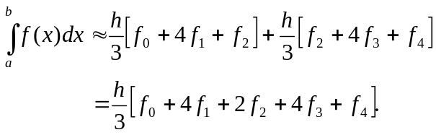

The case 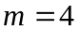: four applications of Simpson's rule require 9 quadrature points and 8 subintervals of , each of length 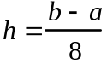 .

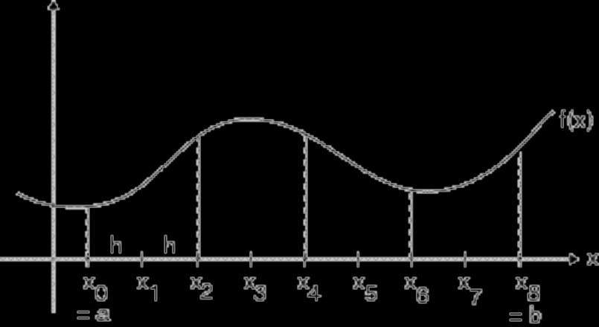

This composite Simpson's rule approximation is

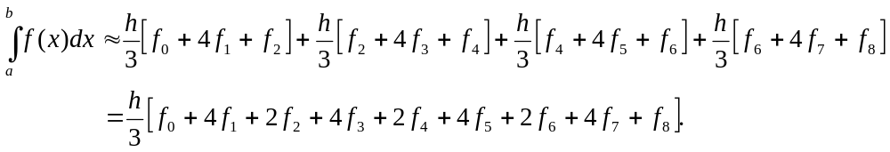

In general, for 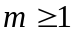, the composite Simpson's rule approximation is

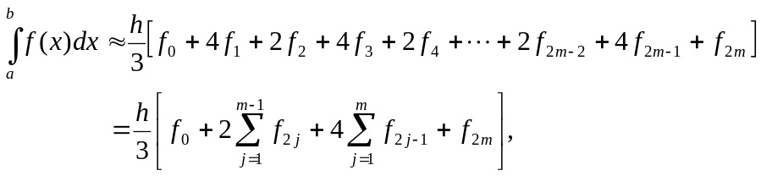

where
.

Note. See (21.18) on p. 616 of the 6th ed. or p. 618 of the 7th ed., where n is equal to 2m.

Usual implementation (in order to re-use function evaluations of , and thus make the computation efficient): initialize , and then double m at each iteration. Continue iterating until two successive approximations are sufficiently close together.

Truncation error

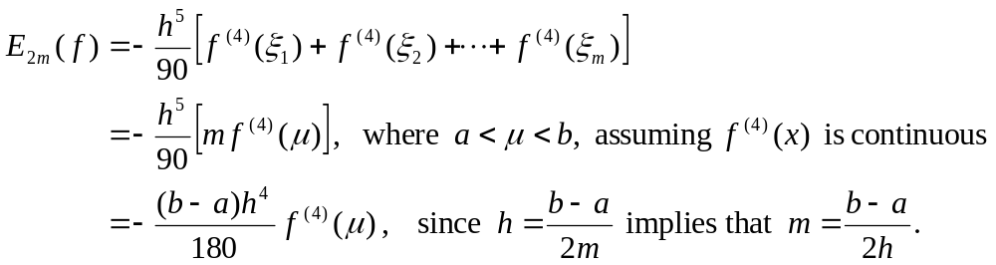

(This is (21.19) on p. 617 of the 6th ed. or p. 619 of the 7th ed., where n is equal to 2m.)

Thus, if 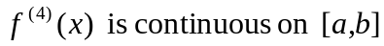, it follows that the composite Simpson's rule approximations converge to 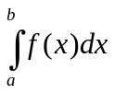 , that is, that 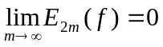. (Note that this is in the absence of roundoff errors, which we have not taken into account; typically it is the case that the accumulated roundoff error is much smaller than the truncation error.)

