COMPUTER SCIENCE 349A
Handout Number 29

USE OF NEWTON-COTES CLOSED QUADRATURE FORMULAS
ON DISCRETE DATA AT UNEQUALLY SPACED POINTS
(Section 21.3)

Consider the data given in Table 21.3 on page 622 of the 6th ed. or page 624 of the 7th ed.

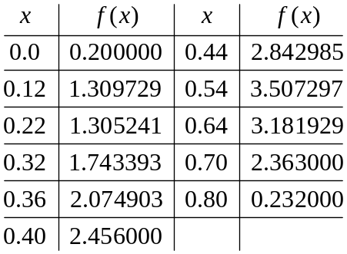

As the data is not specified at equally-spaced points x, no fixed Newton-Cotes formula for a small value of n can be used to approximate the integral of the continuous, but unknown, function  that is represented by this data. This data could be interpolated by a polynomial of degree 10, but such high order Newton-Cotes formulas should be avoided.

Instead, for example, you could do the following:
- use the Trapezoidal rule with h = 0.12 on [0.0, 0.12]
- use Simpson’s rule with h = 0.10 on [0.12, 0.32]
- use Simpson’s 3/8 rule with h = 0.04 on [0.32, 0.44]
- use Simpson’s rule with h = 0.10 on [0.44, 0.64]
- use the Trapezoidal rule with h = 0.06 on [0.64, 0.70]
- use the Trapezoidal rule with h = 0.10 on [0.70, 0.80]

This is done in Example 21.8 on page 623 of the 6th ed. or page 625 of the 7th ed., and yields a computed approximation to 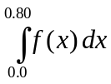 of 1.603641 . In this case, the given data was obtained by sampling a known function, and the correct value of the integral is 1.640533 .

