COMPUTER SCIENCE 349A
Handout Number 30

ROUNDOFF ERROR ANALYSIS FOR COMPOSITE
NEWTON-COTES FORMULAS

For simplicity consider the composite Simpson’s rule

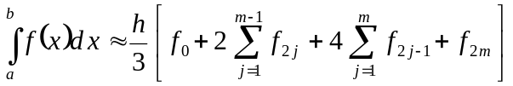 ,

where 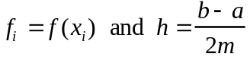. When this formula is evaluated using floating-point arithmetic, there are two main sources of roundoff error: in the evaluation of the values 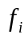, and in calculating the summations. For now, we'll consider only the effect on the computed approximation to 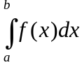 of roundoff errors that occur in evaluating the values .

Suppose denotes the computed approximation to (that is, is inexact due to roundoff error).

Denote the roundoff error by 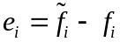 and suppose that 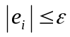 for all (that is, we are assuming that is the largest possible roundoff error when evaluating 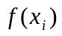 regardless of the value of ).

Then the accumulated effect of these roundoff errors in the composite Simpson’s rule is

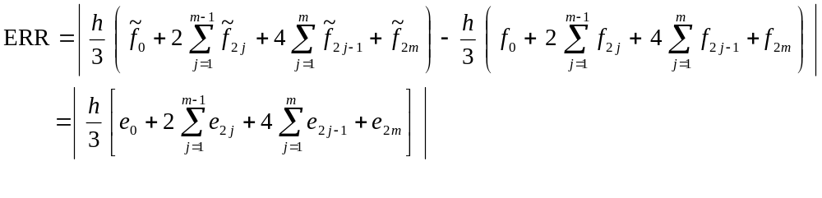

Thus,
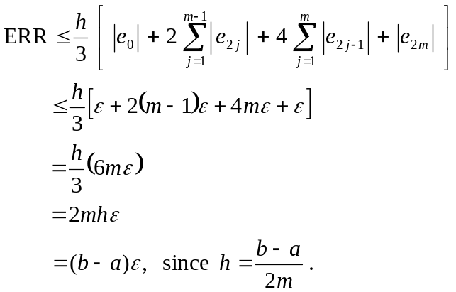

Thus the composite Simpson’s rule is very stable: roundoff errors do not disastrously accumulate as (or 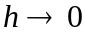)

Notes

1. The above analysis is not complete: it ignores the roundoff errors made in doing the approximately 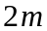 additions (in the composite Simpson’s rule). As , the accumulated effect of these errors will eventually make the total roundoff error large (for extremely large values of m, for example if m were several million or more). However, sufficient accuracy can usually be obtained without using such large values of m, so algorithms for quadrature are stable

2. The roundoff error analysis for other quadrature formulas is similar.

Overall conclusion: quadrature is stable. Sufficient accuracy can be obtained before the negative effects of the roundoff error due to the additions in the quadrature formula become apparent. That is, the magnitude of the accumulated roundoff error when using a quadrature formula is usually just the magnitude of the roundoff due to evaluating the , and the above analysis shows that this is not large.

