COMPUTER SCIENCE 349A
Handout Number 31

RICHARDSON'S EXTRAPOLATION (Section 22.2.1)

-- the technique of combining two different numerical approximations that depend on a parameter (usually a step size h) in order to obtain a new approximation having a smaller truncation error.

Let M denote some value to be computed, for example,

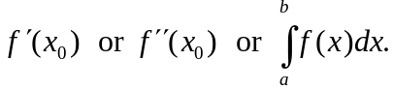

Let 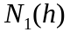 denote a formula (that depends on a parameter h that can take on different values) for computing an approximation to M, and suppose that the form of the truncation error of this formula is a known infinite series in powers of h. For example, the most common case is that the truncation error is 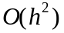 and is an infinite series with only even powers of h, that is,

(1) 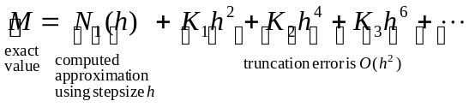

where the values 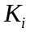 are some (possibly unknown) constants. The parameter h can be any positive value, but as 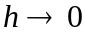, the truncation error 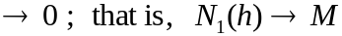.

If (1) holds, then using a stepsize of 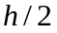,

(2) 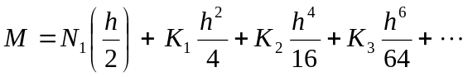 .

In order to obtain an 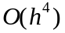 approximation to M, we need to determine a linear combination of equations (1) and (2) in which the terms cancel out; this will occur if we compute

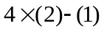,

which gives

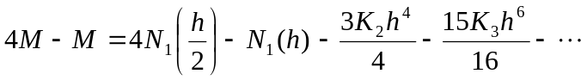 ,

or (by solving for M)

(3) 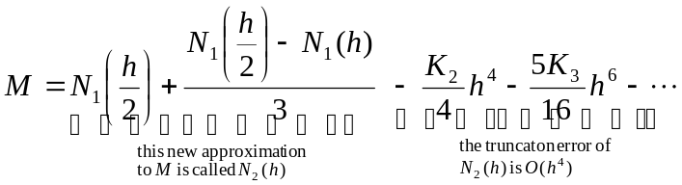 .

The above computation illustrates the basic idea of Richardson's Extrapolation: an formula is used with two different stepsizes 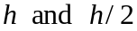 to compute two approximations 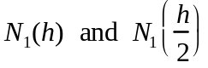to some desired value M; then the simple computation

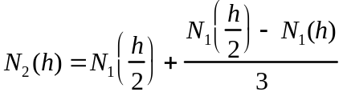

results in an approximation to M that has accuracy.

Note. In the textbook, instead of stepsizes h and 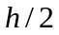, the two different stepsizes are denoted by 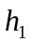 and 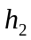.

By further decreasing the stepsize, the extrapolation procedure can be continued to give approximations to M that have accuracy 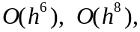 and so on. Provided that the successive stepsizes decrease by the same factor, for example,

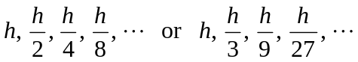 ,

then a simple formula can be determined for computing all of these approximations to M and the computation can be automated.

Summarizing the above, we have:

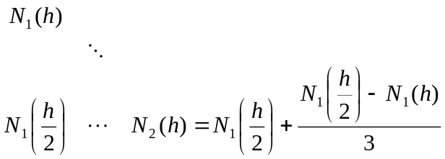

and (3) can be written as

(4) 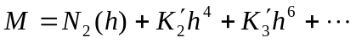 .

for some constants 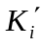. If the formula 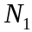 is now used with a stepsize 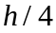, this approximation to M satisfies

(5) 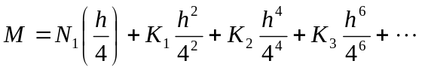 ,

so equations (2) and (5) can be combined to give another approximation to M: calculating 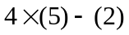 gives

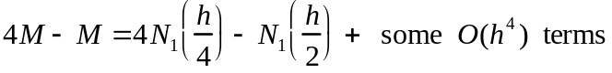

or (analogous to (3) and (4) ), on solving for M this gives

(6) 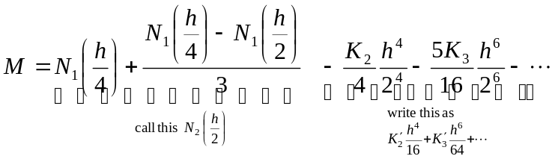

Now, equations (4) and (6) can be combined to give an 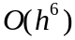 approximation to M: calculating 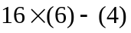 gives



which can be written as

(7) 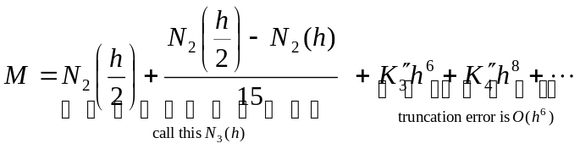

for some constants 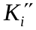. The above procedure can be continued, resulting in the following Richardson's Extrapolation Table (which can have as many rows and columns in it as you want):

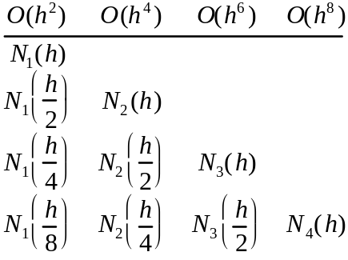

Entries in this table are computed row-by-row as follows:

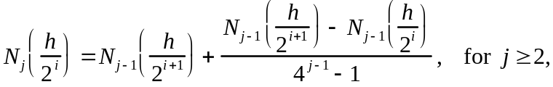

and this approximation to M has truncation error of 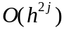.

Example 1

Use Richardson's Extrapolation and the formula

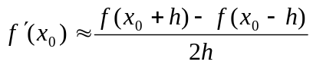 ,

which has a truncation error term of the form in (1) above

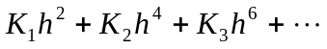 ,

to approximate 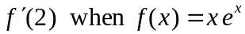. Start with 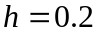 .

In terms of the notation used above, here we have 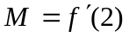 and 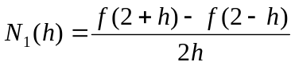. The first 4 rows and columns of the Richardson's Extrapolation table are as follows:

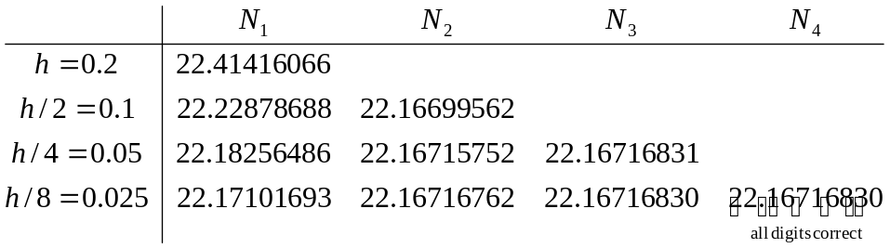

Example 2.

It can be shown that
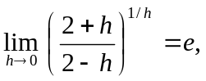

where 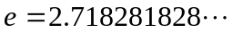 . If
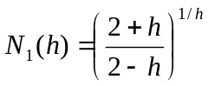
denotes a formula for approximating the value of e for any fixed value of h, then it can be shown that the truncation error of this approximation is of the form

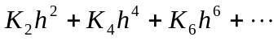

for some constants 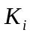 ; that is,

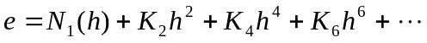 .

Problem. Using h = 0.04 and stepsizes and 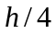, compute an 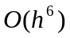 approximation to the value of e using Richardson’s extrapolation.

Solution. Compute the first column of the Richardson’s extrapolation table using the given numerical formula:

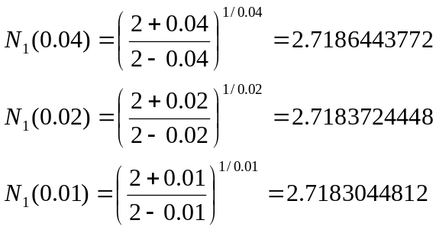

(Note that these approximations each have about 4 correct significant digits.)
Apply Richardson's extrapolation to the above two values in order to obtain two 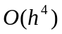 approximations to the value of e.

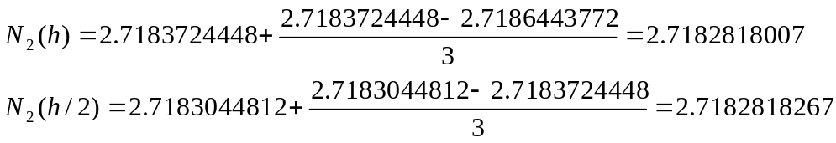

Combine these two values to obtain an approximation to the value of e:

Note. This approximation has 8 correct significant digits.

**************************************

Advantages of Richardson's Extrapolation:
-- obtain high accuracy with little computation
-- doesn't require very small values of h to get high accuracy, so roundoff error is
not a concern. Note that the formulas used in the two examples above would have a loss of significant digits for very small values of h, and would give inaccurate results in floating-point arithmetic.

