COMPUTER SCIENCE 349A
Handout Number 32

ROMBERG INTEGRATION (Section 22.2)

Romberg integration is the application of Richardson's Extrapolation to the composite trapezoidal rule approximations.

Notation: let 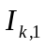 denote the composite trapezoidal rule approximation to 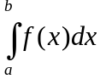 using 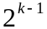 subintervals.

Then, letting 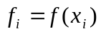 as usual,

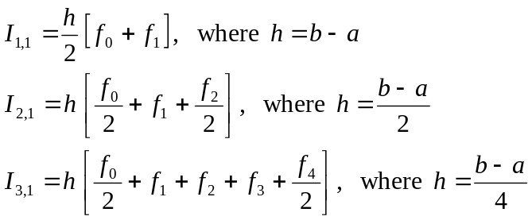

and so on. The error term 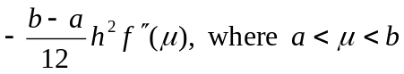, for the composite trapezoidal rule can also be shown to have a series expansion of the form

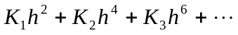 ,

where the 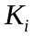 are constants independent of h. That is, this error term has the form (1) in Handout Number 31, so the Richardson's Extrapolation formulas below are the same as those in Handout Number 31.

For example, letting 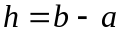,

(a) 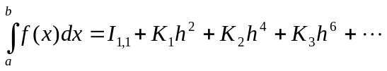
(b) 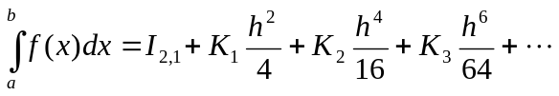

so computing 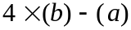 gives

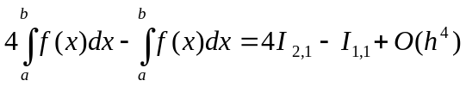.

Thus,
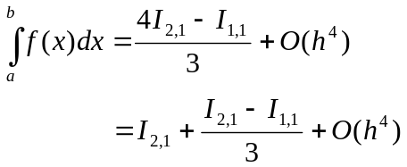

Notation: define

Then, the first two columns of the Richardson's Extrapolation table are

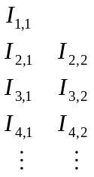

and the entries in the first column have truncation error 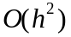, and the entries in the second column have truncation error 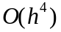. In fact, the truncation error of 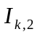 is of the form
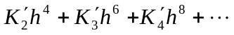

for some constants 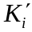 independent of h.

The following illustrates how to compute the entries of the third column of the extrapolation table, which are accurate to 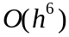:

(c) 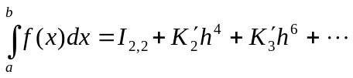
(d) 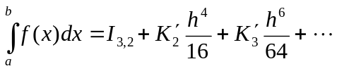

so the computation 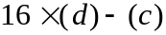 gives

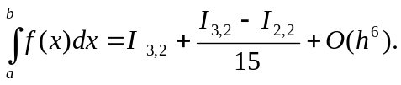

Notation: we define

and all of these entries have accuracy . In this case, the Richardson's Extrapolation table is called the Romberg table:

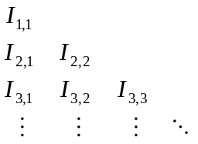

and its entries (in columns 2, 3, ... ) can be computed by

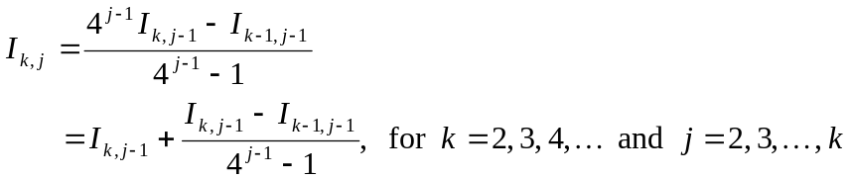

This is similar to (22.8) on page 636 of the 6th ed. or page 638 of the 7th ed.; however, a different indexing scheme is used in the textbook.

EXAMPLE
Approximate 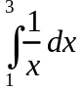 using Romberg integration. The Romberg table is as follows:

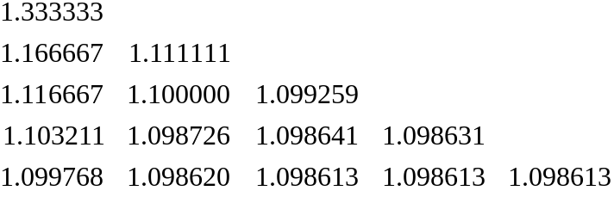

The correct answer is 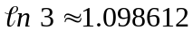 . Note that this very accurate approximation is obtained by extrapolation on the Composite Trapezoidal Rule approximations in the first column, where the smallest value of h is 1/8 and only 17 values 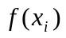 are used.

NOTES

1. The entries in the Romberg table are computed row-by-row, stopping when two successive diagonal entries in the table are sufficiently close together:

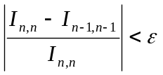 .

2. There is a convergence theorem. If 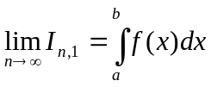 (that is, if the composite trapezoidal rule approximations in the first column of the Romberg table converge), then the diagonal entries in the Romberg table will converge:

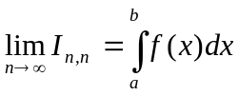 .

(Recall that the composite trapezoidal rule approximations converge if 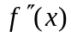 is continuous on 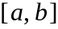.)

3. There is an efficient, recursive formula for computing the entries in the first column of the Romberg table in which the value of is computed by re-using the function values used to compute 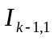:

(*) 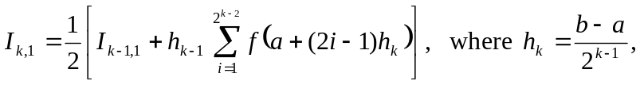

for 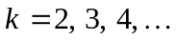 . To see how this works, consider the first 3 steps of the composite trapezoidal rule, and label the quadrature points the same for all 3 approximations as follows:

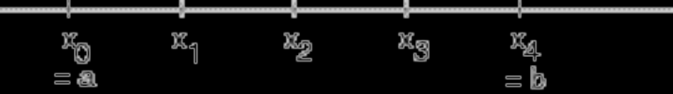

Then

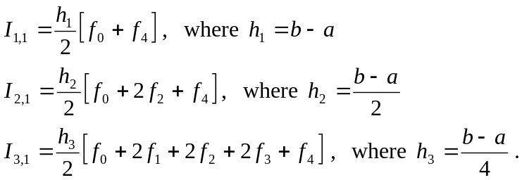

Thus,

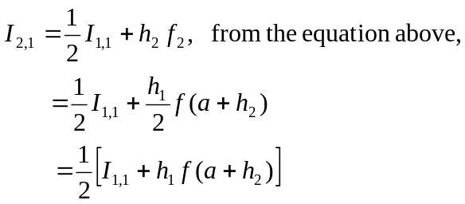

which is (*) when 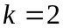. Similarly,

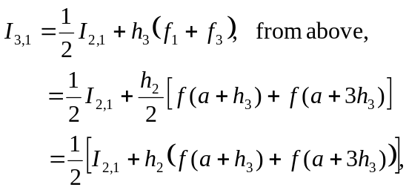

which is (*) when 

