COMPUTER SCIENCE 349A
Handout Number 33

NUMERICAL DIFFERENTIATION FORMULAS
USING TAYLOR'S THEOREM
(Chapter 4, page 90 of the 6th ed. or page 93 of the 7th ed.
and Chapter 23, page 653 of the 6th ed. or page 655 of the 7th ed.)

In Chapter 4, Taylor’s Theorem was used to derive a numerical differentiation formula that was used to approximate a derivative in a mathematical model that was developed to determine the terminal velocity of a free-falling body (a parachutist).

Recall Taylor's Theorem (with 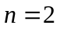):

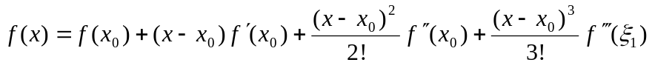
or
(1) 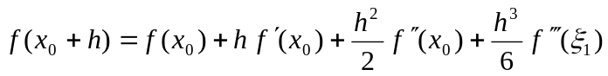

where 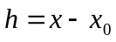 (and thus 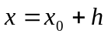) and 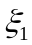 lies between  and .

Solving for 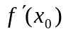 from (1) gives

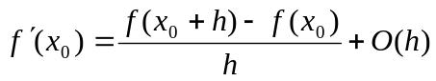.

That is,
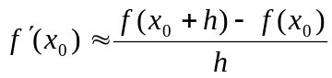 with a truncation error that is 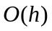;

See page 90 of the 6th ed. or page 93 of the 7th ed. This is called the forward difference approximation to .

A more accurate approximation to a first derivative can be obtained by taking a linear combination of two Taylor Theorem approximations. If h in (1) is replaced by 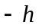, we obtain

(2) 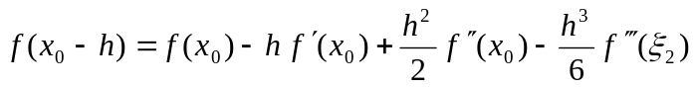,

where 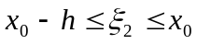. Subtracting (2) from (1) gives

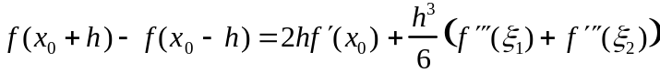,

from which it follows that

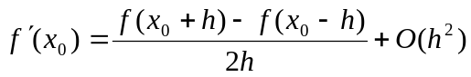.

This central difference approximation to is more accurate than the above forward difference approximation (as such formulas are only used when h is less than 1).

Still more accurate approximations to can be obtained by taking linear combinations of more Taylor Theorem approximations and solving for . For example, Taylor Theorem approximations for each of

can be used to derive the 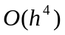 approximation

;

see pages 654-655 of the 6th ed. or pages 656-657 of the 7th ed. for this and other such formulas. For this derivation, one must determine a linear combination of the Taylor polynomial approximations for each of expanded about 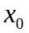, so that all of the terms involving 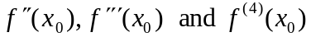 cancel out.

Numerical differentiation formulas for higher derivatives of  can also be obtained using Taylor's Theorem: see pages 654-655 of the 6th ed. or pages 656-657 of the 7th ed. for such formulas.

Example. By Taylor's Theorem,

and

Adding these gives:

,

and solving for the desired derivative 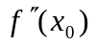 gives

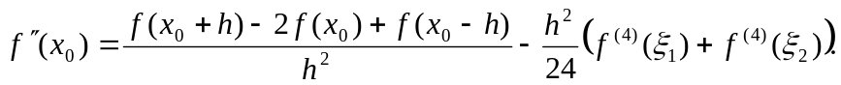

That is,

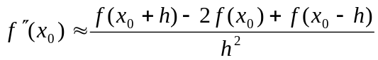

has a truncation error of 

