COMPUTER SCIENCE 349A
Handout Number 34

ORDINARY DIFFERENTIAL EQUATIONS

Part 7 of the textbook: see pages 697-706 of the 6th ed. or pages 699-708 of the 7th ed. for Motivation and Mathematical Background. Recall that the mathematical model of a free-falling body developed in Chapter 1 involved a first order differential equation, and a simple numerical method was developed there for solving that differential equation.

Chapter 25 Runge-Kutta methods

The problem considered is a first-order initial value problem, which is always assumed to be in the form

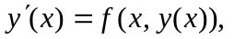subject to the initial condition 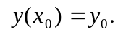

Here x is the independent variable, the dependent variable y is a function of x, and f is a given function of both x and 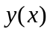 that specifies the derivative of the function y.

Given constants 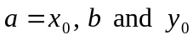 and a function 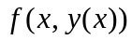, the problem is to determine for 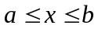.

Example
Determine 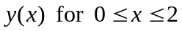 such that

.

This problem has an analytic solution, namely 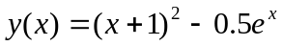 .

Numerical methods
All numerical methods we will consider for approximating are called "difference methods" (or discrete variable methods): that is, the continuous, exact solution is approximated by a finite set of computed values at a set of mesh points (or grid points) 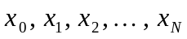 in 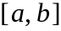.
For now, we consider only equally-spaced mesh points, and let

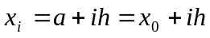, 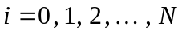,

where
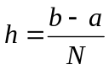

is called the step size.

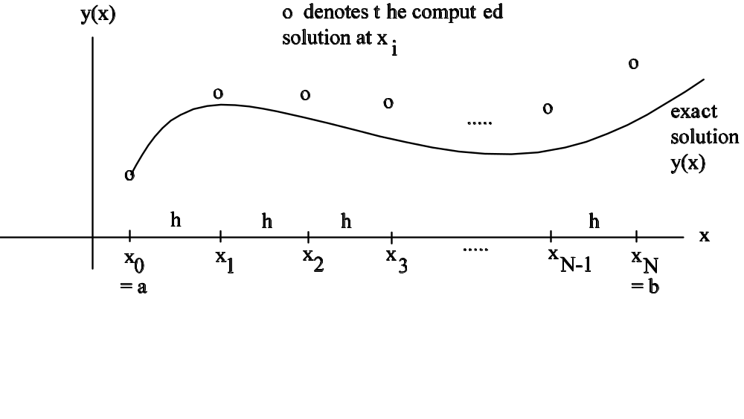
At each of the 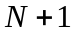 mesh points , the exact solution is denoted by 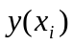, and the computed approximation is denoted by .

Euler’s method (Section 25.1, page 708 of the 6th ed. or page 710 of the 7th ed.)
-- seldom used, but illustrates the derivation and use of numerical methods.

Derivation from Taylor's Theorem:
Taylor's Theorem for (with 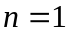) expanded about is

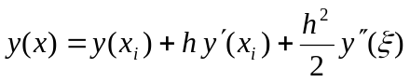

for some value 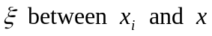. Thus, at 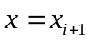,
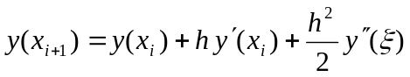
where 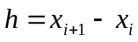.

For small values of h, this suggests the approximation

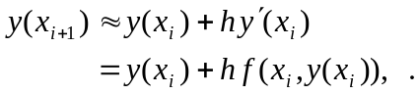

using the differential equation 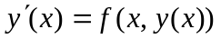.

Euler's method is obtained from this truncated Taylor polynomial approximation by replacing the exact solution 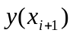 by its numerical approximation 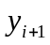, and similarly by replacing 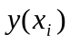 by : given an initial condition
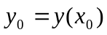,
let
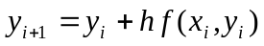, for i = 0 , 1 , 2 , 3 , … , 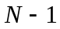.

Example
Consider the initial-value problem

.

Here 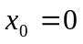 and 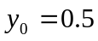 . Let 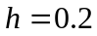 . Using Euler’s method with 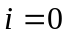 gives

The first few computed approximations and the corresponding exact solutions are as follows:

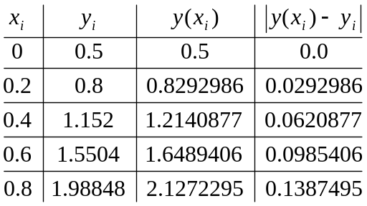

Geometric interpretation of Euler's method:

is the given initial condition. Using this value, we compute

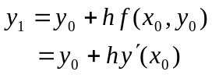

from which it follows that

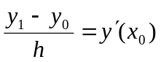.

Geometrically, this says that 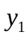 is obtained from 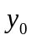 by constructing the tangent line to the graph of at  (which has slope equal to 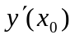 ) and going a distance h.

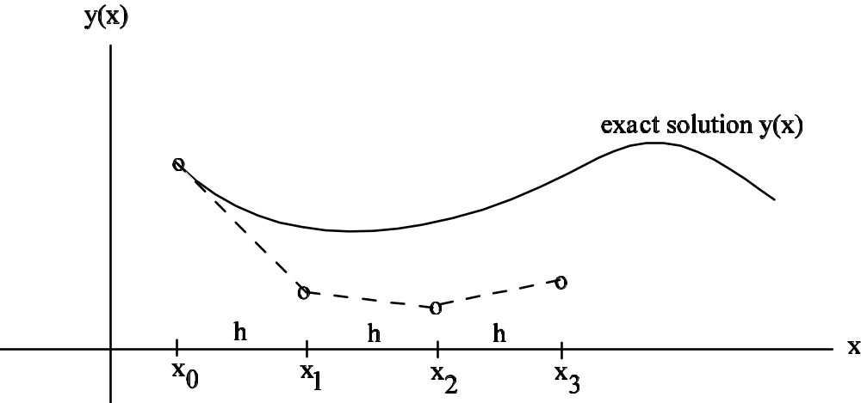

Similarly,
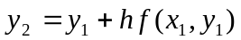,

so 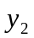 is determined by constructing a straight line through 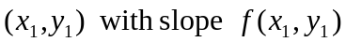. Note, however, that this is not the slope of the tangent line to the graph of 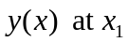, since 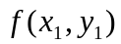 is only an approximation to 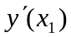 (since the computed approximation is not equal to the exact value 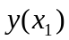).

In general, is obtained by constructing a straight line through 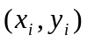 with slope equal to 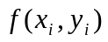, which is an approximation to 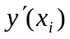. As depends on 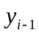, which in turn depends on 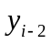 and so on, successive values of tend to be less and less accurate (as the truncation errors accumulate as you go across the interval ).

