COMPUTER SCIENCE 349A
Handout Number 36

RUNGE-KUTTA METHODS
(Section 25.3, page 727 of the 6th ed. or page 729 of the 7th ed.)

Advantage of Taylor methods of order n
- global truncation error of 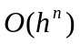insures high accuracy (even for n = 3, 4 or 5)

Disadvantage
- high order derivatives of 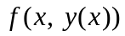 may be difficult and expensive to evaluate.

Runge-Kutta methods are higher order formulas (they can have any order ) that require function evaluations only of , and not of any of its derivatives.

This is accomplished using the Taylor polynomial for a function of 2 variables:

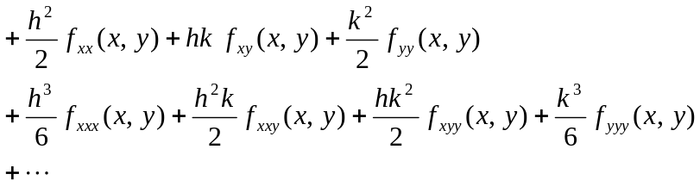

where 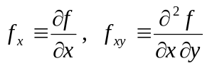, etc.

The derivation of Runge-Kutta methods and an understanding of why they work requires the Taylor polynomial for a function of 2 variables, but this Taylor polynomial is not required to use these methods to numerically approximate the solution of a differential equation.

A second order Runge-Kutta formula is derived in the textbook on page 703 of the 6th ed. or page 705 of the 7th ed.; however, we will not consider their derivation, only their form and how to use them.

Runge-Kutta methods are so-called one-step methods (as also are Euler’s method and all Taylor methods): that is, they are of the form (see 25.28 on page 727 of the 6th ed. of page 729 of the 7th ed.)
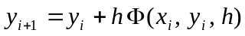

for some (possibly very complicated) function . That is, each computed approximation 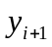 is computed using only the value  at the previous grid point, along with the values of , the step size h, and of course the function that specifies the differential equation.

General form of a Runge-Kutta method of order m:

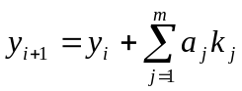
where

Examples

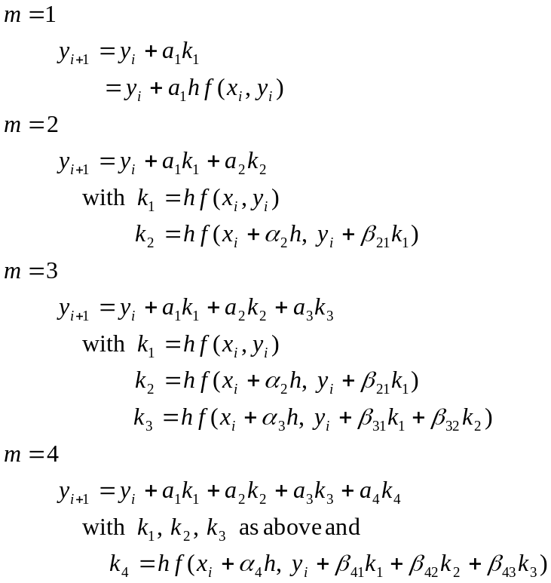

The goal: given any fixed value of 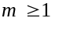, determine values for the parameters:

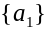 when m = 1

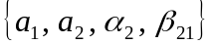 when m = 2

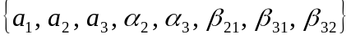 when m = 3

when m = 4

so that the resulting Runge-Kutta method has as high an order as possible (i.e., its local truncation error is as small as possible).

This is accomplished by choosing the unknown parameters 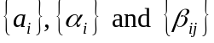 so that the Runge-Kutta formula

is identical to the Taylor series expansion

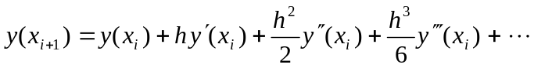

to as many terms as possible.

Case m = 1
The only Runge-Kutta method is Euler’s method

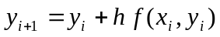.

For each value of 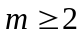, there are an infinite number of Runge-Kutta formulas, each one having local truncation error 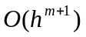 and thus global truncation error 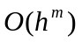.

Case m = 2
Two common Runge-Kutta formulas are derived in the textbook in Section 25.2 (page 719 of the 6th ed. or page 721 of the 7th ed.). It can be shown (by using the Taylor polynomial for a function of 2 variables) that a second-order method is obtained if the 4 parameters satisfy the three non-linear equations

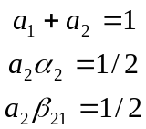

The Modified Euler Method is obtained by choosing the 4 parameters as

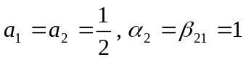

which gives the formula .

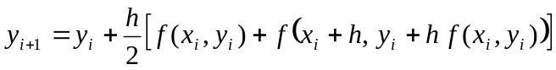.

Note: in the textbook, this is called Heun’s method (see pages 720-721 and 730 of the 6th ed. or pages 722-723 and 732 of the 7th ed.).

The Midpoint Method is obtained by choosing the 4 parameters as

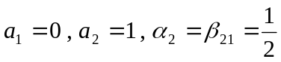

which gives the formula

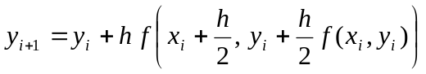.

This is discussed in the textbook on pages 724-726 and 730 of the 6th ed. or pages 726-728 and 732 of the 7th ed.

Case m = 3
It can be shown that any solution of a certain system of 6 nonlinear equations in the 8 unknowns gives a third-order Runge-Kutta method.

One common solution is

which gives the third order Runge-Kutta method (see pages 732-733 of the 6th ed. or pages 734-735 of the 7th ed.)

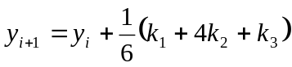
where
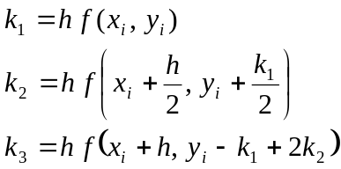

Case m = 4
The 13 Runge-Kutta parameters are obtained by solving a system of 11 nonlinear equations in 13 unknowns.

One solution is the following "classical" Runge-Kutta method, which has order 4 (local truncation error is 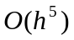 and global truncation error is 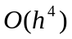):
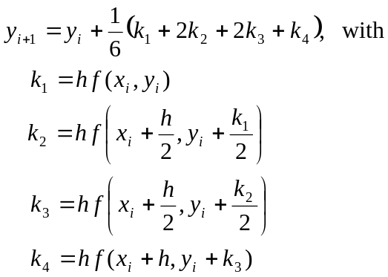

See pages 733-735 of the 6th ed. or pages 735-737 of the 7th ed.

Example
Consider the initial-value problem

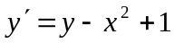 subject to 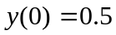 .

The iterative formula for the classical Runge-Kutta method using h = 0.2 is

The given initial condition has

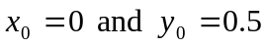,

so setting 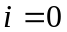 in the above iterative formula gives the following:
and
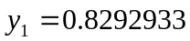

Note: the exact solution is 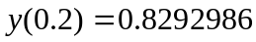 .

***************************************

Which order of a Runge-Kutta method is the best to use (considering both efficiency and accuracy)?

A comparison of several Runge-Kutta methods is given on pages 735-736 of the 6th ed. or pages 737-738 of the 7th ed. A given differential equation is solved by several methods of different orders with the step sizes chosen so that for each of the methods, approximately the same amount of computation is required.

The results indicate that methods of orders 4 and 5 are preferred over methods of orders 2 and 3 in that they give much more accurate computed solutions for about the same amount of effort (where this is measured in terms of the number of times the function is evaluated over the interval of integration).

