COMPUTER SCIENCE 349A
Handout Number 37

Solution of an initial-value problem in MATLAB
using a Runge-Kutta method

The solver "ode45" is a variable step size (or adaptive) Runge-Kutta method that uses two Runge-Kutta formulas of orders 4 and 5; it is similar to the adaptive Runge-Kutta methods in Section 25.5 of the textbook.
In their simplest form, all MATLAB ode solvers can be invoked as follows:

[x, y] = solver (' f ', xspan, y0)

where ' f ' is a string containing the name of the function , xspan is a vector containing the interval of integration, and y0 is the initial condition. Thus, if you have defined a MATLAB function

function z = f(x, y)
z = (1/x)*(y*y+y);

the initial-value problem

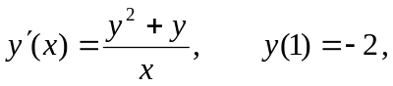

can be solved on the interval [1, 3] by entering

[x, y] = ode45(' f ', [1 3], -2 )

The results will be stored in the (column) vectors x and y (and will be output to the screen, if you don't put a ; at the end of this statement).

In this form, ode45 automatically selects the initial step size and all subsequent step sizes, and attempts to compute the solution so that the global truncation error has a relative error less than 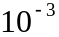.

For the above initial-value problem, if one enters

ode45( ' f ', [1, 3], -2)

without any output parameters on the left hand side of the = , then MATLAB produces a graph of the computed solution.

