COMPUTER SCIENCE 349A

Handout Number 38

ADAPTIVE QUADRATURE
Section 22.3 of the 6th ed. and the 7th ed.

Let denote the (non-composite) Simpson's rule approximation to 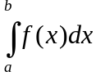.

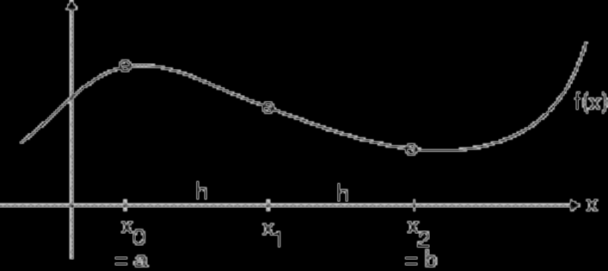

Then
(1) 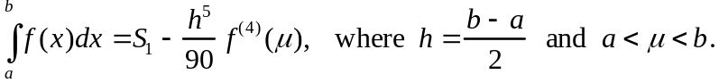

Let 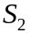 denote the composite Simpson's rule approximation using two applications of Simpson's rule.

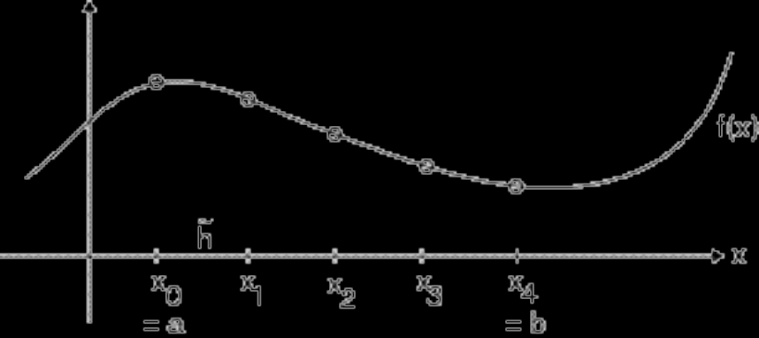

Then
(2) 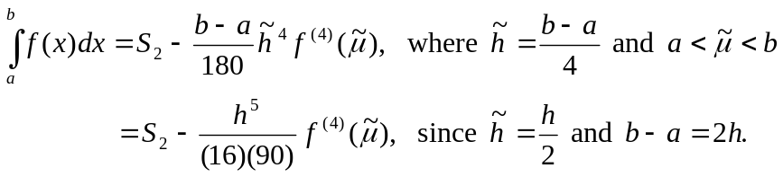

Question: How can the values of 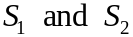 be used to estimate the accuracy of ? To do this, we need to use to estimate the error term for , which (from (2) ) is

(3) 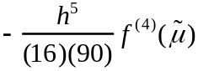 .

In order to do this, we assume that

(4) 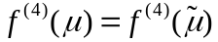.

(Note that if h is very small, this is likely a good assumption, and will lead to an accurate estimate of the truncation error of .) Using (4) in (2), from (1) and (2) we obtain

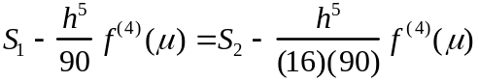,

from which it follows that

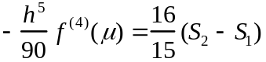,

and thus from (3), an estimate of the truncation error of is

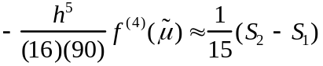.

Consequently, (2) becomes

(5) 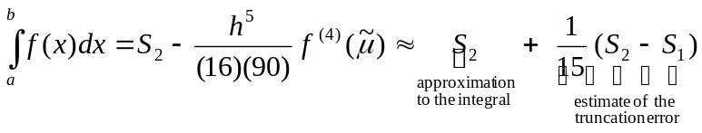 ,

from which it follows that

(6) 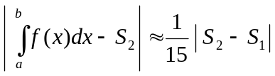 .

How to use this error estimate: Suppose you want to estimate to within an accuracy of . If you compute and it is the case that 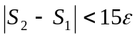, then from (6) we have

(7) 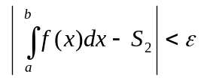

and is the desired approximation. On the other hand, if 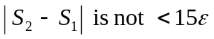, then you must select a smaller value for h and repeat the procedure.

Note 1. The rightmost part of (5) is the result of applying Richardson's Extrapolation to , but it is just and not that extrapolated value that is used here to approximate the integral.

Note 2. A recursive algorithm for the above procedure is given on page 640 of the 6th ed. or page 642 of the 7th ed.

THE ADAPTIVE QUADRATURE ALGORITHM for approximating to an accuracy of :

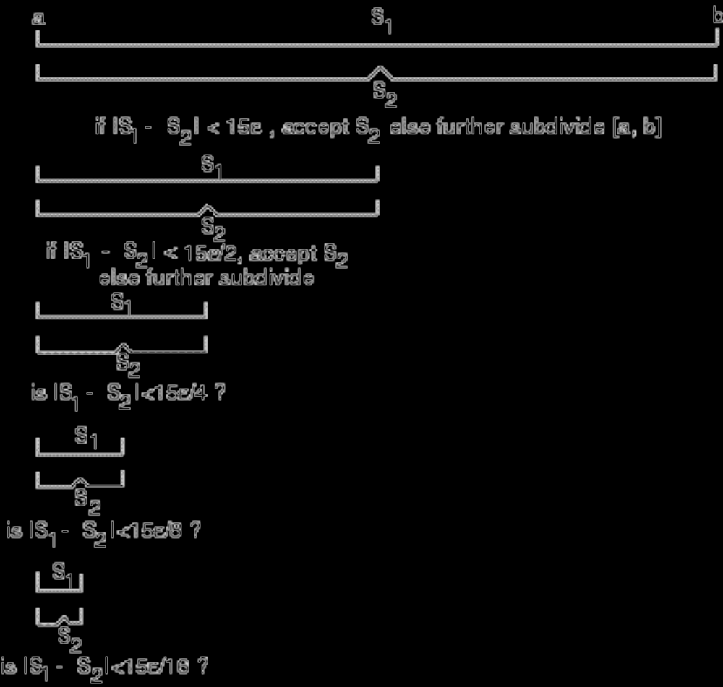

The algorithm proceeds as follows. The interval 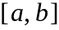 is repeatedly halved, and on each successive subinterval the two Simpson's rule approximations are computed. This continues, working with the leftmost subinterval of , until values are obtained that are sufficiently close together that can be accepted as the approximation of the integral on some subinterval of .

For example, in the above diagram, if the last two values of satisfy 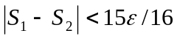, then this value of is accepted as the approximation to 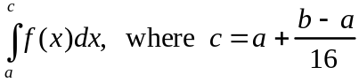, and this approximation has an error of at most 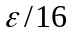. In order to find approximations to the integral on the rest of , the algorithm returns to the last (that is, the leftmost) subinterval on which no approximation to the integral has yet been determined, and continues computing values of , and further subdividing this subinterval if necessary.

This continues until eventually the entire subinterval is subdivided into many subintervals, possibly of many different lengths, and a value has been accepted as the approximation to the integral on each little subinterval. The approximation to is the sum of all of these values ( and the sum of the errors of all of these approximations will be , which is the desired accuracy). The length of each subinterval for which a value is accepted depends on the shape of the graph of . In those parts of where is oscillatory, a very small value of h (that is, a very small subinterval) will be required in order that the computed approximation is sufficiently accurate.

The MATLAB function quad can be used to approximate

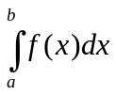

using a recursive adaptive quadrature algorithm based on Simpson's rule. The function can be coded as a MATLAB function M-file, for example,

function y = f(x)
y = ...... ;

and must accept a vector x as an argument (recall that that means you must use ./ .* .^ and so on instead of just / * ^ ). Execution of

[Q, fnc] = quad (@f, a, b, tol )

results in the computation of an approximation to the above integral using tol as the criterion for testing absolute error. The value of the computed approximation is returned as Q, and the value of fnc is equal to the number of function evaluations of f(x) used to compute this approximation.

Other adaptive quadrature algorithms are available in MATLAB; see help quad.
Example.
Use the MATLAB function quad to approximate

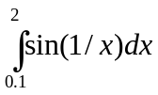

using tol = 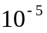 and determine the number of function evaluations required. Use format long .

*******************************

function y=f(x)
y=sin(1./x);

format long

[Q,fnc]=quad('f',0.1,2,1e-5)

Q =

1.145574937627094

fnc =

49

**************************

Note that if this same problem is solved using the composite Trapezoidal rule, it requires over 4000 function evaluations.

