Jesus Gutierrez

Lab #2 Part 2

ID #80518569

**Task #1:**

First, I must compile the program “vul_prog.c” using the command shown below:



Then, I was able to crash the program shown below:

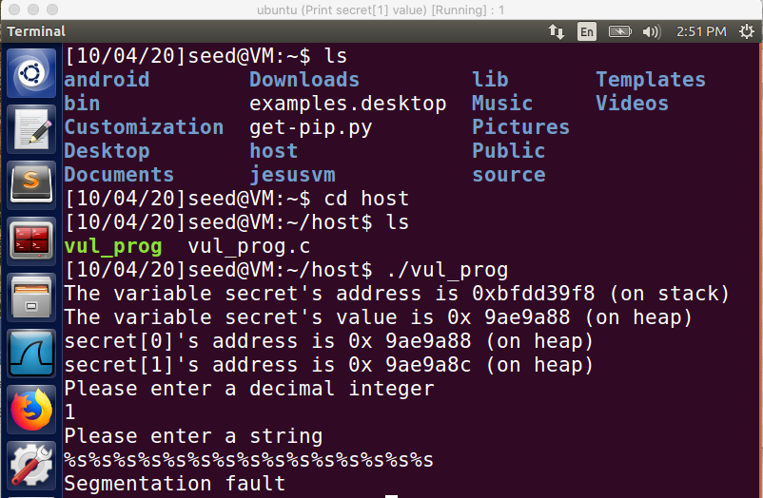

Then, I was able to print out the secret [1] value shown below:

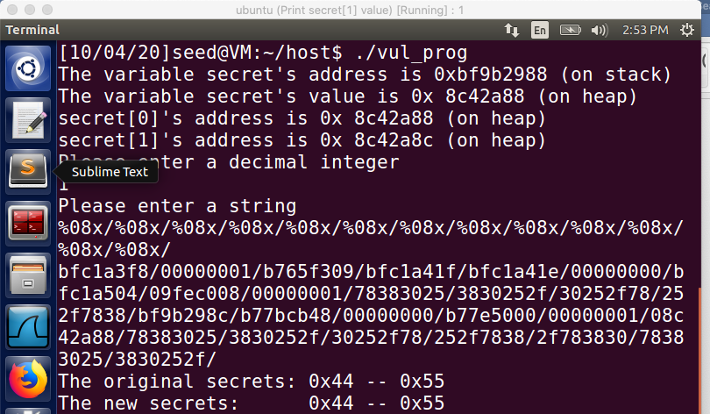

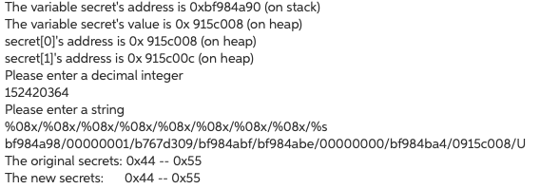

Then, I was able to modify the secret [1] value as shown below:

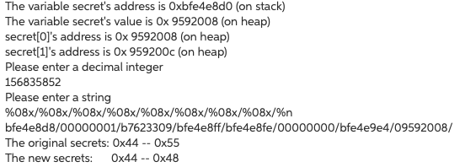

Finally, a pre-determined value for secret [1] shown below:

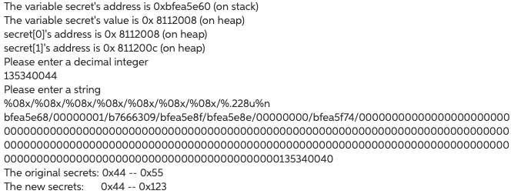

Note: a few pictures I had them done again in a .txt file for better viewing for me.

Task 2:

After turning off the address randomization, and removing the scanf statement from the vulnerable program and running the tasks from the previous problem, I was still getting the same addresses. As show below:

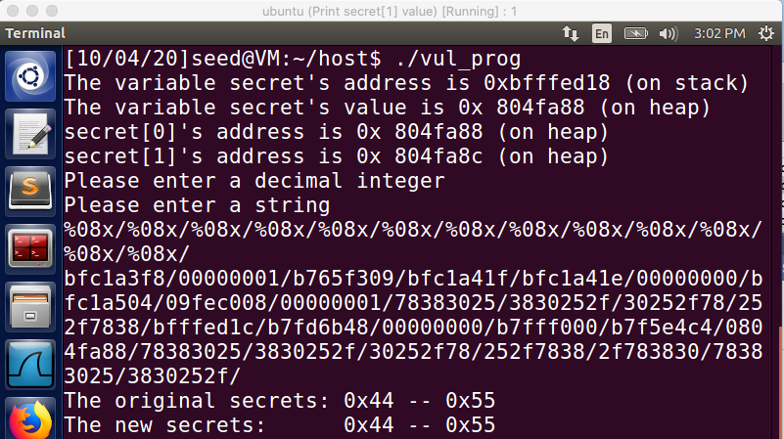

Observations acquired in this lab was that it was a very interesting and surprising lab. A lot more fun than the first lab. Getting used and familiar with security and Linux is always a plus for me because I’m usually not that much involved with this operating system, and all this practice really makes up for a lot of skills I am implementing in my portfolio.