***Assignment #2***

***Jesus Gutierrez***

***LINUX UNIX COMMANDS:***

sleep: suspends program execution for a specified time in seconds.

pwd: writes the full pathname of the current working directory.

echo: outputs the strings it is being passed as arguments.

cat: reads files sequentially, writing them to standard output.

wc: newline count, word count, and byte count

ls: ls lists the files in the current working directory.

Task-1: Basic shell implementation Your shell must execute all simple Linux commands like **ls**, **wc, cat**, **echo, pwd** and **sleep**.

Ls command: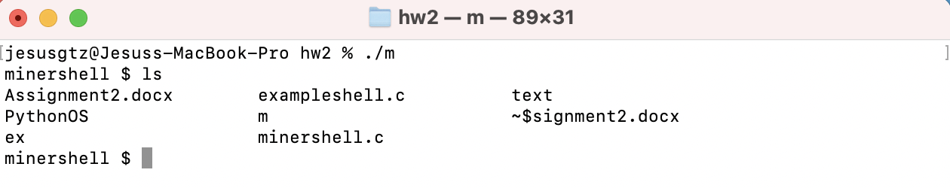

Wc command: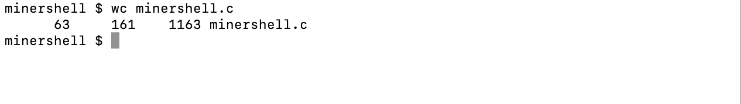

Echo command: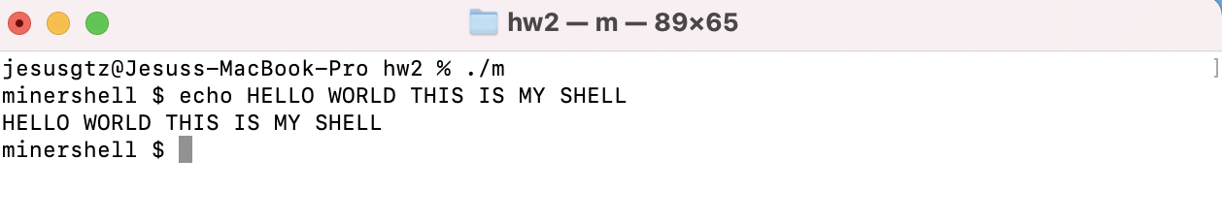

Pwd command: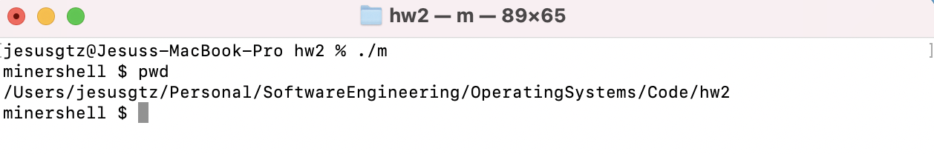

Sleep command:

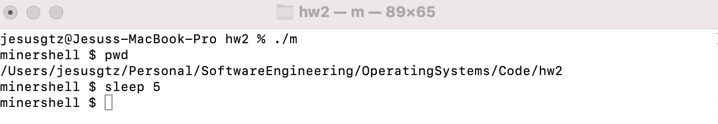

Exit command: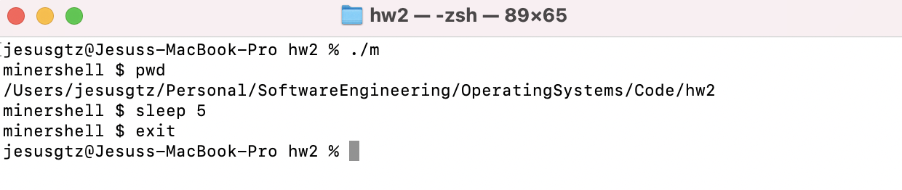

Cat command: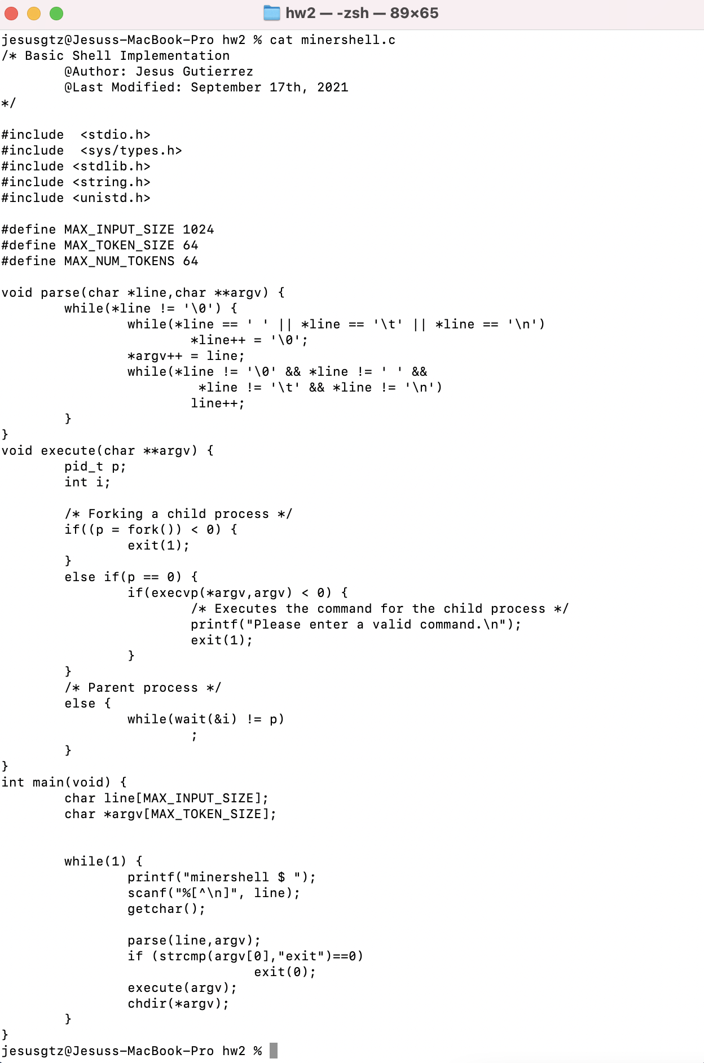

Task-2: Enabling change of directory proceed to implement support for the **cd** command in your shell using the **chdir** system call.

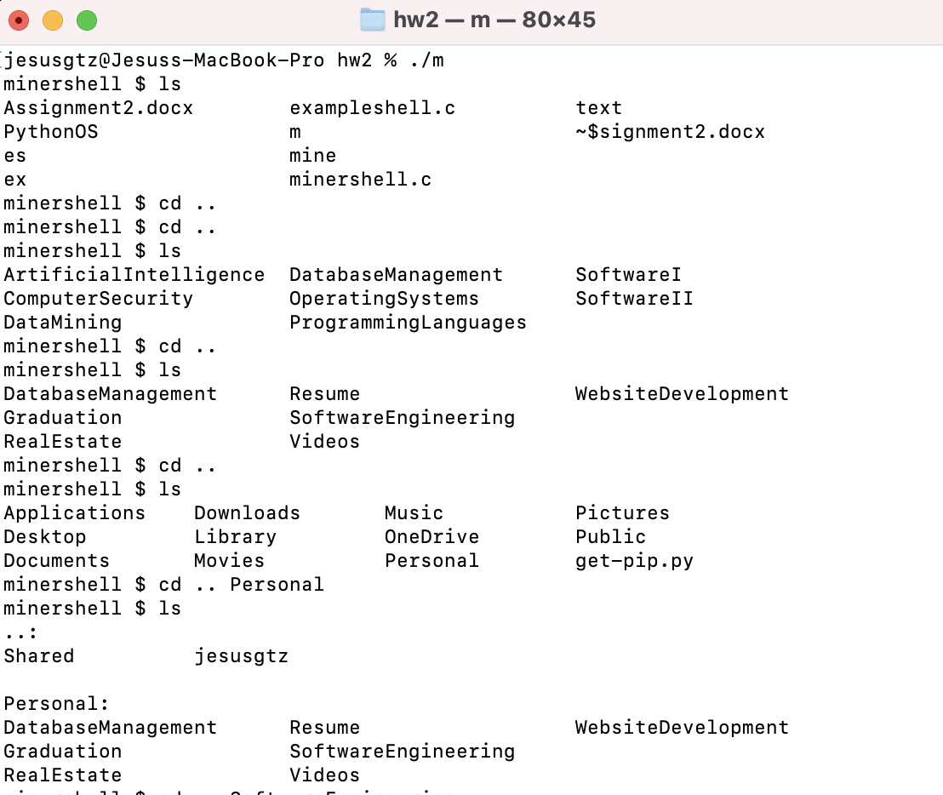

DISCLAIMER, my shell does ***‘cd ..’*** to go back which is the right command, although for moving forward to an existing directory then **‘cd .. *<directory name>’*** can be used.